

**Capstone Project Report**

**TripSharing**

|  |  |
| --- | --- |
| **Group** | |
| **Group Members** | Hà Văn Thái – SE04801  Nguyễn Văn Phong – SE05051  Trần Văn Phong – SE05048  Lê Xuân Trường – SE04616  Lý Phúc Linh – SE04693 |
| **Supervisor** | Đào Trọng Duy |
| **Capstone Project Code** | TripSharing |

**Hanoi, May 30th, 2019**

*This page is intentionally left blank*

Table of Contents

**Acknowledgements** 7

**Definitions and Acronyms** 8

**1.1 Purpose** 9

**1.2 Project Information** 9

**1.3 The People** 9

**1.3.1 Supervisors** 9

**1.3.2 Team Members** 9

**1.4 Background** 9

**1.4.1 The exist sharing travel experience systems are focus on famous travel destination and booking services** 11

**1.4.2 TripAdvisor’s Advantages and Disadvantages** 12

**1.5 Proposal of System** 13

**1.5.1 Our Proposal System** 13

**Chapter 2: Project plan** 17

**2.1 Purpose** 17

**2.2 Project Organization** 17

**2.2.1 Software Development Process** 17

**2.2.2 Role and Responsibilities** 18

**2.2.3 Organization Structure** 19

**2.2.4 Project Team Member** 19

**2.2.5 Tools and Techniques** 20

**2.3 Project Management Plan** 20

**2.3.1 Tasks** 20

**2.3.2 Meeting Minutes** 21

**2.3.3 Code Conventions** 22

**2.3.4 Risk Management Plan** 23

**2.3.5 Communication Plan** 24

**Chapter 3: Software Requirement Specification** 27

**3.1 Purpose** 27

**3.2 Functional Requirements** 27

**3.2.1 Use Case Diagram** 27

**3.2.2 Business Rules** 27

**3.2.3 Use Cases** 28

**3.3 Non-Functional Requirements 78**

**3.3.1 Security 78**

**3.3.2 Maintainability & Extensibility 81**

**3.3.3 Availability and Scalability 81**

**3.3.4 Performance 81**

**3.3.5 Usability** 81

**Chapter 4: Software Design** 82

**4.1 Purpose** 82

**4.2 Architecture Overview** 82

**4.2.1 System Architecture** 82

**4.2.2 System Architecture Explanation** 82

**4.3.2 Database Design** 87

**4.3.3 Common Design** 97

**4.3.4** **Detail Design** 97

**Chapter 5: Software Testing Documentation** 281

**5.1 Introduction** 281

**5.1.1 Purpose** 281

**5.1.2 Scope of testing** 281

**5.2 Test plan** 281

**5.2.1 Testing tools and environment** 281

**5.2.2 Resources and responsibilities** 283

**5.2.3 Test strategy** 283

**5.2.4 Features to be tested** 286

**5.2.5 Features not to be tested** 286

**5.3 Test Approach** 286

**5.3.1 Unit testing** 286

**5.3.2 Integration testing and System test** 290

**5.3.4 Acceptance Test** 290

**5.3.5 Defect Log** 292

**5.4 Test Report** 293

**5.4.1 Unit test report** 293

**5.4.2 Integration test report** 295

**5.4.3 System test report** 296

**Chapter 6: User manual** 298

**6.1 Deployment guidelines** 298

**6.1.1 Environment for development** 298

**6.1.2 Environment for deployment** 304

**6.2 User guidelines** 308

**6.2.1 User sign up** 308

**6.2.2 User sign in** 310

**6.2.3 User sign out** 310

**6.2.4 User update profile** 311

**6.2.5 User searches posts** 312

**6.2.6 User searches other users** 312

**6.2.7 User creates posts** 313

**6.2.8 User chats with other users** 315

**6.2.9 User joins a group** 316

**6.2.10 User follows other users and views followings/followers** 317

**6.2.11 User bookmarks posts and view bookmarked posts** 318

*This page is intentionally left blank*

# **Acknowledgements**

*We wish to express our deepest gratitude to our supervisor, Mr. Dao Trong Duy, for his  
continuously sharing and motivating throughout the project. Following strictly Mr. Duy  
instructions, the TripSharing team has always felt confident in dealing with problems along the way. Taking aside all the technologies and methodologies, Mr. Duy induced us with the idea of having the right attitude & resolution towards tackling obstacles. That was the most important factor that has led us to the completion of this project.*

*Finally, we truly appreciate the instructors at FPT University for all the lectures & knowledge shared to us. We hope you will find this project as a reflection of the knowledge and experiences you have given us during this period of three years.*

# **Definitions and Acronyms**

|  |  |  |
| --- | --- | --- |
| **Acronym** | **Definition** | **Note** |
| API | Application Programming Interface |  |
| JSON | JavaScript Object Notation |  |
| URL | Uniform Resource Locator |  |
| BSON | Binary JSON |  |
| GUI | Graphical User Interface |  |
| UML | Unified Modeling Language |  |
| SDK | Software Development Kit |  |
| OOP | Object-oriented programming |  |
| CLI | Command-line interface |  |

**Chapter 1: Introduction**

* 1. **Purpose**

This chapter provide an overview of the project include background information, a literature review of existing system and raising a proposal for ideas of improvement.

* 1. **Project Information**
* Project name: **TripSharing**
* Project code: **TRIPSHARING**
* Project group name: **SWP491_G26**
* Project type: **Web Application**
* Timeline: **From 13th May 2019 to 29th August 2019**
  1. **The People**
     1. **Supervisors**

|  |  |  |  |  |
| --- | --- | --- | --- | --- |
|  | **Full name** | **Phone** | **E-mail** | **Title** |
| Supervisor | Đào Trọng Duy | 0983204196 | duydt@fe.edu.vn | Lecturer |

Table 1-1: Supervisors' information

* + 1. **Team Members**

|  |  |  |  |  |
| --- | --- | --- | --- | --- |
|  | **Full name** | **Phone** | **E-mail** | **Role in Group** |
| 1 | Hà Văn Thái | 0349940158 | thaihvse04801@fpt.edu.vn | Leader |
| 2 | Nguyễn Văn Phong | 0978296187 | phongnvse05051@fpt.edu.vn | Member |
| 3 | Trần Văn Phong | 0987489397 | phongtvse05048@fpt.edu.vn | Member |
| 4 | Lê Xuân Trường | 0964038801 | truonglxse04616@fpt.edu.vn | Member |
| 5 | Lý Phúc Linh | 0362442818 | linhlpse04693@fpt.edu.vn | Member |

Table 1-2: Team member's information

* 1. **Background**

Along with the development of technology, tourism demand is getting higher, especially young people. Nowadays, people mostly find information about where they want to go on the internet and social network like Facebook, TripAdvisor, Gody.vn, etc. But many websites only provide general information about the destination and only focus on advertising and support booking hotel, restaurant, travel tour…. We can find such post on Facebook but it scattered on many pages and there are many posts created for advertising purpose may make people concern about the correctness of the information.

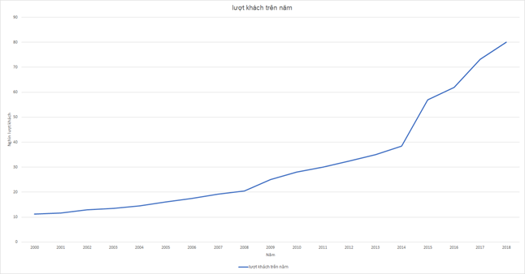

Figure 1-1: Number of local tourists reach 80 million in 2018[1]

Among young people, tourism for exploring and experience is becoming a new trend, and people usually want to share their experience online:

*“Khảo sát về xu hướng du lịch toàn cầu trong năm 2018 do Visa thực hiện với sự tham gia của hơn 15.000 người đến từ 27 quốc gia, trong đó có Việt Nam đã chỉ ra rằng khách du lịch hiện nay thường mong muốn đạt được cả hai mục tiêu “khám phá” và “tận hưởng” trong những chuyến đi của mình. Kết quả khảo sát đã đưa ra ba nhóm động lực chính cho những chuyến du lịch là: gắn kết gia đình, bạn bè (33%), thư giãn (11%) và trải nghiệm (10%). Ranh giới giữa những động lực thúc đẩy người dân đi du lịch đang dần bị xóa nhòa. Những người du lịch vì cảm giác “tận hưởng” thường đi để gắn kết với bạn bè, người thân hay đơn giản là tận hưởng thời gian nghỉ dưỡng của riêng mình. Riêng những du khách đi du lịch để “khám phá” có xu hướng trải nghiệm nhiều hơn với các nền văn hóa mới và thăm quan những điểm đến hấp dẫn. 63% người được hỏi trả lời rằng họ đi du lịch vì cả hai lý do này, tỉ lệ tương ứng tại Việt Nam là 72%.”[2]*

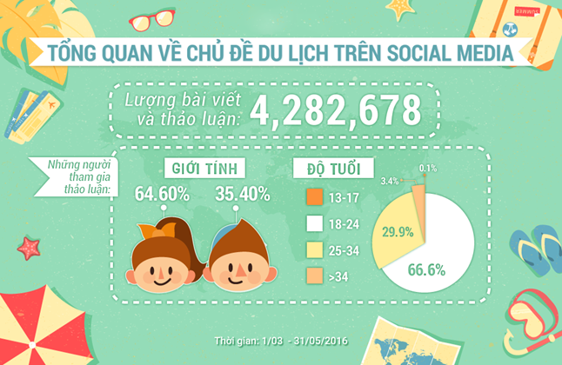

Figure 1-2: Sharing travel information on social media[3]

* + 1. **The exist sharing travel experience systems are focus on famous travel destination and booking services**

Our study shows that travel guides, travel destinations reviews websites are focusing too much on advertising and booking for travel destination than the travel experience of users. Example on Tripadvisor.com and Toidi.net are 2 big websites, but they don’t provide enough interaction between users, Toidi.net is more like a blog then the posts are subjective, on Tripadvisor.com people can post photo or review for a destination but there is no comment section for other to interact with each other. The creation of this project is aiming to improve the lack of interaction between users and focus more on sharing experiences through the trip.

* + 1. **TripAdvisor’s Advantages and Disadvantages**
       1. **TripAdvisor’s Advantages**
* They already have a booking system.

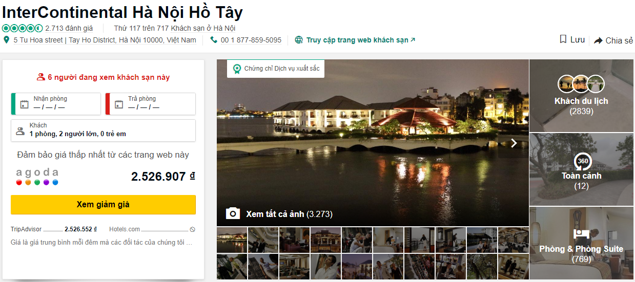

Figure 1-3: Booking function on TripAdvisor

* User can create a virtual trip

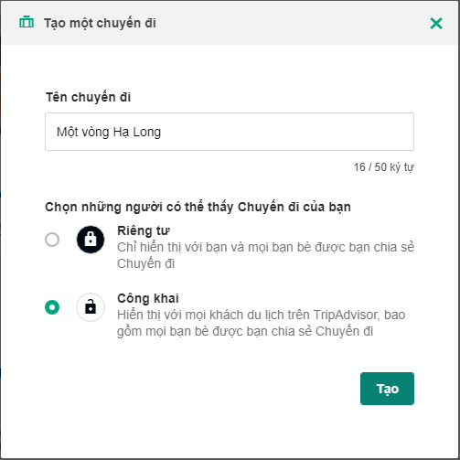

Figure 1-4: Creating a virtual trip function on TripAdvisor

* + - 1. **TripAdvisor’s Disadvantages**
* User can’t comment on other’s posts or photos so they are lack of interaction between users.
* Don’t support users for writing a long sharing experience post, like blog.
  1. **Proposal of System**
     1. **Our Proposal System**

After reviewing all properties of the existing systems as well as the travel trend of young people in Viet Nam, we have come to decision to develop a travel sharing system which allows travelers to share their travel experiences by images, articles or blogs. It will make easier for other travelers to prepare their plans. The purpose of the system is creating a travel community to exchange information. The system is going to encourage travelers to share their experiences by recording their contributions as points and rank all contributors. If contributors have a high rank, they will receive many incentives from the system.

The system does not focus on booking services. A common trip includes three stages. The first stage is planning, the second is experiencing, and the last is sharing. Our system is going to focus on the sharing stage.

* + - 1. **System Functions**
* Allow users to register/sign in with email address.
* Allow users to create/edit their own profile.
* Allow users to search travel destination.
* Allow users to choose interesting topic.
* Allow users to create/edit/delete their post.
* Allow users to like/unlike a post.
* Allow users to share a post to social media.
* Allow users to bookmark a post.
* Allow users to comment to a post.
* Allow users to report a post/comment.
* Allow users to create/edit/delete their virtual trips.
* Allow users to follow/unfollow other users.
* Allow users to create/edit/delete their finding companion posts.
* Allow users to join a finding companion group.
* Allow users to send/receive messages to other users.
* Allow Administrators to manage users’ account, users’ posts, users’ comments.
  + - 1. **The TripSharing User Process**

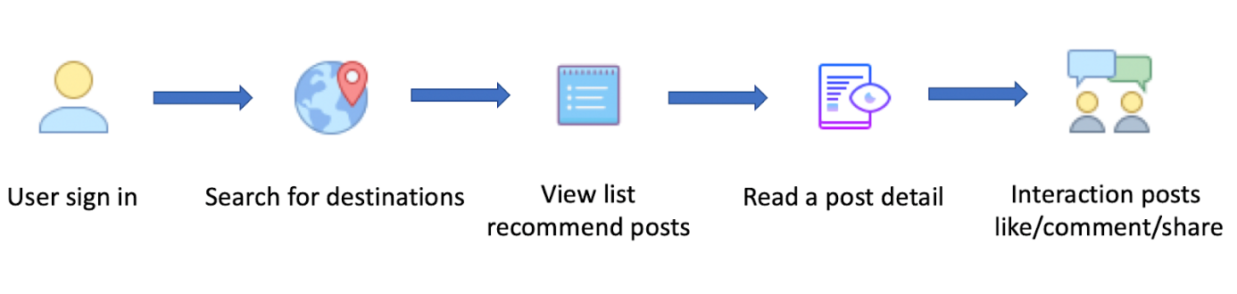

Figure 1-5: User reads and interacts with a post

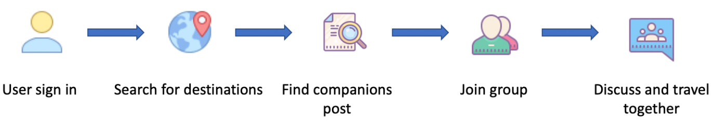

Figure 1-6: Users use Finding Companions function

* + - 1. **Out of Scope Functions**
* Manage group of people who use Finding Companions function.
* Manage travel places obtained from Google Map.
  + - 1. **Special Approaches**
* Using Microservices architecture for application’s deployment.
* Using Docker to compose the project into containers to deploy on Google Cloud.
* Using Google Cloud Kubernetes Engine as deployment host for scaling and load balancing.
* Use Git as source code version control, hosted on Github.
* Having a separate background service to handle heavy tasks.
* Using Google Pub Sub for communicating between microservices.
* Using Google Cloud Storage for images.
* For web frontend system:
* Using Angular 7 for web component rendering.
* Using Angular Material to create all web form components.

# **Chapter 2: Project plan**

* 1. **Purpose**

This chapter provides an overview of the project plan includes project organization and project management plan

* 1. **Project Organization**
     1. **Software Development Process**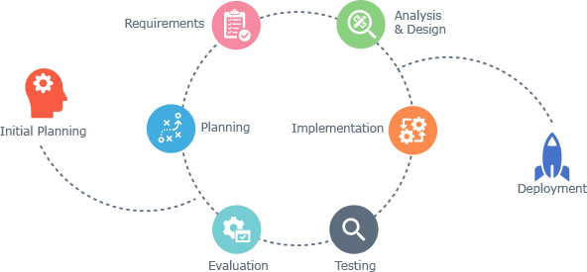

Figure 2-1: Iterative and Incremental Software Development Process[4]

TripSharing project uses the Iterative and Incremental Software Process Model as show in the figure above, which describes the overall lifecycle process.

The Iterative and Incremental Software Process Model is mostly used when the scope of the project is big, the major requirements are defined clearly, some more details will be added later. By using this process model, we break down the developing system tasks into series of smaller tasks which will complete separately, evaluated, and subsequently re-worked until the system perform adequately. In addition, the iterative model is easier than other models when the issues are discovered. The feedbacks are immediately given, and solutions are proposed right on the spot.

* + 1. **Role and Responsibilities**

|  |  |
| --- | --- |
| **Role** | **Responsibilities** |
| Project Manager | Planning, developing schedules, coordinating communication,  generally responsible for keeping the team’s focus on the main  goal |
| Business Analysis Leader | Responsible for managing Business Analyst team and working with them in Analyzing an organization or business domain. |
| Business Analyst | Analyzes an organization or business domain and documents its business or processes or systems. |
| Design Leader | Responsible for managing Design team and working with them to create a best user interface design for our product. |
| Designer | Involve to design product’s user interface. |
| Technical Leader | Responsible for choosing and deciding what technologies should  be used, as well as for overseeing the work being done by other  developers. |
| Developer | Involve to code the product and review code of other developers. |
| Test Leader | Responsible for choosing and deciding what testing tools and techniques should be used, as well as keep the progress of test team on track. |
| Tester | Involve testing the product. |

Table 2-1: Role and Responsibilities

* + 1. **Organization Structure**

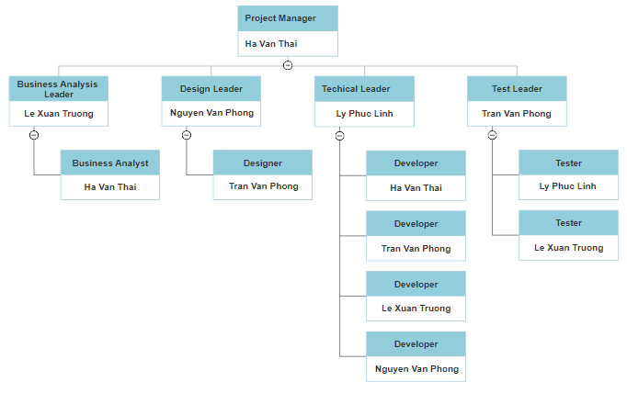

Figure 2-2: Organization Structure

* + 1. **Project Team Member**

|  |  |
| --- | --- |
| **Team Member** | **Role** |
| Ha Van Thai | Project manager, business analyst, developer |
| Nguyen Van Phong | Technical leader, designer |
| Tran Van Phong | Design leader, developer, tester |
| Le Xuan Truong | Business analysis leader, developer, tester |
| Ly Phuc Linh | Test leader, developer |

Table 2-2: Project Team Member

* + 1. **Tools and Techniques**

|  |  |
| --- | --- |
| **Programing Languages:** | C#, JavaScript |
| **Frameworks:** | Angular 7, Angular material |
| **Software Architecture:** | Microservices |
| **Version control:** | Git |
| **IDEs / Editors:** | Visual studio, Visual studio code |
| **UML Tools:** | Astah UML |
| **Web Server:** | Nginx |
| **DBMS:** | MongoDB |
| **Deployment Server:** | Google cloud |
| **Project Management Tools:** | Microsoft Project 2013 |
| **Process Model:** | Iterative and Incremental Software Process Model |

Table 2-3: Tools and Techniques

* 1. **Project Management Plan**
     1. **Task****s**

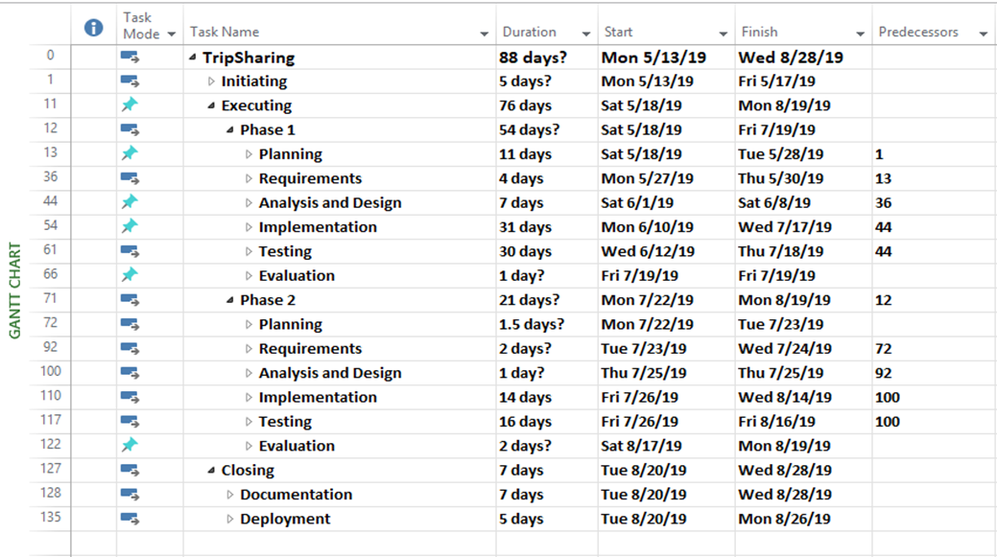

Figure 2-2: Work Breakdown Structure

* + 1. **Meeting Minutes**

All meeting minutes will be written following this template:

|  |  |  |  |
| --- | --- | --- | --- |
| **Meeting/Project Name:** | TripSharing | | |
| **Date of Meeting:** | 06/06/2019 | **Time: (Type)** | 3 hours  (face-to-face) |
| **Meeting Called by:** | ThaiHV | **Location:** | HB206L |
| **Note Taker:** | PhongTV | **Time Keeper:** | PhongNV |
| **1. Meeting Objective** | | | |
|  | | | |
| **2. Attendance** | | | |
| **Name** | **Role** | **Email** | **Phone** |
| ThaiHV | Project Manager  Developer  Business Analyst | thaihvse048010@fpt.edu.vn | 0349940158 |
| PhongNV | Technical Leader  Designer | phongnvse05051@fpt.edu.vn | 0978296187 |
| PhongTV | Design Leader  Developer  Tester | phongtvse05048@fpt.edu.vn | 0987489397 |
| TruongLX | Business Analysis Leader  Developer  Tester | truonglxse04616@fpt.edu.vn | 0964038801 |
| LinhLP | Test Leader  Developer | linhlpse04693@fpt.edu.vn | 0362442818 |
| **3. Content** | | | |
|  | | | |
| **4. Note** | | | |
|  | | | |

Table 2-4: Meeting Minutes

* + 1. **Code Conventions**

We strictly follow Google JavaScript Style Guide and Microsoft C# Programing Guide as the coding convention for the project. Specific convention rules can be found on these pages.

JavaScript: <https://google.github.io/styleguide/jsguide.html>

C#: <https://docs.microsoft.com/en-us/dotnet/csharp/programming-guide/inside-a-program/coding-conventions>

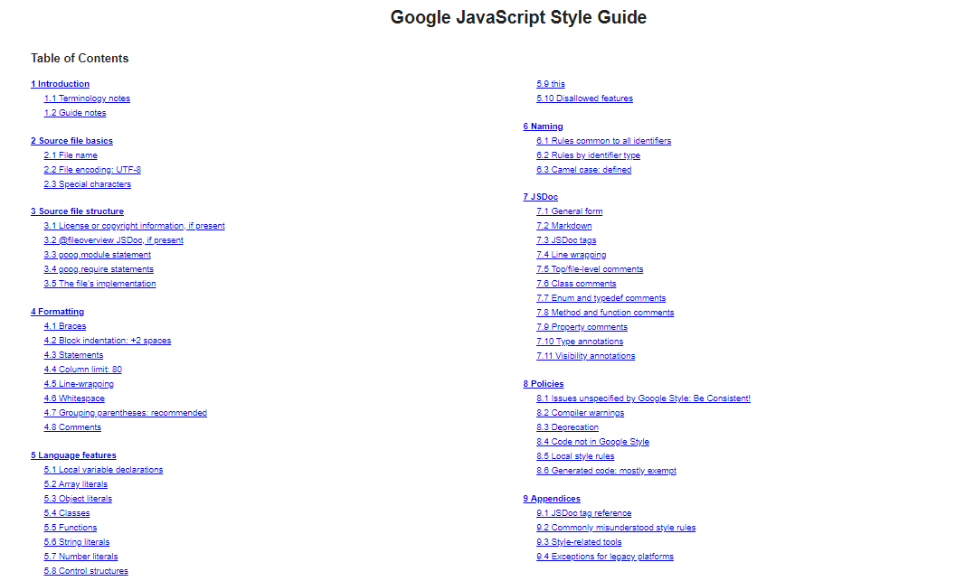

Figure 2-3: Google JavaScript Style Guide

* + 1. **Risk Management Plan**

|  |  |  |  |  |
| --- | --- | --- | --- | --- |
| No | Name | Prevention | Correction | Status |
| R1 | Miscommunication | Any problem raised has to be documented or filed. Team members should express their opinion clearly. | Miscommunication must be resolved early. | Closed |
| R2 | New technology | Choosing technology carefully and based on team member’s qualification. All member must develop self-learning skill. | The technology choice should be consider carefully, well explained and training for member if necessary. | Closed |
| R3 | Member idea conflict | Member is free to express their idea and discuss with others to find the most suitable solution. | Analyze any idea carefully and base on reality and possibility, solve conflict as soon as possible. | Closed |
| R4 | Business problem | Understand business of project, consider if its fit applicability, reality and technology possibility. Ask supervisor if needed. | Project business must be tight and realistic. | Closed |
| R5 | Illness or absence  of team members | Member must notice to the  team about absence period  and the plan of how to  keep up with the work  process. | Ensure that the absence  of a member won’t  affect others and  always have plans to  deal with this problem. | Closed |
| R6 | Resources were lost or deleted | Team must have several online and offline back up copy of project. | At least 3 back up way such as Github, Google Drive, etc. and offline copy on each member computer. | Closed |
| R7 | Illness or absence  of team members | Member must notice to the  team about absence period  and the plan of how to  keep up with the work  process. | Ensure that the absence  of a member won’t  affect others and  always have plans to  deal with this problem. | Closed |
| R8 | Changes of software architecture | Read and understand the software architecture thoroughly before starting to apply it to the project | Changes of software architecture must be done early. | Closed |

Table 2-5: Risk Management Plan

* + 1. **Communication Plan**

**Weekly meeting schedule:** We follow the Iterative and Incremental Process Model, and we separate the project into two main team, back-end API team and front-end web app team. Each team will do the tasks the task assigned to team members by the Team Leader and depending on difficulty the Technical Leader will assign deadlines for each task. We have a meeting every Thursday to update all team members about what has been done during last week.

**Daily meeting schedule:** Each sub team has one development team with different schedule and deadlines. Before the daily meetings, each member will be telling:

* What he has completed.
* What he is working on.
* When he will finish.
* What issues he is encountering, or if he needs assistance.
* What he will be doing after finishing the task.

**Unscheduled meeting:** Assuming someone has encountered a serious problem that he wants to solve immediately, we will have a meeting via some online channel: Skype, or Phone. Face to face meeting in any emergency cases.

**Communication channel:** Our main communication channel is Skype and Facebook group. We use TeamViewer for assisting team member when he meets technical issues.

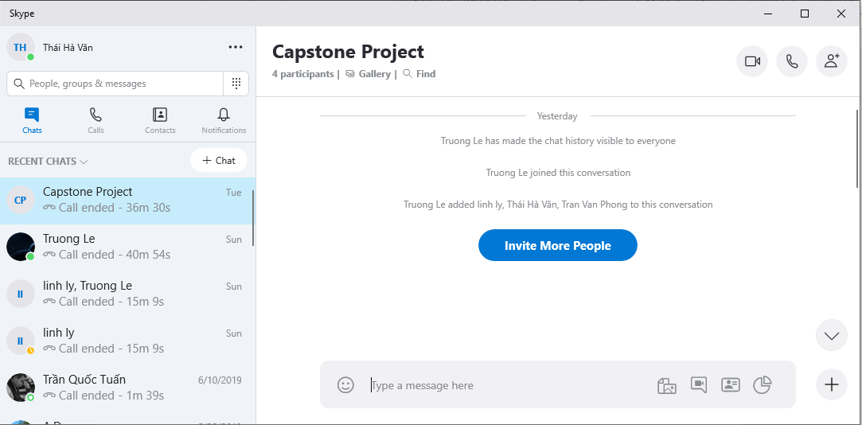

# **Chapter 3: Software Requirement Specification**

## **3.1 Purpose**

This chapter contains details about functional and non-functional requirements the website. Constraints and detailed requirements are specifically described for developers to follow when completing the tasks.

## **3.2 Functional Requirements**

### **3.2.1 Use Case Diagram**

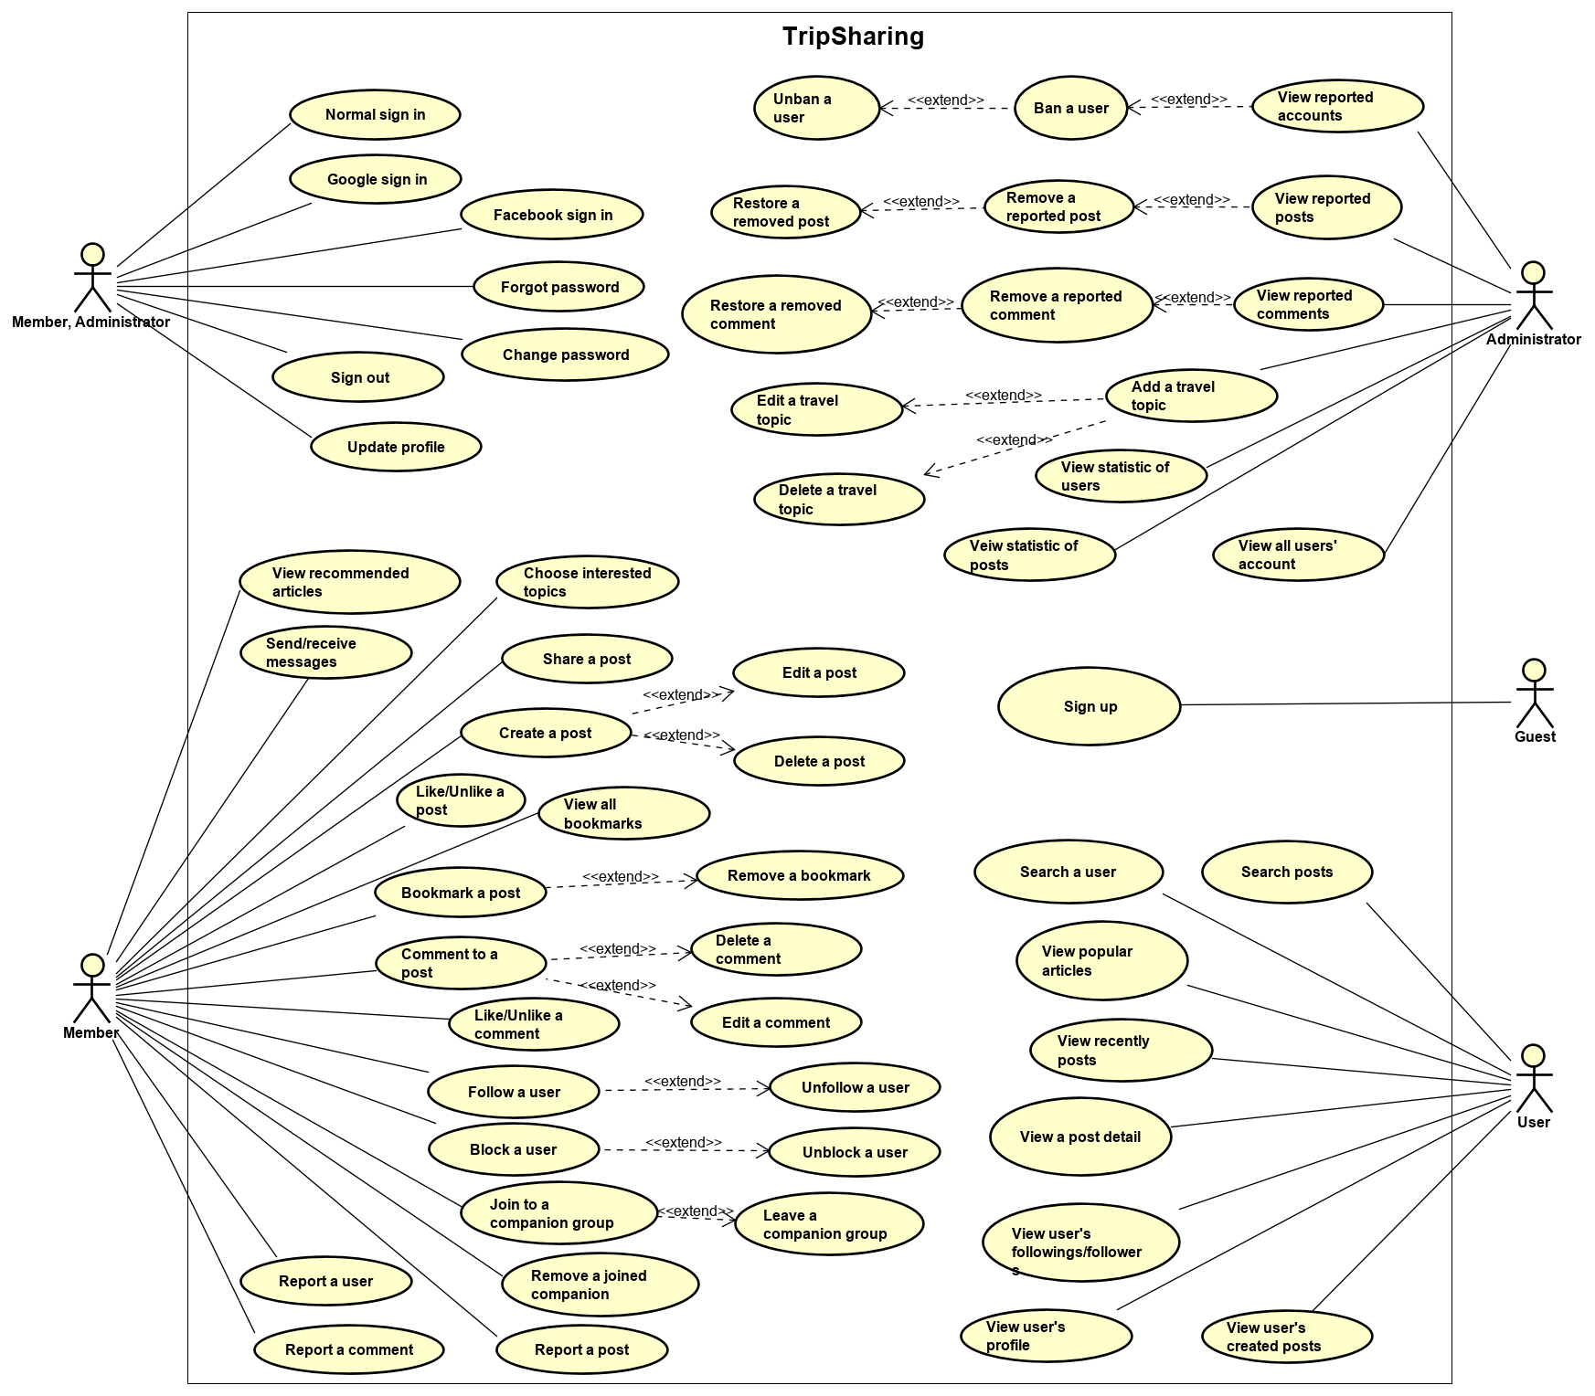

### **3.2.2 Business Rules**

|  |  |
| --- | --- |
| **No** | **Description** |
| **B1** | The email must not be empty and valid. |
| **B2** | The confirm password must be matched with the new password. |
| **B3** | Username must not be empty and not be longer than 100 characters |
| **B4** | Image file's mime type must be: "image/png" or "image/jpeg". |
| **B5** | Maximum file size allowed is 10Mb |
| **B6** | Eve |
| **B7** | The root Administrator has the highest privilege. |
| **B8** | An Administrator can: ban/unban users, remove/restore posts, remove/restore comments. |
| **B9** | A banned user can’t post articles, comment to a post or chat with other users. |
| **B10** | When user sign out, his/her current access token is blacklisted. |
| **B11** | An article title must not be empty and not be longer than 1000 characters. |
| **B12** | An article content must not be empty and not be longer than 100,000 characters. |
| **B13** | An article must be tagged to at least one travel place. |
| **B14** | An article must be tagged to at least one travel topic. |
| **B15** | A comment must not be empty and not be longer than 10,000 characters. |
| **B16** | Each destination in virtual trip has a note and not be longer than 500 characters. |
| **B17** | A chat message must not be empty and not be longer than 10,000 characters. |
| **B18** | Member can report any other member, post or comment |
| **B19** | When a finding companion post is expired, users can’t join to that companion group. |
| **B20** | Contribution points formula:   * Create a post: +5 points * For each 100 likes on a post: +1 points |

### **3.2.3 Use Cases**

|  |  |
| --- | --- |
| **Actor** | **Description** |
| Guest | Anyone who visits the website and doesn’t have an account yet. |
| Member | Those who has registered an account on TripSharing. |
| Administrator | Who has the highest the permission level and has responsible for managing the entire website. |
| User | Any normal user of following types: Guest, Member, and Administrator |

|  |  |  |
| --- | --- | --- |
| ID | Actor | Name |
| UC-001 | Guest | Sign up |
| UC-002 | Member, Administrator | Google sign in |
| UC-003 | Member, Administrator | Facebook sign in |
| UC-004 | Member, Administrator | Normal sign in |
| UC-005 | Member, Administrator | Forgot password |
| UC-006 | Member, Administrator | Sign out |
| UC-007 | Member, Administrator | Change password |
| UC-008 | Member, Administrator | Update profile |
| UC-009 | Member | Choose interested topic |
| UC-010 | Member | Create a post |
| UC-011 | Member | Edit a post |
| UC-012 | Member | Delete a post |
| UC-013 | Member | Like/Unlike a post |
| UC-014 | Member | Share a post |
| UC-015 | Member | Report a post |
| UC-016 | Member | Bookmark a post |
| UC-017 | Member | View all bookmarks |
| UC-018 | Member | Remove a bookmark |
| UC-019 | Member | Comment to a post |
| UC-020 | Member | Edit a comment |
| UC-021 | Member | Delete a comment |
| UC-022 | Member | Like/Unlike a comment |
| UC-023 | Member | Report a comment |
| UC-024 | Member | Follow a user |
| UC-025 | Member | Unfollow a user |
| UC-028 | Member | Report a user |
| UC-029 | Member | Join to a companion group |
| UC-030 | Member | Leave a companion group |
| UC-031 | Member | Remove a joined companion |
| UC-032 | Member | Send/receive messages |
| UC-033 | Member | View recommended articles |
| UC-034 | Administrator | View all users' account |
| UC-035 | Administrator | View reported accounts |
| UC-036 | Administrator | Ban a user |
| UC-037 | Administrator | Unban a user |
| UC-038 | Administrator | View reported posts |
| UC-039 | Administrator | Remove a reported post |
| UC-040 | Administrator | Restore a removed post |
| UC-041 | Administrator | View reported comments |
| UC-042 | Administrator | Remove a reported comment |
| UC-043 | Administrator | Restore a removed comment |
| UC-044 | Administrator | Add a travel topic |
| UC-045 | Administrator | Edit a travel topic |
| UC-046 | Administrator | Delete a travel topic |
| UC-047 | Administrator | View statistic of users |
| UC-048 | Administrator | View statistic of posts |
| UC-049 | User | Search post by travel destinations |
| UC-050 | User | Search a user |
| UC-051 | User | View popular articles |
| UC-052 | User | View recently posts |
| UC-053 | User | View a post detail |
| UC-054 | User | View user's profile |
| UC-055 | User | View user's followings/followers |
| UC-056 | User | View user's created posts |

**3.2.3.1 Guest**

*3.2.3.1.1 Sign up*

*Use Case Specification*

|  |  |  |  |
| --- | --- | --- | --- |
| UC ID and Name: | **UC-001 Sign Up** | | |
| Created by: | **PhongTV** | Date created: | **01/06/2019** |
| Primary Actor: | **Guest** | Secondary Actor: |  |
| Trigger: | N/A | | |
| Description: | Allow user to create an account. | | |
| Preconditions: | Guest has not signed in the website. | | |
| Post conditions: | New account is added to database. | | |
| Normal Flow: | 1. User clicks “Đăng nhập” button on the header. 2. System display a form for sign in function 3. User clicks “Đăng ký” button at the bottom of the form. 4. Browser redirects to the sign up page. 5. User enters email, password and re-enter password and must agree with policy. 6. Click “Đăng kí” button, system send verify email, save user information. 7. System directs to home page. | | |
| Alternative Flows: | N/A | | |
| Exceptions: | N/A | | |
| Priority: | High | | |
| Frequency of Use: | Medium | | |
| Business Rules: | B1, B2 | | |

**3.2.3.2 Member, Administrator**

*3.2.3.2.1 Google sign in*

*Use Case Specification*

|  |  |  |  |
| --- | --- | --- | --- |
| UC ID and Name: | **UC-002 Google sign in** | | |
| Created by: | **PhongTV** | Date created: | **05/06/2019** |
| Primary Actor: | **Member** | Secondary Actor: | **Administrator** |
| Trigger: | N/A | | |
| Description: | Allow user sign in to website with a Google account | | |
| Preconditions: | 1. User has registered an account 2. User has not signed in the website | | |
| Post conditions: | User has signed in successfully | | |
| Normal Flow: | 1. User clicks “Đăng nhập” button on the header 2. System display Login form 3. User clicks “G” button on the login form. 4. Browser displays another window that contains Google sign in form. 5. User selects a Google account or enters email and password 6. Google verifies login and closes the popup. 7. System directs to home page. | | |
| Alternative Flows: | N/A | | |
| Exceptions: | 1. Cannot communicate with Google API 2. Google API return error | | |
| Priority: | High | | |
| Frequency of Use: | Medium | | |
| Business Rules: | N/A | | |

*3.2.3.2.2 Facebook sign in*

*Use Case Specification*

|  |  |  |  |
| --- | --- | --- | --- |
| UC ID and Name: | **UC-003 Facebook sign in** | | |
| Created by: | **PhongTV** | Date created: | **02/08/2019** |
| Primary Actor: | **Member** | Secondary Actor: | **Administrator** |
| Trigger: | N/A | | |
| Description: | Allow user sign in to website with a Facebook account | | |
| Preconditions: | 1. User has registered an account 2. User has not signed in the website | | |
| Post conditions: | User has signed in successfully | | |
| Normal Flow: | 1. User clicks “Đăng nhập” button on the header. 2. System display Login form 3. User clicks “F” button on the login form. 4. Browser displays another window that contains Facebook sign in form. 5. User enters his/her Facebook username and password 6. Facebook verifies login and closes the popup. 7. System directs to home page. | | |
| Alternative Flows: | N/A | | |
| Exceptions: | 1. Cannot communicate with Facebook API 2. Facebook API return error | | |
| Priority: | High | | |
| Frequency of Use: | Medium | | |
| Business Rules: | N/A | | |

*3.2.3.2.3 Normal sign in*

*Use Case Specification*

|  |  |  |  |
| --- | --- | --- | --- |
| UC ID and Name: | **UC-004 Normal sign in** | | |
| Created by: | **PhongTV** | Date created: | **01/06/2019** |
| Primary Actor: | **Member** | Secondary Actor: | **Administrator** |
| Trigger: | N/A | | |
| Description: | Allow user sign in to website with a registered account | | |
| Preconditions: | 1. User has registered an account 2. User has not signed in the website | | |
| Post conditions: | User has signed in successfully | | |
| Normal Flow: | 1. User clicks “Đăng nhập” button on the header 2. System display login form 3. User enters his/her Email and Password 4. User click “Đăng nhập” button on login form 5. System verifies username, password and close the popup. 6. System directs to home page. | | |
| Alternative Flows: | N/A | | |
| Exceptions: | N/A | | |
| Priority: | High | | |
| Frequency of Use: | Medium | | |
| Business Rules: | B1, B3 | | |

*3.2.3.2.4 Forgot password*

*Use Case Specification*

|  |  |  |  |
| --- | --- | --- | --- |
| UC ID and Name: | **UC-005 Forgot Password** | | |
| Created by: | **PhongTV** | Date created: | **02/06/2019** |
| Primary Actor: | **Member** | Secondary Actor: | **Administrator** |
| Trigger: | N/A | | |
| Description: | Allow user reset password if his/her forgot the password | | |
| Preconditions: | User has signed up with an account successfully | | |
| Post conditions: | New password has updated in database | | |
| Normal Flow: | 1. User clicks “Đăng nhập” button on the header 2. System display Login Form 3. User clicks “Quên mật khẩu” link on login form 4. Browser redirects to reset password page 5. User enter email registered account 6. Click “Lấy lại mật khẩu” button on the form 7. Display success message and redirect to home page | | |
| Alternative Flows: | N/A | | |
| Exceptions: | User enters an email that doesn’t exist | | |
| Priority: | High | | |
| Frequency of Use: | Medium | | |
| Business Rules: | N/A | | |

*3.2.3.2.5 Sign out*

*Use Case Specification*

|  |  |  |  |
| --- | --- | --- | --- |
| UC ID and Name: | **UC-006 Sign out** | | |
| Created by: | **PhongTV** | Date created: | **02/06/2019** |
| Primary Actor: | **Member** | Secondary Actor: | **Administrator** |
| Trigger: | N/A | | |
| Description: | Allow user to sign out from the website | | |
| Preconditions: | User has signed in with an account successfully | | |
| Post conditions: | User has signed out | | |
| Normal Flow: | 1. User clicks the user avatar on the header 2. System display a list of options 3. User clicks option “Đăng xuất” 4. User has signed out from the website | | |
| Alternative Flows: | N/A | | |
| Exceptions: | N/A | | |
| Priority: | High | | |
| Frequency of Use: | Medium | | |
| Business Rules: | B10 | | |

*3.2.3.2.6 Change password*

*Use Case Specification*

|  |  |  |  |
| --- | --- | --- | --- |
| UC ID and Name: | **UC-007 Change password** | | |
| Created by: | **PhongTV** | Date created: | **02/06/2019** |
| Primary Actor: | **Member** | Secondary Actor: | **Administrator** |
| Trigger: | N/A | | |
| Description: | Allow user to change his/her password | | |
| Preconditions: | User has signed in with an account successfully | | |
| Post conditions: | New password has updated on the database | | |
| Normal Flow: | 1. User clicks user avatar on the header. 2. System display a list option 3. User clicks option “Thay đổi mật khẩu” on the list 4. Browser redirects to the change-password page. 5. User enter old password, new password and reenter password. 6. After complete, user click “Lưu” button 7. System will display message confirm and change new password | | |
| Alternative Flows: | N/A | | |
| Exceptions: | User sign up with Google account or Facebook account don’t have password to change. | | |
| Priority: | Medium | | |
| Frequency of Use: | Medium | | |
| Business Rules: | N/A | | |

*3.2.3.2.7 Update profile*

*Use Case Specification*

|  |  |  |  |
| --- | --- | --- | --- |
| UC ID and Name: | **UC-008 Update profile** | | |
| Created by: | **PhongTV** | Date created: | **05/06/2019** |
| Primary Actor: | **Member** | Secondary Actor: | **Administrator** |
| Trigger: | N/A | | |
| Description: | Allow user update his/her profile | | |
| Preconditions: | User has signed in successfully | | |
| Post conditions: | New information has updated on database | | |
| Normal Flow: | 1. User clicks user avatar on the header 2. System display a list option 3. User clicks option “Trang cá nhân” 4. Browser redirects to his/her personal page 5. Click “Chỉnh sửa trang cá nhân” 6. User update information on the displayed popup 7. Click “Cập nhật” to finish update | | |
| Alternative Flows: | N/A | | |
| Exceptions: | N/A | | |
| Priority: | Medium | | |
| Frequency of Use: | Medium | | |
| Business Rules: | N/A | | |

**3.2.3.3 Member**

*3.2.3.3.1 Choose interesting topic*

*Use Case Specification*

|  |  |  |  |
| --- | --- | --- | --- |
| UC ID and Name: | **UC-009 Choose interesting topic** | | |
| Created by: | **PhongTV** | Date created: | **02/06/2019** |
| Primary Actor: | **Member** | Secondary Actor: |  |
| Trigger: | N/A | | |
| Description: | Allow user choose travel topics he/she interests in. | | |
| Preconditions: | User has signed in to the website | | |
| Post conditions: | His/her interested topic information has updated on database | | |
| Normal Flow: | 1. User sign-in for the first time 2. System display a page to complete user information 3. User fill all the required field and click “Tiếp tục” button 4. System display a list interesting topic 5. User choose three or more topics 6. User clicks “Tiếp tục” button 7. System redirects to home page. | | |
| Alternative Flows: | 1. On his/her personal page, user click “Chỉnh sửa thông tin cá nhân” 2. On the displayed popup, click “Tiếp tục” button 3. User selects/unselects travel topics 4. User clicks “Cập nhật” button | | |
| Exceptions: | N/A | | |
| Priority: | Medium | | |
| Frequency of Use: | Medium | | |
| Business Rules: | N/A | | |

*3.2.3.3.2 Create a post*

*Use Case Specification*

|  |  |  |  |
| --- | --- | --- | --- |
| UC ID and Name: | **UC-010 Create a post** | | |
| Created by: | **PhongTV** | Date created: | **04/06/2019** |
| Primary Actor: | **Member** | Secondary Actor: |  |
| Trigger: | N/A | | |
| Description: | Allow user create a post to share his/her travel experience | | |
| Preconditions: | User has signed in to the website | | |
| Post conditions: | 1. Post information has created on database 2. System displays a popup to notify that a post has created successfully. | | |
| Normal Flow: | 1. User clicks “+” button on the header. 2. System display a list of post’s types. 3. User choose the post’s type he/she wants to create (article, virtual-trip, finding-companion post). 4. System redirect to the create-post page. 5. User fills all needed information then click “Tạo bài viết” button. 6. System displays a popup notify that a post is created successfully. | | |
| Alternative Flows: | N/A | | |
| Exceptions: | System can’t communicate with Google Map API in creating a virtual-trip function. | | |
| Priority: | Medium | | |
| Frequency of Use: | Medium | | |
| Business Rules: | B4, B5, B6, B11, B12, B13, B14 | | |

*3.2.3.3.3 Edit a post*

*Use Case Specification*

|  |  |  |  |
| --- | --- | --- | --- |
| UC ID and Name: | **UC-011 Edit an article** | | |
| Created by: | **PhongTV** | Date created: | **04/06/2019** |
| Primary Actor: | **Member** | Secondary Actor: |  |
| Trigger: | N/A | | |
| Description: | Allow user to edit his/her created post. | | |
| Preconditions: | 1. User has signed in to the website 2. User has created a post | | |
| Post conditions: | Post’s information has updated on database | | |
| Normal Flow: | 1. From post detail page, user click “…” icon. 2. System displays a list of options 3. User click “Chỉnh sửa” option 4. User edit the information he/she want to change 5. User click “Lưu thay đổi” button 6. System displays a popup that notify a post is updated successful. | | |
| Alternative Flows: | N/A | | |
| Exceptions: | System can’t communicate with Google Map API in editing a virtual-trip function. | | |
| Priority: | Medium | | |
| Frequency of Use: | Medium | | |
| Business Rules: | B11, B12, B13, B14 | | |

*3.2.3.3.4 Delete a post*

*Use Case Specification*

|  |  |  |  |
| --- | --- | --- | --- |
| UC ID and Name: | **UC-012 Delete a post** | | |
| Created by: | **PhongTV** | Date created: | **05/06/2019** |
| Primary Actor: | **Member** | Secondary Actor: |  |
| Trigger: | N/A | | |
| Description: | Allow user to delete a post | | |
| Preconditions: | 1. User has signed in to the website 2. User has created a post | | |
| Post conditions: | Post’s is_active property has changed to “false” on database | | |
| Normal Flow: | 1. From post detail page, user click “…” icon. 2. System displays a list of options 3. User click “Xóa” option. 4. System display popup confirm that if user really want to delete this post. 5. System display pop-up to notify that a post has been deleted. | | |
| Alternative Flows: | N/A | | |
| Exceptions: | N/A | | |
| Priority: | Medium | | |
| Frequency of Use: | Medium | | |
| Business Rules: | N/A | | |

*3.2.3.3.5 Like/Unlike a post*

*Use Case Specification*

|  |  |  |  |
| --- | --- | --- | --- |
| UC ID and Name: | **UC-013 Like/Unlike a post** | | |
| Created by: | **PhongTV** | Date created: | **07/06/2019** |
| Primary Actor: | **Member** | Secondary Actor: |  |
| Trigger: | N/A | | |
| Description: | Allow user to like/unlike a post | | |
| Preconditions: | User has signed in to the website | | |
| Post conditions: | 1. Like information has added on database. 2. Number of post’s like is increase/decrease by one. | | |
| Normal Flow: | 1. From post detail page, user click “like” button (thumb-up button) | | |
| Alternative Flows: | N/A | | |
| Exceptions: | N/A | | |
| Priority: | Medium | | |
| Frequency of Use: | Medium | | |
| Business Rules: | N/A | | |

*3.2.3.3.6 Share a post****<PENDING>***

*Use Case Specification*

|  |  |  |  |
| --- | --- | --- | --- |
| UC ID and Name: | **UC-014 Share a post** | | |
| Created by: | **PhongTV** | Date created: | **02/08/2019** |
| Primary Actor: | **Member** | Secondary Actor: |  |
| Trigger: | N/A | | |
| Description: | Allow user to share a post on facebook | | |
| Preconditions: | User has signed in to the website | | |
| Post conditions: | N/A | | |
| Normal Flow: | ***<PENDING>*** | | |
| Alternative Flows: | N/A | | |
| Exceptions: | 1. Can’t communicate with Facebook API 2. Facebook responds error | | |
| Priority: | Medium | | |
| Frequency of Use: | Medium | | |
| Business Rules: | N/A | | |

*3.2.3.3.7 Report a post*

*Use Case Specification*

|  |  |  |  |
| --- | --- | --- | --- |
| UC ID and Name: | **UC-015 Report a post** | | |
| Created by: | **PhongTV** | Date created: | **20/07/2019** |
| Primary Actor: | **Member** | Secondary Actor: |  |
| Trigger: | User sees a post is violated and want to report that post. | | |
| Description: | Allow user to report a post | | |
| Preconditions: | User has signed in with an account successfully | | |
| Post conditions: | A new report record has added on database. | | |
| Normal Flow: | 1. From post detail page, user click “…” icon. 2. System displays a list of options 3. User clicks “Báo cáo vi phạm” option 4. System displays a list of violation reasons. 5. User chooses one or more reason. 6. User click “Gửi” button. 7. System displays a message to notify that user has sent report successfully. | | |
| Alternative Flows: | N/A | | |
| Exceptions: | N/A | | |
| Priority: | High | | |
| Frequency of Use: | Medium | | |
| Business Rules: | N/A | | |

*3.2.3.3.8 Bookmark a post*

*Use Case Specification*

|  |  |  |  |
| --- | --- | --- | --- |
| UC ID and Name: | **UC-016 Bookmark a post** | | |
| Created by: | **PhongTV** | Date created: | **7/06/2019** |
| Primary Actor: | **Member** | Secondary Actor: |  |
| Trigger: | User sees a post that he/she want to save to read later | | |
| Description: | Allow user to bookmark a post | | |
| Preconditions: | User has signed in with an account successfully | | |
| Post conditions: | 1. A new bookmark record has added on database. 2. Bookmark icon has change color | | |
| Normal Flow: | 1. From a page that display a list of post. 2. User click bookmark icon in the post cover image. | | |
| Alternative Flows: | 1. From a page that display a list of post. 2. User click on title and go to post detail page. 3. Click bookmark icon in left of the post. | | |
| Exceptions: | N/A | | |
| Priority: | Medium | | |
| Frequency of Use: | Medium | | |
| Business Rules: | N/A | | |

*3.2.3.3.9 View all bookmark*

*Use Case Specification*

|  |  |  |  |
| --- | --- | --- | --- |
| UC ID and Name: | **UC-017 View all bookmarks** | | |
| Created by: | **PhongTV** | Date created: | **7/06/2019** |
| Primary Actor: | **Member** | Secondary Actor: |  |
| Trigger: | N/A | | |
| Description: | Allow user to view all bookmarked posts. | | |
| Preconditions: | 1. User has signed in with an account successfully 2. User has bookmarked at least a post | | |
| Post conditions: | A list of bookmarked posts is displayed. | | |
| Normal Flow: | 1. From personal page, user click “Bài viết đã lưu” button 2. Browser redirects to the list-bookmarks page. | | |
| Alternative Flows: | N/A | | |
| Exceptions: | N/A | | |
| Priority: | Medium | | |
| Frequency of Use: | Medium | | |
| Business Rules: | N/A | | |

*3.2.3.3.10 Remove a bookmark*

*Use Case Specification*

|  |  |  |  |
| --- | --- | --- | --- |
| UC ID and Name: | **UC-018 Remove a bookmark** | | |
| Created by: | **PhongTV** | Date created: | **7/06/2019** |
| Primary Actor: | **Member** | Secondary Actor: |  |
| Trigger: | N/A | | |
| Description: | Allow user to remove a bookmarked post from his/her list. | | |
| Preconditions: | 1. User has signed in with an account successfully 2. User has at least one bookmarked post. | | |
| Post conditions: | A bookmark record has been deleted on database | | |
| Normal Flow: | 1. From personal page, user click “Bài viết đã lưu” button 2. Browser redirects to the list-bookmarks page. 3. User click “x” icon on post that he/she wants to remove. 4. A post is removed from list. | | |
| Alternative Flows: | If a bookmarked post is displayed on list of post page:   1. From a page that display a list of post. 2. User click bookmark icon in the post cover image.   If user is viewing bookmarked post on detail page:   1. Click bookmark icon on the left of the post. | | |
| Exceptions: | N/A | | |
| Priority: | Medium | | |
| Frequency of Use: | Medium | | |
| Business Rules: | N/A | | |

*3.2.3.3.11 Comment to a post*

*Use Case Specification*

|  |  |  |  |
| --- | --- | --- | --- |
| UC ID and Name: | **UC-019 Comment to a post** | | |
| Created by: | **PhongNV** | Date created: | **07/06/2019** |
| Primary Actor: | **Member** | Secondary Actors: |  |
| Trigger: | N/A | | |
| Description: | Allow user to comment on a post | | |
| Preconditions: | User has signed in to the website | | |
| Post conditions: | 1. A new comment record has added on database 2. A new comment is displayed on comment section of post detail page. | | |
| Normal Flow: | 1. At post detail page, user scrolls to the end of page 2. User write a comment. 3. User presses click “comment” button. 4. System displays a new comment at the comment section. | | |
| Alternative Flow: | N/A | | |
| Exceptions: | N/A | | |
| Priority: | High | | |
| Frequency of Use: | High | | |
| Business Rules: | B16 | | |

*3.2.3.3.12 Edit a comment*

*Use Case Specification*

|  |  |  |  |
| --- | --- | --- | --- |
| UC ID and Name: | **UC-020 Edit a comment** | | |
| Created by: | **PhongNV** | Date created: | **8/06/2019** |
| Primary Actor: | **Member** | Secondary Actors: |  |
| Trigger: | N/A | | |
| Description: | Allow user to edit a comment which he/she has created. | | |
| Preconditions: | 1. User is signed in to the website 2. User has commented to a post. | | |
| Post conditions: | 1. Comment information has updated on database 2. Comment data has changed on front-end | | |
| Normal Flow: | 1. At post detail page, user scrolls to the end of page 2. At the comment section, user clicks “…” on the comment he/she want to edit. 3. A popup is displayed with a list of options. 4. User clicks on “Chỉnh sửa” option in popup. 5. User edits comment. 6. User presses key enter to finish. | | |
| Alternative Flow: | N/A | | |
| Exceptions: | N/A | | |
| Priority: | Low | | |
| Frequency of Use: | Low | | |
| Business Rules: | B16 | | |

*3.2.3.3.13 Delete a comment*

*Use Case Specification*

|  |  |  |  |
| --- | --- | --- | --- |
| UC ID and Name: | **UC-021 Delete a comment** | | |
| Created by: | **PhongNV** | Date created: | **08/06/2019** |
| Primary Actor: | **Member** | Secondary Actors: |  |
| Trigger: | N/A | | |
| Description: | Allow user to delete a comment which he/she has created. | | |
| Preconditions: | 1. User is signed in to the website 2. User has commented to a post. | | |
| Post conditions: | 1. Comment is_active property has been changed to false on database. 2. That comment has been removed on front-end | | |
| Normal Flow: | 1. At post detail page, user scrolls to the end of page 2. At the comment section, user clicks “…” on the comment he/she want to edit. 3. A popup is displayed with a list of options. 4. User clicks on “Xóa” option in popup. 5. System display a popup to confirm if user is really want to delete this comment. 6. User clicks on “Tiếp tục” button to delete this comment. | | |
| Alternative Flow: | N/A | | |
| Exceptions: | N/A | | |
| Priority: | Low | | |
| Frequency of Use: | Low | | |
| Business Rules: | N/A | | |

*3.2.3.3.14 Like/Unlike a comment*

*Use Case Specification*

|  |  |  |  |
| --- | --- | --- | --- |
| UC ID and Name: | **UC-022 Like/Unlike a comment** | | |
| Created by: | **PhongNV** | Date created: | **08/06/2019** |
| Primary Actor: | **Member** | Secondary Actors: |  |
| Trigger: | N/A | | |
| Description: | Allow user to like/unlike a comment | | |
| Preconditions: | User has signed in to the website. | | |
| Post conditions: | 1. A “like” has been added/removed on database 2. Number of likes on the comment is increased/decreased. | | |
| Normal Flow: | 1. From a post detail page, user scrolls to the comment section. 2. User click on thumb-up button to like/unlike a comment | | |
| Alternative Flow: | N/A | | |
| Exceptions: | N/A | | |
| Priority: | Low | | |
| Frequency of Use: | Low | | |
| Business Rules: | N/A | | |

*3.2.3.3.15 Report a comment*

*Use Case Specification*

|  |  |  |  |
| --- | --- | --- | --- |
| UC ID and Name: | **UC-023 Report a comment** | | |
| Created by: | **PhongNV** | Date created: | **08/06/2019** |
| Primary Actor: | **Member** | Secondary Actors: |  |
| Trigger: | N/A | | |
| Description: | User wants to report a comments | | |
| Preconditions: | 1. User is signed in to the website 2. User has commented to a post. | | |
| Post conditions: | A new report record has been added on database. | | |
| Normal Flow: | 1. From post detail page, user scrolls to the comment section. 2. User clicks on “…” icon at the comment he/she wants to report 3. User clicks on “Báo cáo vi phạm” option in popup. 4. System displays a list of violation reason for user to choose.   10. User selects one ỏ more reasons to report or write another reason.  11. User clicks to button “Gửi” to send report. | | |
| Alternative Flow: | N/A | | |
| Exceptions: | N/A | | |
| Priority: | Low | | |
| Frequency of Use: | Low | | |
| Business Rules: | N/A | | |

*3.2.3.3.16 Follow a user*

*Use Case Specification*

|  |  |  |  |
| --- | --- | --- | --- |
| UC ID and Name: | **UC-024 Follow a user** | | |
| Created by: | **PhongNV** | Date created: | **15/06/2019** |
| Primary Actor: | **Member** | Secondary Actors: |  |
| Trigger: | N/A | | |
| Description: | Allow user to follow other users | | |
| Preconditions: | User has signed in to the website | | |
| Post conditions: | 1. Follow record has been added on database 2. The “Theo dõi” button is disappeared or changed to “Đã theo dõi”. | | |
| Normal Flow: | 1. User go to the user’s personal page that he/she wants to follow. 2. Click on “Theo dõi” button at the right of user’s name 3. The “Theo dõi” button is changed to “Đã theo dõi”. | | |
| Alternative Flow: | At list-posts page:   1. User click on “Theo dõi” button on the post item. 2. The “Theo dõi” button is disappeared.   At list-users page:   1. User click on “Theo dõi” button on the user item. 2. The “Theo dõi” button is disappeared. | | |
| Exceptions: | N/A | | |
| Priority: | Low | | |
| Frequency of Use: | Low | | |
| Business Rules: |  | | |

*3.2.3.3.17 Unfollow a user*

*Use Case Specification*

|  |  |  |  |
| --- | --- | --- | --- |
| UC ID and Name: | **UC-025 Unfollow a user** | | |
| Created by: | **PhongNV** | Date created: | **15/06/2019** |
| Primary Actor: | **Member** | Secondary Actors: |  |
| Trigger: | N/A | | |
| Description: | Allow user to unfollow a user that he/she has already followed. | | |
| Preconditions: | User has signed in to the website | | |
| Post conditions: | 1. Follow record has been delete on database 2. The “Theo dõi” button is appeared or changed from “Đã theo dõi”. | | |
| Normal Flow: | 1. User go to the user’s personal page that he/she wants to unfollow. 2. Click on “Đã theo dõi” button at the right of user’s name 3. The “Đã theo dõi” button is changed to “Theo dõi”. | | |
| Alternative Flow: | 1. User go to his/her personal page. 2. At the left side of page, click on “n – đang theo dõi” / “n – theo dõi” text. 3. A popup is displayed with list of users he/she has already followed 4. User click on “Hủy theo dõi” button 5. The user is removed from the list. | | |
| Exceptions: | N/A | | |
| Priority: | Low | | |
| Frequency of Use: | Low | | |
| Business Rules: | N/A | | |

*3.2.3.3.18 Report a user*

*Use Case Specification*

|  |  |  |  |
| --- | --- | --- | --- |
| UC ID and Name: | **UC-028 Report a user** | | |
| Created by: | **PhongNV** | Date created: | **18/06/2019** |
| Primary Actor: | **Member** | Secondary Actors: |  |
| Trigger: | N/A | | |
| Description: | Allow users to report a violated user. | | |
| Preconditions: | User has signed in to the website | | |
| Post conditions: | Report record has been added on database | | |
| Normal Flow: | 1. At list of posts/users page or post detail page, click on “…” button at the right of user’s name. 2. System displays a list of options 3. User click on “Báo cáo vi phạm” options. 4. A popup is displayed with list of violated reasons. 5. User choose one or more reason, then click “Gửi” button. | | |
| Alternative Flow: | N/A | | |
| Exceptions: | N/A | | |
| Priority: | Low | | |
| Frequency of Use: | Low | | |
| Business Rules: | N/A | | |

*3.2.3.3.19 Join to a companion group.*

*Use Case Specification*

|  |  |  |  |
| --- | --- | --- | --- |
| UC ID and Name: | **UC-29 Join to a companion group** | | |
| Created by: | **PhongNV** | Date created: | **26/06/2019** |
| Primary Actor: | **Member** | Secondary Actors: |  |
| Trigger: | N/A | | |
| Description: | Allow user to join a group to discuss and plan for traveling together | | |
| Preconditions: | User has signed in to the website | | |
| Post conditions: | 1. User information has been added to the group on database 2. User can access to the group chat | | |
| Normal Flow: | 1. At the finding-companion-post detail page, user clicks on “Tham gia” button. 2. System displays a message notify that his/her request has been sent. 3. After the group’s admin accept his/her request, system will send a notification to the user to notify that he/she has joined to the group. | | |
| Alternative Flow: | N/A | | |
| Exceptions: | N/A | | |
| Priority: | Low | | |
| Frequency of Use: | Low | | |
| Business Rules: | N/A | | |

*3.2.3.3.20 Leave a compation group.*

*Use Case Specification*

|  |  |  |  |
| --- | --- | --- | --- |
| UC ID and Name: | **UC-30 Leave a companion group** | | |
| Created by: | **PhongNV** | Date created: | **26/06/2019** |
| Primary Actor: | **Member** | Secondary Actors: |  |
| Trigger: | N/A | | |
| Description: | Allow user to leave a group that he/she has joined. | | |
| Preconditions: | User has signed in to the website | | |
| Post conditions: | 1. User information has been removed from the group on database 2. User can’t access to the group chat any more. | | |
| Normal Flow: | 1. At the home page, User click on message icon. 2. A popup is displayed with a list of conversations, then user click on “Xem tất cả” link to redirect to chat pages 3. At the left side of the page, user select on the conversation that related to the group he/she wants to leave. 4. System displays a popup to confirm that if user really want to leave. 5. User click on “Tiếp tục” button. | | |
| Alternative Flow: | N/A | | |
| Exceptions: | N/A | | |
| Priority: | Low | | |
| Frequency of Use: | Low | | |
| Business Rules: | N/A | | |

*3.2.3.3.21 Remove a joined companion*

*Use Case Specification*

|  |  |  |  |
| --- | --- | --- | --- |
| UC ID and Name: | **UC-31 Remove a joined companion** | | |
| Created by: | **PhongNV** | Date created: | **26/06/2019** |
| Primary Actor: | **Member** | Secondary Actors: |  |
| Trigger: | N/A | | |
| Description: | Allow group’s admin to remove a member in the group. | | |
| Preconditions: | 1. User has signed in to the website 2. User has created a companion group. | | |
| Post conditions: | 1. User information has been removed from the group on database 2. User item has been removed in the list of group members. | | |
| Normal Flow: | 1. At the home page, User click on message icon. 2. A popup is displayed with a list of conversations, then user click on “Xem tất cả” link to redirect to chat pages 3. User selects the group conversation he/she wants to remove a group member. 4. At the right side of page, user click on “Mọi người” button. 5. A list of group members is displayed, then user click on “…” button at the user item that he/she wants to remove 6. A popup with list of options is displayed, user click on “Xóa khỏi nhóm” button. 7. System displays a popup to confirm that if user really wants to remove that user. 8. User click “Tiếp tục” to continue | | |
| Alternative Flow: | N/A | | |
| Exceptions: | N/A | | |
| Priority: | Low | | |
| Frequency of Use: | Low | | |
| Business Rules: | N/A | | |

*3.2.3.3.22 Send/recieve a message.*

*Use Case Specification*

|  |  |  |  |
| --- | --- | --- | --- |
| UC ID and Name: | **UC-32 Send/recieve a message** | | |
| Created by: | **PhongNV** | Date created: | **02/07/2019** |
| Primary Actor: | **Member** | Secondary Actors: |  |
| Trigger: | N/A | | |
| Description: | Allow user to chat with other users | | |
| Preconditions: | User has signed in to the website | | |
| Post conditions: | 1. Messages information has been added on database 2. The user he/she sends message to get a new message notification. | | |
| Normal Flow: | 1. At the homepage, user click on the message icon 2. A list of conversation is displayed 3. User click on the conversation he/she wants to chat 4. User enters message then press “Enter” button or click send button | | |
| Alternative Flow: | For the first time user send message to another user:   1. From the user’s personal page that he/she wants to send message, user click on “Gửi tin nhắn” button 2. A popup is displayed, then user enter message to the text area. 3. User click “Gửi” button | | |
| Exceptions: | N/A | | |
| Priority: | High | | |
| Frequency of Use: | High | | |
| Business Rules: | N/A | | |

*3.2.3.3.23 View recommended articles*

*Use Case Specification*

|  |  |  |  |
| --- | --- | --- | --- |
| UC ID and Name: | **UC-33 View recommended articles** | | |
| Created by: | **PhongNV** | Date created: | **08/07/2019** |
| Primary Actor: | **Member** | Secondary Actors: |  |
| Trigger: | N/A | | |
| Description: | Allow user to see a list of posts which he/she may like. | | |
| Preconditions: | User has signed in to the website | | |
| Post conditions: | A list of articles is displayed for users base on their interests. | | |
| Normal Flow: | 1. At the home page, user can see a small list of recommended post 2. User click “Xem thêm” at the right side of the page to see more recommended post | | |
| Alternative Flow: | N/A | | |
| Exceptions: | N/A | | |
| Priority: | High | | |
| Frequency of Use: | Low | | |
| Business Rules: | N/A | | |

**3.2.3.4 Administrator**

*3.2.3.4.1 View all users' account*

*Use Case Specification*

|  |  |  |  |
| --- | --- | --- | --- |
| UC ID and Name: | **UC-034 View all users' account** | | |
| Created by: | **LinhLP** | Date created: | **15/07/2019** |
| Primary Actor: | **Administrator** | Secondary Actor: |  |
| Trigger: | N/A | | |
| Description: | Allow admin to view all users' account of the system | | |
| Preconditions: | Admin has successfully logged in the system | | |
| Post conditions: | List of user account is displayed. | | |
| Normal Flow: | 1. At the admin-dashboard page, admin click on “Người dùng” tab at the left side of the page. 2. A list of user account is displayed | | |
| Alternative Flows: | N/A | | |
| Exceptions: | N/A | | |
| Priority: | High | | |
| Frequency of Use: | High | | |
| Business Rules: | N/A | | |

*3.2.3.4.2 View reported accounts*

*Use Case Specification*

|  |  |  |  |
| --- | --- | --- | --- |
| UC ID and Name: | **UC-035 View reported accounts** | | |
| Created by: | **LinhLP** | Date created: | **15/07/2019** |
| Primary Actor: | **Administrator** | Secondary Actor: |  |
| Trigger: | N/A | | |
| Description: | Allow admin to view reported accounts | | |
| Preconditions: | Admin has successfully logged in the system | | |
| Post conditions: | Reported accounts is displayed to admin | | |
| Normal Flow: | 1. Admin click on “Vi phạm” tab at the left side of the page. 2. An expansion options is displayed, then admin click on “Người dùng” tab 3. A list of reported users is displayed | | |
| Alternative Flows: | N/A | | |
| Exceptions: | N/A | | |
| Priority: | High | | |
| Frequency of Use: | High | | |
| Business Rules: | N/A | | |

*3.2.3.4.3 Ban a user*

*Use Case Specification*

|  |  |  |  |
| --- | --- | --- | --- |
| UC ID and Name: | **UC-036 Ban a user** | | |
| Created by: | **LinhLP** | Date created: | **12/07/2019** |
| Primary Actor: | **Administrator** | Secondary Actor: |  |
| Trigger: | N/A | | |
| Description: | Allow admin to ban a user | | |
| Preconditions: | Admin has successfully logged in the system | | |
| Post conditions: | User’s is_active property has been changed to false on database | | |
| Normal Flow: | 1. At the admin dashboard page, admin click on “Người dùng” tab. 2. A list of user is displayed 3. Admin click on option on top right of user item. 4. A list of options is displayed 5. Admin click “Đình chỉ” option 6. System displays a popup to confirm 7. Admin clicks “Tiếp tục” to continue. | | |
| Alternative Flows: | N/A | | |
| Exceptions: | N/A | | |
| Priority: | High | | |
| Frequency of Use: | High | | |
| Business Rules: | N/A | | |

*3.2.3.4.4 Unban a user*

*Use Case Specification*

|  |  |  |  |
| --- | --- | --- | --- |
| UC ID and Name: | **UC-037 Unban a user** | | |
| Created by: | **LinhLP** | Date created: | **12/07/2019** |
| Primary Actor: | **Administrator** | Secondary Actor: |  |
| Trigger: | N/A | | |
| Description: | Allow admin to unban a user | | |
| Preconditions: | Admin has successfully logged in the system | | |
| Post conditions: | User’s is_active property has been changed to true on database | | |
| Normal Flow: | 1. At the admin dashboard page, admin click on “Người dùng” tab. 2. A list of users is displayed 3. Admin click on option on top right of user item who admin wants to unban. 4. A list of options is displayed 5. Admin click “Bỏ đình chỉ” option 6. System displays a popup to confirm 7. Admin clicks “Tiếp tục” to continue. | | |
| Alternative Flows: | N/A | | |
| Exceptions: | N/A | | |
| Priority: | High | | |
| Frequency of Use: | High | | |
| Business Rules: | N/A | | |

*3.2.3.4.5 View reported posts*

*Use Case Specification*

|  |  |  |  |
| --- | --- | --- | --- |
| UC ID and Name: | **UC-038 View reported posts** | | |
| Created by: | **LinhLP** | Date created: | **15/07/2019** |
| Primary Actor: | **Administrator** | Secondary Actor: |  |
| Trigger: | N/A | | |
| Description: | Allow admin to view reported posts | | |
| Preconditions: | Admin has successfully logged in the system | | |
| Post conditions: | A list of reported post is displayed | | |
| Normal Flow: | 1. Admin click on “Vi phạm” tab at the left side of the page. 2. An expansion options is displayed, then admin click on “Bài viết” tab 3. A list of reported posts is displayed | | |
| Alternative Flows: | N/A | | |
| Exceptions: | N/A | | |
| Priority: | High | | |
| Frequency of Use: | High | | |
| Business Rules: | N/A | | |

*3.2.3.4.6 Remove a reported post*

*Use Case Specification*

|  |  |  |  |
| --- | --- | --- | --- |
| UC ID and Name: | **UC-039 Remove a reported post** | | |
| Created by: | **LinhLP** | Date created: | **15/07/2019** |
| Primary Actor: | **Administrator** | Secondary Actor: |  |
| Trigger: | N/A | | |
| Description: | Allow admin to remove a reported post | | |
| Preconditions: | Admin has successfully logged in the system | | |
| Post conditions: | Post’s is_active property has been changed to false on database | | |
| Normal Flow: | 1. Admin click on “Vi phạm” tab at the left side of the page. 2. An expansion options is displayed, then admin click on “Bài viết” tab 3. A list of reported posts is displayed 4. Admin click on “…” button on the post item 5. A list of options is displayed, then admin click on “Gỡ bài viết”. 6. A popup is displayed to confirm 7. Admin click on “Tiếp tục” button. | | |
| Alternative Flows: | N/A | | |
| Exceptions: | N/A | | |
| Priority: | High | | |
| Frequency of Use: | High | | |
| Business Rules: | N/A | | |

*3.2.3.4.7 Restore a removed post*

*Use Case Specification*

|  |  |  |  |
| --- | --- | --- | --- |
| UC ID and Name: | **UC-040 Restore a removed post** | | |
| Created by: | **LinhLP** | Date created: | **15/07/2019** |
| Primary Actor: | **Administrator** | Secondary Actor: |  |
| Trigger: | N/A | | |
| Description: | Allow admin to restore a post which admin has already removed. | | |
| Preconditions: | Admin has successfully logged in the system | | |
| Post conditions: | Post’s is_active property has been changed to true on database | | |
| Normal Flow: | 1. Admin click on “Bài viết” tab at the left side of the page 2. A list of posts is displayed 3. Admin click on “…” button on the post item 4. A list of options is displayed, then admin click on “Khôi phục”. 5. A popup is displayed to confirm 6. Admin click on “Tiếp tục” button. | | |
| Alternative Flows: | N/A | | |
| Exceptions: | N/A | | |
| Priority: | High | | |
| Frequency of Use: | High | | |
| Business Rules: | N/A | | |

*3.2.3.4.8 View reported comments*

*Use Case Specification*

|  |  |  |  |
| --- | --- | --- | --- |
| UC ID and Name: | **UC-041 View reported comments** | | |
| Created by: | **LinhLP** | Date created: | **18/07/2019** |
| Primary Actor: | **Administrator** | Secondary Actor: |  |
| Trigger: | N/A | | |
| Description: | Allow admin to restore a removed post | | |
| Preconditions: | Admin has successfully logged in the system | | |
| Post conditions: | A list of reported comments is displayed | | |
| Normal Flow: | 1. Admin click on “Vi phạm” tab at the left side of the page. 2. An expansion options is displayed, then admin click on “Bình luận” tab 3. A list of reported comments is displayed | | |
| Alternative Flows: | N/A | | |
| Exceptions: | N/A | | |
| Priority: | High | | |
| Frequency of Use: | High | | |
| Business Rules: | N/A | | |

*3.2.3.4.9 Remove a reported comment*

*Use Case Specification*

|  |  |  |  |
| --- | --- | --- | --- |
| UC ID and Name: | **UC-042 Remove a reported comment** | | |
| Created by: | **LinhLP** | Date created: | **18/07/2019** |
| Primary Actor: | **Administrator** | Secondary Actor: |  |
| Trigger: | N/A | | |
| Description: | Allow admin to remove a reported comment. | | |
| Preconditions: | Admin has successfully logged in the system | | |
| Post conditions: | Comment’s is_active property is changed to false. | | |
| Normal Flow: | 1. Admin click on “Vi phạm” tab at the left side of the page. 2. An expansion options is displayed, then admin click on “Bình luận” tab 3. A list of comments is displayed 4. Admin click on “…” button on the comment item 5. A list of options is displayed, then admin click on “Gỡ bình luận”. 6. A popup is displayed to confirm 7. Admin click on “Tiếp tục” button. | | |
| Alternative Flows: | N/A | | |
| Exceptions: | N/A | | |
| Priority: | High | | |
| Frequency of Use: | High | | |
| Business Rules: | N/A | | |

*3.2.3.4.10 Restore a removed comment*

*Use Case Specification*

|  |  |  |  |
| --- | --- | --- | --- |
| UC ID and Name: | **UC-043 Restore a removed comment** | | |
| Created by: | **LinhLP** | Date created: | **18/07/2019** |
| Primary Actor: | **Administrator** | Secondary Actor: |  |
| Trigger: | N/A | | |
| Description: | Allow admin to restore a removed comment | | |
| Preconditions: | Admin has successfully logged in the system | | |
| Post conditions: | Comment’s is_active property is changed to true. | | |
| Normal Flow: | 1. Admin click on “Bình luận” tab at the left side of the page 2. A list of comments is displayed 3. Admin click on “…” button on the comment item 4. A list of options is displayed, then admin click on “Khôi phục”. 5. A popup is displayed to confirm 6. Admin click on “Tiếp tục” button. | | |
| Alternative Flows: | N/A | | |
| Exceptions: | N/A | | |
| Priority: | High | | |
| Frequency of Use: | High | | |
| Business Rules: | N/A | | |

*3.2.3.4.11 Add a travel topic*

*Use Case Specification*

|  |  |  |  |
| --- | --- | --- | --- |
| UC ID and Name: | **UC-044 Add a travel topic** | | |
| Created by: | **LinhLP** | Date created: | **05/07/2019** |
| Primary Actor: | **Administrator** | Secondary Actor: |  |
| Trigger: | N/A | | |
| Description: | Allow admin to add a travel topic | | |
| Preconditions: | Admin has successfully logged in the system | | |
| Post conditions: | A travel topic is added on database | | |
| Normal Flow: | 1. At the admin dashboard page, admin click on “Chủ đề” tab at the left side of the page 2. A list of topic is displayed 3. Admin click “Thêm” button 4. System displays a popup form to add topic 5. Admin fill the form and click “OK” button | | |
| Alternative Flows: | N/A | | |
| Exceptions: | N/A | | |
| Priority: | High | | |
| Frequency of Use: | High | | |
| Business Rules: | N/A | | |

*3.2.3.4.12 Edit a travel topic*

*Use Case Specification*

|  |  |  |  |
| --- | --- | --- | --- |
| UC ID and Name: | **UC-045 Edit a travel topic** | | |
| Created by: | **LinhLP** | Date created: | **05/07/2019** |
| Primary Actor: | **Administrator** | Secondary Actor: |  |
| Trigger: | N/A | | |
| Description: | Allow admin to edit a travel topic | | |
| Preconditions: | Admin has successfully logged in the system | | |
| Post conditions: | Travel topic’s information is updated on database | | |
| Normal Flow: | 1. At the admin dashboard page, admin click on “Chủ đề” tab at the left side of the page 2. A list of topic is displayed 3. Admin choose one topic admin want to edit. 4. Admin click on “Sửa” button 5. System displays a popup form to edit topic information 6. Admin fill the form and click “OK” button | | |
| Alternative Flows: | N/A | | |
| Exceptions: | N/A | | |
| Priority: | High | | |
| Frequency of Use: | High | | |
| Business Rules: | N/A | | |

*3.2.3.4.13 Delete a travel topic*

*Use Case Specification*

|  |  |  |  |
| --- | --- | --- | --- |
| UC ID and Name: | **UC-046 Delete a travel topic** | | |
| Created by: | **LinhLP** | Date created: | **05/07/2019** |
| Primary Actor: | **Administrator** | Secondary Actor: |  |
| Trigger: | N/A | | |
| Description: | Allow admin to delete a travel topic | | |
| Preconditions: | Admin has successfully logged in the system | | |
| Post conditions: | Topic’s is_active property is changed to false. | | |
| Normal Flow: | 1. At the admin dashboard page, admin click on “Chủ đề” tab at the left side of the page 2. A list of topic is displayed 3. Admin choose one or more topics admin wants to delete. 4. Admin click on “Xóa” button 5. System displays a popup form to edit topic information 6. Admin fill the form and click “OK” button | | |
| Alternative Flows: | N/A | | |
| Exceptions: | N/A | | |
| Priority: | High | | |
| Frequency of Use: | High | | |
| Business Rules: | N/A | | |

* + - * 1. *View statistic of users*

*Use Case Specification*

|  |  |  |  |
| --- | --- | --- | --- |
| UC ID and Name: | **UC-047 View statistic of users** | | |
| Created by: | **ThaiHV** | Date created: | **12/07/2019** |
| Primary Actor: | **Administrator** | Secondary Actor: |  |
| Trigger: | N/A | | |
| Description: | Allow admin to view statistic of new registered user in day, month, year | | |
| Preconditions: | User has signed in as Administrator | | |
| Post conditions: | Chart of users’ statistic is displayed. | | |
| Normal Flow: | 1. User visits admin dashboard page. 2. User click on “Tổng quan” tab at the left side of the page 3. A chart of users statistic is displayed | | |
| Alternative Flows: | N/A | | |
| Exceptions: | N/A | | |
| Priority: | High | | |
| Frequency of Use: | High | | |
| Business Rules: | N/A | | |

*3.2.3.4.15 View statistic of posts*

*Use Case Specification*

|  |  |  |  |
| --- | --- | --- | --- |
| UC ID and Name: | **UC-056 View statistic of posts** | | |
| Created by: | **ThaiHV** | Date created: | **12/07/2019** |
| Primary Actor: | **Administrator** | Secondary Actor: |  |
| Trigger: | N/A | | |
| Description: | Allow admin to view statistic of new post user in day, month, year | | |
| Preconditions: | User has signed in as Administrator | | |
| Post conditions: | Chart of posts’ statistic is displayed. | | |
| Normal Flow: | 1. User visits admin dashboard page. 2. User click on “Tổng quan” tab at the left side of the page 3. A chart of posts statistic is displayed | | |
| Alternative Flows: | N/A | | |
| Exceptions: | N/A | | |
| Priority: | High | | |
| Frequency of Use: | High | | |
| Business Rules: | N/A | | |

**3.2.3.5 User**

*3.2.3.5.1 Search posts*

*Use Case Specification*

|  |  |  |  |
| --- | --- | --- | --- |
| UC ID and Name: | **UC-049 Search posts** | | |
| Created by: | **LinhLP** | Date created: | **05/07/2019** |
| Primary Actor: | **User** | Secondary Actor: |  |
| Trigger: | N/A | | |
| Description: | Allow user to search posts by location or by text | | |
| Preconditions: | N/A | | |
| Post conditions: | Posts related to search parameters is displayed | | |
| Normal Flow: | Search by location:   1. At the homepage, user type destination in search box “Bạn muốn đi đâu” 2. User chose destination from drop down list 3. A list of posts is displayed   Search by text:   1. User enter text parameter on the search box at the top-right of the page 2. A list of posts is displayed | | |
| Alternative Flows: | N/A | | |
| Exceptions: | Google Map API can’t return list of location while user typing in the search box. | | |
| Priority: | High | | |
| Frequency of Use: | High | | |
| Business Rules: | N/A | | |

*3.2.3.5.2 Search a member*

*Use Case Specification*

|  |  |  |  |
| --- | --- | --- | --- |
| UC ID and Name: | **UC-050** Search a member | | |
| Created by: | **LinhLP** | Date created: | **05/07/2019** |
| Primary Actor: | **User** | Secondary Actor: |  |
| Trigger: | N/A | | |
| Description: | Allow user to search a member | | |
| Preconditions: | N/A | | |
| Post conditions: | Member search result is displayed | | |
| Normal Flow: | 1. User type text parameter into search box top-right of screen and hit enter 2. Result is displayed 3. User click “Mọi người” tab 4. A list of member related to search name is displayed | | |
| Alternative Flows: | N/A | | |
| Exceptions: | N/A | | |
| Priority: | High | | |
| Frequency of Use: | High | | |
| Business Rules: | N/A | | |

3.2.3.5.3 View popular articlesUse Case Specification

|  |  |  |  |
| --- | --- | --- | --- |
| UC ID and Name: | **UC-051 View popular articles** | | |
| Created by: | **TruongLX** | Date created: | **13/06/2019** |
| Primary Actor: | **User** | Secondary Actor: |  |
| Trigger: | N/A | | |
| Description: | Allow user to view popular articles. | | |
| Preconditions: | Uservisit the website. | | |
| Post conditions: | A list of popular articles is displayed. | | |
| Normal Flow: | 1. User visit website. 2. User see some post on “phổ biến” section at home page. 3. Click “Xem thêm >” link on the top right of section. 4. System display popular articles. | | |
| Alternative Flows: | N/A | | |
| Exceptions: | N/A | | |
| Priority: | High | | |
| Frequency of Use: | High | | |
| Business Rules: | N/A | | |

3.2.3.5.4 View recently postsUse Case Specification

|  |  |  |  |
| --- | --- | --- | --- |
| UC ID and Name: | **UC-052 View recently posts** | | |
| Created by: | **TruongLX** | Date created: | **13/06/2019** |
| Primary Actor: | **User** | Secondary Actor: |  |
| Trigger: | N/A | | |
| Description: | Allow user to view the newest post | | |
| Preconditions: | Guest visit the website. | | |
| Post conditions: | A list of newest posts is displayed. | | |
| Normal Flow: | 1. User visit website. 2. User see some post on “Mới nhất” section at home page. 3. Click “Xem thêm >” link on the top right of section. 4. System display popular posts. | | |
| Alternative Flows: | N/A | | |
| Exceptions: | N/A | | |
| Priority: | High | | |
| Frequency of Use: | High | | |
| Business Rules: | N/A | | |

3.2.3.5.5 View a post detailUse Case Specification

|  |  |  |  |
| --- | --- | --- | --- |
| UC ID and Name: | **UC-053 View a post detail** | | |
| Created by: | **TruongLX** | Date created: | **11/06/2019** |
| Primary Actor: | **User** | Secondary Actor: |  |
| Trigger: | N/A | | |
| Description: | Allow user to view a post detail | | |
| Preconditions: | User has visited the website | | |
| Post conditions: | An post detail page is displayed | | |
| Normal Flow: | 1. User visit website. 2. From list-post page, user clicks on a post’s title or post’s cover image. 3. A post detail page displayed. | | |
| Alternative Flows: | N/A | | |
| Exceptions: | N/A | | |
| Priority: | High | | |
| Frequency of Use: | High | | |
| Business Rules: | N/A | | |

3.2.3.5.6 View user’s profileUse Case Specification

|  |  |  |  |
| --- | --- | --- | --- |
| UC ID and Name: | **UC-054** **View user’s profile** | | |
| Created by: | **TruongLX** | Date created: | **01/06/2019** |
| Primary Actor: | **User** | Secondary Actor: |  |
| Trigger: | N/A | | |
| Description: | Allow user to view profile of other users. | | |
| Preconditions: | If user has signed in | | |
| Post conditions: | A profile page of member displayed. | | |
| Normal Flow: | 1. User visit website. 2. At the list of posts/users, or at the detail post page, user click on user’s name or avatar. 3. Browser redirects to user’s personal page. 4. User’s profile is displayed at the left side of the page | | |
| Alternative Flows: | N/A | | |
| Exceptions: | N/A | | |
| Priority: | High | | |
| Frequency of Use: | High | | |
| Business Rules: | N/A | | |

3.2.3.5.7 View user’s followings/followersUse Case Specification

|  |  |  |  |
| --- | --- | --- | --- |
| UC ID and Name: | **UC-055** **View user’s followings/followers** | | |
| Created by: | **TruongLX** | Date created: | **20/06/2019** |
| Primary Actor: | **User** | Secondary Actor: |  |
| Trigger: | N/A | | |
| Description: | Allow user to view other users’ followings/followers. | | |
| Preconditions: | User has signed in | | |
| Post conditions: | A list of followings/followers is displayed. | | |
| Normal Flow: | 1. User visit user’s personal page. 2. User click on “n - đang theo dõi” or “n - theo dõi” link on the left side panel. 3. A list of followers/followings displayed. | | |
| Alternative Flows: | N/A | | |
| Exceptions: | N/A | | |
| Priority: | High | | |
| Frequency of Use: | High | | |
| Business Rules: | N/A | | |

3.2.3.5.8 View user’s created postsUse Case Specification

|  |  |  |  |
| --- | --- | --- | --- |
| UC ID and Name: | **UC-056 View user’s created posts** | | |
| Created by: | **TruongLX** | Date created: | **20/06/2019** |
| Primary Actor: | **User** | Secondary Actor: |  |
| Trigger: | N/A | | |
| Description: | Allow user to view created posts of other users. | | |
| Preconditions: | If user has signed in | | |
| Post conditions: | A list of created posts is displayed. | | |
| Normal Flow: | 1. User visit user’s personal page. 2. User choose list post he/she wants to see 3. A list of posts is displayed | | |
| Alternative Flows: | N/A | | |
| Exceptions: | N/A | | |
| Priority: | High | | |
| Frequency of Use: | High | | |
| Business Rules: | N/A | | |
| Other Information: | N/A | | |
| Assumptions: | N/A | | |

3.3 Non-Functional Requirements

3.3.1 Security

* Token-Based Authentication, relies on a signed token that is sent to the server on each request.
* All requests are secured by HTTPS protocol.
* Because we use Token-Based Authentication, so all request must be made on the correct frontend website otherwise it will be rejected, which made Cross-Site Request Forgery (CSRF) is impossible.
* All query made to MongoDB must be escaped so no NoSQL Injection.
* Apply SSL encryption to restrict user access and prevent man-in-the-middle attacking.
* All passwords are encrypted by PBKDF2 algorithm with salt.
* The security matrix is as following table:

|  |  |  |  |
| --- | --- | --- | --- |
| Function | Guest | Member | Administrator |
| Sign up |  |  |  |
| Google sign in |  |  |  |
| Facebook sign in |  |  |  |
| Normal sign in |  |  |  |
| Forgot password |  |  |  |
| Sign out |  |  |  |
| Change password |  |  |  |
| Update profile |  |  |  |
| Choose interested topic |  |  |  |
| Update interested topic |  |  |  |
| Create a post |  |  |  |
| Edit a post |  |  |  |
| Delete a post |  |  |  |
| Like/Unlike a post |  |  |  |
| Share a post |  |  |  |
| Report a post |  |  |  |
| Bookmark a post |  |  |  |
| View all bookmarks |  |  |  |
| Remove a bookmark |  |  |  |
| Comment to a post |  |  |  |
| Edit a comment |  |  |  |
| Delete a comment |  |  |  |
| Like/Unlike a comment |  |  |  |
| Report a comment |  |  |  |
| Create a virtual trip |  |  |  |
| Edit a virtual trip |  |  |  |
| Delete a virtual trip |  |  |  |
| Follow a user |  |  |  |
| Unfollow a user |  |  |  |
| Report a user |  |  |  |
| Create a finding companions post |  |  |  |
| Edit a finding companions post |  |  |  |
| Delete a finding companions post |  |  |  |
| Join to a companion group |  |  |  |
| Leave a companion group |  |  |  |
| Remove a joined companion |  |  |  |
| Send/receive messages |  |  |  |
| View followers' posts |  |  |  |
| View recommended posts |  |  |  |
| View all users' account |  |  |  |
| View reported accounts |  |  |  |
| Ban a user |  |  |  |
| Unban a user |  |  |  |
| View reported posts |  |  |  |
| Remove a reported post |  |  |  |
| Restore a removed post |  |  |  |
| View reported comments |  |  |  |
| Remove a reported comment |  |  |  |
| Restore a removed comment |  |  |  |
| Add a travel topic |  |  |  |
| Edit a travel topic |  |  |  |
| Delete a travel topic |  |  |  |
| View statistic of users |  |  |  |
| View statistic of posts |  |  |  |
| Search post by travel destinations |  |  |  |
| Search a member |  |  |  |
| Search finding companion posts |  |  |  |
| View popular posts |  |  |  |
| View recently posts |  |  |  |
| View a post detail |  |  |  |
| View a virtual trip |  |  |  |
| View member's profile |  |  |  |
| View member's followings/followers |  |  |  |
| View member's created posts |  |  |  |
| View member's created virtual trips |  |  |  |
| View member's created finding companions’ posts |  |  |  |

3.3.2 Maintainability & Extensibility

* Microservices architecture for backend.
* Unit Tests and Integration Tests are written using NUnit.
* Using TSLint for a consistent coding convention.
* Maintainable source code and easy deployment since we follow a single coding convention & a highly maintainable architecture design.
* Object Oriented Programming paradigm is applied in order to ensure scalability & maintainability.

### **3.3.3 Availability and Scalability**

* Google Cloud service for automatic horizontal scalability.
* Third-party services for convenient development:
* SendGrid for sending emails.
* Google storage for storing images.

3.3.4 **Performance**

* Web front-end is a Single Page Application with the goal of providing a more fluid user experience similar to a desktop application.
* Backend system uses background job for external requests, heavy processing requests such as:
* Sending email

### **3.3.5 Usability**

* The interface should be elegant and simple.
* Alt attributes are provided for non-text elements, such as images and maps.
* Links, buttons and checkboxes are easily clickable, for example a user can select a checkbox by clicking the text, not just the checkbox.
* Search box is wide enough, so that users can see what they've typed.
* Search is available on every page, not just the homepage.
* Links are easily recognizable. They look clickable. Items that aren't links don't look clickable, for example underlining text is avoided.
* Important commands are displayed as buttons, not links. For example, "Đăng nhập" or "Đăng kí" is a button, not a link.

# **Chapter 4: Software Design**

## **4.1 Purpose**

This chapter is to give the development team aware of what the system architecture is, and how they should be implemented. This chapter consists of:

* Architecture overview
* Detailed design
* Database design

## **4.2 Architecture Overview**

### **4.2.1 System Architecture**

**4.2.1.1 Diagram**

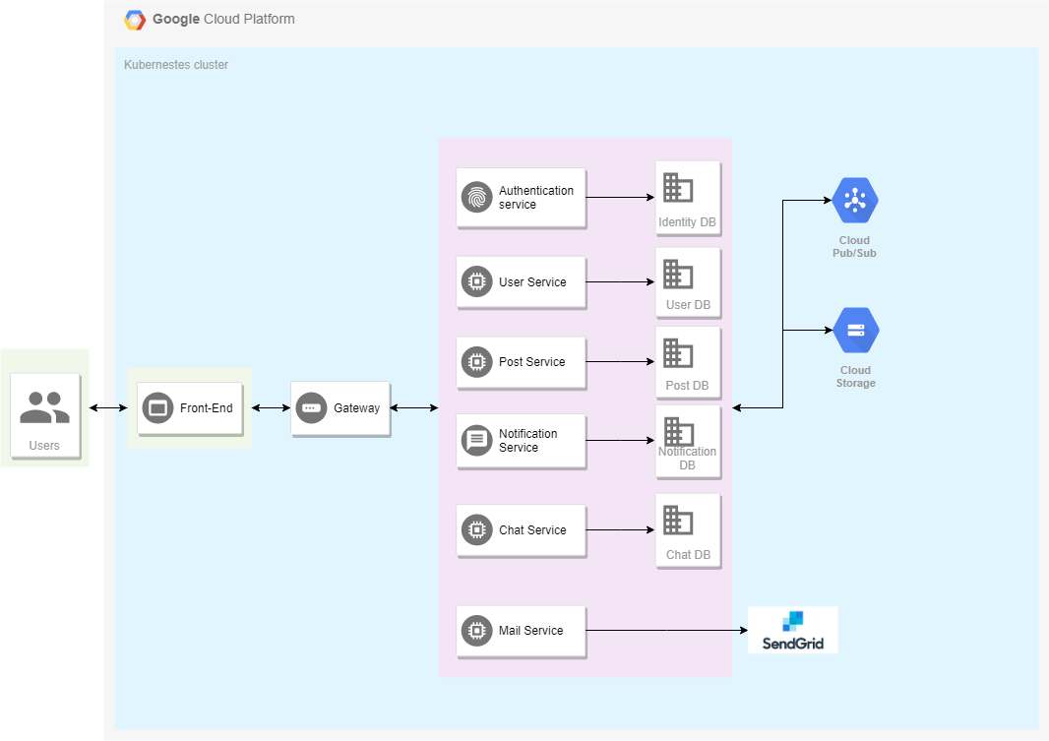

Figure 4-1: TripSharing System Architecture

### **4.2.2 System Architecture Explanation**

The entire project will be deployed on Google Cloud. We aim at delivering a secured,

responsive, and highly available system. In the following section, we will explain the function and mechanism of each unit in the system architecture design.

**4.2.2.1 Google Cloud**



Figure 4-5: Google cloud

**Google Cloud Platform** is a suite of cloud computing services that runs on the same infrastructure that Google uses internally for its end-user products. Alongside a set of management tools, it provides a series of modular cloud services including computing, data storage, data analytics and machine learning. Apart from Cloud Storage and Pub/Sub mentioned above, the main part of operation lies in the usage of the Kubernetes Engine that supports easy deployment and scaling from docker images.

**4.2.2.2 Google Cloud Storage**



Figure 4-2: Google cloud storage

**Google Cloud Storage** is a web-services interface data storage & retrieval. We use Google Cloud Storage for storing images.

**4.2.2.3 Google Cloud Pub/Sub**



Figure 4-3: Google cloud pub/sub

**Cloud Pub/Sub** is a fully-managed real-time messaging service that allows you to send and receive messages between independent applications. We use Cloud Pub/Sub to handle communication among microservices.

**4.2.2.4 Docker**



Figure 4-4: Docker

**Docker** is a tool designed to make it easier to create, deploy, and run applications by using containers. Containers allow a developer to package up an application with all of the parts it needs, such as libraries and other dependencies, and ship it all out as one package. We use Docker to build and push images to Docker Hub for deployment and testing.

**4.2.2.5 Nginx**



Figure 4-6: Nginx

**NGINX** is a free, open-source, high-performance HTTP server and reverse proxy, as well as an IMAP/POP3 proxy server. NGINX is known for its high performance, stability, rich feature set, simple configuration, and low resource consumption. We use Nginx to serve the frontend service of TripSharing.

**4.2.2.6 MongoDB**



Figure 4-7: MongoDB

**MongoDB** is an open source database and is the leading NoSQL database, used by millions of people. MongoDB is written in C ++. In addition, MongoDB is a cross-platform database, operating on the concepts of Collection and Document, it provides high performance, high availability and easy scalability.

**4.2.2.7 Angular 7**



Figure 4-8: Angular 7

**Angular 7** is the library of Angular, a framework created by Google that supports Flat & Material design website. Supporting Progressive Web Application, this framework has become very popular nowadays.

**4.2.2.8 Angular Material**



Figure 4-9: Angular Material

**Angular Material** is a great JavaScript framework for creating themed UI components that ignite good user experience.

**4.2.2.9 C#**



Figure 4-10: C# (C Sharp)

**C#** is a general object-oriented programming (OOP) language for networking and Web development. C# is specified as a common language infrastructure (CLI) language. Its NET framework promotes multiple Web technologies. We use C# to write back-end code.

**4.2.2.10 ASP.NET Core**



Figure 4-11: ASP.NET Core

**ASP.NET Core** is a cross-platform, high-performance, open-source framework for building modern, cloud-based, Internet-connected applications. We use ASP.NET Core to write back-end API services.

**4.2.2.11 ASP.NET Core SignalR**



Figure 4-12: Signal R

**ASP.NET Core SignalR** is an open-source library that simplifies adding real-time web functionality to apps. Real-time web functionality enables server-side code to push content to clients instantly. We user SignalR for chat and notification.

**4.2.2.12 SendGrid**



Figure 4-13: SendGrid

**SendGrid** is a platform for transactional and marketing email. We use SendGrid to send emails to users for verification.

**4.3 Design of TripSharing System**

**4.3.1 Architecture Layers Design**

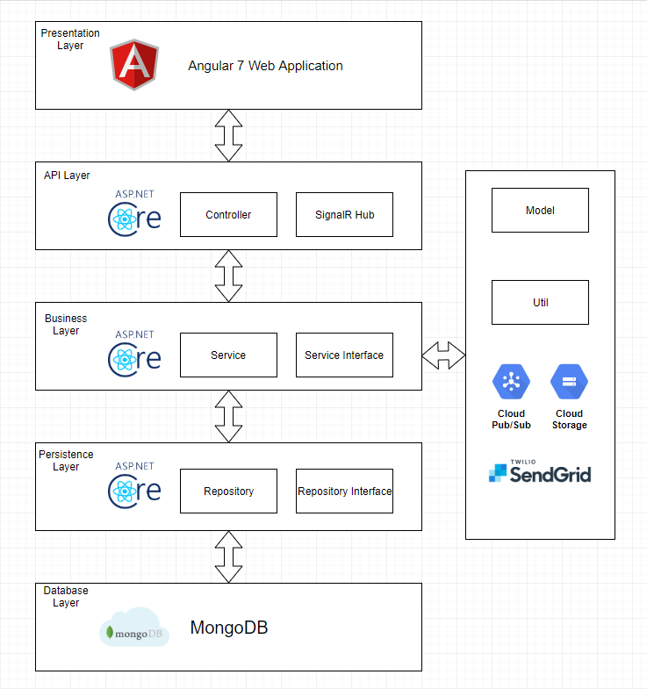

Figure 4-14: Architecture Layer Design

### **4.3.2 Database Design**

**4.3.2.1 Explanation of database decision**

**4.3.2.1.1 Operational Database – MongoDB**



MongoDB is our first choice for storing operational data because it has powerful features that suit our needs:

* The very basic feature of MongoDB is that it is a schema-less database. No schema migrations anymore.
* Stores the data in the form of BSON (Binary JSON), ruby hashes etc., helps to store the data in a very rich way while being capable of holding arrays and other documents.
* Reliability, Performance & Ease of Use.

**4.3.2.2 Database Diagram**

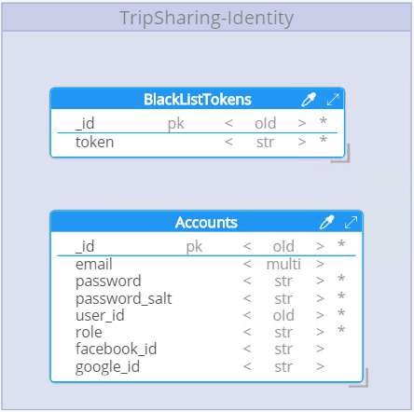

Figure 4-15: Identity Provider Database Design

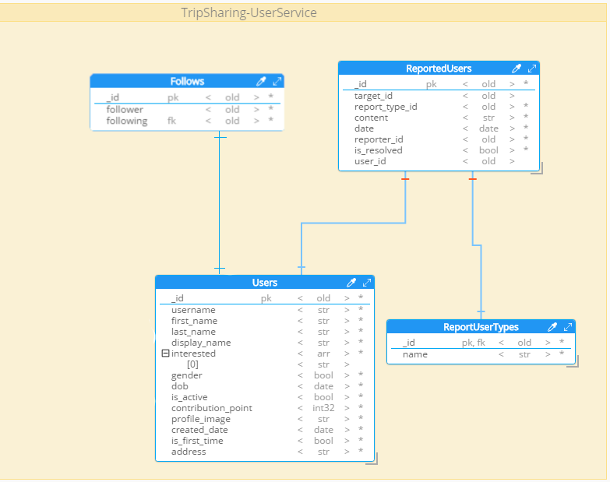

Figure 4-16: User Database Design

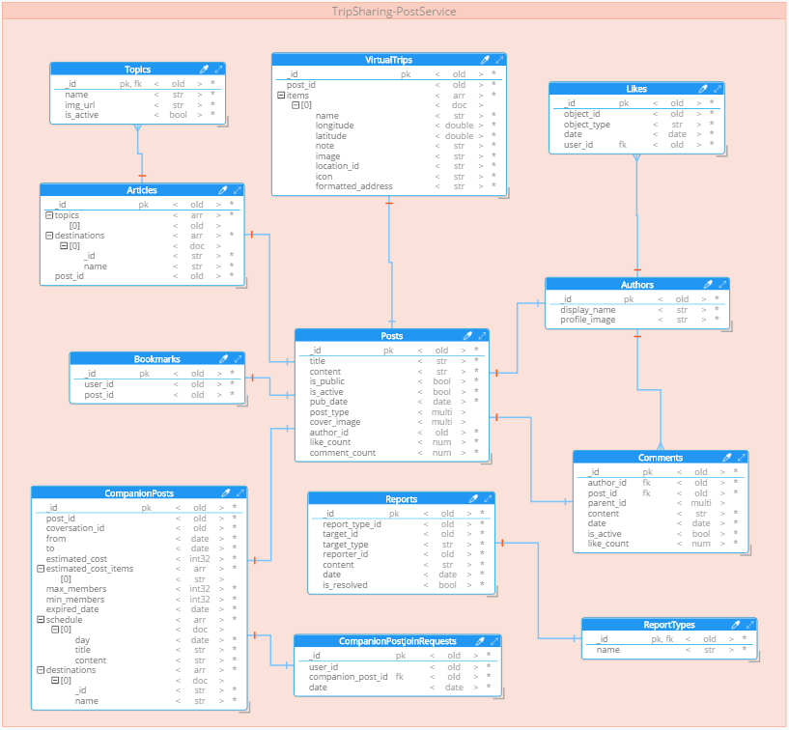

Figure 4-17: Post Database Design

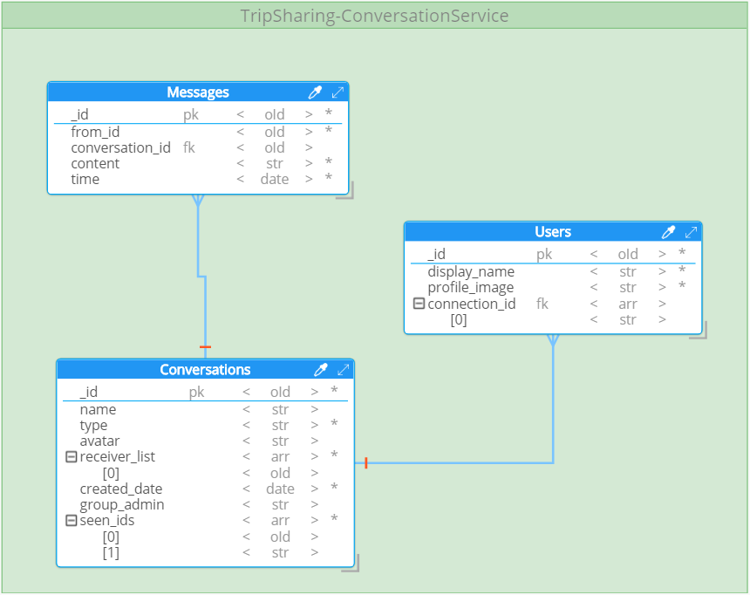

Figure 4-18: Conversation Database Design

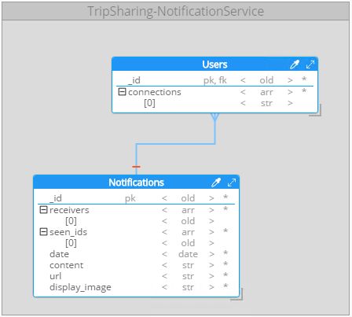

Figure 4-19: Notification Database Design

**4.3.2.3 Data Dictionary**

*4.3.2.3.1 TripSharing – Operational database*

*4.3.2.3.1.1 Entities*

|  |  |  |  |  |
| --- | --- | --- | --- | --- |
| **No** | **Entity Name** | **Description** | **Alias** | **Occurrence** |
| 1 | Users | General term describing  a user profiles. |  | Each user has one account.  Each user has many interested topics. |
| 2 | Follows | General term describing a follow relation between users. |  | Each user has many followers.  Each user can follow many others. |
| 3 | Bookmarks | General term describing bookmarks of each user. |  | Each user has many bookmarks. |
| 4 | Accounts | General term describing a registered account of a user. |  | Each account belongs to one user.  Each account has one email. |
| 5 | Posts | General term describing a post. |  | Each post has one type (companion, article or virtual trip).  Each post has many comments.  Each post has many likes.  Each post has one author. |
| 6 | Likes | General term describing a “like” action of user. |  | Each user can like many posts or comments. |
| 7 | Comments | General term describing comments of user. |  | Each user has many comments.  Each comment has many child comments. |
| 8 | Author | General term describing a user who is author of a post. |  | Each user has many posts. |
| 9 | Articles | General term describing an article type of post. |  | Each article has one post.  Each article has many topics.  Each article has many destinations. |
| 10 | Topics | General term describing a topic of an article. |  |  |
| 11 | VirtualTrips | General term describing a virtual trip type of post. |  | Each virtual trip has many items, each item contains destination information. |
| 12 | CompanionPosts | General term describing a companion type of post. |  | Each companion post has one conversation. |
| 13 | CompanionJoinRequest | General term describing a request to join companion. |  |  |
| 14 | Notifications | General term describing a notification. |  | Each notification has many receivers(user). |
| 15 | Conversations | General term describing a conversation between two or more users. |  | Each conversation has many receivers(user).  Each conversation has many messages. |
| 16 | Messages | General term describing a message send to conversation. |  | Each message has one sender(user). |
| 17 | BlackListTokens | General term describing a token that no longer valid |  | Token will be moved to black list if user sign-out. |

*4.3.2.3.1.2 Attributes*

|  |  |  |  |  |  |
| --- | --- | --- | --- | --- | --- |
| **No** | **Entities Name** | **Field Name** | **Data Type** | **Description** | **Not Null** |
| 1 | Users | _id | Object Id |  | Yes |
| account_id | Object Id |  | Yes |
| username | String |  | Yes |
| first_name | String |  | Yes |
| last_name | String |  | Yes |
| display_name | String |  | Yes |
| interested | Array | User interested topic | Yes |
| gender | Boolean |  | Yes |
| dob | Date |  | Yes |
| is_active | Boolean | Whether user is banned. | Yes |
| contribution_point | Integer |  | Yes |
| profile_image | String |  | Yes |
| created_date | Date |  | Yes |
| is_first_time | Boolean | Whether user is first time sign-in. | Yes |
| address | String |  | Yes |
| 2 | Accounts | _id | Object Id |  | Yes |
| email | String |  | Yes |
| password | String | Encrypted password | Yes |
| password_salt | string |  | Yes |
| user_id | Object Id |  | Yes |
| role | String | Role of user | Yes |
| 3 | BlackListTokens | _id | Object Id |  | Yes |
| token | String |  | Yes |
| 4 | Follows | _id | Object Id |  | Yes |
| follower | Object Id |  | Yes |
| following | Object Id |  | Yes |
| 5 | Bookmarks | _id | Object Id |  | Yes |
| user_id | Object Id |  | Yes |
| post_id | Object Id |  | Yes |
| title | String |  | Yes |
| cover_image | String |  | Yes |
| post_type | String |  | Yes |
| title | String |  | Yes |
| 6 | Authors | _id | Object Id |  | Yes |
| display_name | String |  | Yes |
| profile_image | String |  | Yes |
| 7 | Posts | _id | Object Id |  | Yes |
| title | String |  | Yes |
| content | String |  | Yes |
| is_public | Boolean | Whether post is show for another user or just author. | Yes |
| is_active | Boolean | Whether post is banned. | Yes |
| pub_date | Date |  | Yes |
| post_type | String |  | Yes |
| author_id | Object Id |  | Yes |
| like_count | Integer |  | Yes |
| comment_count | Integer |  | Yes |
| cover_image | String |  | Yes |
| 8 | Articles | _id | Object Id |  | Yes |
| topics | Array | An array of string to store topics. | Yes |
| destinations | Array | An array of object store information about destinations on the trip. | Yes |
| post_id | Object Id |  | Yes |
| 9 | Topics | _id | Object Id |  | Yes |
| name | String |  | Yes |
| img_url | String |  | Yes |
| 10 | VirtualTrips | _id | Object Id |  | Yes |
| post_id | Object Id |  | Yes |
| items | Array | List of object store information about destinations on the trip. | Yes |
| 11 | CompanionPosts | _id | Object Id |  | Yes |
| post_id | Object Id |  | Yes |
| conversation_id | Object Id |  | Yes |
| from | Date |  | Yes |
| to | Date |  | Yes |
| estimated_cost | Double |  | Yes |
| estimated_cost_item | Array |  | Yes |
| max_members | Integer |  | Yes |
| min_members | Integer |  | Yes |
| expired_date | Date |  | Yes |
| schedule | Array | List of notes what to do on the trip, added by user. | Yes |
| destinations | Array | List of object store information about destinations on the trip. | Yes |
| 12 | CompanionPostJoinRequest | _id | Object Id |  | Yes |
| user_id | Object Id |  | Yes |
| companion_post_id | Object Id |  | Yes |
| date | Date |  | Yes |
| 13 | Likes | _id | Object Id |  | Yes |
| object_id | Object Id |  | Yes |
| object_type | String | Whether user like post or comment | Yes |
| date | Date |  | Yes |
| user_id | Object Id |  | Yes |
| 14 | Comments | _id | Object Id |  | Yes |
| Author_id | Object Id |  | Yes |
| Post_id | Object Id |  | Yes |
| Parent_id | Object Id |  | No |
| Content | String |  | Yes |
| Date | Date |  | Yes |
| Is_active | Boolean | Whether comment is deleted | Yes |
| Like_count | Integer |  | Yes |
| 15 | Conversation | _id | Object Id |  | Yes |
| name | String |  | Yes |
| type | String |  | Yes |
| receiver_list | Array | List of users receive message from conversation | Yes |
| last_message | Object |  | Yes |
| 16 | Messages | _id | Object Id |  | Yes |
| from_id | Object Id |  | Yes |
| conversation_id | Object Id |  | Yes |
| content | String |  | Yes |
| time | Date |  | Yes |
| seen_id | Object Id | List of users already see the message. | Yes |
| 17 | Notifications | _id | Object Id |  | Yes |
| receivers | Array | List of users receive notification. | Yes |
| seen_ids | Array | List of users already see the notification. | Yes |
| date | Date |  | Yes |
| content | String |  | Yes |
| url | String |  | Yes |
| display_image | String |  | Yes |

### **4.3.3 Common Design**

**4.3.3.1 Microservice Architecture**

*4.3.3.1.1 What is Microservice?*

Microservices is a software architecture style in which complex applications are composed of small, independent processes communicating with each other using language-agnostic APIs. These services are small, highly decoupled and focus on doing a small task, facilitating a modular approach to system-building.

* + - * 1. *Philosophy*

Philosophy of Microservices architecture essentially equals the Unix philosophy of "Do one thing and do it well". It is described as follows:

* The services are small - fine-grained to perform a single function.
* The organization culture should embrace automation of deployment and testing. This eases the burden on management and Operations.
* The culture and design principles should embrace failure and faults, similar to anti-fragile systems.
* Each service is elastic, resilient, composable, minimal, and complete.
  + - * 1. *Microservice in TripSharing*

In TripSharing, we implement Microservices as the following things:

* The overall system is divided into small microservices according to their domain of operation.
* Deployment of services is done by using Kubernetes.
* Use third-party services: SendGrid for sending mail.
  + 1. **Detail Design**
       1. **Sign-up**

**Screen design**

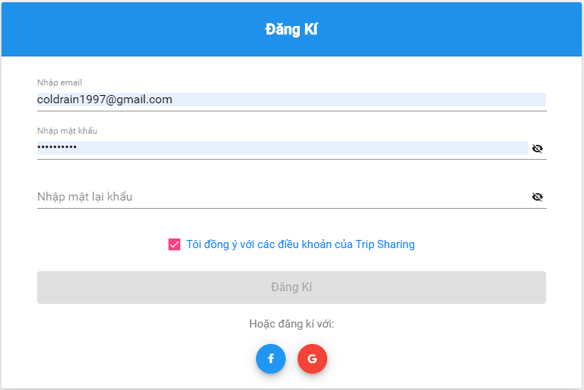

Figure 4-20: Sign up screen

**Class Diagram**

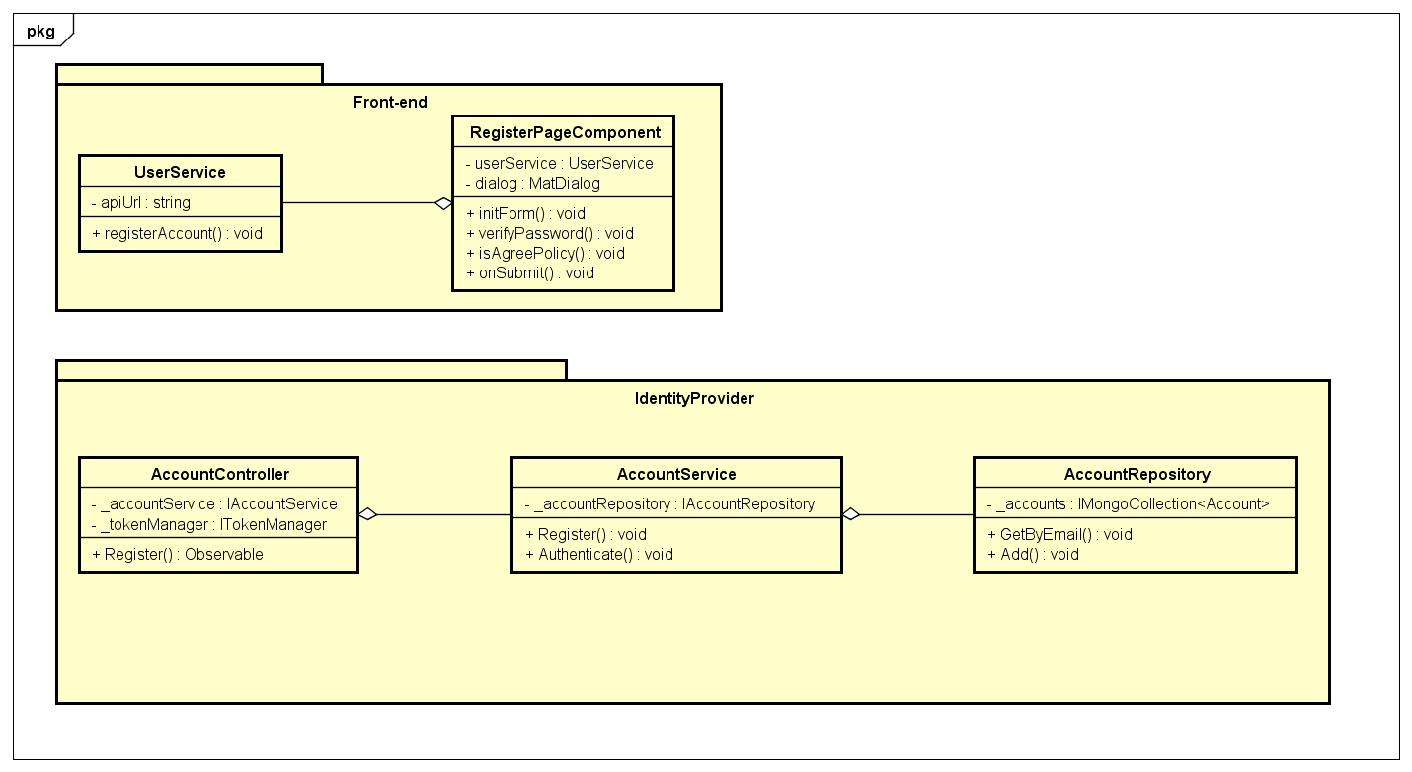

Figure 4-21: Sign-up Class Diagram

**Class Specification**

***RegisterPageComponent***

|  |  |  |  |
| --- | --- | --- | --- |
| **RegisterPageComponent** | | | |
| Physical address | src\app\pages\register-page\ register-page.component.ts | | |
| Base Class | Class | | |
| **Attributes** | | | |
| No | Name | Type | Description |
| 1 | userService | UserService |  |
| 2 | dialog | MatDialog |  |
| **Operations** | | | |
| No | Name | Return Type | Description |
| 1 | initForm | Void | Create sign-up form |
| 2 | verifyPassword | Void | Verify if re-enter password match |
| 3 | isAgreePolicy | Void | Check if guest agree with policy |
| 4 | onSubmit | Void | Submit register form |

***UserService***

|  |  |  |  |
| --- | --- | --- | --- |
| **UserService** | | | |
| Physical address | src\app\core\services\user-service\user.service.ts | | |
| Base Class | Class | | |
| **Attributes** | | | |
| No | Name | Type | Description |
| 1 | apiURL | String |  |
| **Operations** | | | |
| No | Name | Return Type | Description |
| 1 | registerAccount | Void |  |

***AccountController***

|  |  |  |  |
| --- | --- | --- | --- |
| **AccountController** | | | |
| Physical address | \src\Services\IdentityProvider\IdentityProvider\Controllers\  AccountController.cs | | |
| Base Class | Class | | |
| **Attributes** | | | |
| No | Name | Type | Description |
| 1 | _accountService | IAccountService |  |
| 2 | _tokenManager | ITokenManager |  |
| **Operations** | | | |
| No | Name | Return Type | Description |
| 1 | Register | Observable |  |

***AccountService***

|  |  |  |  |
| --- | --- | --- | --- |
| **AccountService** | | | |
| Physical address | \src\Services\IdentityProvider\IdentityProvider\Services\AccountService.cs | | |
| Base Class | Class | | |
| **Attributes** | | | |
| No | Name | Type | Description |
| 1 | _accountRepository | IAccountRepository |  |
| **Operations** | | | |
| No | Name | Return Type | Description |
| 1 | Register | Void |  |
| 2 | Authenticate | Void |  |

***AccountRepository***

|  |  |  |  |
| --- | --- | --- | --- |
| **AccountRepository** | | | |
| Physical address | \src\Services\IdentityProvider\IdentityProvider\Repositories\AccountRepository.cs | | |
| Base Class | Class | | |
| **Attributes** | | | |
| No | Name | Type | Description |
| 1 | _accounts | IMongoCollection<Account> |  |
| **Operations** | | | |
| No | Name | Return Type | Description |
| 1 | GetByEmail | Void |  |
| 2 | Add | Void |  |

**Sequence Diagram**

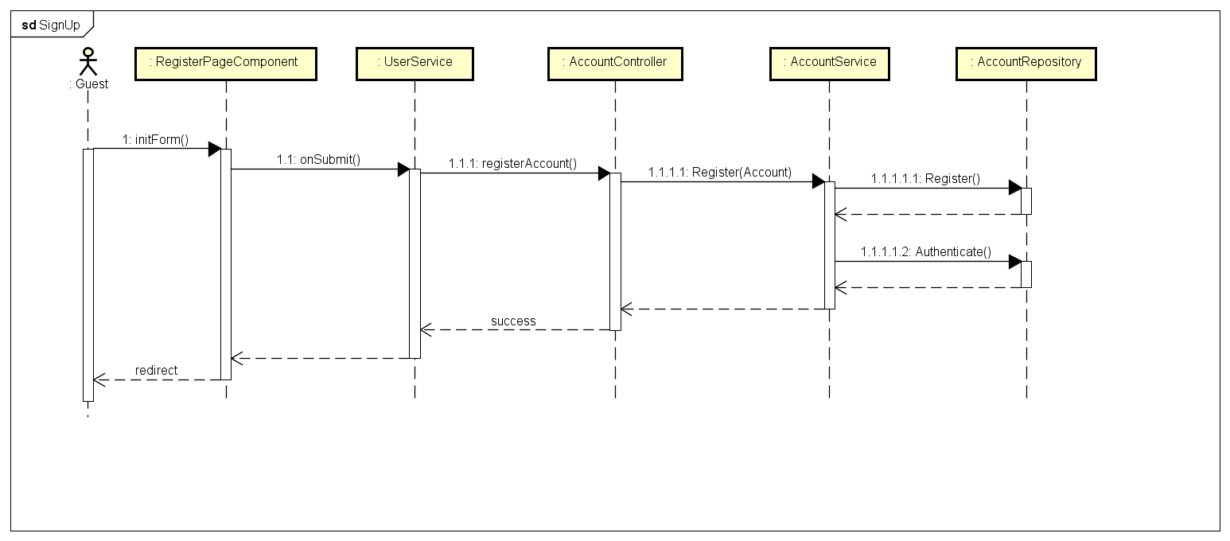

Figure 4-22: Sign-up Sequence Diagram

* + - 1. **Google Sign-in**

**Screen Design**

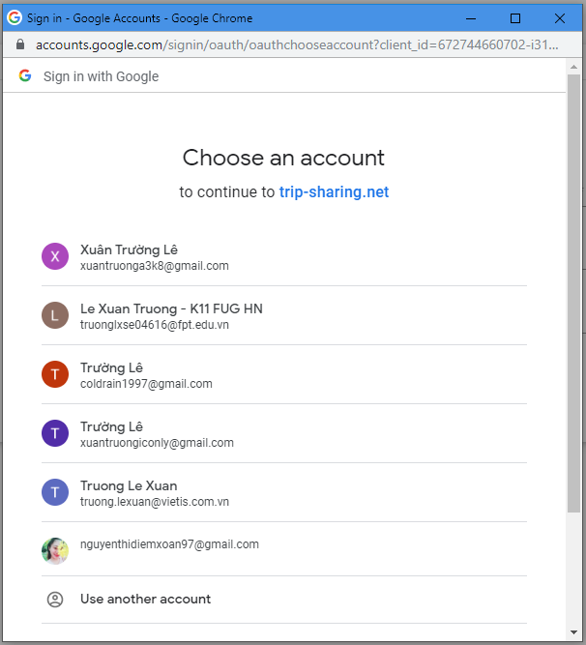

Figure 4-23: Google Sign in Screen Design

**Class Diagram**

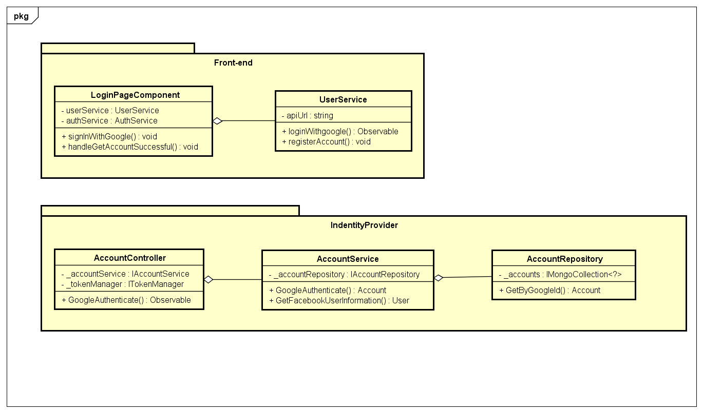

Figure 4-24: Google Sign-in Class Diagram

**Class Specification**

***LoginPageComponent***

|  |  |  |  |
| --- | --- | --- | --- |
| **LoginPageComponent** | | | |
| Physical address | src\app\pages\login-page\login-page.component.ts | | |
| Base Class | Class | | |
| **Attributes** | | | |
| No | Name | Type | Description |
| 1 | userService | UserService |  |
| 2 | authService | AuthService |  |
| **Operations** | | | |
| No | Name | Return Type | Description |
| 1 | signInWithGoogle | Void |  |
| 2 | handleGetAccountSuccessful | Void |  |

***UserService***

|  |  |  |  |
| --- | --- | --- | --- |
| **UserService** | | | |
| Physical address | src\app\core\services\user-service\user.service.ts | | |
| Base Class | Class | | |
| **Attributes** | | | |
| No | Name | Type | Description |
| 1 | apiURL | String |  |
| **Operations** | | | |
| No | Name | Return Type | Description |
| 1 | loginWithGoogle | Observable |  |

***AccountController***

|  |  |  |  |
| --- | --- | --- | --- |
| **AccountController** | | | |
| Physical address | \src\Services\IdentityProvider\IdentityProvider\Controllers\  AccountController.cs | | |
| Base Class | Class | | |
| **Attributes** | | | |
| No | Name | Type | Description |
| 1 | _accountService | IAccountService |  |
| 2 | _tokenManager | ITokenManager |  |
| **Operations** | | | |
| No | Name | Return Type | Description |
| 1 | GoogleAuthenticate | Observable |  |

***AccountService***

|  |  |  |  |
| --- | --- | --- | --- |
| **AccountService** | | | |
| Physical address | \src\Services\IdentityProvider\IdentityProvider\Services\AccountService.cs | | |
| Base Class | Class | | |
| **Attributes** | | | |
| No | Name | Type | Description |
| 1 | _accountRepository | IAccountRepository |  |
| **Operations** | | | |
| No | Name | Return Type | Description |
| 1 | GoogleAuthenticate | Void |  |
| 2 | GetGoogleUserInformation | Void |  |

***AccountRepository***

|  |  |  |  |
| --- | --- | --- | --- |
| **AccountRepository** | | | |
| Physical address | \src\Services\IdentityProvider\IdentityProvider\Repositories\AccountRepository.cs | | |
| Base Class | Class | | |
| **Attributes** | | | |
| No | Name | Type | Description |
| 1 | _accounts | IMongoCollection<Account> |  |
| **Operations** | | | |
| No | Name | Return Type | Description |
| 1 | GetByGoogleId | Void |  |
|  |  |  |  |

**Sequence Diagram**

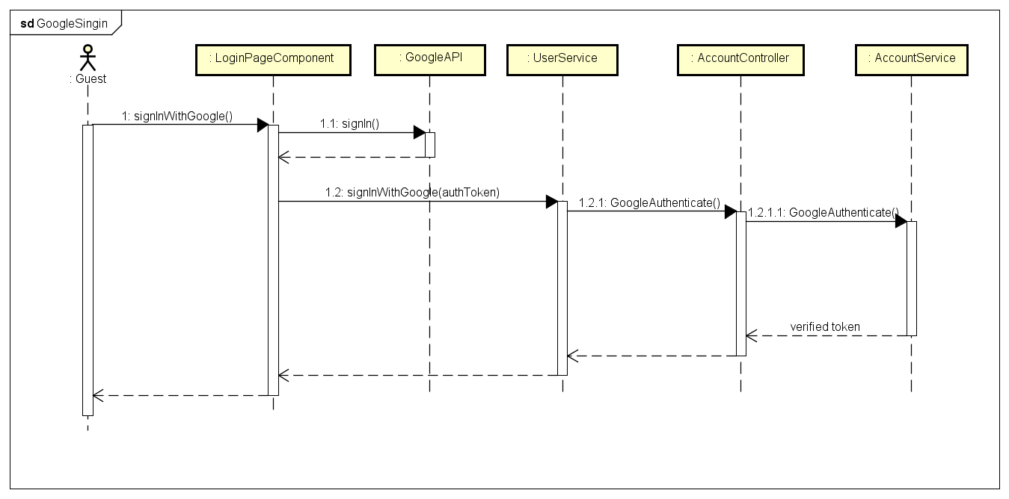

Figure 4-25: Google Sign-in Sequence Diagram

* + - 1. **Facebook Sign-in**

**Screen Design**

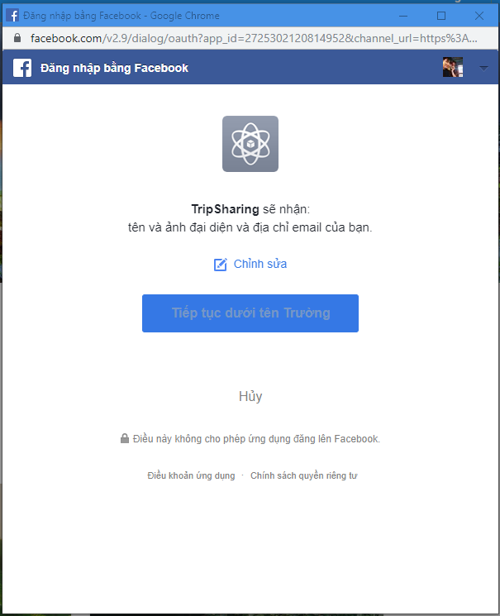

Figure 4-26: Facebook Sign-in Sequence Diagram

**Class Diagram**

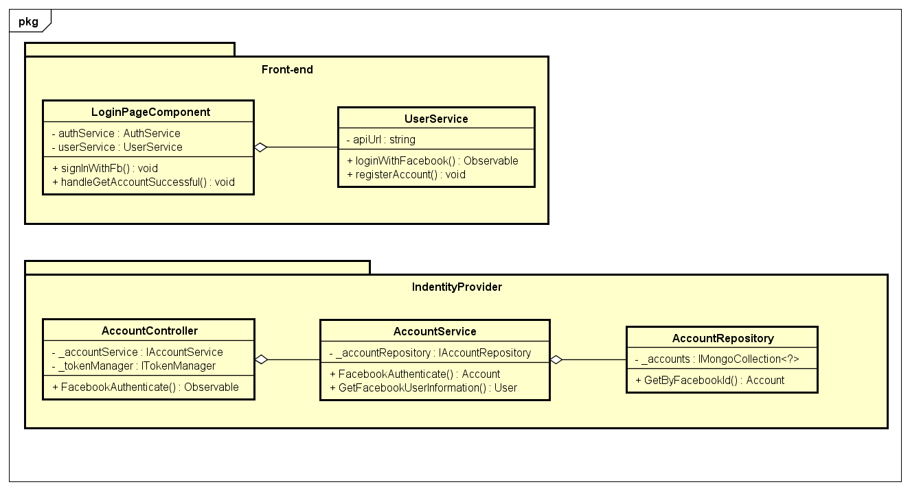

Figure 4-27: Facebook Sign-in Class Diagram

**Class Specification**

***LoginPageComponent***

|  |  |  |  |
| --- | --- | --- | --- |
| **LoginPageComponent** | | | |
| Physical address | src\app\pages\login-page\login-page.component.ts | | |
| Base Class | Class | | |
| **Attributes** | | | |
| No | Name | Type | Description |
| 1 | userService | UserService |  |
| 2 | authService | AuthService |  |
| **Operations** | | | |
| No | Name | Return Type | Description |
| 1 | signInWithFb | Void |  |
| 2 | handleGetAccountSuccessful | Void |  |

***UserService***

|  |  |  |  |
| --- | --- | --- | --- |
| **UserService** | | | |
| Physical address | src\app\core\services\user-service\user.service.ts | | |
| Base Class | Class | | |
| **Attributes** | | | |
| No | Name | Type | Description |
| 1 | apiURL | String |  |
| **Operations** | | | |
| No | Name | Return Type | Description |
| 1 | loginWithFacebook | Observable |  |

***AccountController***

|  |  |  |  |
| --- | --- | --- | --- |
| **AccountController** | | | |
| Physical address | \src\Services\IdentityProvider\IdentityProvider\Controllers\  AccountController.cs | | |
| Base Class | Class | | |
| **Attributes** | | | |
| No | Name | Type | Description |
| 1 | _accountService | IAccountService |  |
| 2 | _tokenManager | ITokenManager |  |
| **Operations** | | | |
| No | Name | Return Type | Description |
| 1 | FacebookAuthenticate | Observable |  |

***AccountService***

|  |  |  |  |
| --- | --- | --- | --- |
| **AccountService** | | | |
| Physical address | \src\Services\IdentityProvider\IdentityProvider\Services\AccountService.cs | | |
| Base Class | Class | | |
| **Attributes** | | | |
| No | Name | Type | Description |
| 1 | _accountRepository | IAccountRepository |  |
| **Operations** | | | |
| No | Name | Return Type | Description |
| 1 | FacebookAuthenticate | Void |  |
| 2 | GetFacebookUserInformation | Void |  |

***AccountRepository***

|  |  |  |  |
| --- | --- | --- | --- |
| **AccountRepository** | | | |
| Physical address | \src\Services\IdentityProvider\IdentityProvider\Repositories\AccountRepository.cs | | |
| Base Class | Class | | |
| **Attributes** | | | |
| No | Name | Type | Description |
| 1 | _accounts | IMongoCollection<Account> |  |
| **Operations** | | | |
| No | Name | Return Type | Description |
| 1 | GetByFacebookId | Void |  |
|  |  |  |  |

**Sequence Diagram**

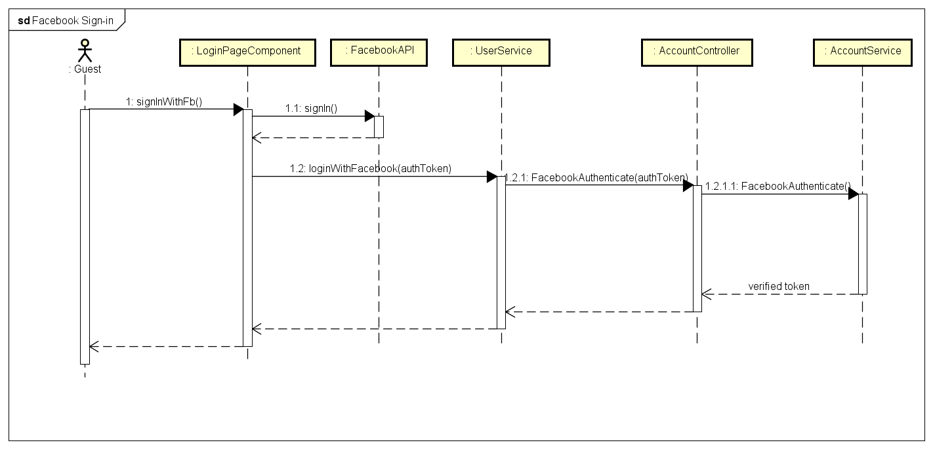

Figure 4-28: Facebook Sign-in Sequence Diagram

* + - 1. **Normal Sign-in**

**Screen Design**

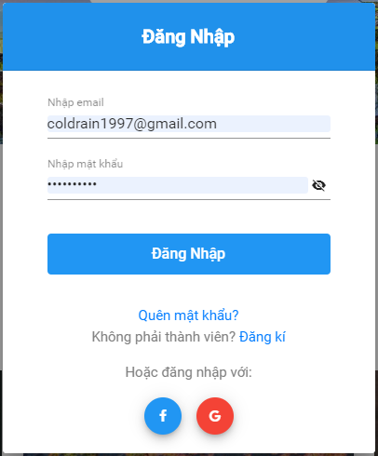

Figure 4-29: Normal Sign-in Screen Design

**Class Diagram**

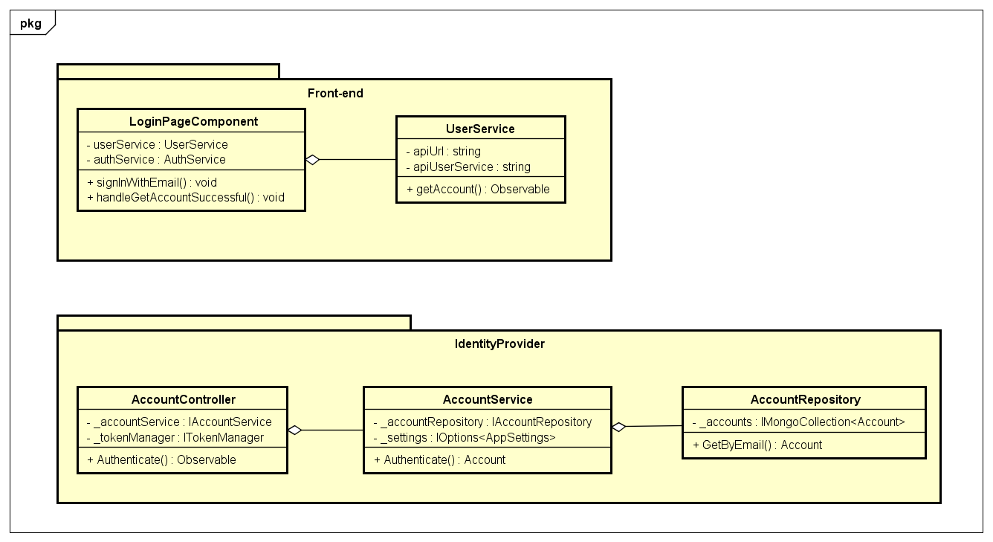

Figure 4-30: Normal Sign-in Class Diagram

**Class Specification**

***LoginPageComponent***

|  |  |  |  |
| --- | --- | --- | --- |
| **LoginPageComponent** | | | |
| Physical address | src\app\pages\login-page\login-page.component.ts | | |
| Base Class | Class | | |
| **Attributes** | | | |
| No | Name | Type | Description |
| 1 | userService | UserService |  |
| 2 | authService | AuthService |  |
| **Operations** | | | |
| No | Name | Return Type | Description |
| 1 | signInWithEmail | Void |  |
| 2 | handleGetAccountSuccessful | Void |  |

***UserService***

|  |  |  |  |
| --- | --- | --- | --- |
| **UserService** | | | |
| Physical address | src\app\core\services\user-service\user.service.ts | | |
| Base Class | Class | | |
| **Attributes** | | | |
| No | Name | Type | Description |
| 1 | apiURL | String |  |
| 2 | apiUserService | String |  |
| **Operations** | | | |
| No | Name | Return Type | Description |
| 1 | getAccount | Observable |  |

***AccountController***

|  |  |  |  |
| --- | --- | --- | --- |
| **AccountController** | | | |
| Physical address | src\Services\IdentityProvider\IdentityProvider\Controllers\  AccountController.cs | | |
| Base Class | ControllerBase | | |
| **Attributes** | | | |
| No | Name | Type | Description |
| 1 | _accountService | IAccountService |  |
| 2 | _tokenManager | ITokenManager |  |
| **Operations** | | | |
| No | Name | Return Type | Description |
| 1 | Authenticate | Observable |  |

***AccountService***

|  |  |  |  |
| --- | --- | --- | --- |
| **AccountService** | | | |
| Physical address | \src\Services\IdentityProvider\IdentityProvider\Services\AccountService.cs | | |
| Base Class | IAccountService | | |
| **Attributes** | | | |
| No | Name | Type | Description |
| 1 | _accountRepository | IAccountRepository |  |
| **Operations** | | | |
| No | Name | Return Type | Description |
| 1 | Authenticate | Void |  |

***AccountRepository***

|  |  |  |  |
| --- | --- | --- | --- |
| **AccountRepository** | | | |
| Physical address | \src\Services\IdentityProvider\IdentityProvider\Repositories\AccountRepository.cs | | |
| Base Class | IAccountRepository | | |
| **Attributes** | | | |
| No | Name | Type | Description |
| 1 | _accounts | IMongoCollection<?> |  |
| **Operations** | | | |
| No | Name | Return Type | Description |
| 1 | GetByEmail | Account |  |

**Sequence Diagram**

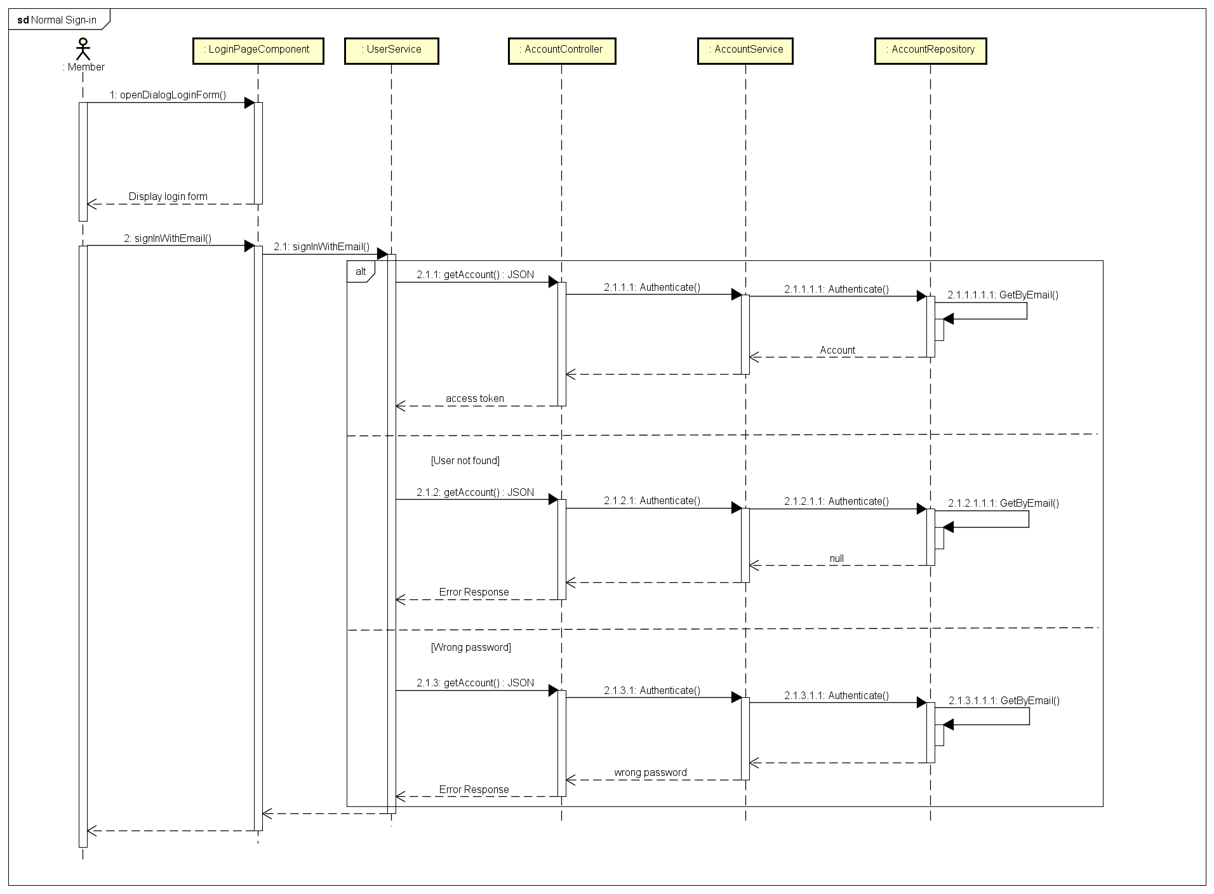

Figure 4-31: Normal Sign-in Sequence Diagram

* + - 1. **Forgot Password**

**Screen Design**

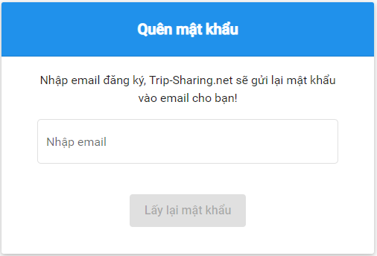

Figure 4-32: Forgot Password Screen Design

**Class Diagram**

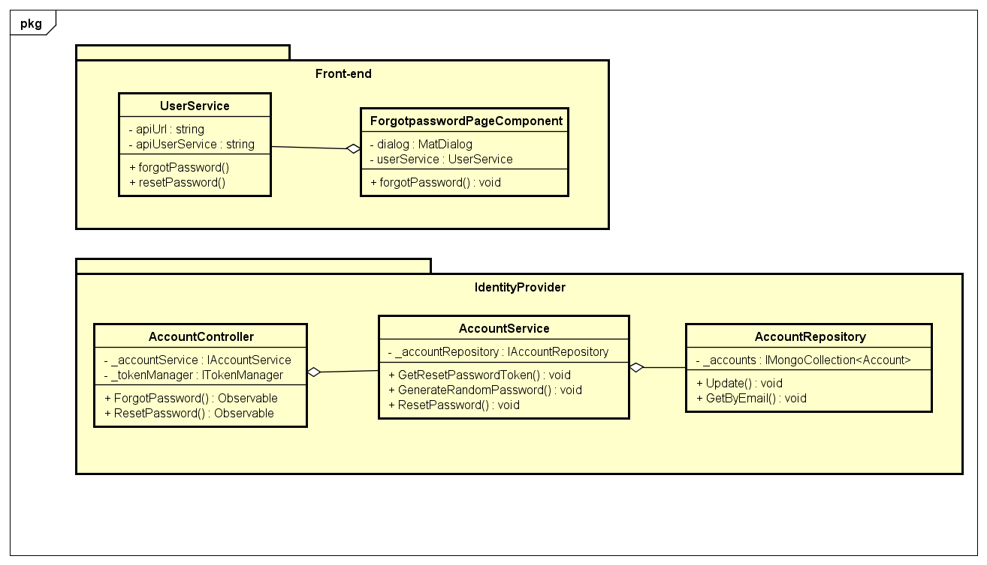

Figure 4-33: Forgot Password Class Diagram

**Class Specification**

***ForgotpasswordPageComponent***

|  |  |  |  |
| --- | --- | --- | --- |
| **ForgotpasswordPageComponent** | | | |
| Physical address | src\app\pages\login-page\forgotpassword-page.component.ts | | |
| Base Class | Class | | |
| **Attributes** | | | |
| No | Name | Type | Description |
| 1 | dialog | MatDialog |  |
| 2 | userService | UserService |  |
| **Operations** | | | |
| No | Name | Return Type | Description |
| 1 | forgotPassword | Void |  |
| 2 | resetPassword | Void |  |

***UserService***

|  |  |  |  |
| --- | --- | --- | --- |
| **UserService** | | | |
| Physical address | src\app\core\services\user-service\user.service.ts | | |
| Base Class | Class | | |
| **Attributes** | | | |
| No | Name | Type | Description |
| 1 | apiUrl | String |  |
| 2 | apiUserService | String |  |
| **Operations** | | | |
| No | Name | Return Type | Description |
| 1 | forgotPassword | Observable |  |
| 2 | resetPassword | Observable |  |

***AccountController***

|  |  |  |  |
| --- | --- | --- | --- |
| **AccountController** | | | |
| Physical address | src\Services\IdentityProvider\IdentityProvider\Controllers\  AccountController.cs | | |
| Base Class | ControllerBase | | |
| **Attributes** | | | |
| No | Name | Type | Description |
| 1 | _accountService | IAccountService |  |
| 2 | _tokenManager | ITokenManager |  |
| **Operations** | | | |
| No | Name | Return Type | Description |
| 1 | ForgotPassword | Observable |  |
| 2 | ResetPassword | Observable |  |

***AccountService***

|  |  |  |  |
| --- | --- | --- | --- |
| **AccountService** | | | |
| Physical address | \src\Services\IdentityProvider\IdentityProvider\Services\AccountService.cs | | |
| Base Class | IAccountService | | |
| **Attributes** | | | |
| No | Name | Type | Description |
| 1 | _accountRepository | IAccountRepository |  |
| **Operations** | | | |
| No | Name | Return Type | Description |
| 1 | GetResetPasswordToken | Void |  |
| 2 | GenerateRandomPassword | Void |  |
| 3 | ResetPassword | Void |  |

***AccountRepository***

|  |  |  |  |
| --- | --- | --- | --- |
| **AccountRepository** | | | |
| Physical address | \src\Services\IdentityProvider\IdentityProvider\Repositories\AccountRepository.cs | | |
| Base Class | IAccountRepository | | |
| **Attributes** | | | |
| No | Name | Type | Description |
| 1 | _accounts | IMongoCollection<?> |  |
| **Operations** | | | |
| No | Name | Return Type | Description |
| 1 | GetByEmail | Account |  |
| 2 | Update | Void |  |

**Sequence Diagram**

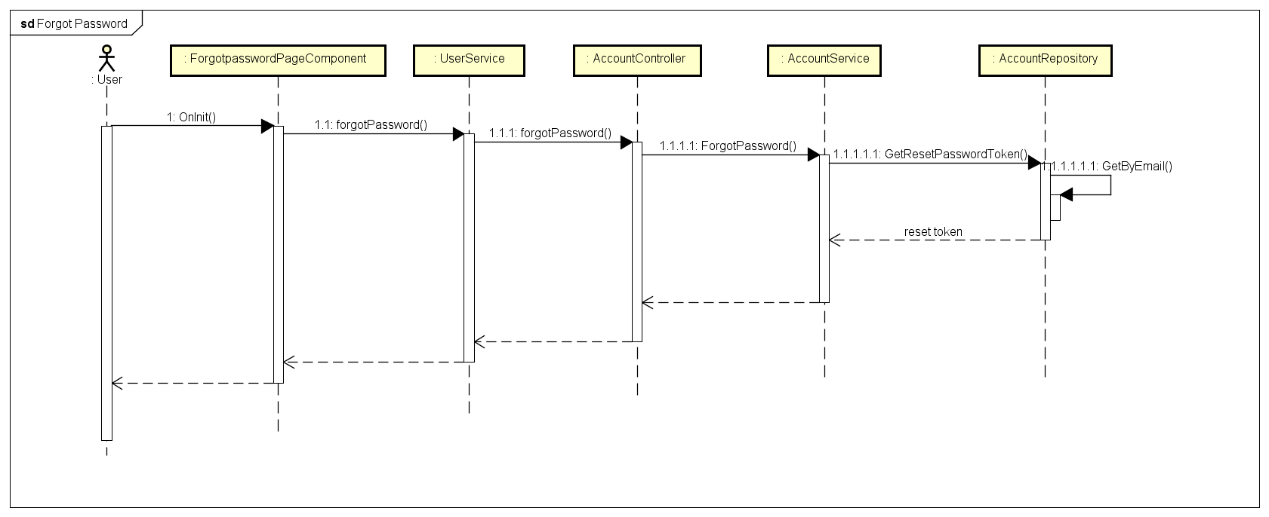

Figure 4-34: Forgot Password Sequence Diagram

* + - 1. **Sign-out**

**Screen Design**

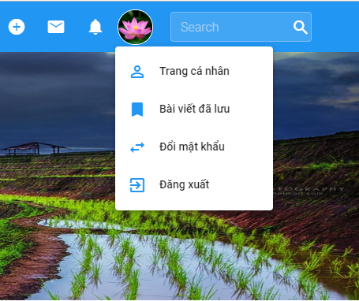

Figure 4-35: Sign-out Screen Design

**Class Diagram**

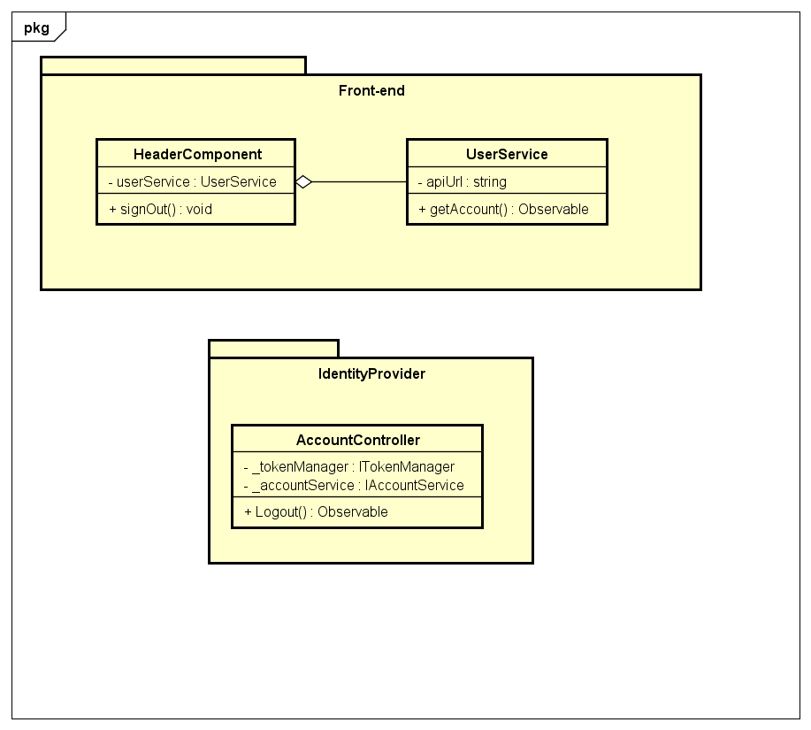

Figure 4-36: Sign-out Class Diagram

**Class Specification**

***HeaderComponent***

|  |  |  |  |
| --- | --- | --- | --- |
| **HeaderComponent** | | | |
| Physical address | src\app\core\components\header\ header.component.ts | | |
| Base Class | Class | | |
| **Attributes** | | | |
| No | Name | Type | Description |
| 1 | userService | UserService |  |
| **Operations** | | | |
| No | Name | Return Type | Description |
| 1 | signOut | Void |  |

***UserService***

|  |  |  |  |
| --- | --- | --- | --- |
| **UserService** | | | |
| Physical address | src\app\core\services\user-service\user.service.ts | | |
| Base Class | Class | | |
| **Attributes** | | | |
| No | Name | Type | Description |
| 1 | apiUrl | String |  |
| **Operations** | | | |
| No | Name | Return Type | Description |
| 1 | getAccount | Observable |  |

***AccountController***

|  |  |  |  |
| --- | --- | --- | --- |
| **AccountController** | | | |
| Physical address | src\Services\IdentityProvider\IdentityProvider\Controllers\  AccountController.cs | | |
| Base Class | Class | | |
| **Attributes** | | | |
| No | Name | Type | Description |
| 1 | _accountService | IAccountService |  |
| 2 | _tokenManager | ITokenManager |  |
| **Operations** | | | |
| No | Name | Return Type | Description |
| 1 | Logout | Observable |  |

**Sequence Diagram**

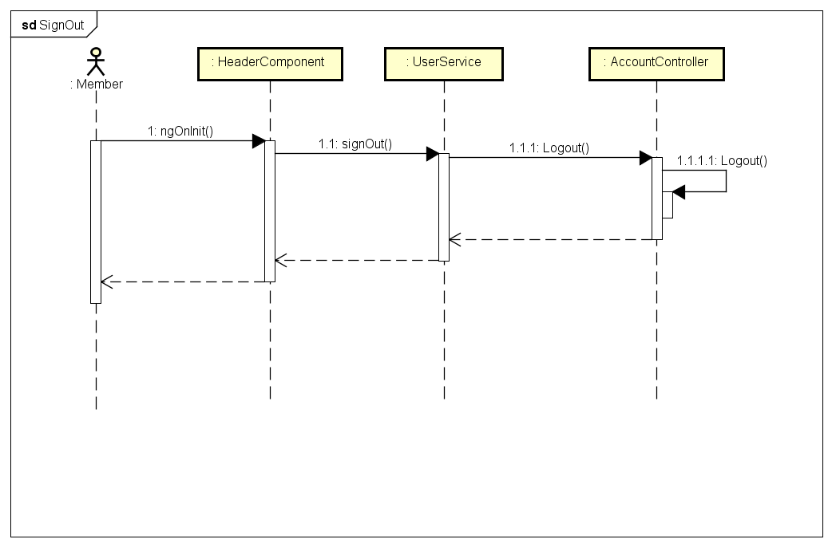

Figure 4-37: Sign-out Sequence Diagram

* + - 1. **Change Password**

**Screen Design**

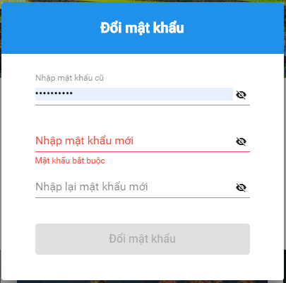

Figure 4-38: Change Password Screen Design

**Class Diagram**

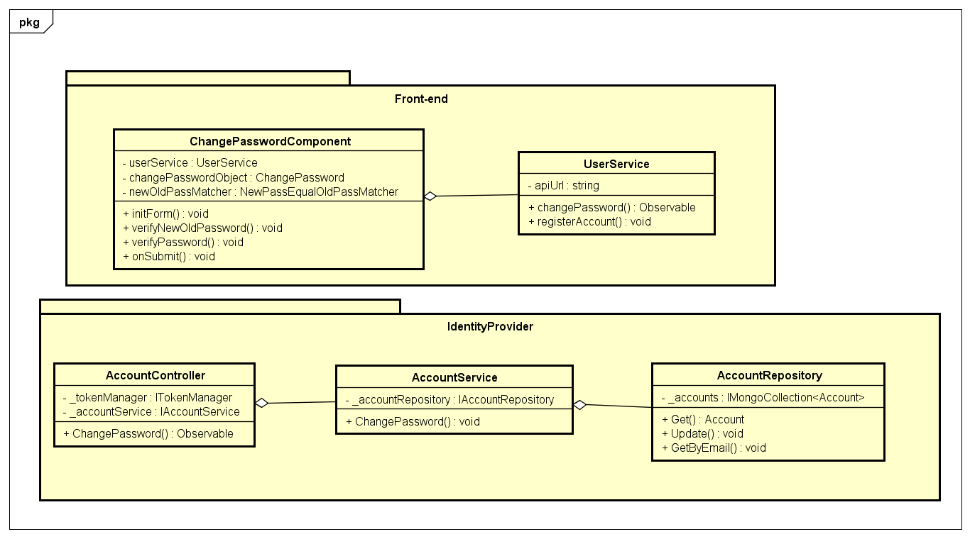

Figure 4-39: Change Password Class Diagram

**Class Specification**

***ChangePasswordComponent***

|  |  |  |  |
| --- | --- | --- | --- |
| **ChangePasswordComponent** | | | |
| Physical address | \src\app\shared\components\change-password\change-password.component.ts | | |
| Base Class | Class | | |
| **Attributes** | | | |
| No | Name | Type | Description |
| 1 | userService | UserService |  |
| 2 | changePasswordObject | ChangePassword |  |
| 3 | newOldPassMatcher | NewPassEqualOldPassMatcher |  |
| **Operations** | | | |
| No | Name | Return Type | Description |
| 1 | initForm | Void |  |
| 2 | verifyNewOldPassword | Void |  |
| 3 | verifyPassword | Void |  |
| 4 | onSubmit | Void |  |

***UserService***

|  |  |  |  |
| --- | --- | --- | --- |
| **UserService** | | | |
| Physical address | src\app\core\services\user-service\user.service.ts | | |
| Base Class | Class | | |
| **Attributes** | | | |
| No | Name | Type | Description |
| 1 | apiUrl | String |  |
| 2 | apiUserService | String |  |
| **Operations** | | | |
| No | Name | Return Type | Description |
| 1 | changePassword | Observable |  |
| 2 | registerAccount | Observable |  |

***AccountController***

|  |  |  |  |
| --- | --- | --- | --- |
| **AccountController** | | | |
| Physical address | src\Services\IdentityProvider\IdentityProvider\Controllers\  AccountController.cs | | |
| Base Class | ControllerBase | | |
| **Attributes** | | | |
| No | Name | Type | Description |
| 1 | _accountService | IAccountService |  |
| 2 | _tokenManager | ITokenManager |  |
| **Operations** | | | |
| No | Name | Return Type | Description |
| 1 | ChangePassword | Observable |  |

***AccountService***

|  |  |  |  |
| --- | --- | --- | --- |
| **AccountService** | | | |
| Physical address | \src\Services\IdentityProvider\IdentityProvider\Services\AccountService.cs | | |
| Base Class | IAccountService | | |
| **Attributes** | | | |
| No | Name | Type | Description |
| 1 | _accountRepository | IAccountRepository |  |
| **Operations** | | | |
| No | Name | Return Type | Description |
| 1 | ChangePassword | Void |  |

***AccountRepository***

|  |  |  |  |
| --- | --- | --- | --- |
| **AccountRepository** | | | |
| Physical address | \src\Services\IdentityProvider\IdentityProvider\Repositories\AccountRepository.cs | | |
| Base Class | IAccountRepository | | |
| **Attributes** | | | |
| No | Name | Type | Description |
| 1 | _accounts | IMongoCollection<?> |  |
| **Operations** | | | |
| No | Name | Return Type | Description |
| 1 | GetByEmail | Account |  |
| 2 | Update | Void |  |
| 3 | Get | Account |  |

**Sequence Diagram**

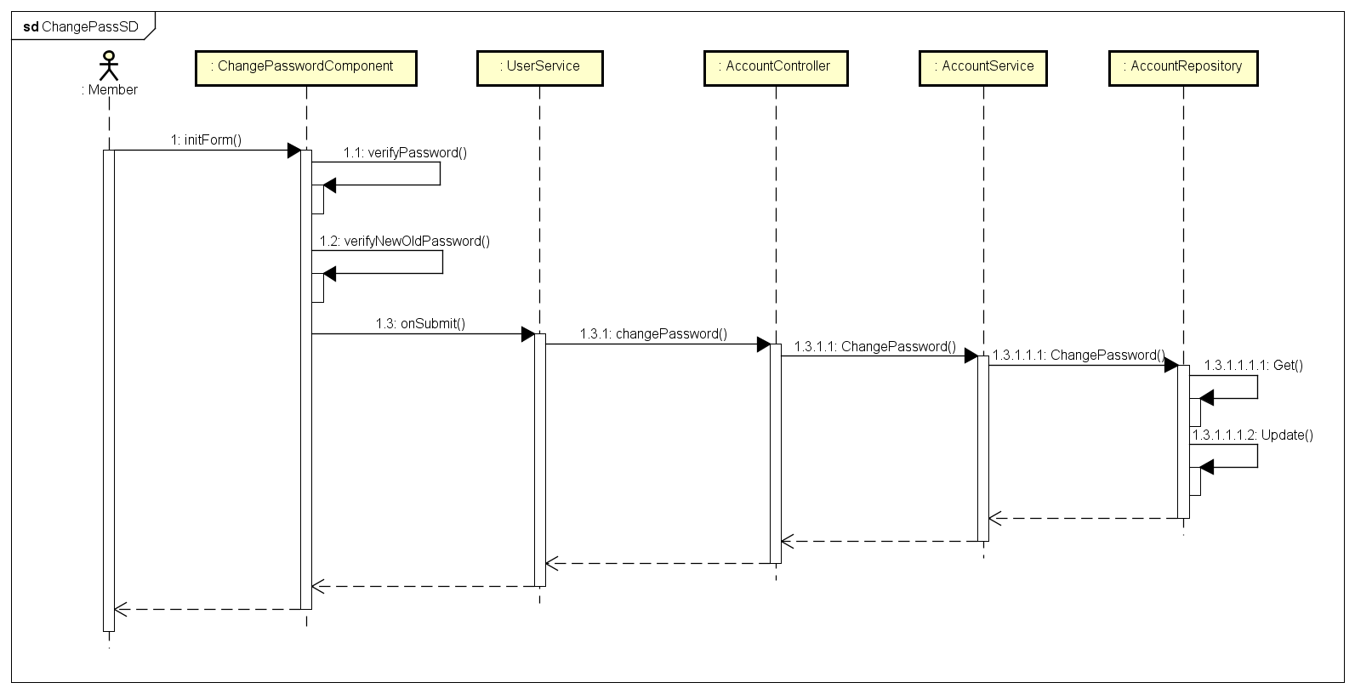

Figure 4-40: Change Password Sequence Diagram

* + - 1. **Update Profile**

**Screen Design**

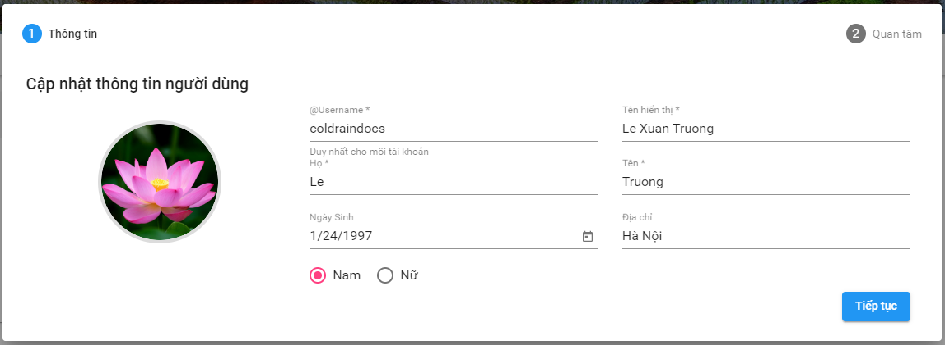

Figure 4-41: Update Profile Screen Design

**Class Diagram**

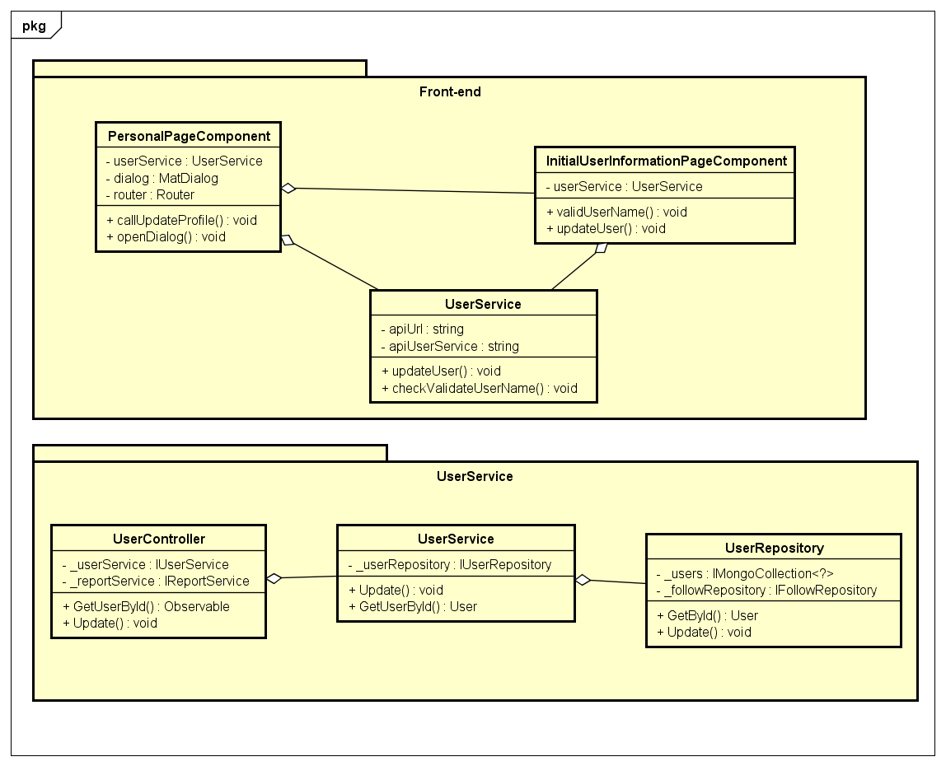

Figure 4-42: Update Profile Class Diagram

**Class Specification**

***PersonalPageComponent***

|  |  |  |  |
| --- | --- | --- | --- |
| **PersonalPageComponent** | | | |
| Physical address | src\app\pages\personal-page\ personal-page.component.ts | | |
| Base Class | Class | | |
| **Attributes** | | | |
| No | Name | Type | Description |
| 1 | userService | UserService |  |
| 2 | dialog | MatDialog |  |
| 3 | router | Router |  |
| **Operations** | | | |
| No | Name | Return Type | Description |
| 1 | callUpdateProfile | Void |  |
| 2 | openDialog | Void |  |

***InitialUserInformationPageComponent***

|  |  |  |  |
| --- | --- | --- | --- |
| **InitialUserInformationPageComponent** | | | |
| Physical address | src\app\pages\initial-user-information-page\initial-user-information-page.component.ts | | |
| Base Class | Class | | |
| **Attributes** | | | |
| No | Name | Type | Description |
| 1 | userService | UserService |  |
| **Operations** | | | |
| No | Name | Return Type | Description |
| 1 | validUserName | Void |  |
| 2 | updateUser | Void |  |

***UserService***

|  |  |  |  |
| --- | --- | --- | --- |
| **UserService** | | | |
| Physical address | src\app\core\services\user-service\user.service.ts | | |
| Base Class | Class | | |
| **Attributes** | | | |
| No | Name | Type | Description |
| 1 | apiUrl | String |  |
| **Operations** | | | |
| No | Name | Return Type | Description |
| 1 | checkValidateUserName | Observable |  |
| 2 | updateUser | Observable |  |

***UserController***

|  |  |  |  |
| --- | --- | --- | --- |
| **UserController** | | | |
| Physical address | \src\Services\UserService\UserService\Controllers\UserController.cs | | |
| Base Class | ControllerBase | | |
| **Attributes** | | | |
| No | Name | Type | Description |
| 1 | _userService | IUserService |  |
| 2 | _reportService | IReportService |  |
| **Operations** | | | |
| No | Name | Return Type | Description |
| 1 | GetUserById | Observable |  |
| 2 | Update | Observable |  |

***UserService (back-end)***

|  |  |  |  |
| --- | --- | --- | --- |
| **UserService** | | | |
| Physical address | \src\Services\UserService\UserService\Services\UserService.cs | | |
| Base Class | IUserService | | |
| **Attributes** | | | |
| No | Name | Type | Description |
| 1 | _userRepository | IUserRepository |  |
| **Operations** | | | |
| No | Name | Return Type | Description |
| 1 | GetUserById | User |  |
| 2 | Update | Void |  |

***UserRepository***

|  |  |  |  |
| --- | --- | --- | --- |
| **UserRepository** | | | |
| Physical address | \src\Services\UserService\UserService\Reponsitories\UserRepository.cs | | |
| Base Class | IUserRepository | | |
| **Attributes** | | | |
| No | Name | Type | Description |
| 1 | _users | IMongoCollection<?> |  |
| 2 | _followRepository | IFollowRepository |  |
| **Operations** | | | |
| No | Name | Return Type | Description |
| 1 | GetById | User |  |
| 2 | Update | Void |  |

**Sequence Diagram**

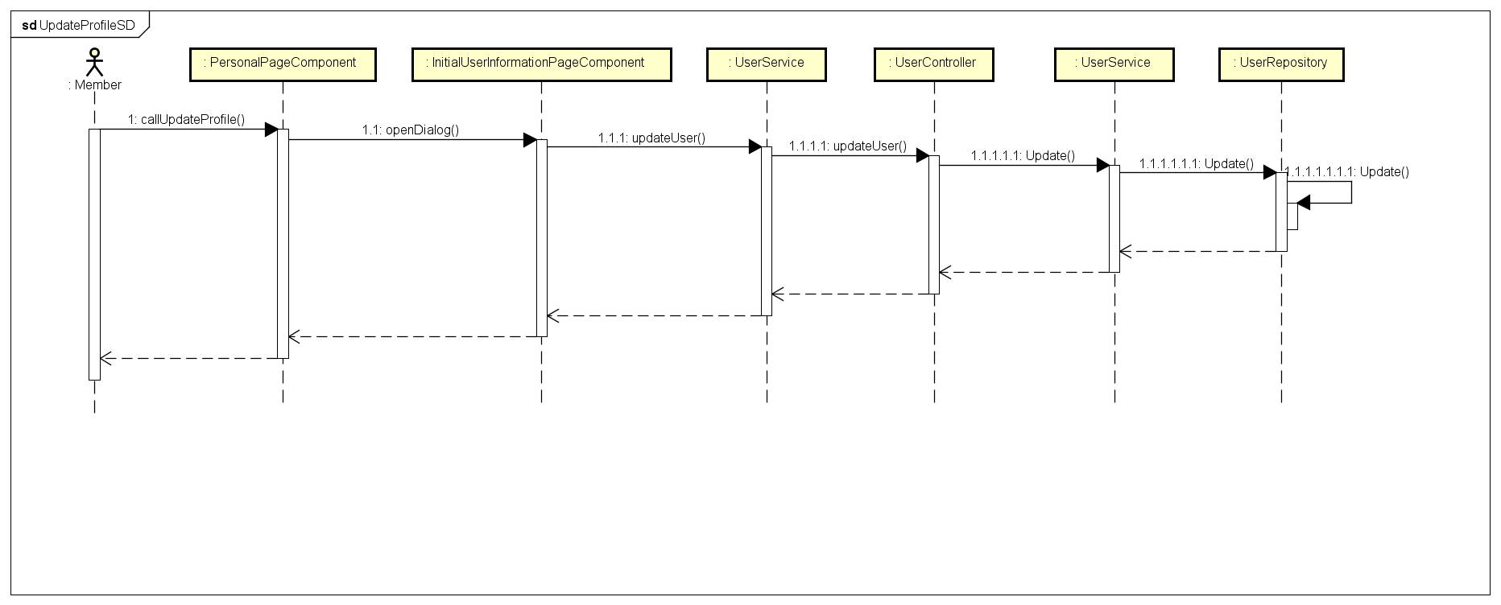

Figure 4-43: Update Profile Sequence Diagram

* + - 1. **Choose Interested Topic**

**Screen Design**

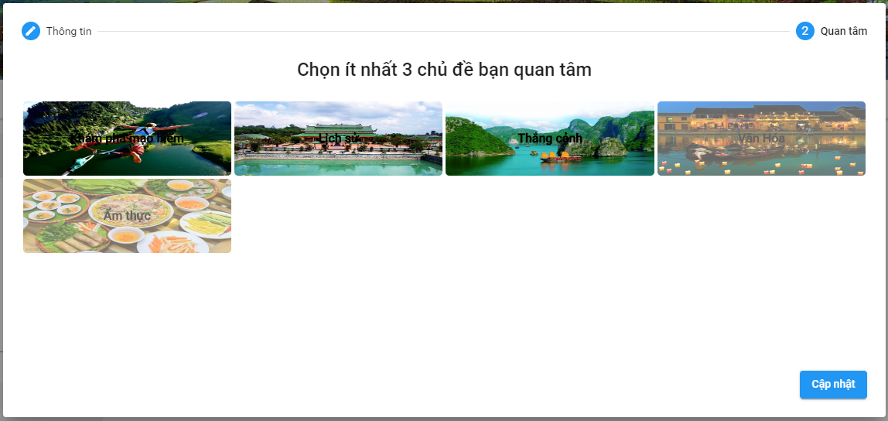

Figure 4-44: Choose Interested Topic

**Class Diagram**

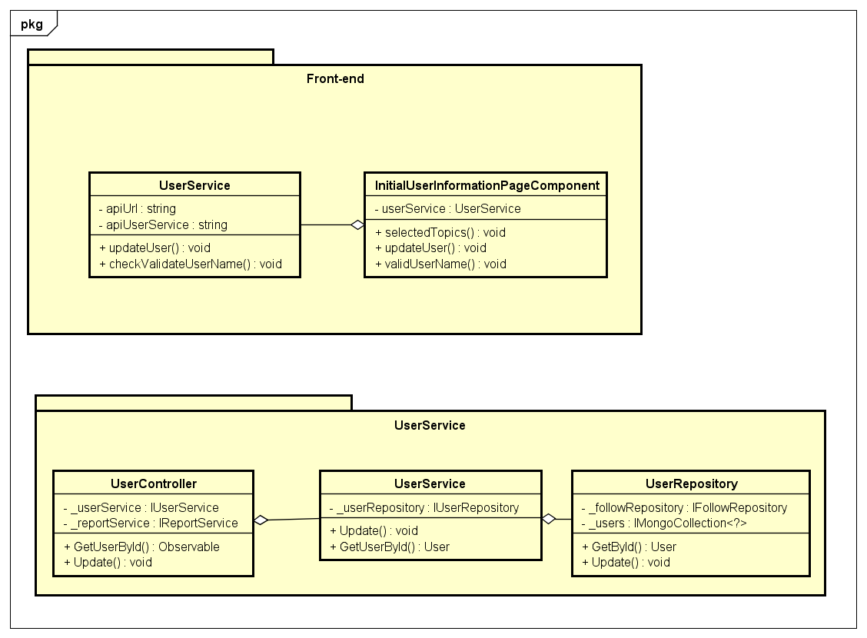

Figure 4-45: Choose Interested Topic Class Diagram

**Class Specification**

***InitialUserInformationPageComponent***

|  |  |  |  |
| --- | --- | --- | --- |
| **InitialUserInformationPageComponent** | | | |
| Physical address | src\app\pages\initial-user-information-page\initial-user-information-page.component.ts | | |
| Base Class | Class | | |
| **Attributes** | | | |
| No | Name | Type | Description |
| 1 | userService | UserService |  |
| **Operations** | | | |
| No | Name | Return Type | Description |
| 1 | validUserName | Void |  |
| 2 | updateUser | Void |  |
| 3 | selectedTopics | Void |  |

***UserService***

|  |  |  |  |
| --- | --- | --- | --- |
| **UserService** | | | |
| Physical address | src\app\core\services\user-service\user.service.ts | | |
| Base Class | Class | | |
| **Attributes** | | | |
| No | Name | Type | Description |
| 1 | apiUrl | String |  |
| **Operations** | | | |
| No | Name | Return Type | Description |
| 1 | checkValidateUserName | Observable |  |
| 2 | updateUser | Observable |  |

***UserController***

|  |  |  |  |
| --- | --- | --- | --- |
| **UserController** | | | |
| Physical address | \src\Services\UserService\UserService\Controllers\UserController.cs | | |
| Base Class | ControllerBase | | |
| **Attributes** | | | |
| No | Name | Type | Description |
| 1 | _userService | IUserService |  |
| 2 | _reportService | IReportService |  |
| **Operations** | | | |
| No | Name | Return Type | Description |
| 1 | GetUserById | Observable |  |
| 2 | Update | Observable |  |

***UserService (back-end)***

|  |  |  |  |
| --- | --- | --- | --- |
| **UserService** | | | |
| Physical address | \src\Services\UserService\UserService\Services\UserService.cs | | |
| Base Class | IUserService | | |
| **Attributes** | | | |
| No | Name | Type | Description |
| 1 | _userRepository | IUserRepository |  |
| **Operations** | | | |
| No | Name | Return Type | Description |
| 1 | GetUserById | User |  |
| 2 | Update | Void |  |

***UserRepository***

|  |  |  |  |
| --- | --- | --- | --- |
| **UserRepository** | | | |
| Physical address | \src\Services\UserService\UserService\Reponsitories\UserRepository.cs | | |
| Base Class | IUserRepository | | |
| **Attributes** | | | |
| No | Name | Type | Description |
| 1 | _users | IMongoCollection<?> |  |
| 2 | _followRepository | IFollowRepository |  |
| **Operations** | | | |
| No | Name | Return Type | Description |
| 1 | GetById | User |  |
| 2 | Update | Void |  |

**Sequence Diagram**

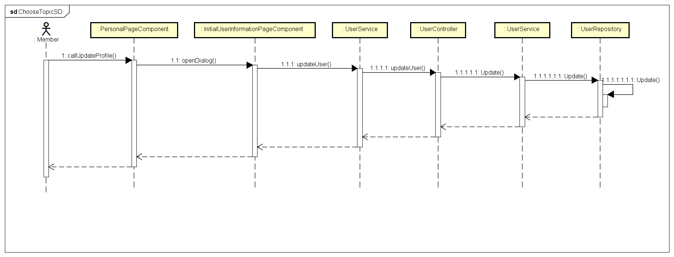

Figure 4-46: Choose Interested Topic Sequence Diagram

* + - 1. **Create A Post**

**Screen Design**

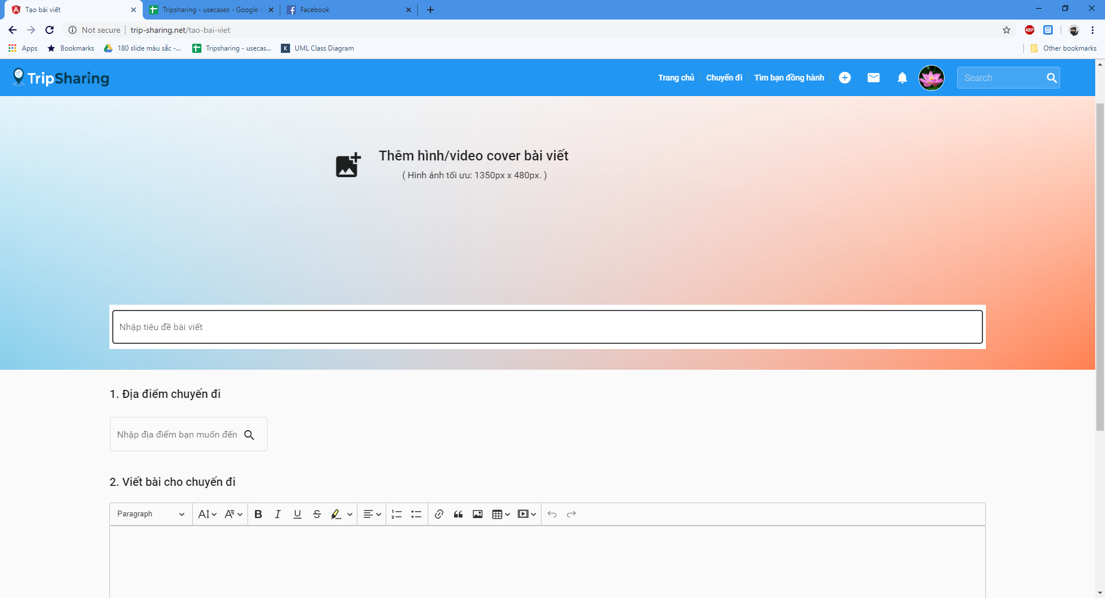

Figure 4-47: Create A Post Screen Design

**Class Diagram**

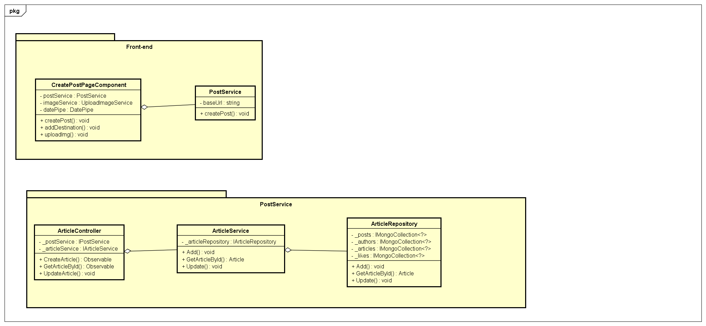

Figure 4-48: Create A Post Class Diagram

**Class Specification**

***CreatePostPageComponent***

|  |  |  |  |
| --- | --- | --- | --- |
| **CreatePostPageComponent** | | | |
| Physical address | src\app\pages\create-post-page\ create-post-page.component.ts | | |
| Base Class | Class | | |
| **Attributes** | | | |
| No | Name | Type | Description |
| 1 | postService | PostService |  |
| 2 | imageService | UploadImageService |  |
| 3 | datePipe | DatePipe |  |
| **Operations** | | | |
| No | Name | Return Type | Description |
| 1 | createPost | Void |  |
| 2 | addDestination | Void | User must choose a destination |
| 3 | uploadImg | Void | Upload image |

***PostService***

|  |  |  |  |
| --- | --- | --- | --- |
| **PostService** | | | |
| Physical address | src\app\core\services\post-service\post.service.ts | | |
| Base Class | Class | | |
| **Attributes** | | | |
| No | Name | Type | Description |
| 1 | baseUrl | String |  |
| **Operations** | | | |
| No | Name | Return Type | Description |
| 1 | createPost | Void |  |
|  |  |  |  |

***ArticleController***

|  |  |  |  |
| --- | --- | --- | --- |
| **ArticleController** | | | |
| Physical address | src\Services\PostService\PostService\Controllers\ArticleController.cs | | |
| Base Class | ControllerBase | | |
| **Attributes** | | | |
| No | Name | Type | Description |
| 1 | _articleService | IArticleService |  |
| 2 | _postService | IPostService |  |
| **Operations** | | | |
| No | Name | Return Type | Description |
| 1 | GetArticleById | Observable |  |
| 2 | UpdateArticle | Void |  |
| 3 | CreateArticle | Void |  |

***ArticleService***

|  |  |  |  |
| --- | --- | --- | --- |
| **ArticleService** | | | |
| Physical address | src\Services\PostService\PostService\Services\ArticleService.cs | | |
| Base Class | IArticleService | | |
| **Attributes** | | | |
| No | Name | Type | Description |
| 1 | _articleService | IArticleService |  |
| 2 | _postService | IPostService |  |
| **Operations** | | | |
| No | Name | Return Type | Description |
| 1 | GetArticleById | Article |  |
| 2 | Update | Void |  |
| 3 | Add | Void |  |

***ArticleRepository***

|  |  |  |  |
| --- | --- | --- | --- |
| **ArticleRepository** | | | |
| Physical address | src\Services\PostService\PostService\Repositories\ArticleRepository.cs | | |
| Base Class | IArticleRepository | | |
| **Attributes** | | | |
| No | Name | Type | Description |
| 1 | _articles | IMongoCollection<?> |  |
| 2 | _posts | IMongoCollection<?> |  |
| 3 | _authors | IMongoCollection<?> |  |
| 4 | _likes | IMongoCollection<?> |  |
| **Operations** | | | |
| No | Name | Return Type | Description |
| 1 | GetArticleById | Article |  |
| 2 | Update | Void |  |
| 3 | Add | Void |  |

**Sequence Diagram**

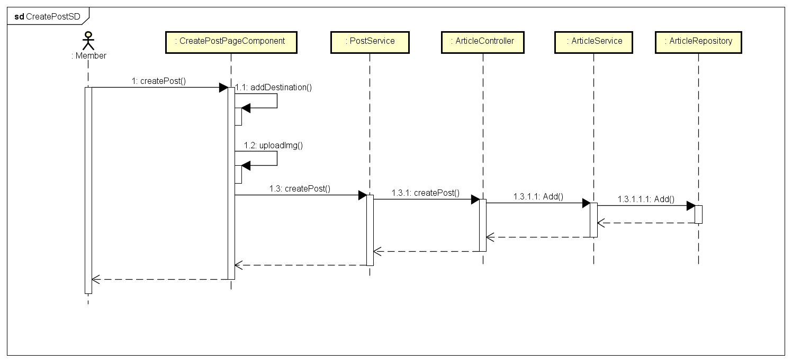

Figure 4-49: Create A Post Sequence Diagram

* + - 1. **Edit A Post**

**Screen Design**

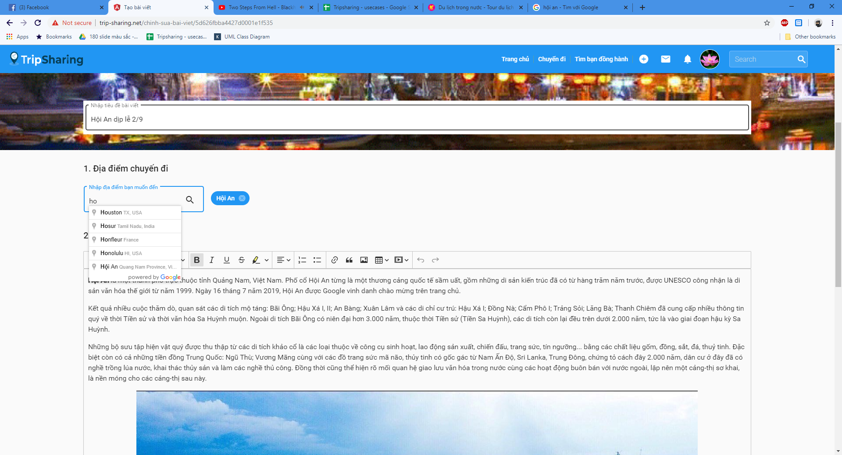

Figure 4-50: Edit A Post Sequence Diagram

**Class Diagram**

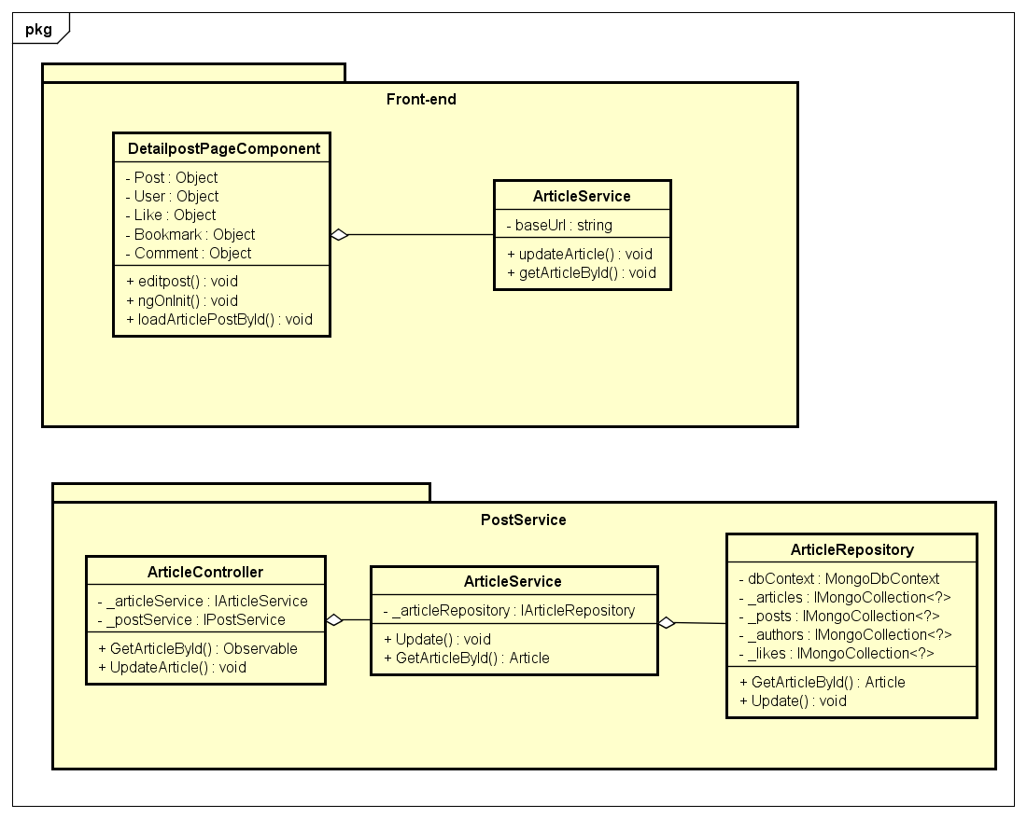

Figure 4-51: Edit A Post Class Diagram

**Class Specification**

***DetailpostPageComponent***

|  |  |  |  |
| --- | --- | --- | --- |
| **DetailpostPageComponent** | | | |
| Physical address | src\app\pages\detailpost-page\detailpost-page.component.ts | | |
| Base Class | Class | | |
| **Attributes** | | | |
| No | Name | Type | Description |
| 1 | Post | Object | Instance of Post object |
| 2 | User | Object | Instance of User object |
| 3 | Like | Object | Instance of Like object |
| 4 | Bookmark | Object | Instance of Bookmark object |
| 5 | Comment | Object | Instance of Comment object |
| **Operations** | | | |
| No | Name | Return Type | Description |
| 1 | editpost | Void |  |
| 2 | ngOnInit | Void |  |
| 3 | loadArticlePostById | Void |  |

***PostService***

|  |  |  |  |
| --- | --- | --- | --- |
| **PostService** | | | |
| Physical address | src\app\core\services\post-service\post.service.ts | | |
| Base Class | Class | | |
| **Attributes** | | | |
| No | Name | Type | Description |
| 1 | baseUrl | String |  |
| **Operations** | | | |
| No | Name | Return Type | Description |
| 1 | getArticleById | Article |  |
| 2 | updateArticle | Void |  |

***ArticleController***

|  |  |  |  |
| --- | --- | --- | --- |
| **ArticleController** | | | |
| Physical address | src\Services\PostService\PostService\Controllers\ArticleController.cs | | |
| Base Class | ControllerBase | | |
| **Attributes** | | | |
| No | Name | Type | Description |
| 1 | _articleService | IArticleService |  |
| 2 | _postService | IPostService |  |
| **Operations** | | | |
| No | Name | Return Type | Description |
| 1 | GetArticleById | Observable |  |
| 2 | UpdateArticle | Void |  |

***ArticleService***

|  |  |  |  |
| --- | --- | --- | --- |
| **ArticleService** | | | |
| Physical address | src\Services\PostService\PostService\Services\ArticleService.cs | | |
| Base Class | IArticleService | | |
| **Attributes** | | | |
| No | Name | Type | Description |
| 1 | _articleService | IArticleService |  |
| 2 | _postService | IPostService |  |
| **Operations** | | | |
| No | Name | Return Type | Description |
| 1 | GetArticleById | Article |  |
| 2 | Update | Void |  |

***ArticleRepository***

|  |  |  |  |
| --- | --- | --- | --- |
| **ArticleRepository** | | | |
| Physical address | src\Services\PostService\PostService\Repositories\ArticleRepository.cs | | |
| Base Class | IArticleRepository | | |
| **Attributes** | | | |
| No | Name | Type | Description |
| 1 | dbContext | MongoDbContext |  |
| 2 | _articles | IMongoCollection<?> |  |
| 3 | _posts | IMongoCollection<?> |  |
| 4 | _authors | IMongoCollection<?> |  |
| 5 | _likes | IMongoCollection<?> |  |
| **Operations** | | | |
| No | Name | Return Type | Description |
| 1 | GetArticleById | Article |  |
| 2 | Update | Void |  |

**Sequence Diagram**

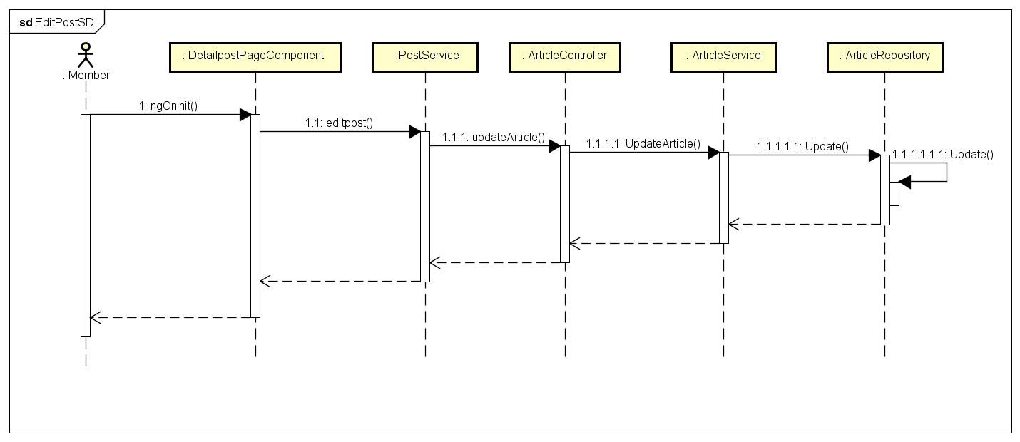

Figure 4-52: Edit A Post Sequence Diagram

**4.3.4.12 Delete A Post**

**Screen Design**

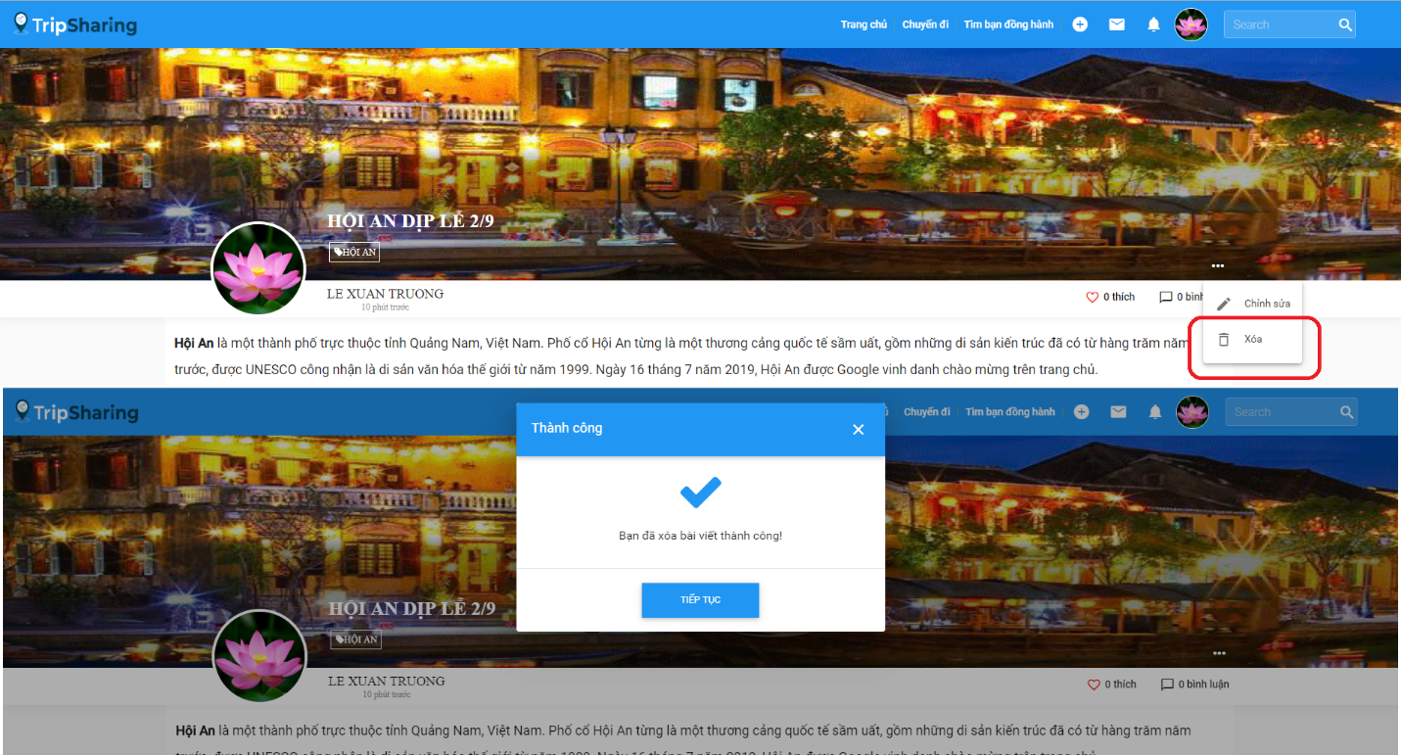

Figure 4-53: Delete A Post Screen Design

**Class Diagram**

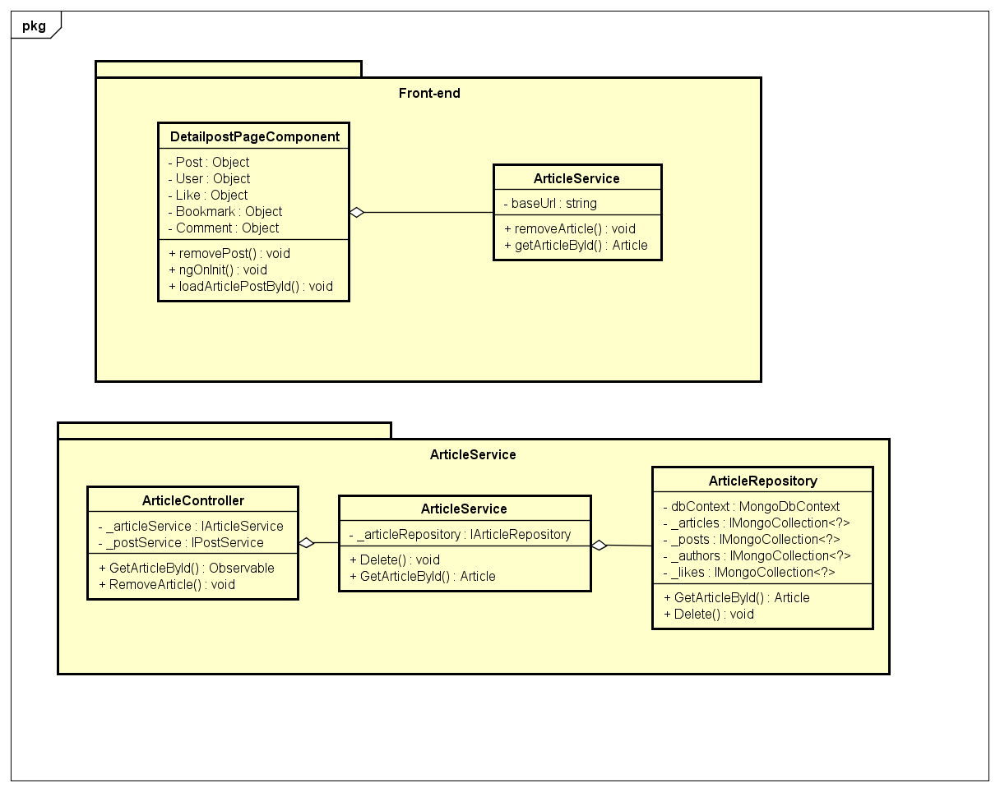

Figure 4-53: Delete A Post Class Diagram

**Class Specification**

***DetailpostPageComponent***

|  |  |  |  |
| --- | --- | --- | --- |
| **DetailpostPageComponent** | | | |
| Physical address | src\app\pages\detailpost-page\detailpost-page.component.ts | | |
| Base Class | Class | | |
| **Attributes** | | | |
| No | Name | Type | Description |
| 1 | Post | Object | Instance of Post object |
| 2 | User | Object | Instance of User object |
| 3 | Like | Object | Instance of Like object |
| 4 | Bookmark | Object | Instance of Bookmark object |
| 5 | Comment | Object | Instance of Comment object |
| **Operations** | | | |
| No | Name | Return Type | Description |
| 1 | removePost | Void |  |
| 2 | ngOnInit | Void |  |
| 3 | loadArticlePostById | Void |  |

***PostService***

|  |  |  |  |
| --- | --- | --- | --- |
| **PostService** | | | |
| Physical address | src\app\core\services\post-service\post.service.ts | | |
| Base Class | Class | | |
| **Attributes** | | | |
| No | Name | Type | Description |
| 1 | baseUrl | String |  |
| **Operations** | | | |
| No | Name | Return Type | Description |
| 1 | getArticleById | Article |  |
| 2 | removeArticle | Void |  |

***ArticleController***

|  |  |  |  |
| --- | --- | --- | --- |
| **ArticleController** | | | |
| Physical address | src\Services\PostService\PostService\Controllers\ArticleController.cs | | |
| Base Class | ControllerBase | | |
| **Attributes** | | | |
| No | Name | Type | Description |
| 1 | _articleService | IArticleService |  |
| 2 | _postService | IPostService |  |
| **Operations** | | | |
| No | Name | Return Type | Description |
| 1 | GetArticleById | Observable |  |
| 2 | RemoveArticle | Void |  |

***ArticleService***

|  |  |  |  |
| --- | --- | --- | --- |
| **ArticleService** | | | |
| Physical address | src\Services\PostService\PostService\Services\ArticleService.cs | | |
| Base Class | IArticleService | | |
| **Attributes** | | | |
| No | Name | Type | Description |
| 1 | _articleService | IArticleService |  |
| 2 | _postService | IPostService |  |
| **Operations** | | | |
| No | Name | Return Type | Description |
| 1 | GetArticleById | Article |  |
| 2 | Delete | Void |  |

***ArticleRepository***

|  |  |  |  |
| --- | --- | --- | --- |
| **ArticleRepository** | | | |
| Physical address | src\Services\PostService\PostService\Repositories\ArticleRepository.cs | | |
| Base Class | IArticleRepository | | |
| **Attributes** | | | |
| No | Name | Type | Description |
| 1 | dbContext | MongoDbContext |  |
| 2 | _articles | IMongoCollection<?> |  |
| 3 | _posts | IMongoCollection<?> |  |
| 4 | _authors | IMongoCollection<?> |  |
| 5 | _likes | IMongoCollection<?> |  |
| **Operations** | | | |
| No | Name | Return Type | Description |
| 1 | GetArticleById | Article |  |
| 2 | Delete | Void |  |

**Sequence Diagram**

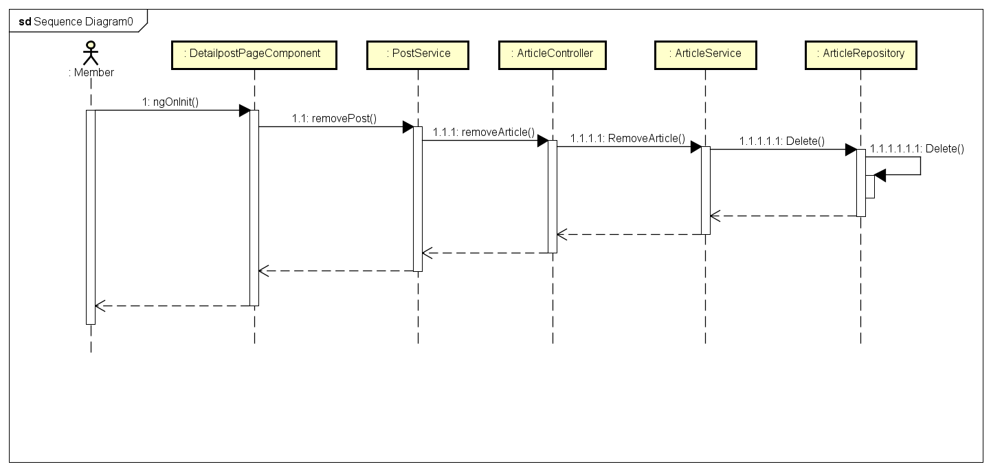

Figure 4-54: Delete A Post Sequence Diagram

**4.3.4.13 Like/Unlike A Post**

**Screen Design**

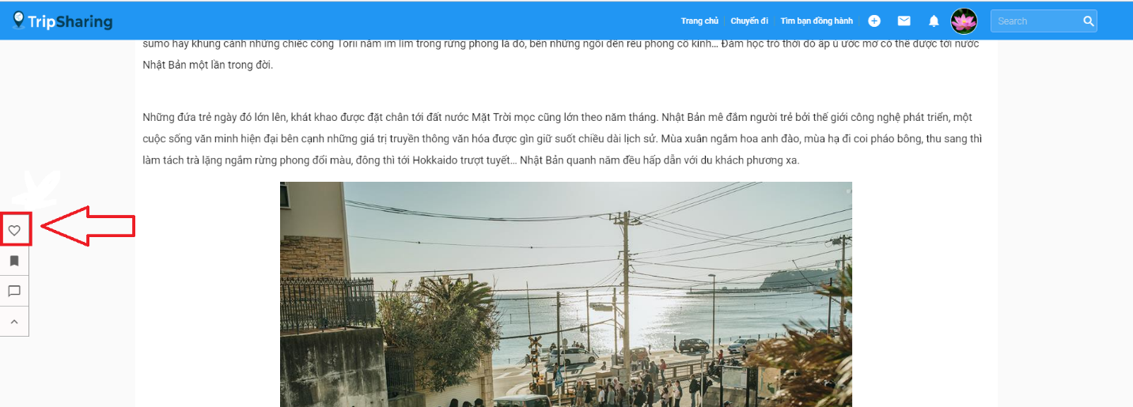

Figure 4-55: Like/Unlike A Post Screen Design

**Class Diagram**

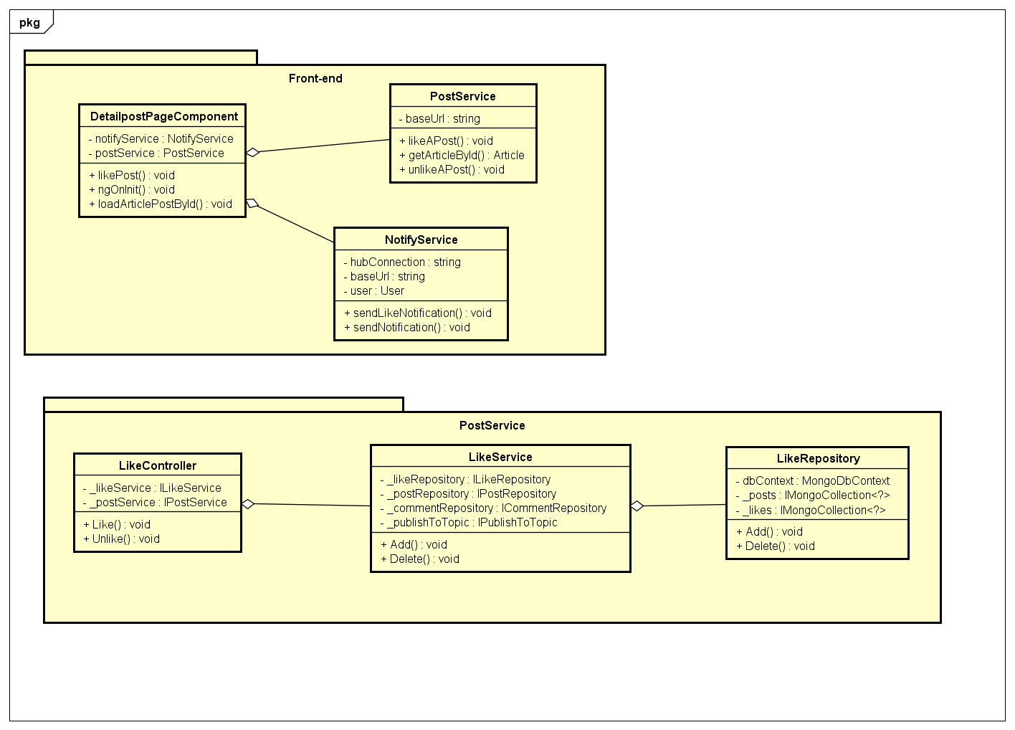

Figure 4-55: Like/Unlike A Post Class Diagram

**Class Specification**

***DetailpostPageComponent***

|  |  |  |  |
| --- | --- | --- | --- |
| **DetailpostPageComponent** | | | |
| Physical address | src\app\pages\detailpost-page\detailpost-page.component.ts | | |
| Base Class | Class | | |
| **Attributes** | | | |
| No | Name | Type | Description |
| 1 | notifyService | NotifyService |  |
| 2 | postService | PostService |  |
| **Operations** | | | |
| No | Name | Return Type | Description |
| 1 | likePost | Void |  |
| 2 | ngOnInit | Void |  |
| 3 | loadArticlePostById | Void |  |

***NotifyService***

|  |  |  |  |
| --- | --- | --- | --- |
| **NotifyService** | | | |
| Physical address | src\app\core\services\post-service\post.service.ts | | |
| Base Class | Class | | |
| **Attributes** | | | |
| No | Name | Type | Description |
| 1 | hubConnection | String |  |
| 2 | baseUrl | String |  |
| 3 | user | User |  |
| **Operations** | | | |
| No | Name | Return Type | Description |
| 1 | sendLikeNotification | Void |  |
| 2 | sendNotification | Void |  |

***PostService***

|  |  |  |  |
| --- | --- | --- | --- |
| **PostService** | | | |
| Physical address | src\app\core\services\post-service\post.service.ts | | |
| Base Class | Class | | |
| **Attributes** | | | |
| No | Name | Type | Description |
| 1 | baseUrl | String |  |
| **Operations** | | | |
| No | Name | Return Type | Description |
| 1 | getArticleById | Article |  |
| 2 | likeAPost | Void |  |
| 3 | unlikeAPost | Void |  |

***LikeController***

|  |  |  |  |
| --- | --- | --- | --- |
| **LikeController** | | | |
| Physical address | src\Services\PostService\PostService\Controllers\LikeController.cs | | |
| Base Class | ControllerBase | | |
| **Attributes** | | | |
| No | Name | Type | Description |
| 1 | _ likeService | ILikeService |  |
| 2 | _postService | IPostService |  |
| **Operations** | | | |
| No | Name | Return Type | Description |
| 1 | Like | Void |  |
| 2 | Unlike | Void |  |

***LikeService***

|  |  |  |  |
| --- | --- | --- | --- |
| **LikeService** | | | |
| Physical address | src\Services\PostService\PostService\Services\LikeService.cs | | |
| Base Class | ILikeService | | |
| **Attributes** | | | |
| No | Name | Type | Description |
| 1 | _likeRepository | ILikeRepository |  |
| 2 | _postService | IPostService |  |
| 3 | _commentRepository | ICommentRepository |  |
| 4 | _publishToTopic | IPublishToTopic |  |
| **Operations** | | | |
| No | Name | Return Type | Description |
| 1 | Add | Void |  |
| 2 | Delete | Void |  |

***LikeRepository***

|  |  |  |  |
| --- | --- | --- | --- |
| **LikeRepository** | | | |
| Physical address | src\Services\PostService\PostService\Repositories\LikeRepository.cs | | |
| Base Class | ILikeRepository | | |
| **Attributes** | | | |
| No | Name | Type | Description |
| 1 | dbContext | MongoDbContext |  |
| 2 | _likes | IMongoCollection<?> |  |
| 3 | _posts | IMongoCollection<?> |  |
| **Operations** | | | |
| No | Name | Return Type | Description |
| 1 | Add | Void |  |
| 2 | Delete | Void |  |

**Sequence Diagram**

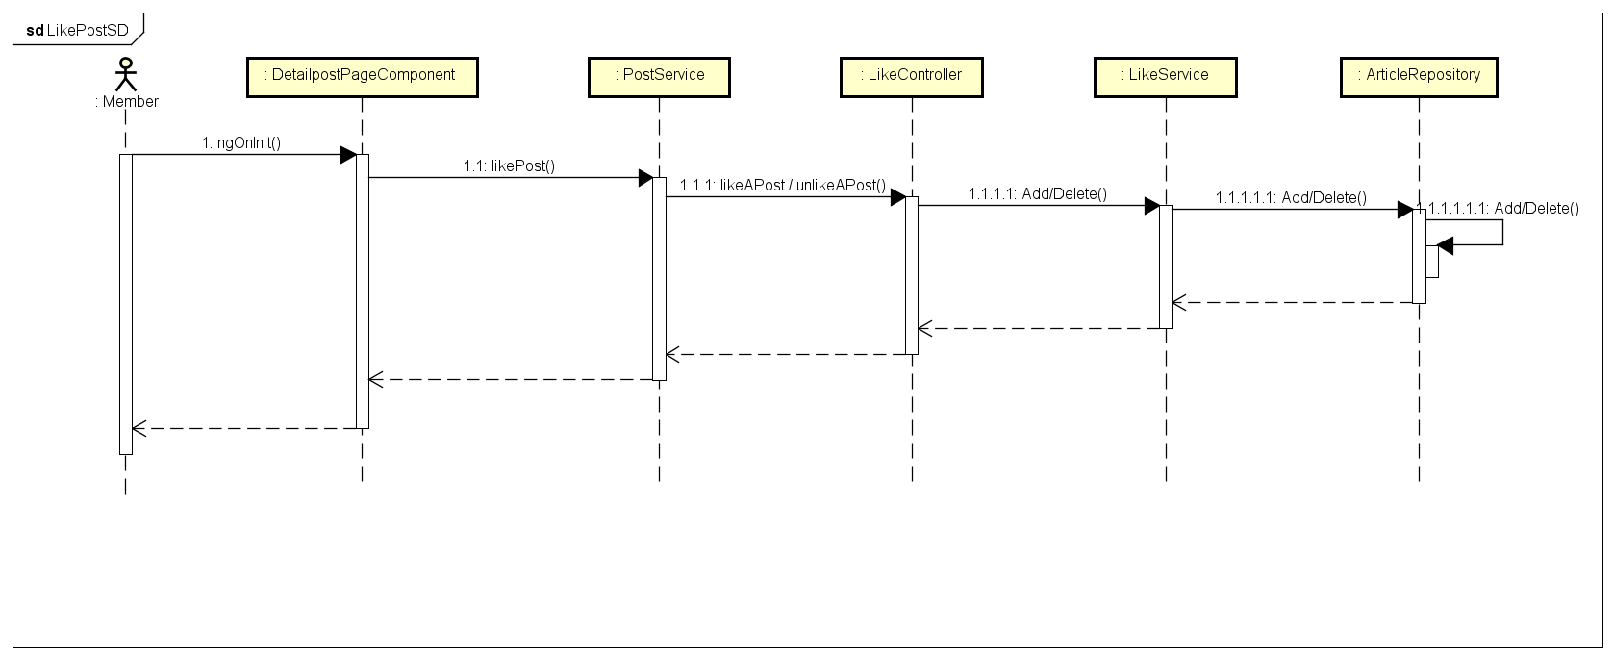

Figure 4-56: Like/Unlike A Post Sequence Diagram

**4.3.4.14 Share A Post**

**Screen Design**

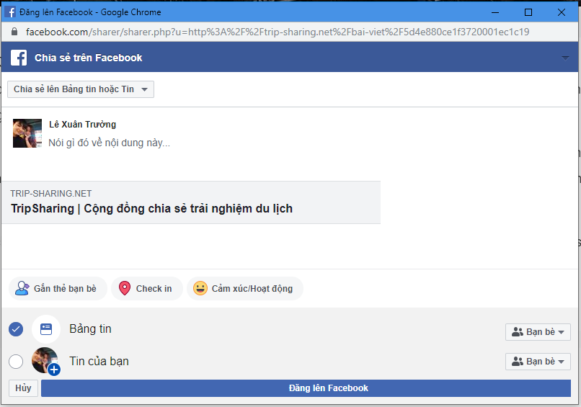

Figure 4-57: Share A Post Screen Design

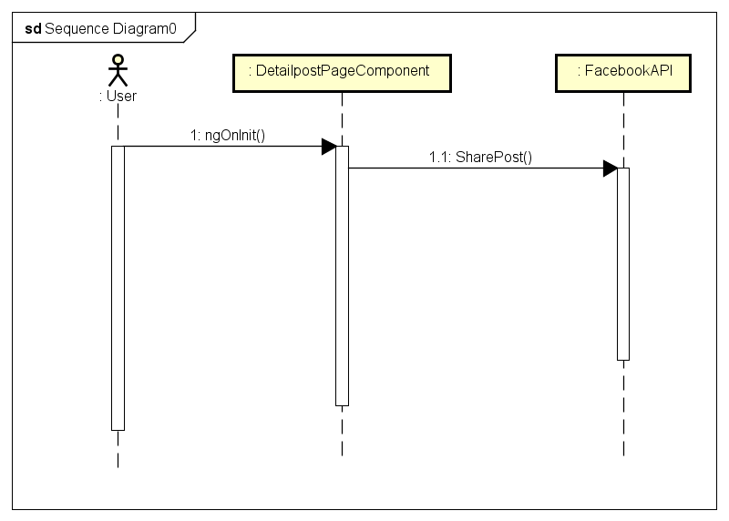

Figure 4-58: Share A Post Sequence Diagram

**4.3.4.15 Report A Post**

**Screen Design**

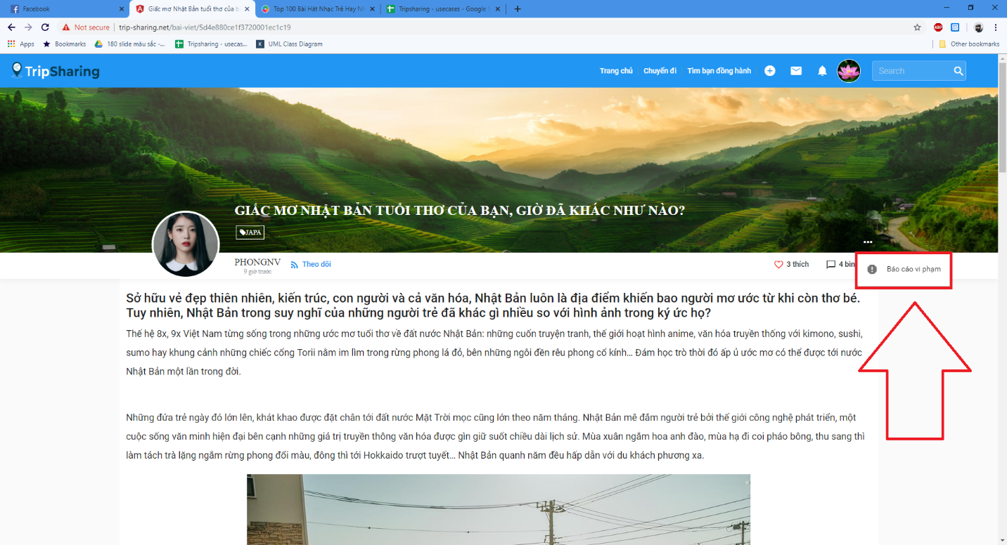

Figure 4-59: Report A Post Screen Design

**Class Diagram**

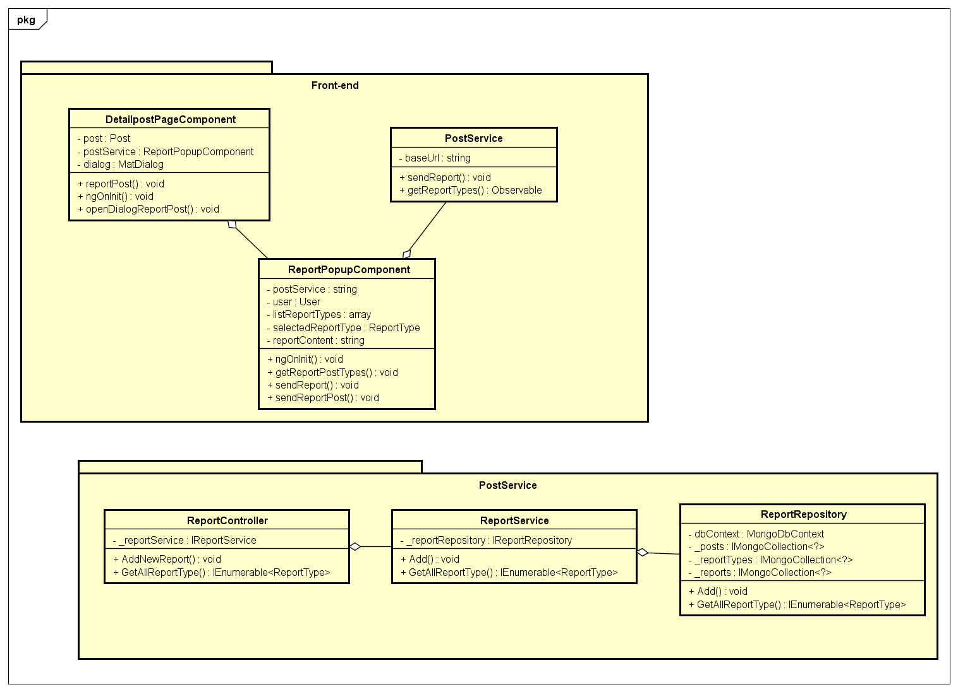Figure 4-60: Report A Post Class Diagram

**Class Specification**

***DetailpostPageComponent***

|  |  |  |  |
| --- | --- | --- | --- |
| **DetailpostPageComponent** | | | |
| Physical address | src\app\pages\detailpost-page\detailpost-page.component.ts | | |
| Base Class | Class | | |
| **Attributes** | | | |
| No | Name | Type | Description |
| 1 | post | Post |  |
| 2 | postService | PostService |  |
| 3 | dialog | MatDialog |  |
| **Operations** | | | |
| No | Name | Return Type | Description |
| 1 | reportPost | Void |  |
| 2 | ngOnInit | Void |  |
| 3 | openDialogReportPost | Void |  |

***ReportPopupComponent***

|  |  |  |  |
| --- | --- | --- | --- |
| **ReportPopupComponent** | | | |
| Physical address | src\app\shared\components\report-popup\report-popup.component.ts | | |
| Base Class | Class | | |
| **Attributes** | | | |
| No | Name | Type | Description |
| 1 | postService | String |  |
| 2 | reportContent | String |  |
| 3 | user | User |  |
| 4 | listReportTypes | Array |  |
| 5 | selectedReportType | ReportType |  |
| **Operations** | | | |
| No | Name | Return Type | Description |
| 1 | ngOnInit | Void |  |
| 2 | getReportPostTypes | Void |  |
| 3 | sendReportPost | Void |  |
| 4 | sendReport | Void |  |

***PostService***

|  |  |  |  |
| --- | --- | --- | --- |
| **PostService** | | | |
| Physical address | src\app\core\services\post-service\post.service.ts | | |
| Base Class | Class | | |
| **Attributes** | | | |
| No | Name | Type | Description |
| 1 | baseUrl | String |  |
| **Operations** | | | |
| No | Name | Return Type | Description |
| 1 | sendReport | Void |  |
| 2 | getReportTypes | Observable |  |

***ReportController***

|  |  |  |  |
| --- | --- | --- | --- |
| **ReportController** | | | |
| Physical address | src\Services\PostService\PostService\Controllers\ReportController.cs | | |
| Base Class | ControllerBase | | |
| **Attributes** | | | |
| No | Name | Type | Description |
| 1 | _reportService | IReportService |  |
| **Operations** | | | |
| No | Name | Return Type | Description |
| 1 | AddNewReport | Void |  |
| 2 | GetAllReportType | IEnumerable<ReportType> |  |

***ReportService***

|  |  |  |  |
| --- | --- | --- | --- |
| **ReportService** | | | |
| Physical address | src\Services\PostService\PostService\Services\ReportService.cs | | |
| Base Class | IReportService | | |
| **Attributes** | | | |
| No | Name | Type | Description |
| 1 | _reportRepository | IReportRepository |  |
| **Operations** | | | |
| No | Name | Return Type | Description |
| 1 | Add | Void |  |
| 2 | GetAllReportType | IEnumerable<ReportType> |  |

***ReportRepository***

|  |  |  |  |
| --- | --- | --- | --- |
| **ReportRepository** | | | |
| Physical address | src\Services\PostService\PostService\Repositories\ReportRepository.cs | | |
| Base Class | IReportRepository | | |
| **Attributes** | | | |
| No | Name | Type | Description |
| 1 | dbContext | MongoDbContext |  |
| 2 | _reportTypes | IMongoCollection<?> |  |
| 3 | _posts | IMongoCollection<?> |  |
| 4 | _reports | IMongoCollection<?> |  |
| **Operations** | | | |
| No | Name | Return Type | Description |
| 1 | Add | Void |  |
| 2 | GetAllReportType | IEnumerable<ReportType> |  |

**Sequence Diagram**

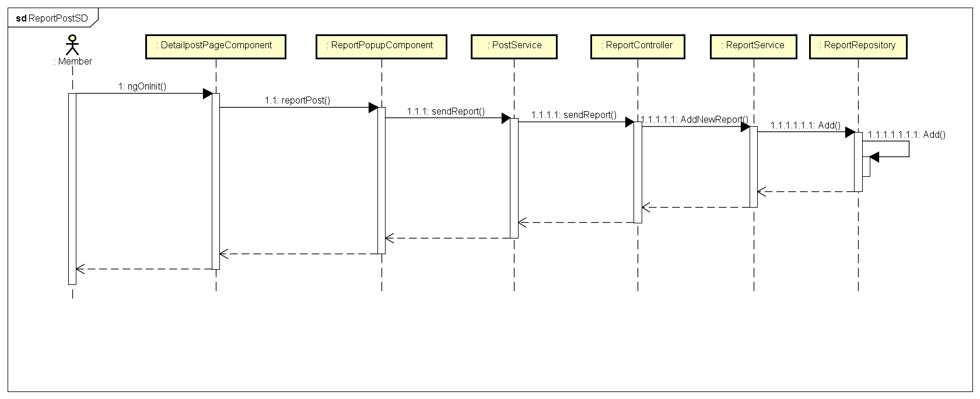

Figure 4-61: Report A Post Sequence Diagram

* + - 1. **Bookmark a post**

**Screen Design**

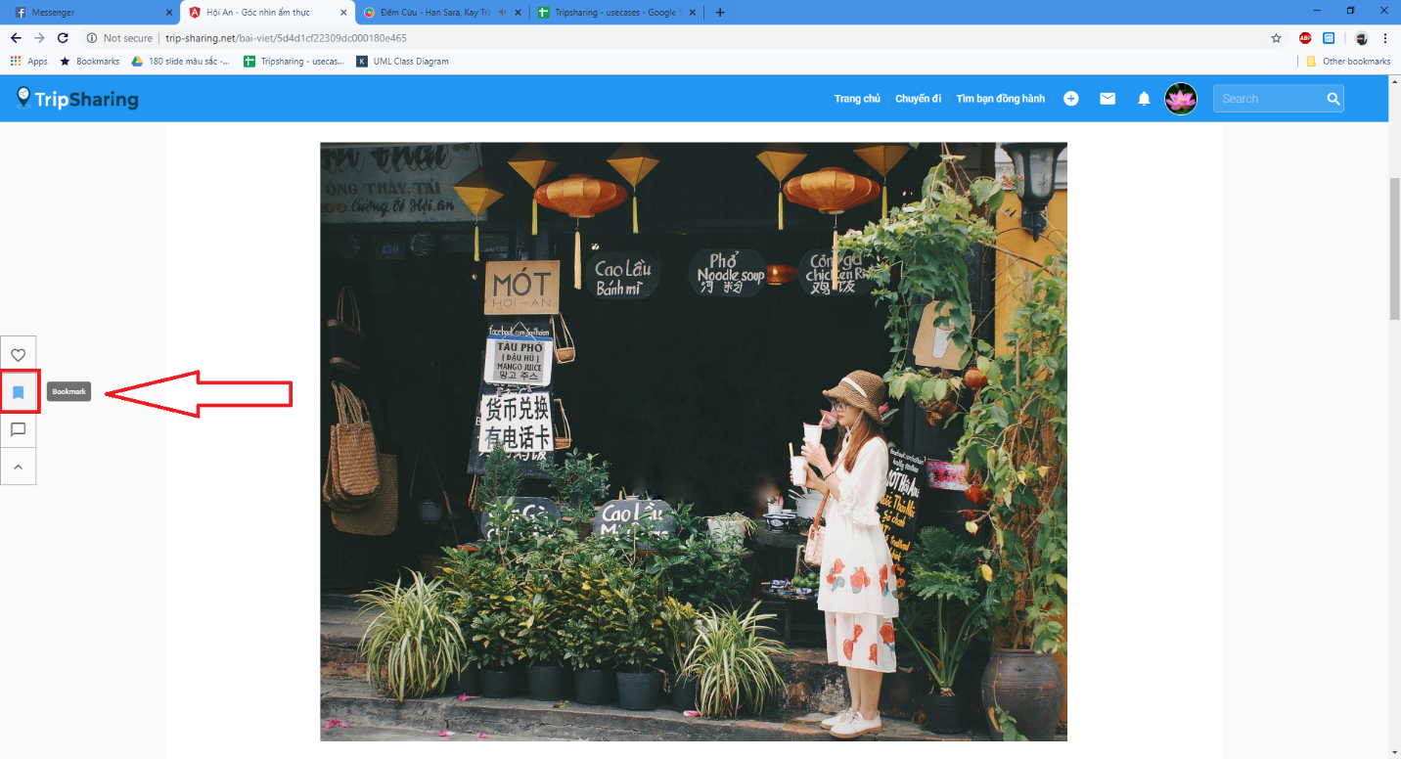

Figure 4-62: Bookmark A Post Screen Design

**Class Diagram**

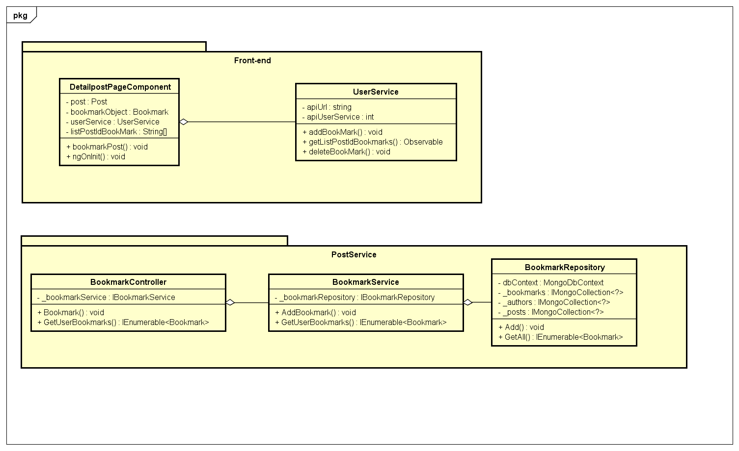

Figure 4-63: Bookmark A Post Class Diagram

**Class Specification**

***DetailpostPageComponent***

|  |  |  |  |
| --- | --- | --- | --- |
| **DetailpostPageComponent** | | | |
| Physical address | src\app\pages\detailpost-page\detailpost-page.component.ts | | |
| Base Class | Class | | |
| **Attributes** | | | |
| No | Name | Type | Description |
| 1 | post | Post |  |
| 2 | bookmarkObject | Bookmark |  |
| 3 | userService | UserService |  |
| 4 | listPostIdBookMark | String[] |  |
| **Operations** | | | |
| No | Name | Return Type | Description |
| 1 | bookmarkPost | Void |  |
| 2 | ngOnInit | Void |  |

***UserService***

|  |  |  |  |
| --- | --- | --- | --- |
| **UserService** | | | |
| Physical address | src\app\core\services\user-service\user.service.ts | | |
| Base Class | Class | | |
| **Attributes** | | | |
| No | Name | Type | Description |
| 1 | apiUrl | String |  |
| 2 | apiUserService | String |  |
| **Operations** | | | |
| No | Name | Return Type | Description |
| 1 | addBookMark | Void |  |
| 2 | getListPostIdBookmarks | Observable |  |
| 3 | deleteBookMark | Void |  |

***BookmarkController***

|  |  |  |  |
| --- | --- | --- | --- |
| **BookmarkController** | | | |
| Physical address | src\Services\PostService\PostService\Controllers\BookmarkController.cs | | |
| Base Class | ControllerBase | | |
| **Attributes** | | | |
| No | Name | Type | Description |
| 1 | _bookmarkService | IBookmarkService |  |
| **Operations** | | | |
| No | Name | Return Type | Description |
| 1 | Bookmark | Void |  |
| 2 | GetUserBookmarks | IEnumerable<Bookmark> |  |

***BookmarkService***

|  |  |  |  |
| --- | --- | --- | --- |
| **BookmarkService** | | | |
| Physical address | src\Services\PostService\PostService\Services\BookmarkService.cs | | |
| Base Class | IBookmarkService | | |
| **Attributes** | | | |
| No | Name | Type | Description |
| 1 | _bookmarkRepository | IBookmarkRepository |  |
| **Operations** | | | |
| No | Name | Return Type | Description |
| 1 | AddBookmark | Void |  |
| 2 | GetUserBookmarks | IEnumerable<Bookmark> |  |

***BookmarkRepository***

|  |  |  |  |
| --- | --- | --- | --- |
| **BookmarkRepository** | | | |
| Physical address | src\Services\PostService\PostService\Repositories\BookmarkRepository.cs | | |
| Base Class | IBookmarkRepository | | |
| **Attributes** | | | |
| No | Name | Type | Description |
| 1 | dbContext | MongoDbContext |  |
| 2 | _bookmarks | IMongoCollection<?> |  |
| 3 | _posts | IMongoCollection<?> |  |
| 4 | _authors | IMongoCollection<?> |  |
| **Operations** | | | |
| No | Name | Return Type | Description |
| 1 | Add | Void |  |
| 2 | GetAll | IEnumerable<Bookmark> |  |

**Sequence Diagram**

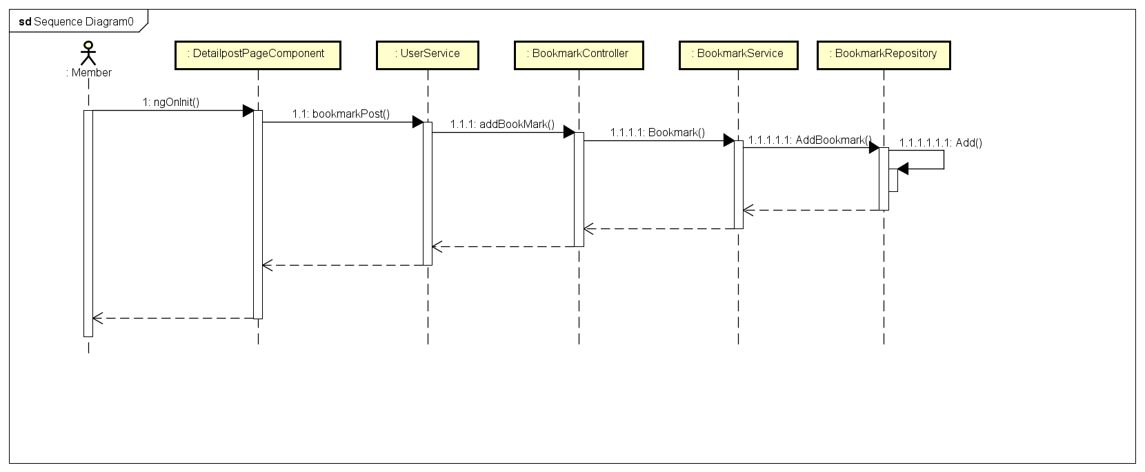

Figure 4-64: Bookmark A Post Sequence Diagram

**4.3.4.17 View All Bookmark**

**Screen Design**

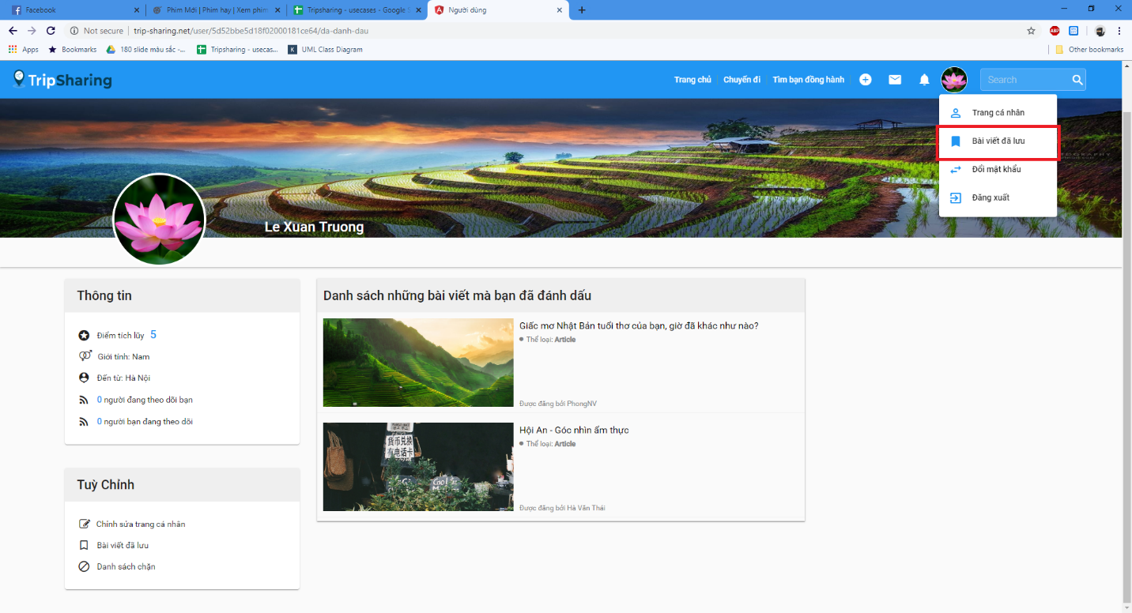

Figure 4-65: View All Bookmark Screen Design

**Class Diagram**

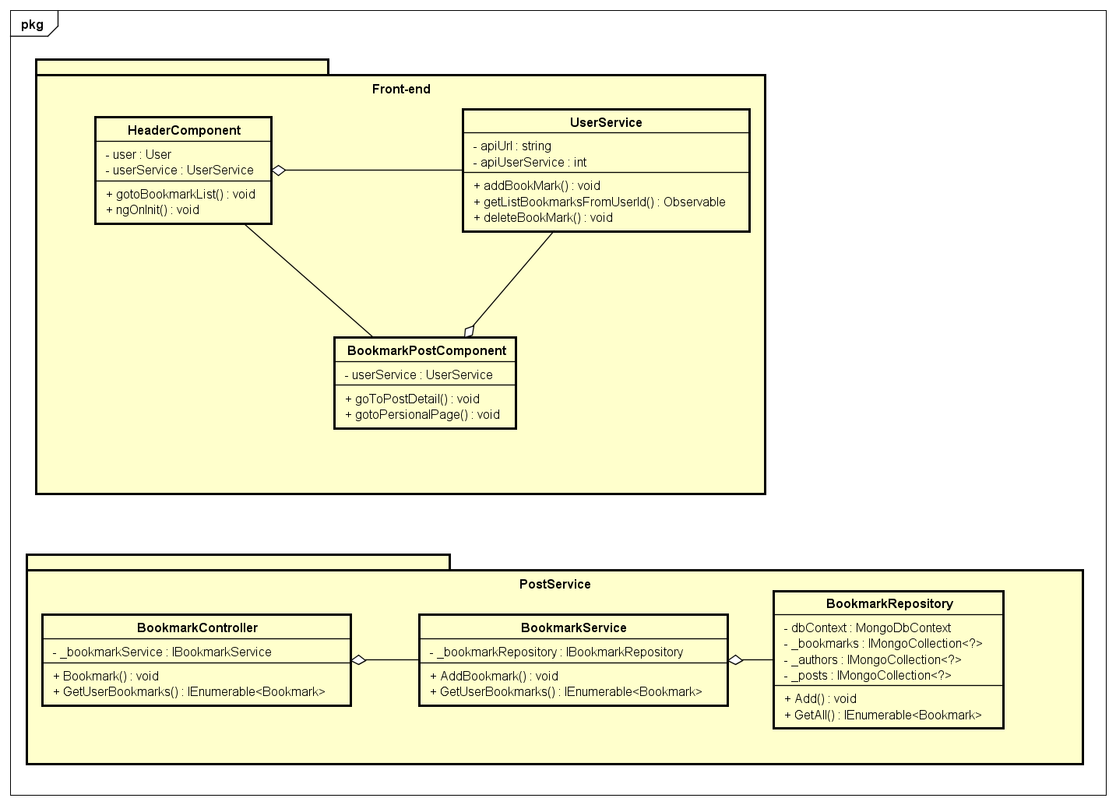

Figure 4-66: View All Bookmark Class Diagram

**Class Specification**

***HeaderComponent***

|  |  |  |  |
| --- | --- | --- | --- |
| **HeaderComponent** | | | |
| Physical address | src\app\core\components\header\header.component.ts | | |
| Base Class | Class | | |
| **Attributes** | | | |
| No | Name | Type | Description |
| 1 | user | Post |  |
| 2 | userService | UserService |  |
| **Operations** | | | |
| No | Name | Return Type | Description |
| 1 | bookmarkPost | Void |  |
| 2 | ngOnInit | Void |  |

***BookmarkPostComponent***

|  |  |  |  |
| --- | --- | --- | --- |
| **BookmarkPostComponent** | | | |
| Physical address | src\app\shared\components\bookmark-post\bookmark-post.component.ts | | |
| Base Class | Class | | |
| **Attributes** | | | |
| No | Name | Type | Description |
| 2 | userService | UserService |  |
| **Operations** | | | |
| No | Name | Return Type | Description |
| 1 | goToPostDetail | Void |  |
| 2 | gotoPersionalPage | Void |  |

***UserService***

|  |  |  |  |
| --- | --- | --- | --- |
| **UserService** | | | |
| Physical address | src\app\core\services\user-service\user.service.ts | | |
| Base Class | Class | | |
| **Attributes** | | | |
| No | Name | Type | Description |
| 1 | apiUrl | String |  |
| 2 | apiUserService | String |  |
| **Operations** | | | |
| No | Name | Return Type | Description |
| 1 | addBookMark | Void |  |
| 2 | getListBookmarksFromUserId | Observable |  |
| 3 | deleteBookMark | Void |  |

***BookmarkController***

|  |  |  |  |
| --- | --- | --- | --- |
| **BookmarkController** | | | |
| Physical address | src\Services\PostService\PostService\Controllers\BookmarkController.cs | | |
| Base Class | ControllerBase | | |
| **Attributes** | | | |
| No | Name | Type | Description |
| 1 | _bookmarkService | IBookmarkService |  |
| **Operations** | | | |
| No | Name | Return Type | Description |
| 1 | Bookmark | Void |  |
| 2 | GetUserBookmarks | IEnumerable<Bookmark> |  |

***BookmarkService***

|  |  |  |  |
| --- | --- | --- | --- |
| **BookmarkService** | | | |
| Physical address | src\Services\PostService\PostService\Services\BookmarkService.cs | | |
| Base Class | IBookmarkService | | |
| **Attributes** | | | |
| No | Name | Type | Description |
| 1 | _bookmarkRepository | IBookmarkRepository |  |
| **Operations** | | | |
| No | Name | Return Type | Description |
| 1 | AddBookmark | Void |  |
| 2 | GetUserBookmarks | IEnumerable<Bookmark> |  |

***BookmarkRepository***

|  |  |  |  |
| --- | --- | --- | --- |
| **BookmarkRepository** | | | |
| Physical address | src\Services\PostService\PostService\Repositories\BookmarkRepository.cs | | |
| Base Class | IBookmarkRepository | | |
| **Attributes** | | | |
| No | Name | Type | Description |
| 1 | dbContext | MongoDbContext |  |
| 2 | _bookmarks | IMongoCollection<?> |  |
| 3 | _posts | IMongoCollection<?> |  |
| 4 | _authors | IMongoCollection<?> |  |
| **Operations** | | | |
| No | Name | Return Type | Description |
| 1 | Add | Void |  |
| 2 | GetAll | IEnumerable<Bookmark> |  |

**Sequence Diagram**

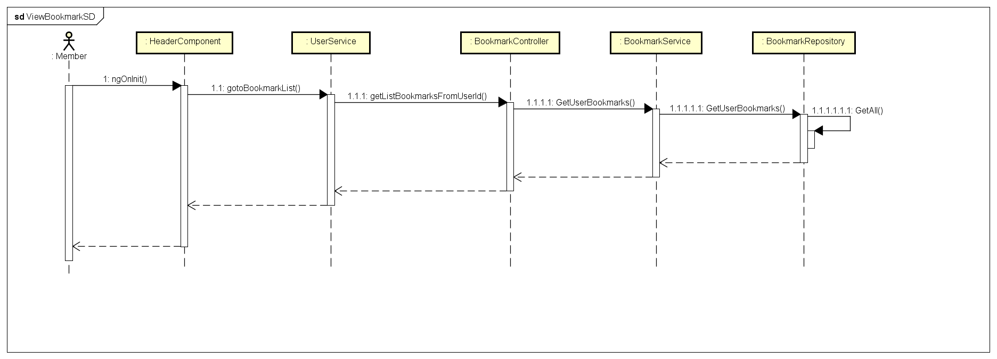

Figure 4-66: View All Bookmark Sequence Diagram

**4.3.4.18 Remove A Bookmark**

**Screen Design**

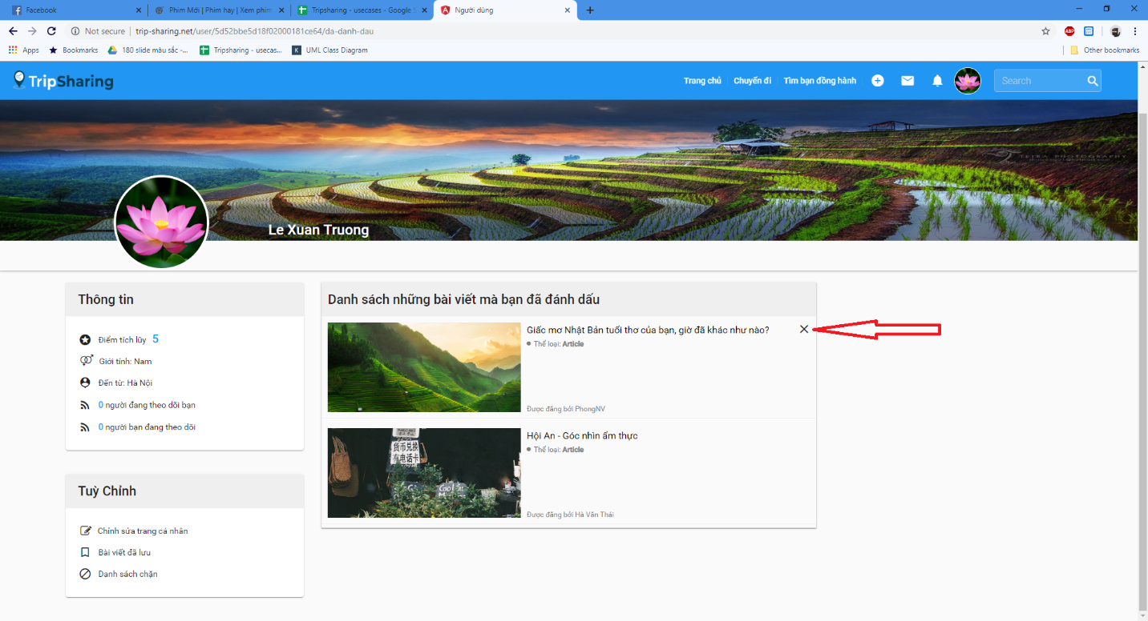

Figure 4-67: Remove A Bookmark Screen Design

**Class Diagram**

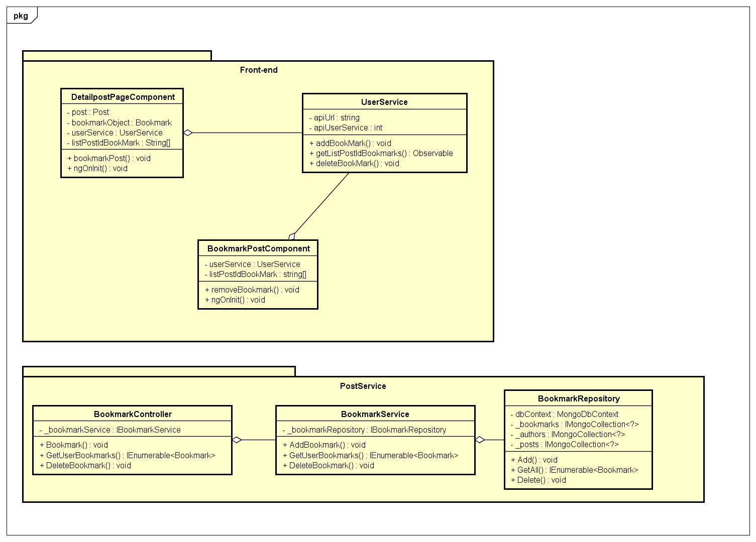

Figure 4-67: Remove A Bookmark Class Diagram

**Class Specification**

***DetailpostPageComponent***

|  |  |  |  |
| --- | --- | --- | --- |
| **DetailpostPageComponent** | | | |
| Physical address | src\app\pages\detailpost-page\detailpost-page.component.ts | | |
| Base Class | Class | | |
| **Attributes** | | | |
| No | Name | Type | Description |
| 1 | post | Post |  |
| 2 | bookmarkObject | Bookmark |  |
| 3 | userService | UserService |  |
| 4 | listPostIdBookMark | String[] |  |
| **Operations** | | | |
| No | Name | Return Type | Description |
| 1 | bookmarkPost | Void |  |
| 2 | ngOnInit | Void |  |
| 3 | DeleteBookmark | Void |  |

***BookmarkPostComponent***

|  |  |  |  |
| --- | --- | --- | --- |
| **BookmarkPostComponent** | | | |
| Physical address | src\app\shared\components\bookmark-post\bookmark-post.component.ts | | |
| Base Class | Class | | |
| **Attributes** | | | |
| No | Name | Type | Description |
| 1 | post | Post |  |
| 2 | bookmarkObject | Bookmark |  |
| **Operations** | | | |
| No | Name | Return Type | Description |
| 1 | removeBookmark | Void |  |
| 2 | ngOnInit | Void |  |

***UserService***

|  |  |  |  |
| --- | --- | --- | --- |
| **UserService** | | | |
| Physical address | src\app\core\services\user-service\user.service.ts | | |
| Base Class | Class | | |
| **Attributes** | | | |
| No | Name | Type | Description |
| 1 | apiUrl | String |  |
| 2 | apiUserService | String |  |
| **Operations** | | | |
| No | Name | Return Type | Description |
| 1 | addBookMark | Void |  |
| 2 | getListPostIdBookmarks | Observable |  |
| 3 | deleteBookMark | Void |  |

***BookmarkController***

|  |  |  |  |
| --- | --- | --- | --- |
| **BookmarkController** | | | |
| Physical address | src\Services\PostService\PostService\Controllers\BookmarkController.cs | | |
| Base Class | ControllerBase | | |
| **Attributes** | | | |
| No | Name | Type | Description |
| 1 | _bookmarkService | IBookmarkService |  |
| **Operations** | | | |
| No | Name | Return Type | Description |
| 1 | Bookmark | Void |  |
| 2 | GetUserBookmarks | IEnumerable<Bookmark> |  |
| 3 | DeleteBookmark | Void |  |

***BookmarkService***

|  |  |  |  |
| --- | --- | --- | --- |
| **BookmarkService** | | | |
| Physical address | src\Services\PostService\PostService\Services\BookmarkService.cs | | |
| Base Class | IBookmarkService | | |
| **Attributes** | | | |
| No | Name | Type | Description |
| 1 | _bookmarkRepository | IBookmarkRepository |  |
| **Operations** | | | |
| No | Name | Return Type | Description |
| 1 | AddBookmark | Void |  |
| 2 | GetUserBookmarks | IEnumerable<Bookmark> |  |
| 3 | DeleteBookmark | Void |  |

***BookmarkRepository***

|  |  |  |  |
| --- | --- | --- | --- |
| **BookmarkRepository** | | | |
| Physical address | src\Services\PostService\PostService\Repositories\BookmarkRepository.cs | | |
| Base Class | IBookmarkRepository | | |
| **Attributes** | | | |
| No | Name | Type | Description |
| 1 | dbContext | MongoDbContext |  |
| 2 | _bookmarks | IMongoCollection<?> |  |
| 3 | _posts | IMongoCollection<?> |  |
| 4 | _authors | IMongoCollection<?> |  |
| **Operations** | | | |
| No | Name | Return Type | Description |
| 1 | Add | Void |  |
| 2 | GetAll | IEnumerable<Bookmark> |  |
| 3 | Delete | Void |  |

**Sequence Diagram**

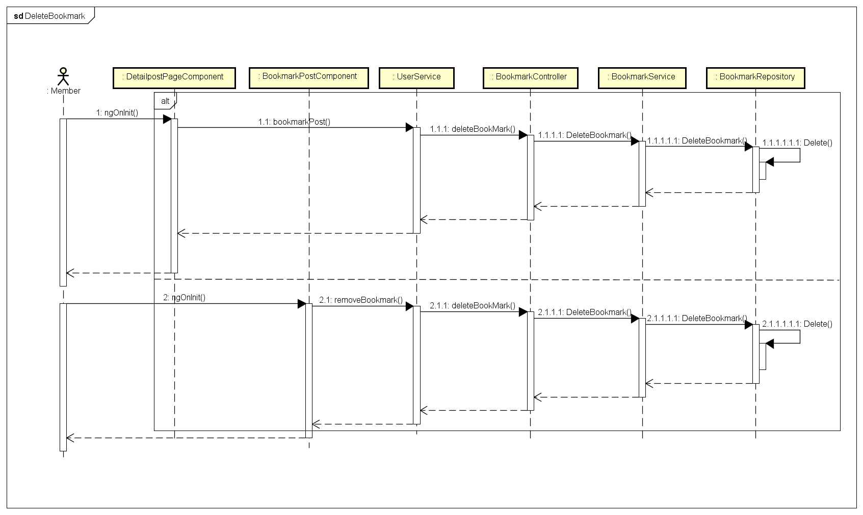

Figure 4-68: Remove A Bookmark Sequence Diagram

**4.3.4.19 Comment to A Post**

**Screen Design**

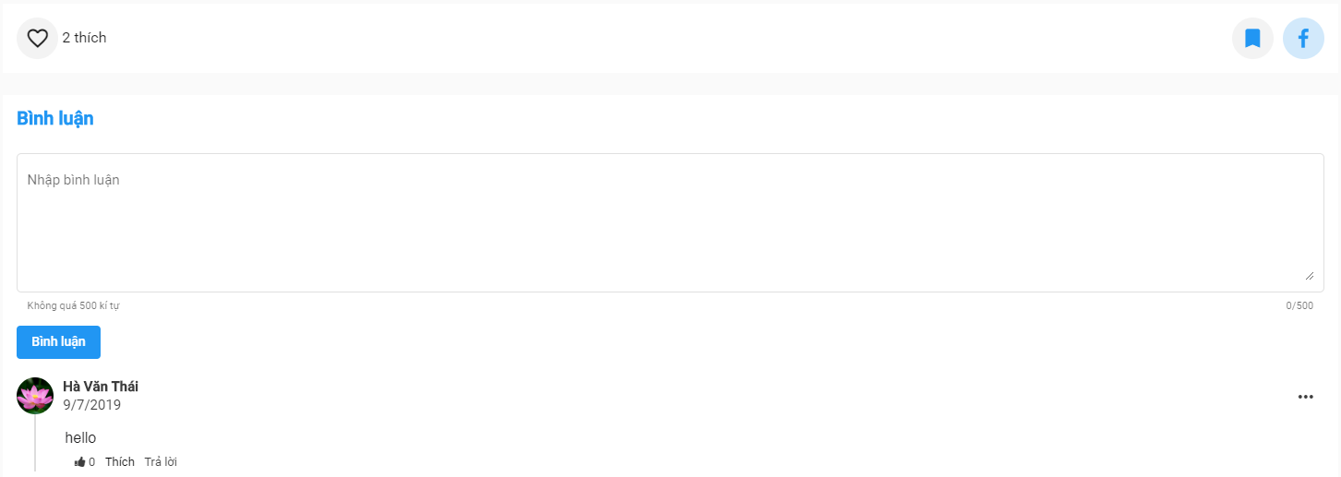

Figure 4-69: Comment to A Post Screen Design

**Class Diagram**

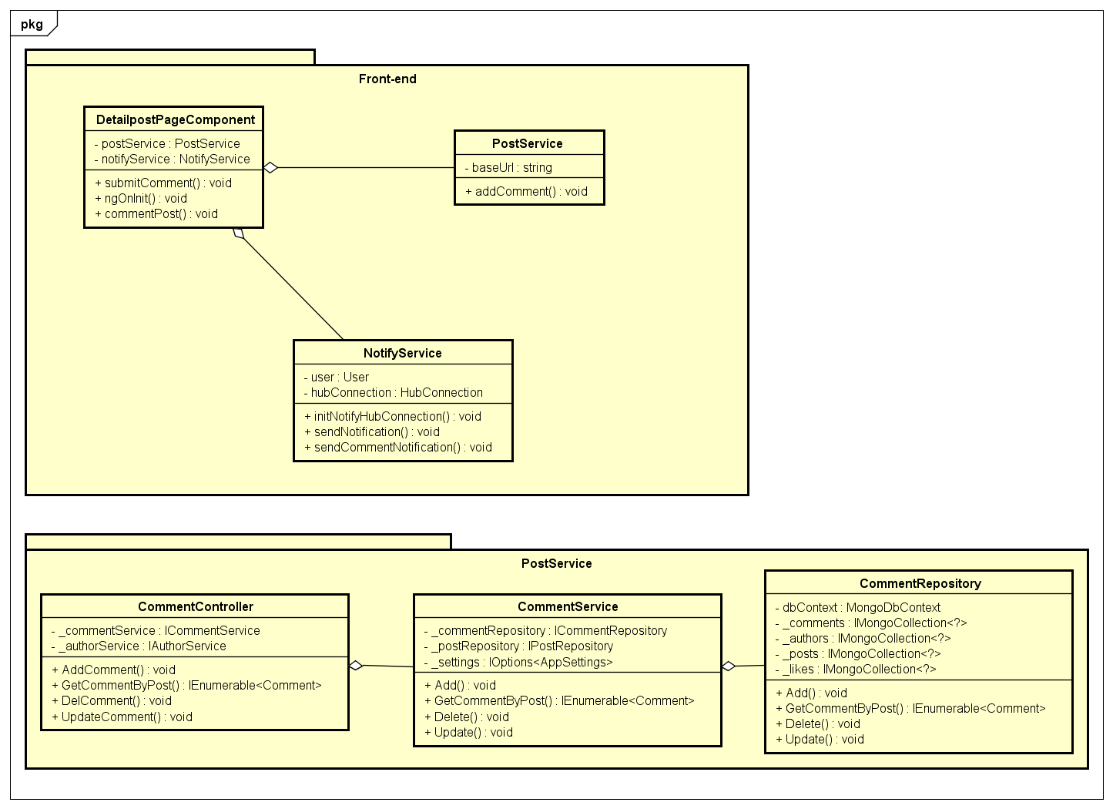

Figure 4-70:Comment to A Post Class Diagram

**Class Specification**

***DetailpostPageComponent***

|  |  |  |  |
| --- | --- | --- | --- |
| **DetailpostPageComponent** | | | |
| Physical address | src\app\pages\detailpost-page\detailpost-page.component.ts | | |
| Base Class | Class | | |
| **Attributes** | | | |
| No | Name | Type | Description |
| 1 | postService | PostService |  |
| 2 | notifyService | NotifyService |  |
| **Operations** | | | |
| No | Name | Return Type | Description |
| 1 | submitComment | Void |  |
| 2 | ngOnInit | Void |  |
| 3 | commentPost | Void |  |

***PostService***

|  |  |  |  |
| --- | --- | --- | --- |
| **PostService** | | | |
| Physical address | src\app\core\services\post-service\post.service.ts | | |
| Base Class | Class | | |
| **Attributes** | | | |
| No | Name | Type | Description |
| 1 | baseUrl | String |  |
| **Operations** | | | |
| No | Name | Return Type | Description |
| 1 | addComment | Void |  |

***NotifyService***

|  |  |  |  |
| --- | --- | --- | --- |
| **NotifyService** | | | |
| Physical address | src\app\core\services\notify-service\notify.service.ts | | |
| Base Class | Class | | |
| **Attributes** | | | |
| No | Name | Type | Description |
| 1 | user | User |  |
| 2 | hubConnection | HubConnection |  |
| **Operations** | | | |
| No | Name | Return Type | Description |
| 1 | initNotifyHubConnection | Void |  |
| 2 | sendNotification | Void |  |
| 3 | sendCommentNotification | Void |  |

***CommentController***

|  |  |  |  |
| --- | --- | --- | --- |
| **CommentController** | | | |
| Physical address | src\Services\PostService\PostService\Controllers\CommentController.cs | | |
| Base Class | ControllerBase | | |
| **Attributes** | | | |
| No | Name | Type | Description |
| 1 | _commentService | ICommentService |  |
| 2 | _authorService | IAuthorService |  |
| **Operations** | | | |
| No | Name | Return Type | Description |
| 1 | AddComment | Void |  |
| 2 | GetCommentByPost | IEnumerable<Comment> |  |
| 3 | DelComment | Void |  |
| 4 | UpdateComment | Void |  |

***CommentService***

|  |  |  |  |
| --- | --- | --- | --- |
| **CommentService** | | | |
| Physical address | src\Services\PostService\PostService\Services\CommentService.cs | | |
| Base Class | ICommentService | | |
| **Attributes** | | | |
| No | Name | Type | Description |
| 1 | _commentRepository | ICommentRepository |  |
| 2 | _postRepository | IPostRepository |  |
| 3 | _settings | IOptions<AppSettings> |  |
| **Operations** | | | |
| No | Name | Return Type | Description |
| 1 | Add | Void |  |
| 2 | GetCommentByPost | IEnumerable<Comment> |  |
| 3 | Delete | Void |  |
| 4 | Update | Void |  |

***CommentRepository***

|  |  |  |  |
| --- | --- | --- | --- |
| **CommentRepository** | | | |
| Physical address | src\Services\PostService\PostService\Repositories\CommentRepository.cs | | |
| Base Class | IBookmarkRepository | | |
| **Attributes** | | | |
| No | Name | Type | Description |
| 1 | dbContext | MongoDbContext |  |
| 2 | _comments | IMongoCollection<?> |  |
| 3 | _posts | IMongoCollection<?> |  |
| 4 | _authors | IMongoCollection<?> |  |
| 5 | _likes | IMongoCollection<?> |  |
| **Operations** | | | |
| No | Name | Return Type | Description |
| 1 | Add | Void |  |
| 2 | GetCommentByPost | IEnumerable<Comment> |  |
| 3 | Delete | Void |  |
| 4 | Update | Void |  |

**Sequence Diagram**

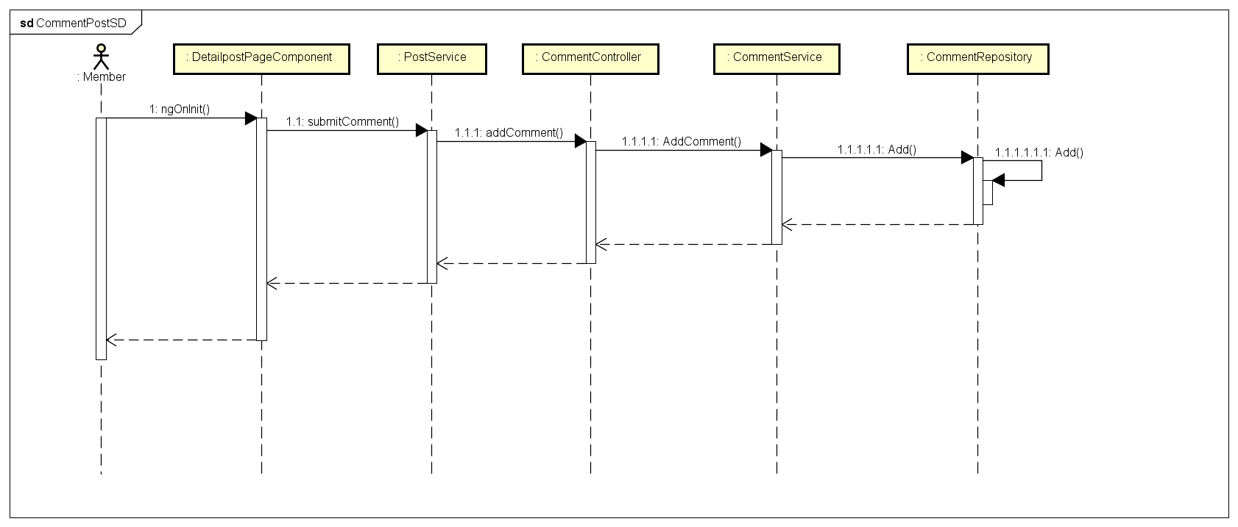

Figure 4-71: Comment to A Post Sequence Diagram

**4.3.4.20 Edit A Comment**

**Screen Design**

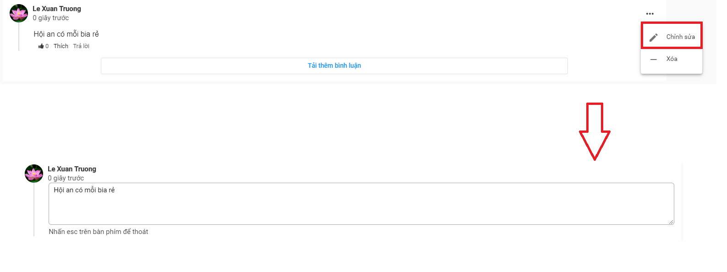

Figure 4-72: Edit A Comment Screen Design

**Class Diagram**

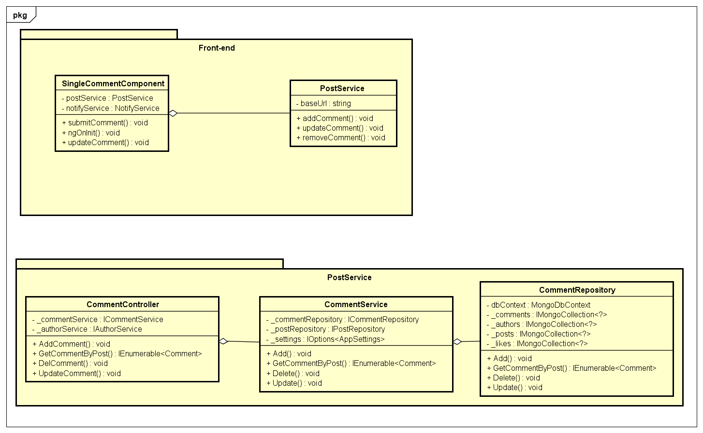

Figure 4-73: Edit A Comment Class Diagram

**Class Specification**

***SingleCommentComponent***

|  |  |  |  |
| --- | --- | --- | --- |
| **SingleCommentComponent** | | | |
| Physical address | src\app\shared\components\single-comment\single-comment.component.ts | | |
| Base Class | Class | | |
| **Attributes** | | | |
| No | Name | Type | Description |
| 1 | postService | PostService |  |
| 2 | notifyService | NotifyService |  |
| **Operations** | | | |
| No | Name | Return Type | Description |
| 1 | submitComment | Void |  |
| 2 | ngOnInit | Void |  |
| 3 | updateComment | Void |  |

***PostService***

|  |  |  |  |
| --- | --- | --- | --- |
| **PostService** | | | |
| Physical address | src\app\core\services\post-service\post.service.ts | | |
| Base Class | Class | | |
| **Attributes** | | | |
| No | Name | Type | Description |
| 1 | baseUrl | String |  |
| **Operations** | | | |
| No | Name | Return Type | Description |
| 1 | addComment | Void |  |
| 2 | updateComment | Void |  |
| 3 | removeComment | Void |  |

***CommentController***

|  |  |  |  |
| --- | --- | --- | --- |
| **CommentController** | | | |
| Physical address | src\Services\PostService\PostService\Controllers\CommentController.cs | | |
| Base Class | ControllerBase | | |
| **Attributes** | | | |
| No | Name | Type | Description |
| 1 | _commentService | ICommentService |  |
| 2 | _authorService | IAuthorService |  |
| **Operations** | | | |
| No | Name | Return Type | Description |
| 1 | AddComment | Void |  |
| 2 | GetCommentByPost | IEnumerable<Comment> |  |
| 3 | DelComment | Void |  |
| 4 | UpdateComment | Void |  |

***CommentService***

|  |  |  |  |
| --- | --- | --- | --- |
| **CommentService** | | | |
| Physical address | src\Services\PostService\PostService\Services\CommentService.cs | | |
| Base Class | ICommentService | | |
| **Attributes** | | | |
| No | Name | Type | Description |
| 1 | _commentRepository | ICommentRepository |  |
| 2 | _postRepository | IPostRepository |  |
| 3 | _settings | IOptions<AppSettings> |  |
| **Operations** | | | |
| No | Name | Return Type | Description |
| 1 | Add | Void |  |
| 2 | GetCommentByPost | IEnumerable<Comment> |  |
| 3 | Delete | Void |  |
| 4 | Update | Void |  |

***CommentRepository***

|  |  |  |  |
| --- | --- | --- | --- |
| **CommentRepository** | | | |
| Physical address | src\Services\PostService\PostService\Repositories\CommentRepository.cs | | |
| Base Class | IBookmarkRepository | | |
| **Attributes** | | | |
| No | Name | Type | Description |
| 1 | dbContext | MongoDbContext |  |
| 2 | _comments | IMongoCollection<?> |  |
| 3 | _posts | IMongoCollection<?> |  |
| 4 | _authors | IMongoCollection<?> |  |
| 5 | _likes | IMongoCollection<?> |  |
| **Operations** | | | |
| No | Name | Return Type | Description |
| 1 | Add | Void |  |
| 2 | GetCommentByPost | IEnumerable<Comment> |  |
| 3 | Delete | Void |  |
| 4 | Update | Void |  |

**Sequence Diagram**

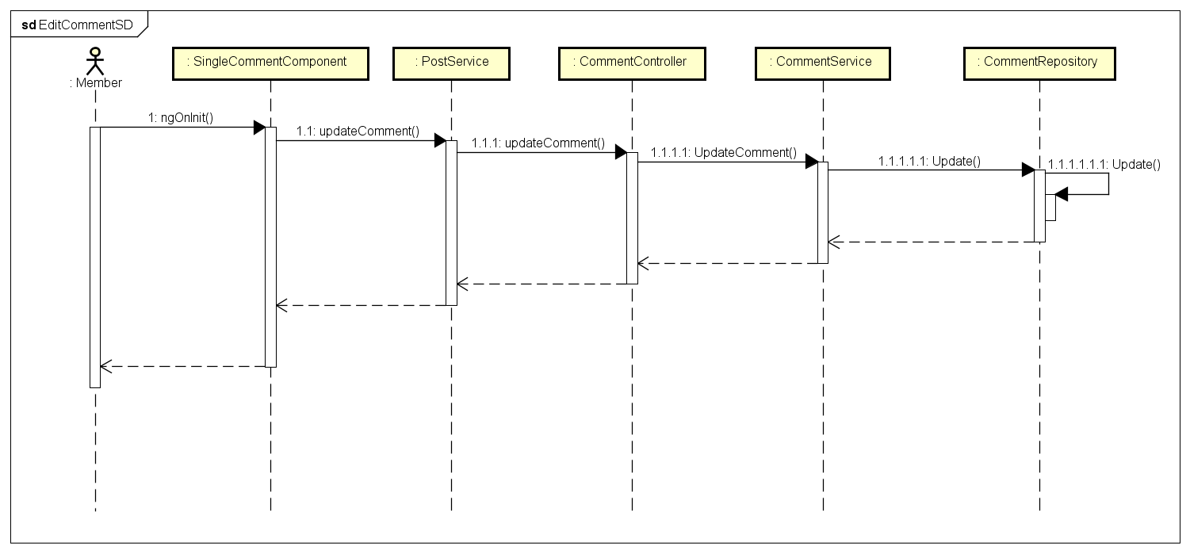Figure 4-74: Edit A Comment Class Diagram

**4.3.4.21 Delete a comment**

**Screen design**

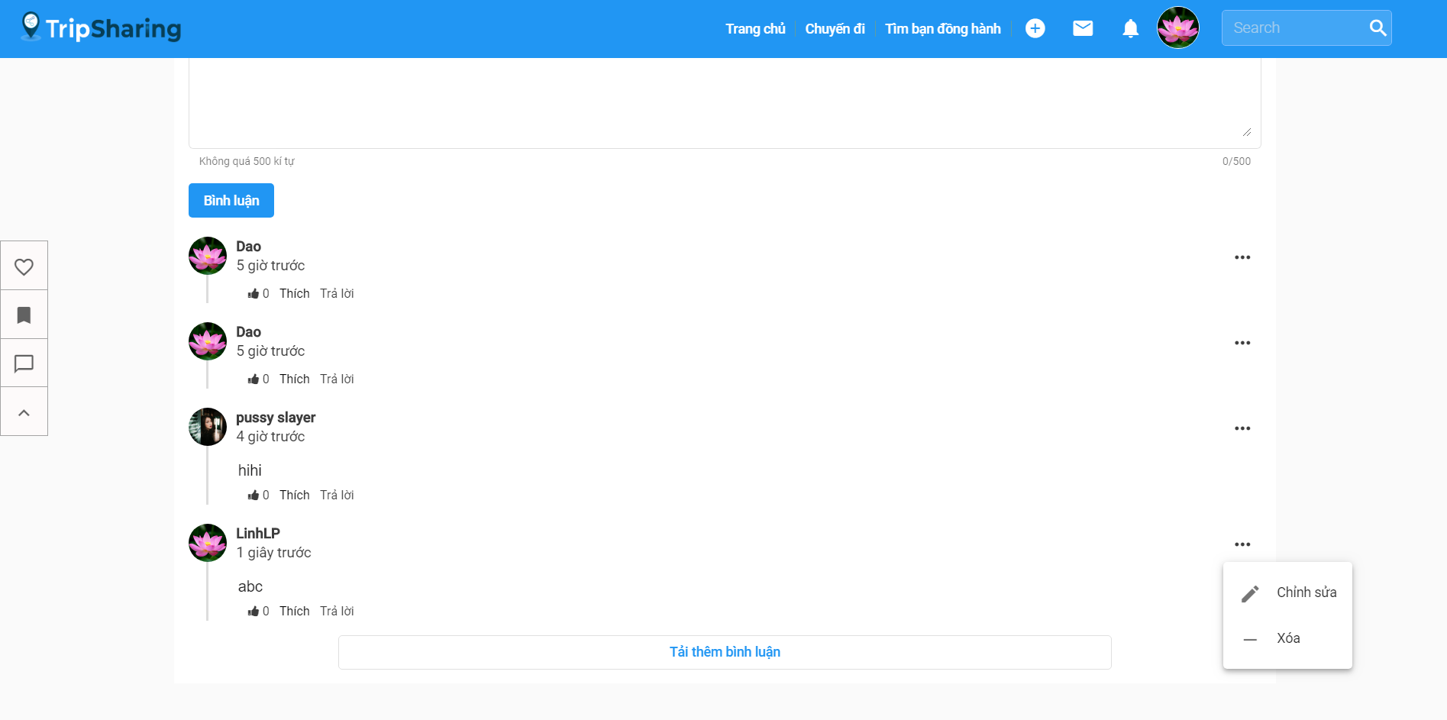

Figure 4-75: Delete A Comment Screen Design

**Class Diagram**

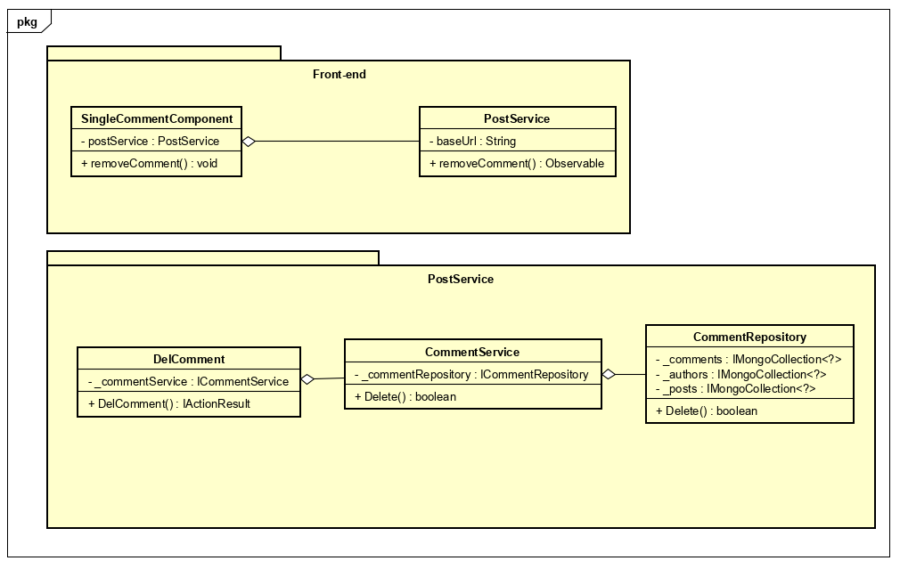

Figure 4-76: Delete A Comment Class Diagram

**Class Specification**

***SingleCommentComponent***

|  |  |  |  |  |
| --- | --- | --- | --- | --- |
| **SingleCommentComponent** | | | | |
| Physical address | src\app\shared\components\single-comment\  single-comment.component.spec.ts | | | |
| Base Class | Class | | | |
| **Attributes** | | | | |
| No | Name | Type | Description | |
| 1 | postService | PostService |  | |
| **Operations** | | | | |
| No | Name | Return Type | | Description |
| 1 | removeComment | void | |  |

***PostService***

|  |  |  |  |
| --- | --- | --- | --- |
| **PostService** | | | |
| Physical address | src\app\core\services\post-service\virtual-trip.service.ts | | |
| Base Class | Class | | |
| **Attributes** | | | |
| No | Name | Type | Description |
| 1 | baseUrl | String |  |
| **Operations** | | | |
| No | Name | Return Type | Description |
| 1 | removeComment | Observable |  |

***Comment***

|  |  |  |  |
| --- | --- | --- | --- |
| **CommentController** | | | |
| Physical address | src\Services\PostService\PostService\Controllers\CommentController.cs | | |
| Base Class | ControllerBase | | |
| **Attributes** | | | |
| No | Name | Type | Description |
| 1 | _commentService | ICommentService |  |
| **Operations** | | | |
| No | Name | Return Type | Description |
| 1 | DelComment | IActionResult |  |

***CommentService***

|  |  |  |  |
| --- | --- | --- | --- |
| **CommentService** | | | |
| Physical address | src\Services\PostService\PostService\Services\CommentService.cs | | |
| Base Class | ICommentService | | |
| **Attributes** | | | |
| No | Name | Type | Description |
| 1 | _commentRepository | ICommentRepository |  |
| **Operations** | | | |
| No | Name | Return Type | Description |
| 1 | Delete | Bool |  |

***CommentRepository***

|  |  |  |  |
| --- | --- | --- | --- |
| **CommentRepository** | | | |
| Physical address | src\Services\PostService\PostService \Reponsitories\CommentRepository.cs | | |
| Base Class | ICommentRepository | | |
| **Attributes** | | | |
| No | Name | Type | Description |
| 1 | _comments | IMongoCollection<?> |  |
| 2 | _posts | IMongoCollection<?> |  |
| 3 | _authors | IMongoCollection<?> |  |
| **Operations** | | | |
| No | Name | Return Type | Description |
| 1 | Delete | Bool |  |

**Sequence Diagram**

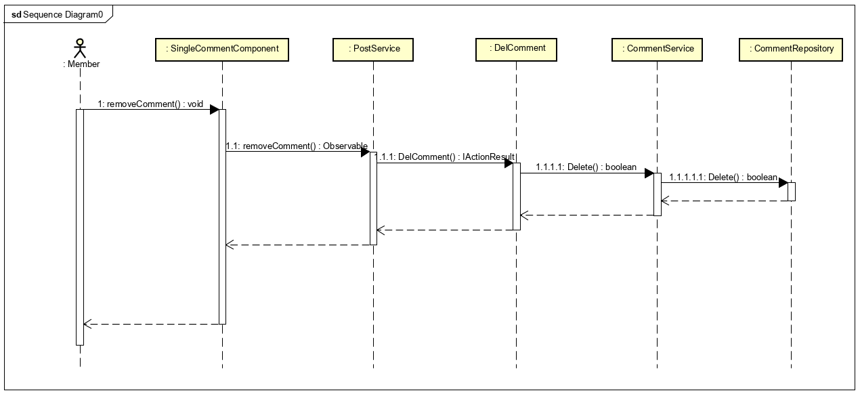

Figure 4-77: Delete A Comment Screen Design

**4.3.4.22 Like/Unlike a comment**

**Screen design**

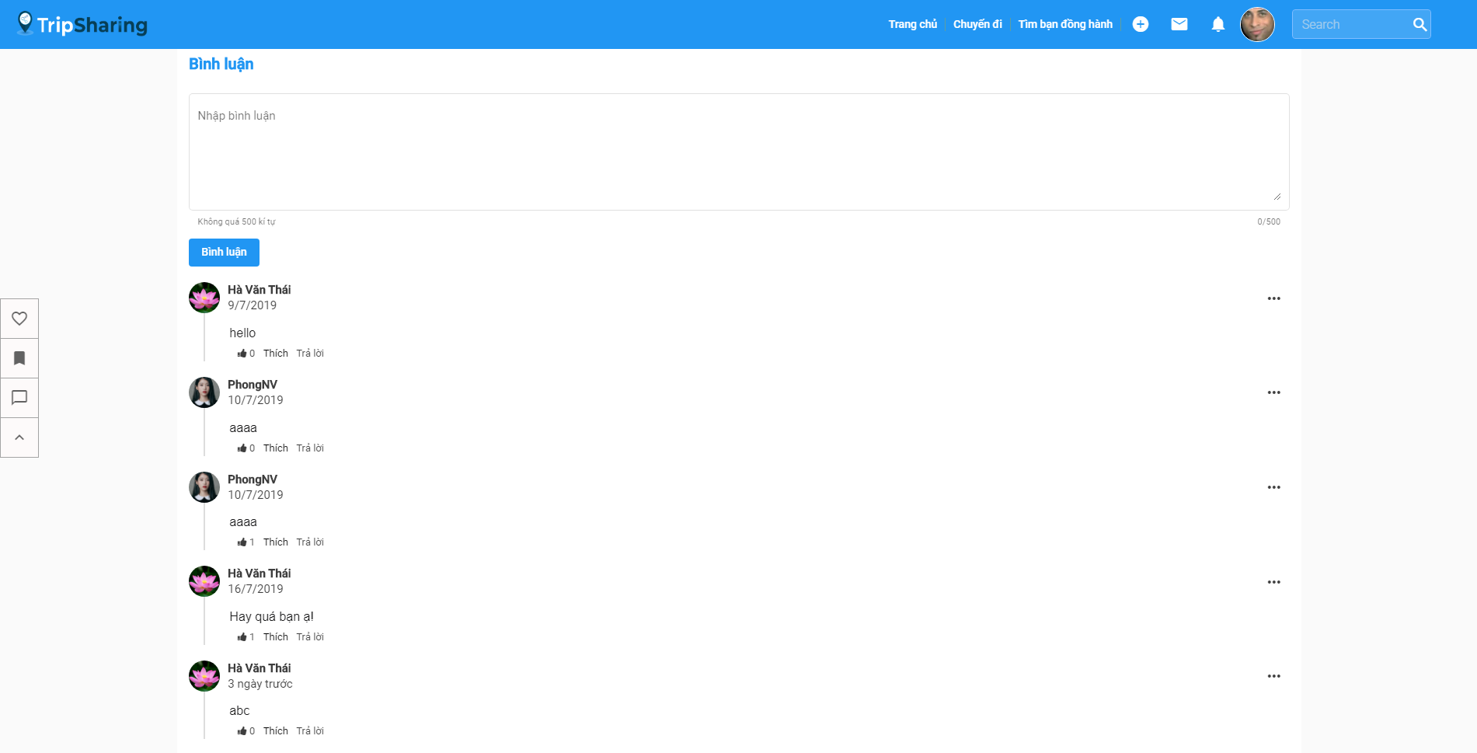

Figure 4-78: Like/Unlike a comment Screen Design

**Class Diagram**

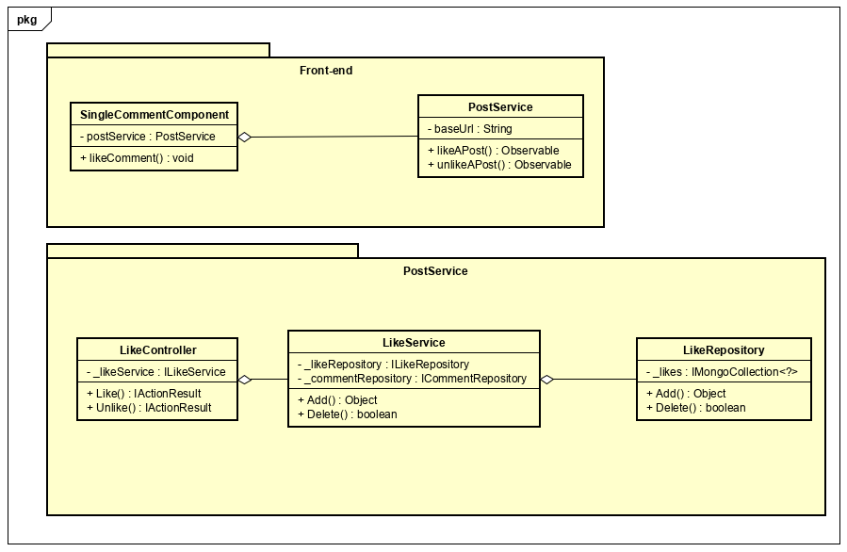

Figure 4-79: Like/Unlike a comment Class Diagram

**Class Specification**

***SingleCommentComponent***

|  |  |  |  |  |
| --- | --- | --- | --- | --- |
| **SingleCommentComponent** | | | | |
| Physical address | src\app\shared\components\single-comment\  single-comment.component.spec.ts | | | |
| Base Class | Class | | | |
| **Attributes** | | | | |
| No | Name | Type | Description | |
| 1 | postService | PostService |  | |
| **Operations** | | | | |
| No | Name | Return Type | | Description |
| 1 | likeComment | void | |  |

***PostService***

|  |  |  |  |
| --- | --- | --- | --- |
| **PostService** | | | |
| Physical address | src\app\core\services\post-service\virtual-trip.service.ts | | |
| Base Class | Class | | |
| **Attributes** | | | |
| No | Name | Type | Description |
| 1 | baseUrl | String |  |
| **Operations** | | | |
| No | Name | Return Type | Description |
| 1 | likeAPost | Observable |  |
| 2 | unlikeAPost | Observable |  |

***LikeController***

|  |  |  |  |
| --- | --- | --- | --- |
| **LikeController** | | | |
| Physical address | src\Services\PostService\PostService\Controllers\LikeController.cs | | |
| Base Class | ControllerBase | | |
| **Attributes** | | | |
| No | Name | Type | Description |
| 1 | _likeService | ILikeService |  |
| **Operations** | | | |
| No | Name | Return Type | Description |
| 1 | Like | IActionResult |  |
| 2 | Unlike | IActionResult |  |

***LikeService***

|  |  |  |  |
| --- | --- | --- | --- |
| **LikeService** | | | |
| Physical address | src\Services\PostService\PostService\Services\LikeService.cs | | |
| Base Class | ILikeService | | |
| **Attributes** | | | |
| No | Name | Type | Description |
| 1 | _likeRepository | ILikeRepository |  |
| 2 | _commentRepository | ICommentRepository |  |
| **Operations** | | | |
| No | Name | Return Type | Description |
| 1 | Add | Object |  |
| 2 | Delete | Bool |  |

***LikeRepository***

|  |  |  |  |
| --- | --- | --- | --- |
| **LikeRepository** | | | |
| Physical address | src\Services\PostService\PostService \Reponsitories\LikeRepository.cs | | |
| Base Class | ILikeRepository | | |
| **Attributes** | | | |
| No | Name | Type | Description |
| 1 | _likes | IMongoCollection<?> |  |
| **Operations** | | | |
| No | Name | Return Type | Description |
| 1 | Add | Object |  |
| 2 | Delete | Bool |  |

**Sequence Diagram**

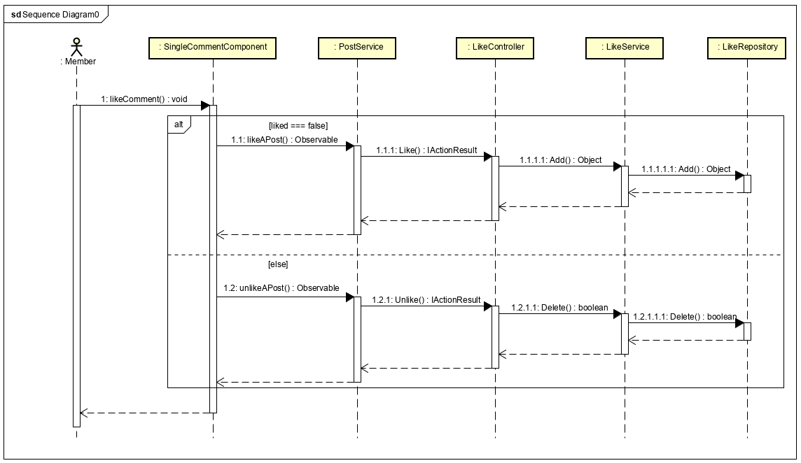

Figure 4-80: Like/Unlike a comment Sequence Diagram

**4.3.4.23 Report a comment**

**Screen design**

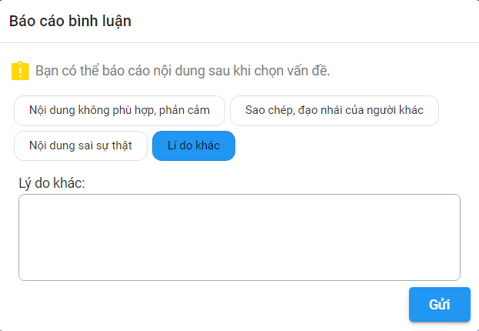

Figure 4-81: Report a comment Screen Design

**Class Diagram**

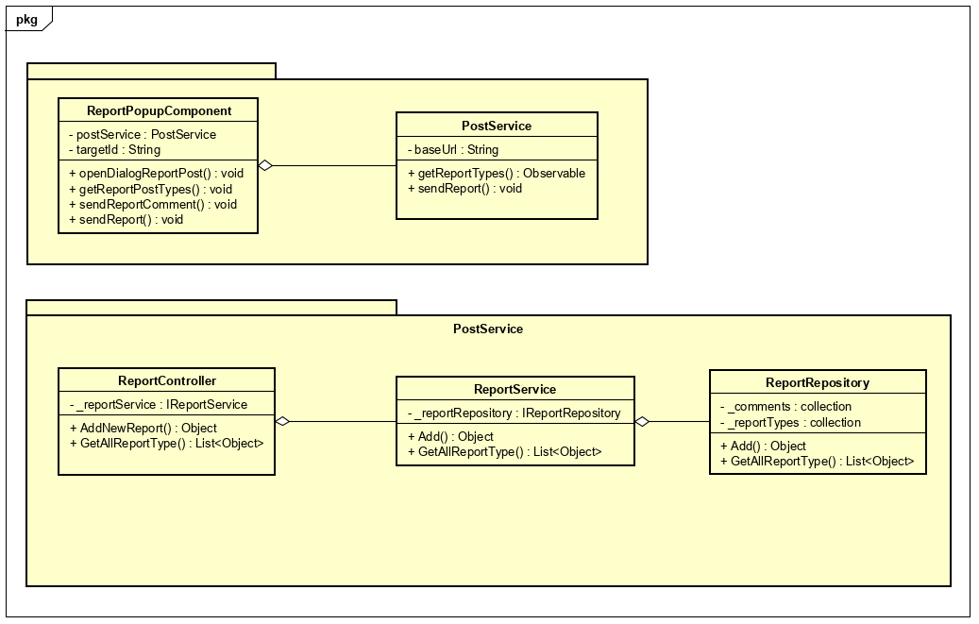

Figure 4-82: Report a comment Class Diagram

**Class Specification**

***ReportPopupComponent***

|  |  |  |  |  |
| --- | --- | --- | --- | --- |
| **ReportPopupComponent** | | | | |
| Physical address | src\app\shared\components\report-popup\ report-popup.component.ts | | | |
| Base Class | Class | | | |
| **Attributes** | | | | |
| No | Name | Type | Description | |
| 1 | postService | PostService |  | |
| 2 | targetId | String | Specify object id of reported comment | |
| **Operations** | | | | |
| No | Name | Return Type | | Description |
| 1 | openDialogReportPost | void | | Show the report dialog |
| 2 | getReportPostTypes | observable | | Get the report type from database |
| 13 | sendReportComment | void | | Send report with type = comment |
| 4 | sendReport | void | | Send report |

***PostService***

|  |  |  |  |
| --- | --- | --- | --- |
| **PostService** | | | |
| Physical address | src\app\core\services\post-service\virtual-trip.service.ts | | |
| Base Class | Class | | |
| **Attributes** | | | |
| No | Name | Type | Description |
| 1 | baseUrl | String |  |
| **Operations** | | | |
| No | Name | Return Type | Description |
| 1 | sendReport | observable |  |
| 2 | getReportTypes | observable |  |

***ReportController***

|  |  |  |  |
| --- | --- | --- | --- |
| **ReportController** | | | |
| Physical address | src\Services\PostService\PostService\Controllers\ReportController.cs | | |
| Base Class | ControllerBase | | |
| **Attributes** | | | |
| No | Name | Type | Description |
| 1 | _reportService | IReportService |  |
| **Operations** | | | |
| No | Name | Return Type | Description |
| 1 | AddNewReport | object |  |
| 2 | GetAllReportType | List<object> |  |

***ReportService***

|  |  |  |  |
| --- | --- | --- | --- |
| **ReportService** | | | |
| Physical address | src\Services\PostService\PostService\Services\ReportService.cs | | |
| Base Class | IReportService | | |
| **Attributes** | | | |
| No | Name | Type | Description |
| 1 | _reportRepository | IReportRepository |  |
| **Operations** | | | |
| No | Name | Return Type | Description |
| 1 | Add | Object |  |
| 2 | GetAllReportType | List<Object> |  |

***ReportRepository***

|  |  |  |  |
| --- | --- | --- | --- |
| **ReportRepository** | | | |
| Physical address | src\Services\PostService\PostService\Reponsitories\ReportRepository.cs | | |
| Base Class | IReportRepository | | |
| **Attributes** | | | |
| No | Name | Type | Description |
| 1 | _comments |  |  |
| 2 | _reportTypes |  |  |
| **Operations** | | | |
| No | Name | Return Type | Description |
| 1 | Add | Object |  |
| 2 | GetAllReportType | List<Object> |  |

**Sequence Diagram**

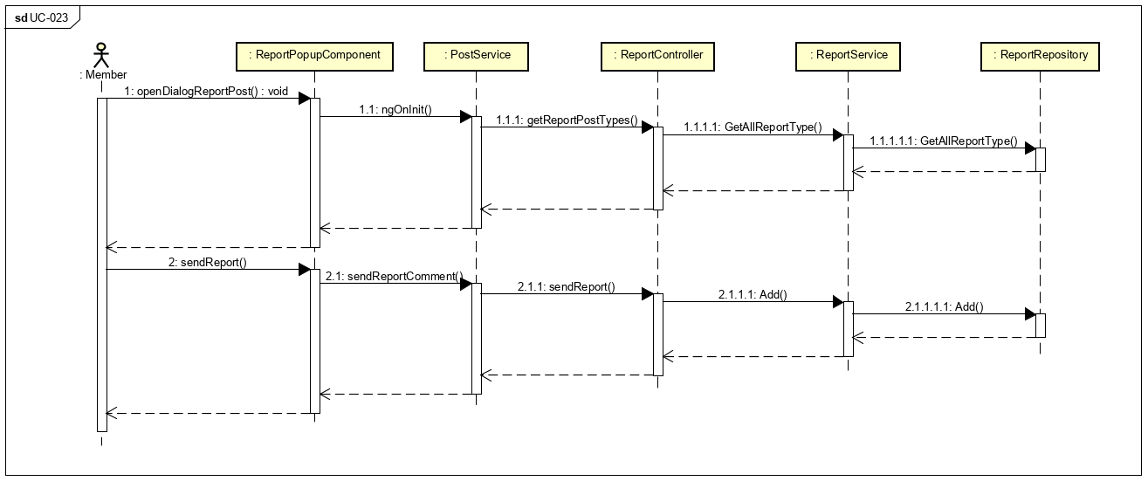

Figure 4-83: Report a comment Sequence Diagram

**4.3.4.24** **Follow a User**

**Screen design**

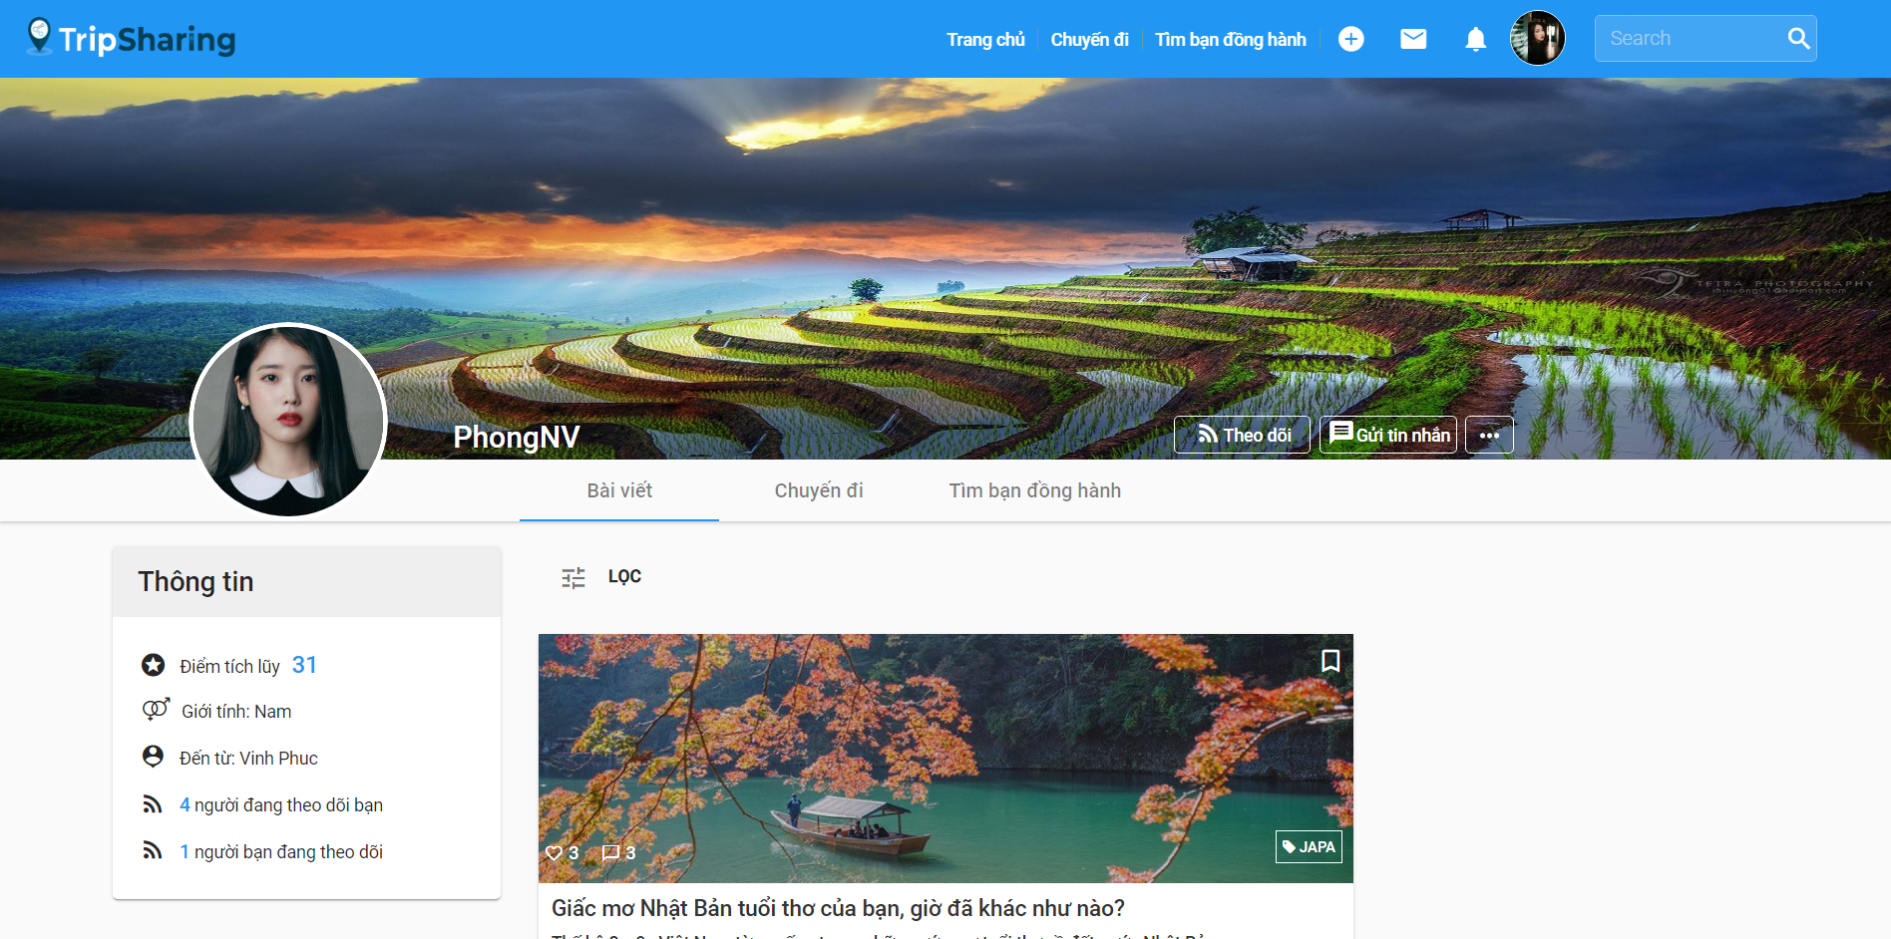

Figure 4-84: Follow a User Screen Design

**Class Diagram**

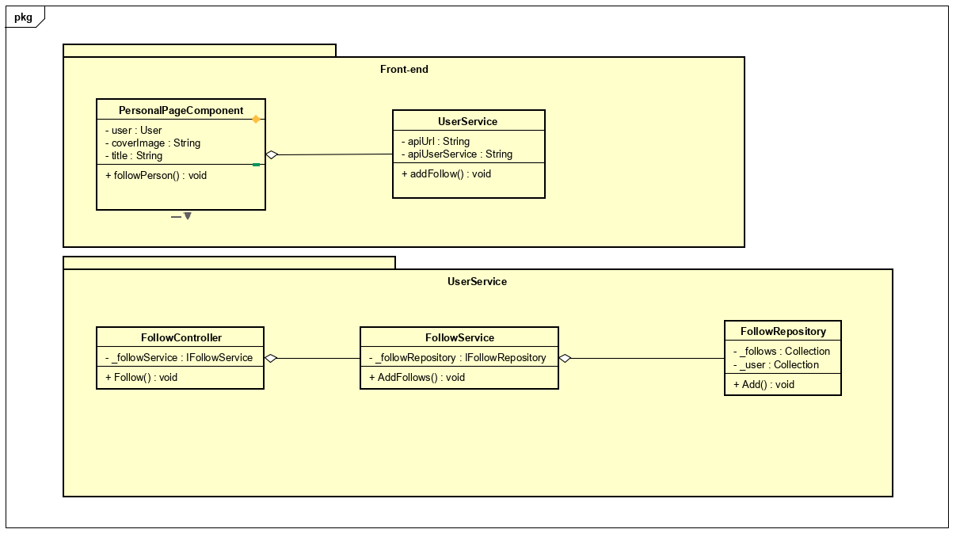

Figure 4-85: Follow a User Class Diagram

**Class Specification**

***PersonalPageComponent***

|  |  |  |  |  |
| --- | --- | --- | --- | --- |
| **PersonalPageComponent** | | | | |
| Physical address | src\app\pages\personal-page\personal-page.component.ts | | | |
| Base Class | Class | | | |
| **Attributes** | | | | |
| No | Name | Type | Description | |
| 1 | user | User |  | |
| 2 | coverImage | String |  | |
| 3 | title | string |  | |
| **Operations** | | | | |
| No | Name | Return Type | | Description |
| 1 | followPerson | void | |  |

***UserService***

|  |  |  |  |
| --- | --- | --- | --- |
| **UserService** | | | |
| Physical address | src\app\core\services\user-service\user.service.ts | | |
| Base Class | Class | | |
| **Attributes** | | | |
| No | Name | Type | Description |
| 1 | apiUrl | String |  |
| 2 | apiUserService | String |  |
| **Operations** | | | |
| No | Name | Return Type | Description |
| 1 | addFollow | observable |  |

***FollowController***

|  |  |  |  |
| --- | --- | --- | --- |
| **FollowController** | | | |
| Physical address | src\Services\UserService\UserService\Controllers\FollowController.cs | | |
| Base Class | ControllerBase | | |
| **Attributes** | | | |
| No | Name | Type | Description |
| 1 | _followService | IFollowService |  |
| **Operations** | | | |
| No | Name | Return Type | Description |
| 1 | Follow | object |  |

***FollowService***

|  |  |  |  |
| --- | --- | --- | --- |
| **FollowService** | | | |
| Physical address | src\Services\UserService\UserService\Services\FollowService.cs | | |
| Base Class | IFollowService | | |
| **Attributes** | | | |
| No | Name | Type | Description |
| 1 | _followRepository | IFollowRepository |  |
| **Operations** | | | |
| No | Name | Return Type | Description |
| 1 | AddFollows | Object |  |

***FollowRepository***

|  |  |  |  |
| --- | --- | --- | --- |
| **FollwRepository** | | | |
| Physical address | src\Services\UserService\UserService\Reponsitories\ReportRepository.cs | | |
| Base Class | IFollowRepository | | |
| **Attributes** | | | |
| No | Name | Type | Description |
| 1 | _follows | Collection |  |
| 2 | _user | Collection |  |
| **Operations** | | | |
| No | Name | Return Type | Description |
| 1 | Add | Object |  |

**Sequence Diagram**

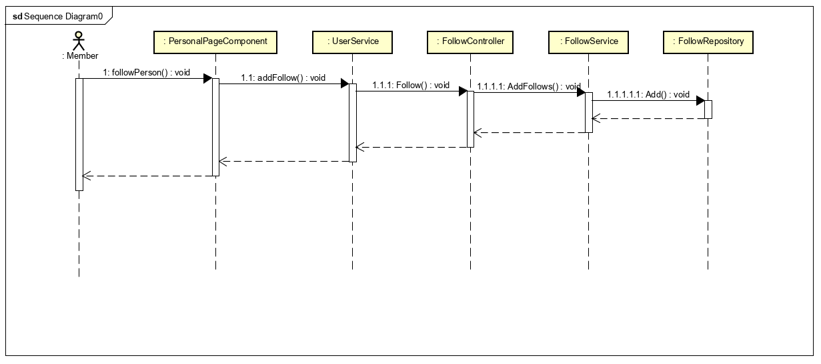Figure 4-86: Follow a User Sequence Diagram

**4.3.4.25 Unfollow a user**

**Screen design**

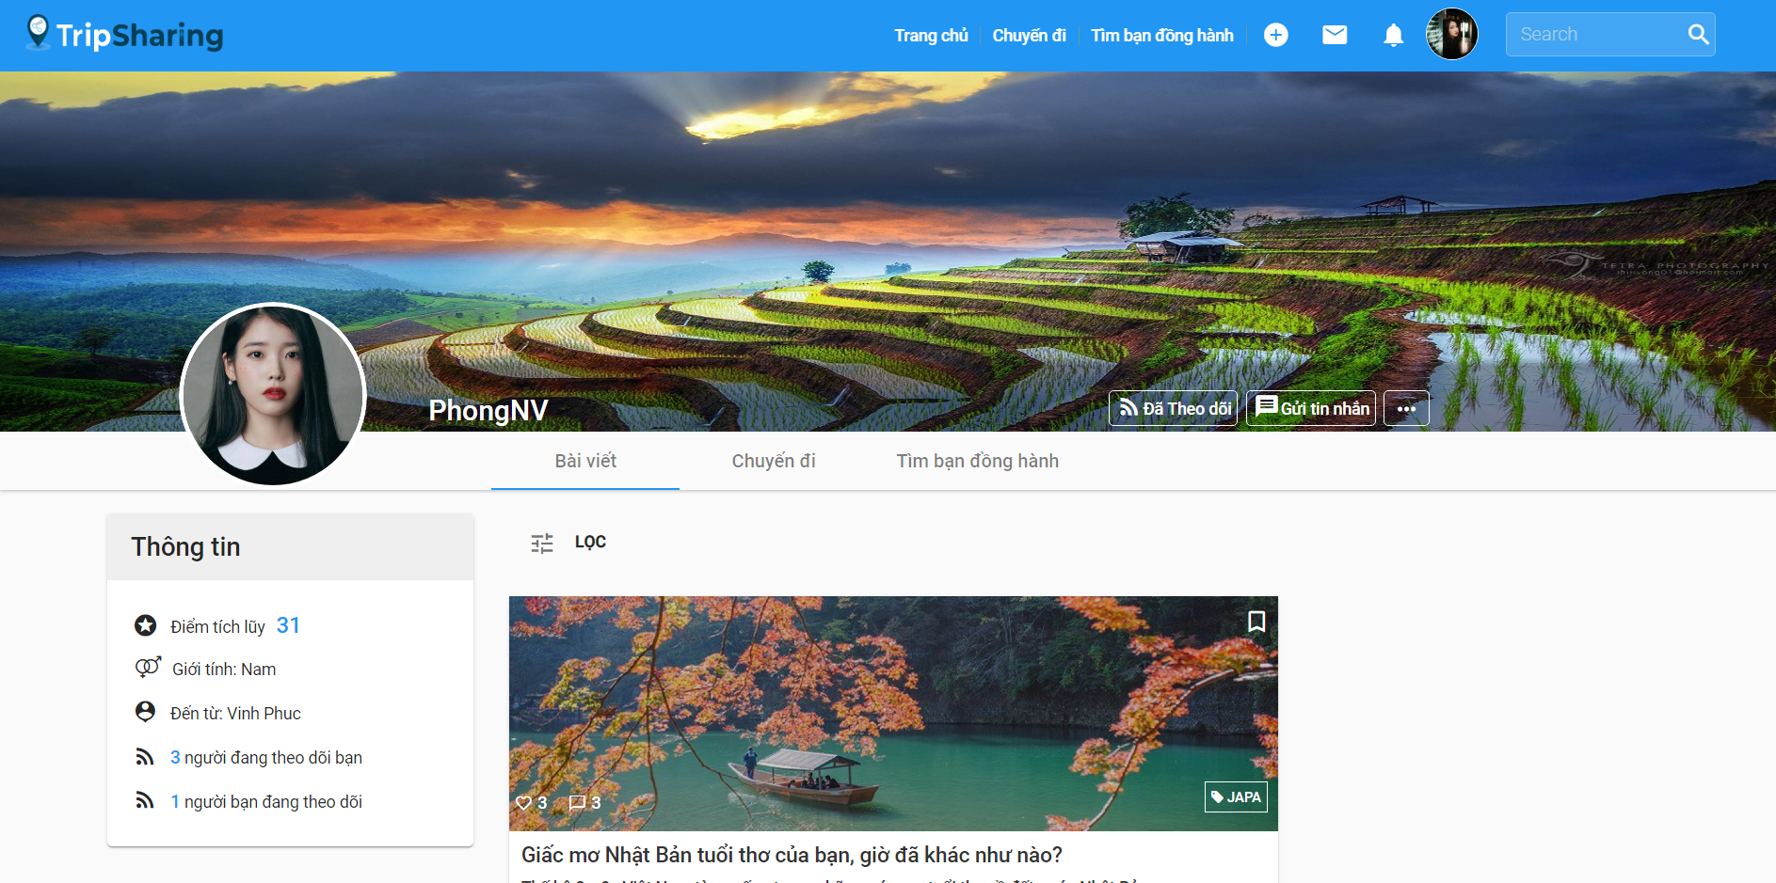 Figure 4-83: Unfollow a user Screen Design

**Class Diagram**

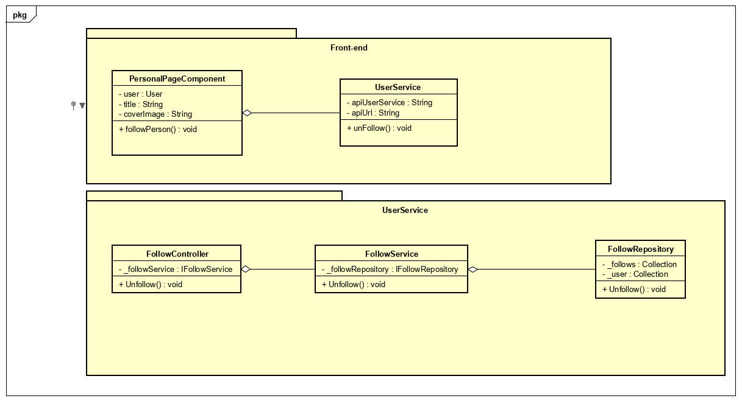

Figure 4-84: Unfollow a user Class Diagram

**Class Specification**

***PersonalPageComponent***

|  |  |  |  |  |
| --- | --- | --- | --- | --- |
| **PersonalPageComponent** | | | | |
| Physical address | src\app\pages\personal-page\personal-page.component.ts | | | |
| Base Class | Class | | | |
| **Attributes** | | | | |
| No | Name | Type | Description | |
| 1 | user | User |  | |
| 2 | coverImage | String |  | |
| 3 | title | string |  | |
| **Operations** | | | | |
| No | Name | Return Type | | Description |
| 1 | followPerson | void | |  |

***UserService***

|  |  |  |  |
| --- | --- | --- | --- |
| **UserService** | | | |
| Physical address | src\app\core\services\user-service\user.service.ts | | |
| Base Class | Class | | |
| **Attributes** | | | |
| No | Name | Type | Description |
| 1 | apiUrl | String |  |
| 2 | apiUserService | String |  |
| **Operations** | | | |
| No | Name | Return Type | Description |
| 1 | unFollow | Void |  |

***FollowController***

|  |  |  |  |
| --- | --- | --- | --- |
| **FollowController** | | | |
| Physical address | src\Services\UserService\UserService\Controllers\FollowController.cs | | |
| Base Class | ControllerBase | | |
| **Attributes** | | | |
| No | Name | Type | Description |
| 1 | _followService | IFollowService |  |
| **Operations** | | | |
| No | Name | Return Type | Description |
| 1 | UnFollow | void |  |

***FollowService***

|  |  |  |  |
| --- | --- | --- | --- |
| **FollowService** | | | |
| Physical address | src\Services\UserService\UserService\Services\FollowService.cs | | |
| Base Class | IFollowService | | |
| **Attributes** | | | |
| No | Name | Type | Description |
| 1 | _followRepository | IFollowRepository |  |
| **Operations** | | | |
| No | Name | Return Type | Description |
| 1 | UnFollow | Void |  |

***FollowRepository***

|  |  |  |  |
| --- | --- | --- | --- |
| **FollwRepository** | | | |
| Physical address | src\Services\UserService\UserService\Reponsitories\ReportRepository.cs | | |
| Base Class | IFollowRepository | | |
| **Attributes** | | | |
| No | Name | Type | Description |
| 1 | _follows | Collection |  |
| 2 | _user | Collection |  |
| **Operations** | | | |
| No | Name | Return Type | Description |
| 1 | UnFollow | Void |  |

**Sequence Diagram**

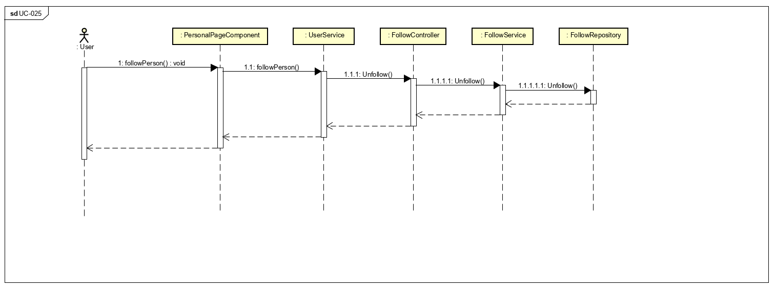

Figure 4-85: Unfollow a user Sequence Diagram

**4.3.4.26 Report a user**

**Screen design**

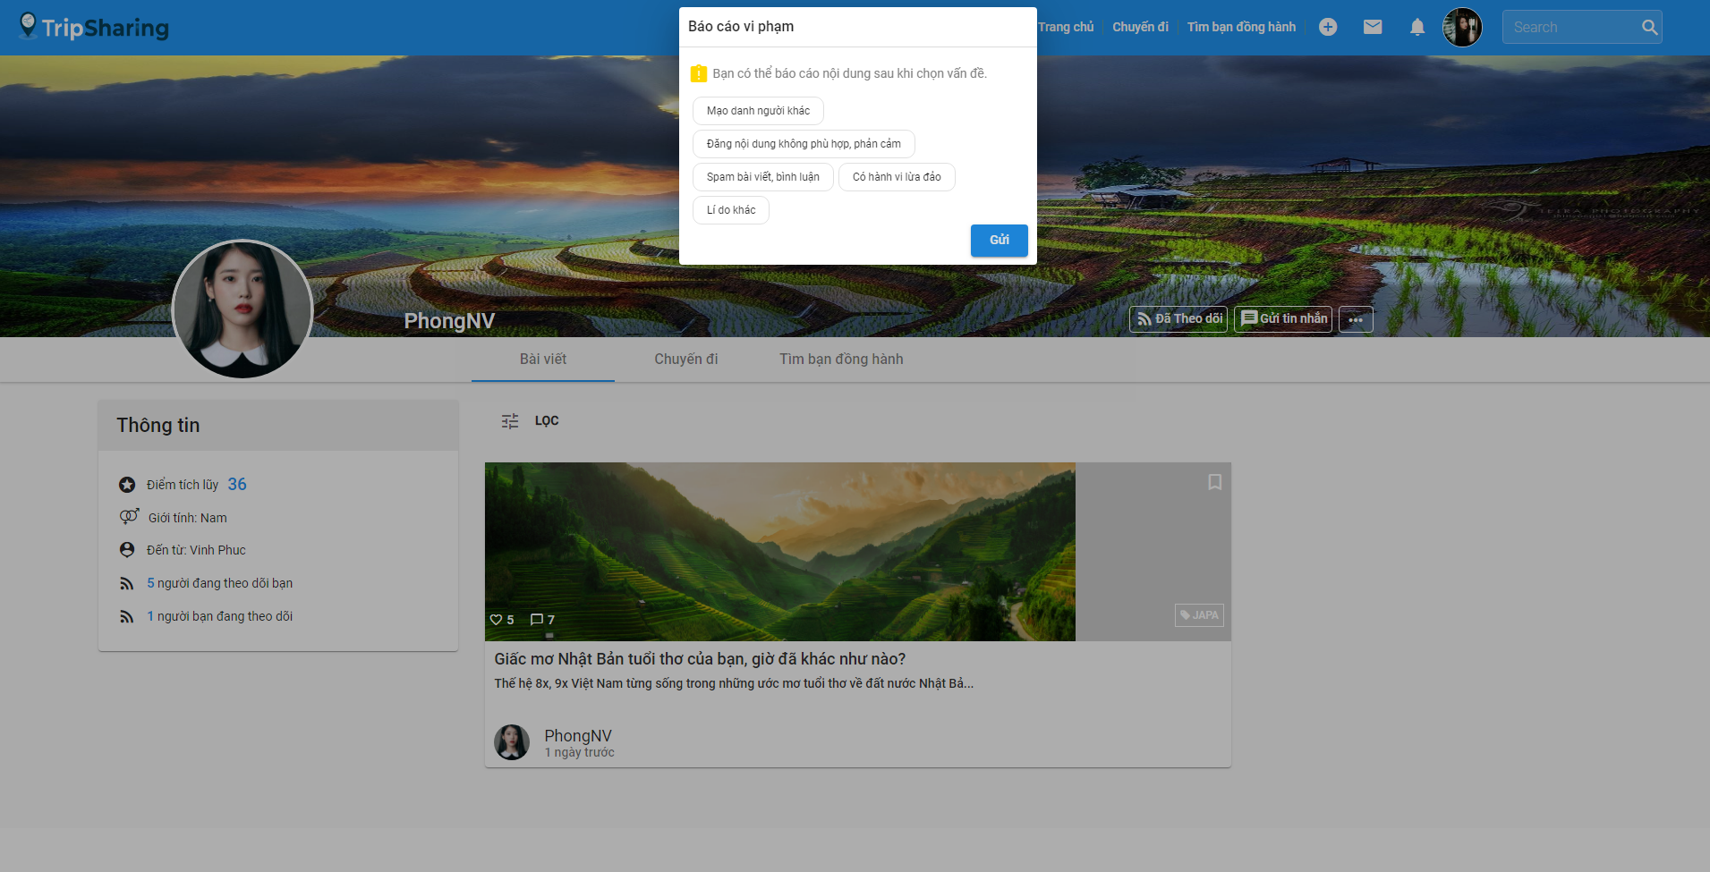

Figure 4-86: Report a user Screen Design

**Class Diagram**

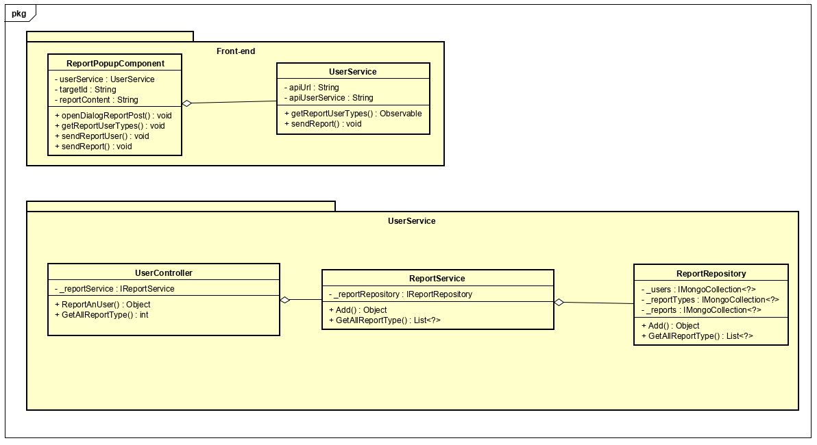 Figure 4-87: Report a user Class Diagram

**Class Specification**

***ReportPopupComponent***

|  |  |  |  |  |
| --- | --- | --- | --- | --- |
| **ReportPopupComponent** | | | | |
| Physical address | src\app\shared\components\report-popup\report-popup.component.ts | | | |
| Base Class | Class | | | |
| **Attributes** | | | | |
| No | Name | Type | Description | |
| 1 | userService | UserService |  | |
| 2 | targetId | String |  | |
| 3 | reportContent | String |  | |
| **Operations** | | | | |
| No | Name | Return Type | | Description |
| 1 | openDialogReportPost | Void | |  |
| 2 | getReportUserTypes | Void | |  |
| 3 | sendReportUser | Void | |  |
| 4 | sendReport | Void | |  |

***UserService***

|  |  |  |  |
| --- | --- | --- | --- |
| **UserService** | | | |
| Physical address | src\app\core\services\user-service\user.service.ts | | |
| Base Class | Class | | |
| **Attributes** | | | |
| No | Name | Type | Description |
| 1 | apiUrl | String |  |
| 2 | apiUserService | String |  |
| **Operations** | | | |
| No | Name | Return Type | Description |
| 1 | getReportUserTypes | Observable |  |
| 2 | sendReport | Void |  |

***UserController***

|  |  |  |  |
| --- | --- | --- | --- |
| **UserController** | | | |
| Physical address | src\Services\UserService\UserService\Controllers\UserController.cs | | |
| Base Class | ControllerBase | | |
| **Attributes** | | | |
| No | Name | Type | Description |
| 1 | _reportService | IReportService |  |
| **Operations** | | | |
| No | Name | Return Type | Description |
| 1 | Add | Object |  |

***ReportService***

|  |  |  |  |
| --- | --- | --- | --- |
| **ReportService** | | | |
| Physical address | src\Services\UserService\UserService\Services\ReportService.cs | | |
| Base Class | IReportService | | |
| **Attributes** | | | |
| No | Name | Type | Description |
| 1 | _reportRepository | IReportRepository |  |
| **Operations** | | | |
| No | Name | Return Type | Description |
| 1 | Add | Object |  |
| 2 | GetAllReportType | List<?> |  |

***ReportRepository***

|  |  |  |  |
| --- | --- | --- | --- |
| **ReportRepository** | | | |
| Physical address | src\Services\UserService\UserService\Reponsitories\ReportRepository.cs | | |
| Base Class | IReportRepository | | |
| **Attributes** | | | |
| No | Name | Type | Description |
| 1 | _ reportTypes | IMongoCollection<?> |  |
| 2 | _users | IMongoCollection<?> |  |
| 3 | _ reports | IMongoCollection<?> |  |
| **Operations** | | | |
| No | Name | Return Type | Description |
| 1 | Add | Object |  |
| 2 | GetAllReportType | List<?> |  |

**Sequence Diagram**

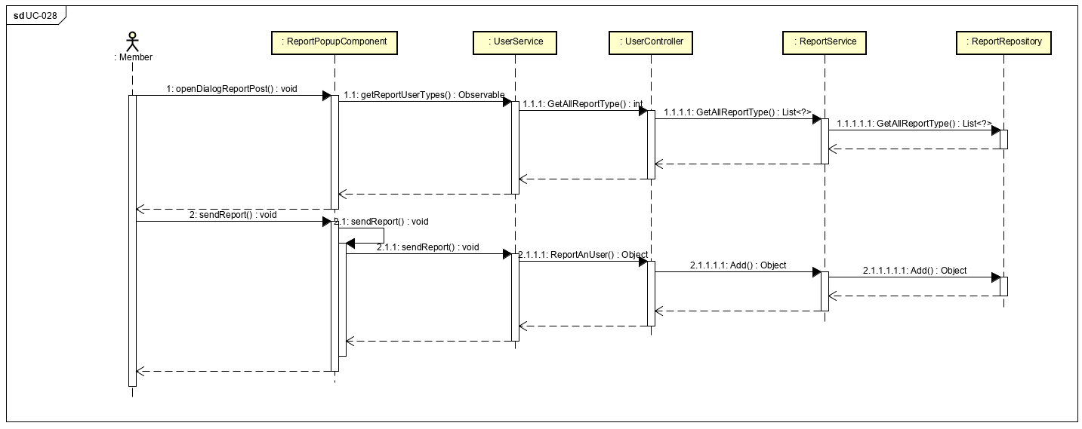

Figure 4-88: Report a user Sequence Diagram

**4.3.4.27 Join to a companion group**

**Screen design**

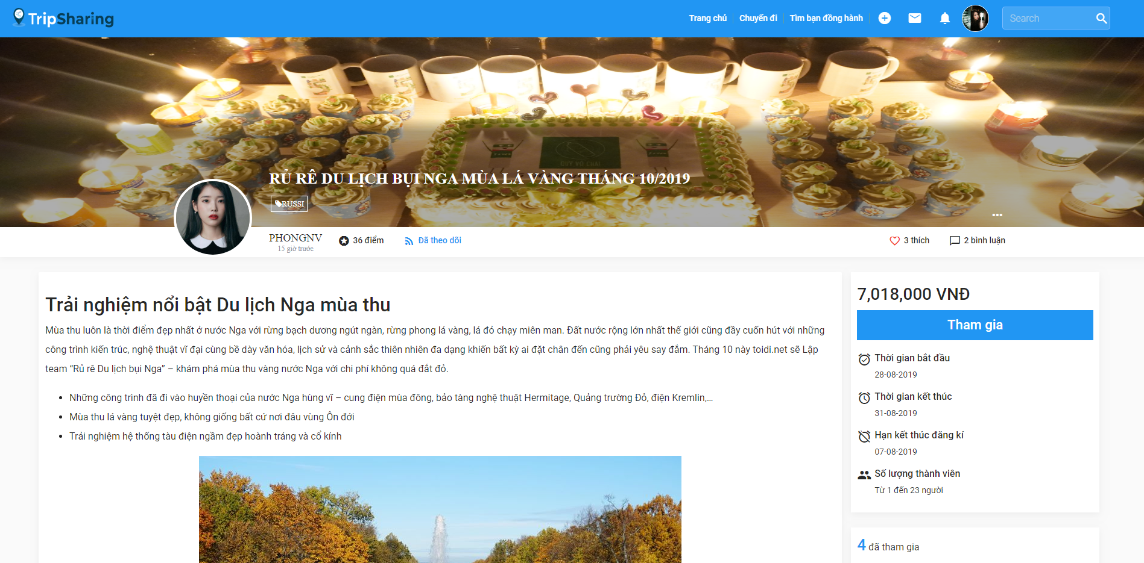

Figure 4-89: Join to a companion group Screen Design

**Class Diagram**

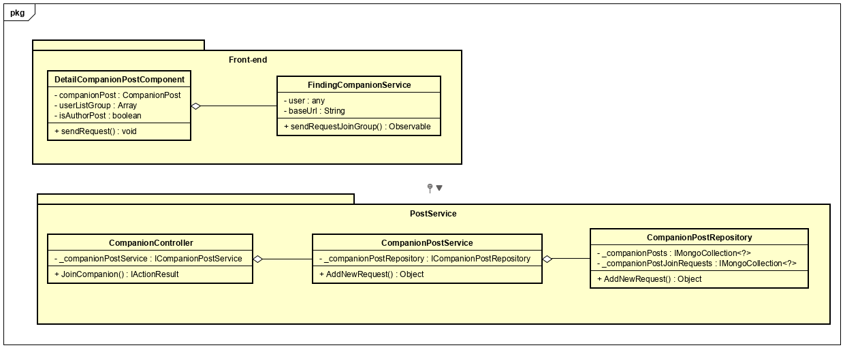

Figure 4-90: Join to a companion group Class Diagram

**Class Specification**

***DetailCompanionPostComponent***

|  |  |  |  |  |
| --- | --- | --- | --- | --- |
| **DetailCompanionPostComponent** | | | | |
| Physical address | src\app\shared\components\detail-companion-post\detail-companion-post.component.ts | | | |
| Base Class | Class | | | |
| **Attributes** | | | | |
| No | Name | Type | Description | |
| 1 | companionPost | CompanionPost |  | |
| 2 | userListGroup | Array |  | |
| 3 | isAuthorPost | boolean |  | |
| **Operations** | | | | |
| No | Name | Return Type | | Description |
| 1 | sendRequest | Void | |  |

***FindingCompanionService***

|  |  |  |  |
| --- | --- | --- | --- |
| **FindingCompanionService** | | | |
| Physical address | src\app\core\services\post-service\finding-companion.service.ts | | |
| Base Class | Class | | |
| **Attributes** | | | |
| No | Name | Type | Description |
| 1 | apiUrl | String |  |
| 2 | apiUserService | String |  |
| **Operations** | | | |
| No | Name | Return Type | Description |
| 1 | getReportUserTypes | Observable |  |
| 2 | sendReport | Void |  |

***CompanionController***

|  |  |  |  |
| --- | --- | --- | --- |
| **CompanionController** | | | |
| Physical address | src\Services\PostService\PostService\Controllers\CompanionController.cs | | |
| Base Class | ControllerBase | | |
| **Attributes** | | | |
| No | Name | Type | Description |
| 1 | _companionPostService | ICompanionPostService |  |
| **Operations** | | | |
| No | Name | Return Type | Description |
| 1 | JoinCompanion | IActionResult |  |

***CompanionPostService***

|  |  |  |  |
| --- | --- | --- | --- |
| **CompanionPostService** | | | |
| Physical address | src\Services\PostService\PostService\Services\CompanionPostService.cs | | |
| Base Class | ICompanionPostService | | |
| **Attributes** | | | |
| No | Name | Type | Description |
| 1 | _companionPostRepository | ICompanionPostRepository |  |
| **Operations** | | | |
| No | Name | Return Type | Description |
| 1 | AddNewRequest | Object |  |

***CompanionPostRepository***

|  |  |  |  |
| --- | --- | --- | --- |
| **ReportRepository** | | | |
| Physical address | src\Services\PostService\PostService\Repositories\CompanionPostRepository.cs | | |
| Base Class | ICompanionPostRepository | | |
| **Attributes** | | | |
| No | Name | Type | Description |
| 1 | _companionPostJoinRequests | IMongoCollection<?> |  |
| **Operations** | | | |
| No | Name | Return Type | Description |
| 1 | AddNewRequest | Object |  |

**Sequence Diagram**

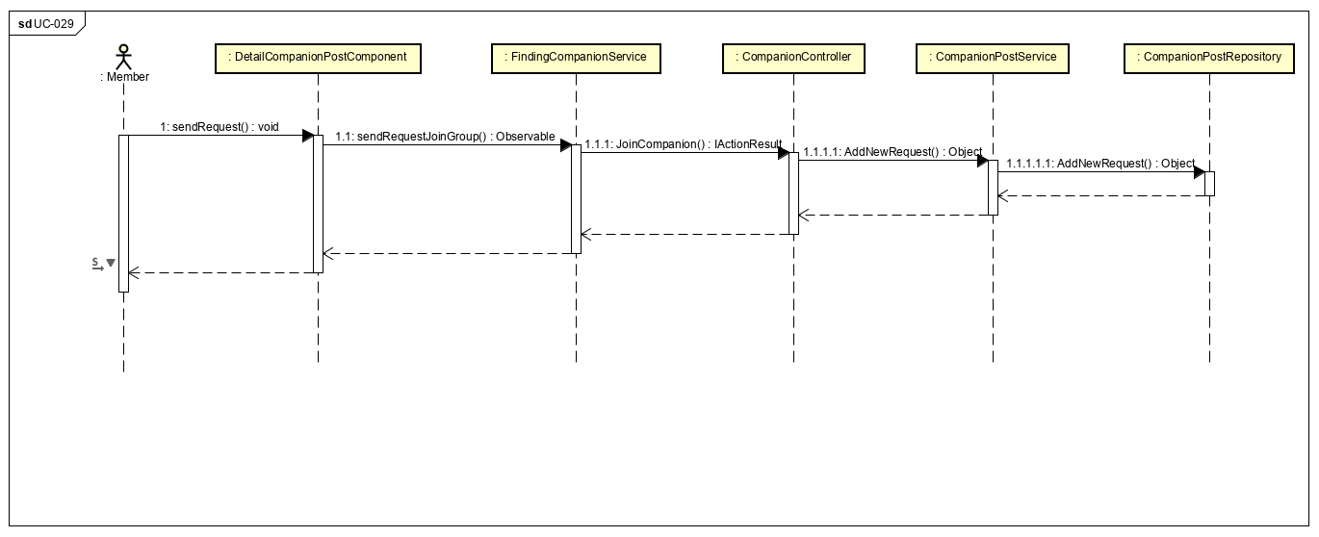

Figure 4-91: Join to a companion group Sequence Diagram

**4.3.4.28 Leave a companion group**

**Screen design**

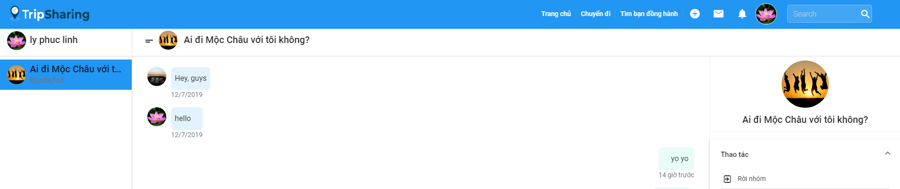

Figure 4-92: Leave a companion group Screen Design

**Class Diagram**

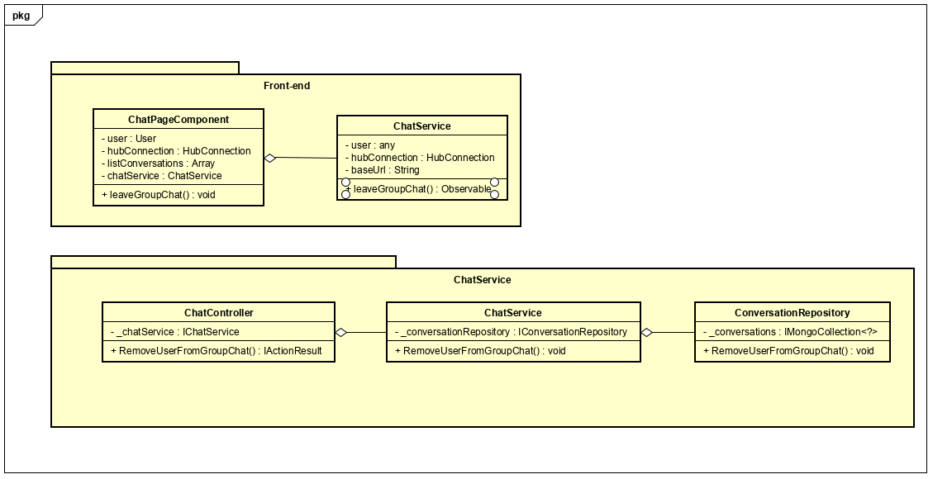

Figure 4-93: Leave a companion group Class Diagram

**Class Specification**

***ChatPageComponent***

|  |  |  |  |  |
| --- | --- | --- | --- | --- |
| **ChatPageComponent** | | | | |
| Physical address | src\app\pages\chat-page\chat-page.component.ts | | | |
| Base Class | Class | | | |
| **Attributes** | | | | |
| No | Name | Type | Description | |
| 1 | user | User |  | |
| 2 | hubConnection | HubConnection |  | |
| 3 | listConversation | Array |  | |
| 4 | chatService | ChatService |  | |
| **Operations** | | | | |
| No | Name | Return Type | | Description |
| 1 | leaveGroupChat | Void | |  |

***ChatService***

|  |  |  |  |
| --- | --- | --- | --- |
| **ChatService** | | | |
| Physical address | src\app\core\services\chat-service\chat.service.ts | | |
| Base Class | Class | | |
| **Attributes** | | | |
| No | Name | Type | Description |
| 1 | user | Any |  |
| 2 | hubConnection | HubConnection |  |
| 3 | baseUrl | String |  |
| **Operations** | | | |
| No | Name | Return Type | Description |
| 1 | leaveGroupChat | Observable |  |

***ChatController***

|  |  |  |  |
| --- | --- | --- | --- |
| **ChatController** | | | |
| Physical address | src\Services\ChatService\ChatService\Controllers\ChatController.cs | | |
| Base Class | ControllerBase | | |
| **Attributes** | | | |
| No | Name | Type | Description |
| 1 | _chatService | IChatService |  |
| **Operations** | | | |
| No | Name | Return Type | Description |
| 1 | RemoveUserFromGroupChat | IActionResult |  |

***ChatService***

|  |  |  |  |
| --- | --- | --- | --- |
| **ChatService** | | | |
| Physical address | src\Services\PostService\PostService\Services\CompanionPostService.cs | | |
| Base Class | IChatService | | |
| **Attributes** | | | |
| No | Name | Type | Description |
| 1 | _conversationRepository | IConversationRepository |  |
| **Operations** | | | |
| No | Name | Return Type | Description |
| 1 | RemoveUserFromGroupChat | Bool |  |

***ConversationRepository***

|  |  |  |  |
| --- | --- | --- | --- |
| **ConversationRepository** | | | |
| Physical address | src\Services\ChatService\ChatService\Repositories\ConversationRepository.cs | | |
| Base Class | IConversationRepository | | |
| **Attributes** | | | |
| No | Name | Type | Description |
| 1 | _conversations | IMongoCollection<?> |  |
| **Operations** | | | |
| No | Name | Return Type | Description |
| 1 | RemoveUserFromGroupChat | Bool |  |

**Sequence Diagram**

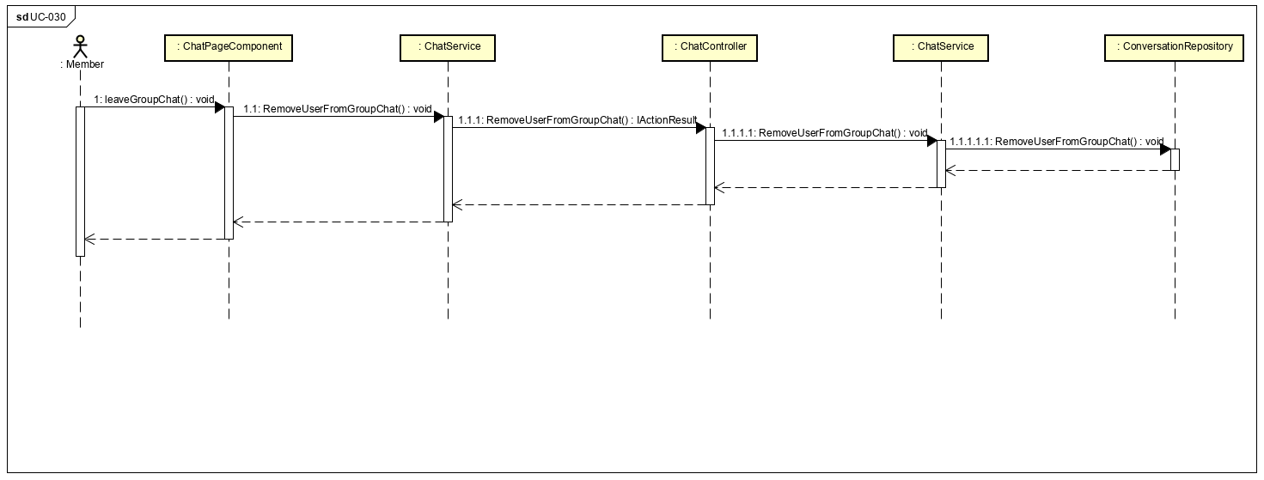

Figure 4-94: Leave a companion group Sequence Diagram

**4.3.4.29 Remove a member**

**Screen design**

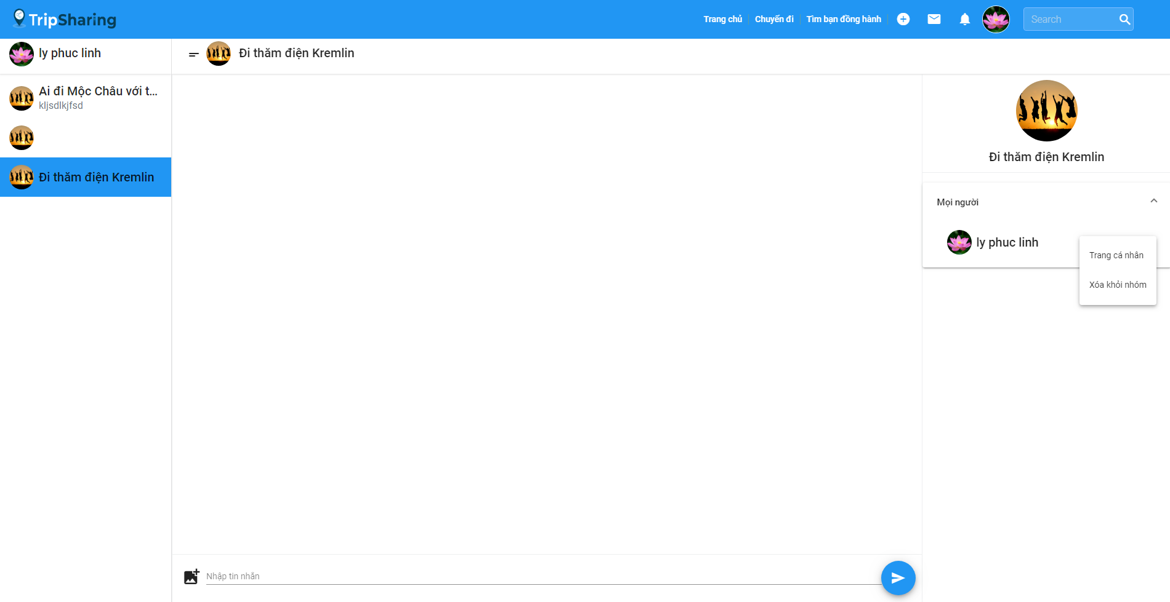

Figure 4-95: Remove a member Screen Design

**Class Diagram**

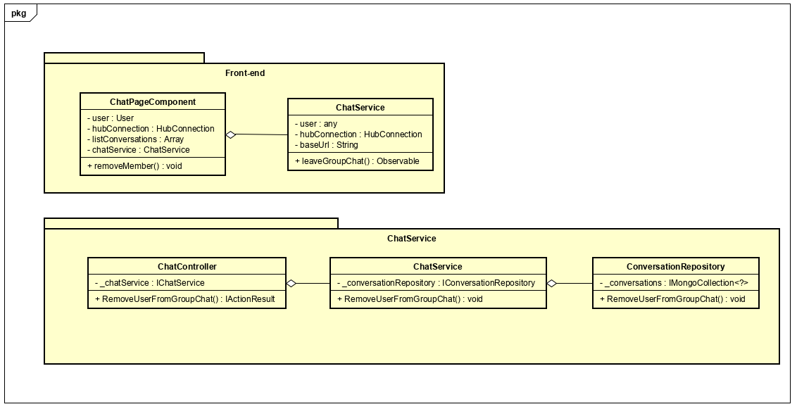

Figure 4-96: Remove a member Class Diagram

**Class Specification**

***ChatPageComponent***

|  |  |  |  |  |
| --- | --- | --- | --- | --- |
| **ChatPageComponent** | | | | |
| Physical address | src\app\pages\chat-page\chat-page.component.ts | | | |
| Base Class | Class | | | |
| **Attributes** | | | | |
| No | Name | Type | Description | |
| 1 | user | User |  | |
| 2 | hubConnection | HubConnection |  | |
| 3 | listConversation | Array |  | |
| 4 | chatService | ChatService |  | |
| **Operations** | | | | |
| No | Name | Return Type | | Description |
| 1 | removeMember | Void | |  |

***ChatService***

|  |  |  |  |
| --- | --- | --- | --- |
| **ChatService** | | | |
| Physical address | src\app\core\services\chat-service\chat.service.ts | | |
| Base Class | Class | | |
| **Attributes** | | | |
| No | Name | Type | Description |
| 1 | user | Any |  |
| 2 | hubConnection | HubConnection |  |
| 3 | baseUrl | String |  |
| **Operations** | | | |
| No | Name | Return Type | Description |
| 1 | leaveGroupChat | Observable |  |

***ChatController***

|  |  |  |  |
| --- | --- | --- | --- |
| **ChatController** | | | |
| Physical address | src\Services\ChatService\ChatService\Controllers\ChatController.cs | | |
| Base Class | ControllerBase | | |
| **Attributes** | | | |
| No | Name | Type | Description |
| 1 | _chatService | IChatService |  |
| **Operations** | | | |
| No | Name | Return Type | Description |
| 1 | RemoveUserFromGroupChat | IActionResult |  |

***ChatService***

|  |  |  |  |
| --- | --- | --- | --- |
| **ChatService** | | | |
| Physical address | src\Services\PostService\PostService\Services\CompanionPostService.cs | | |
| Base Class | IChatService | | |
| **Attributes** | | | |
| No | Name | Type | Description |
| 1 | _conversationRepository | IConversationRepository |  |
| **Operations** | | | |
| No | Name | Return Type | Description |
| 1 | RemoveUserFromGroupChat | Bool |  |

***ConversationRepository***

|  |  |  |  |
| --- | --- | --- | --- |
| **ConversationRepository** | | | |
| Physical address | src\Services\ChatService\ChatService\Repositories\ConversationRepository.cs | | |
| Base Class | IConversationRepository | | |
| **Attributes** | | | |
| No | Name | Type | Description |
| 1 | _conversations | IMongoCollection<?> |  |
| **Operations** | | | |
| No | Name | Return Type | Description |
| 1 | RemoveUserFromGroupChat | Bool |  |

**Sequence Diagram**

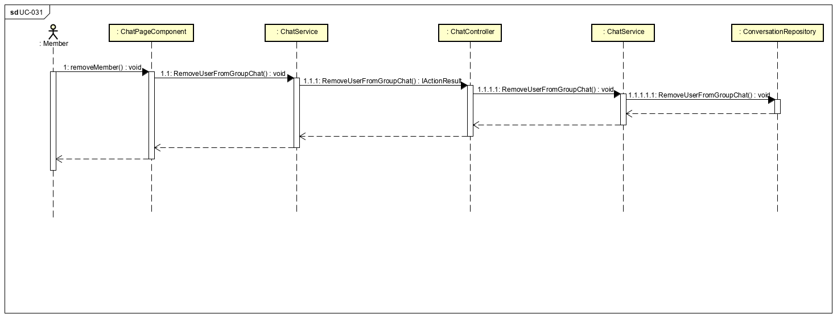

Figure 4-97: Remove a member Sequence Diagram

**4.3.4.30 Send/receive messages**

**Screen design**

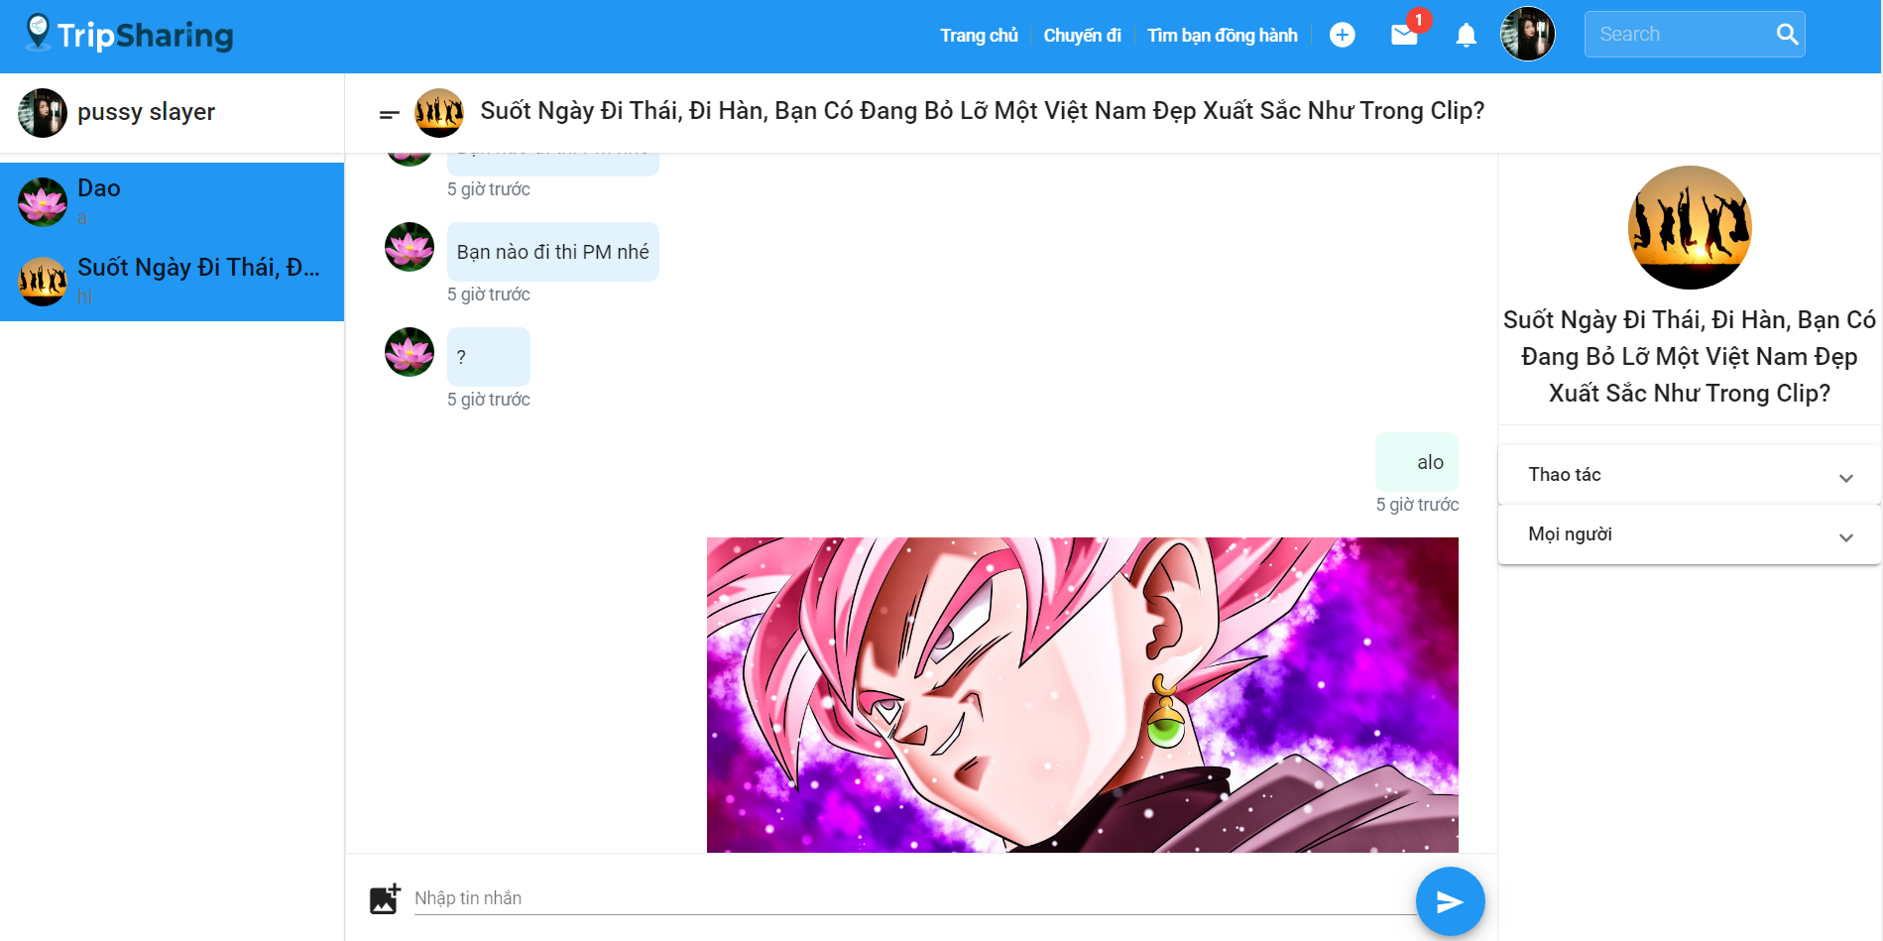

Figure 4-98: Send/receive messages Screen Design

**Class Diagram**

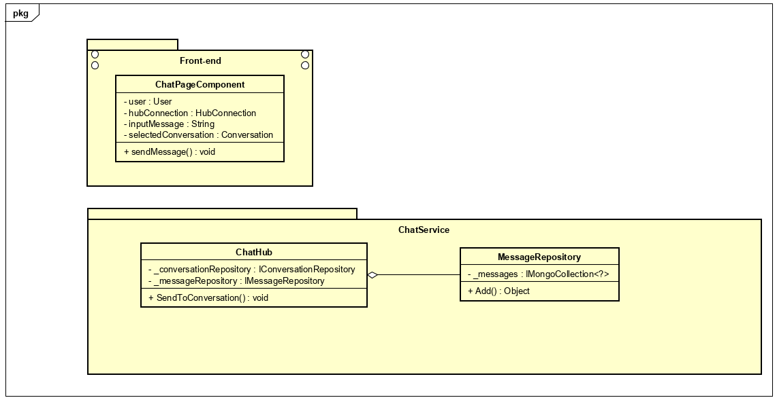

Figure 4-99: Send/receive messages Class Diagram

**Class Specification**

***ChatPageComponent***

|  |  |  |  |  |
| --- | --- | --- | --- | --- |
| **ChatPageComponent** | | | | |
| Physical address | src\app\pages\chat-page\chat-page.component.ts | | | |
| Base Class | Class | | | |
| **Attributes** | | | | |
| No | Name | Type | Description | |
| 1 | user | User |  | |
| 2 | hubConnection | HubConnection |  | |
| 3 | listConversation | Array |  | |
| 4 | chatService | ChatService |  | |
| **Operations** | | | | |
| No | Name | Return Type | | Description |
| 1 | sendMessage | Void | |  |

***ChatHub***

|  |  |  |  |
| --- | --- | --- | --- |
| **ChatHub** | | | |
| Physical address | src\Services\ChatService\ChatService\HubConfig\ChatHub.cs | | |
| Base Class | Hub | | |
| **Attributes** | | | |
| No | Name | Type | Description |
| 1 | _messageRepository | IMessageRepository |  |
| **Operations** | | | |
| No | Name | Return Type | Description |
| 1 | SendToConversation | Void |  |

***MessageRepository***

|  |  |  |  |
| --- | --- | --- | --- |
| **MessageRepository** | | | |
| Physical address | src\Services\ChatService\ChatService\Repositories\MessageRepository.cs | | |
| Base Class | IConversationRepository | | |
| **Attributes** | | | |
| No | Name | Type | Description |
| 1 | _messages | IMongoCollection<?> |  |
| **Operations** | | | |
| No | Name | Return Type | Description |
| 1 | Add | Object |  |

**Sequence Diagram**

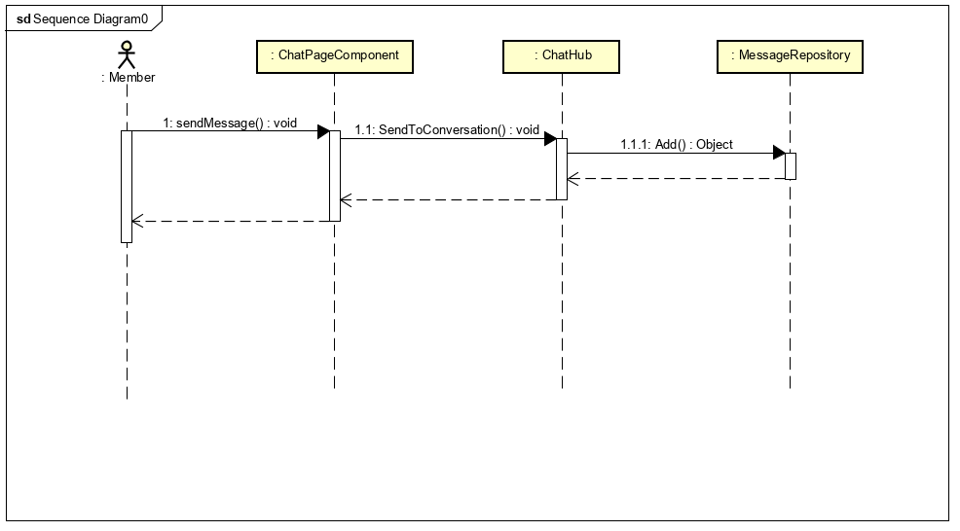

Figure 4-100: Send/receive messages Sequence Diagram

**4.3.4.31 View recommended articles**

**Screen design**

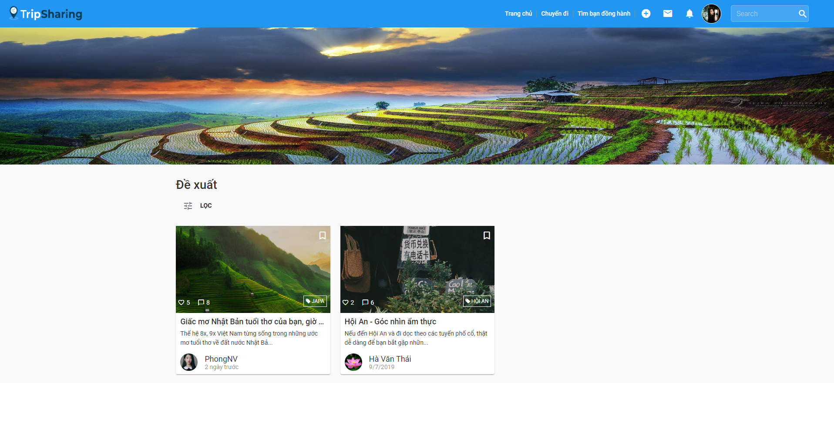 Figure 4-101: View recommended articles Screen Design

**Class Diagram**

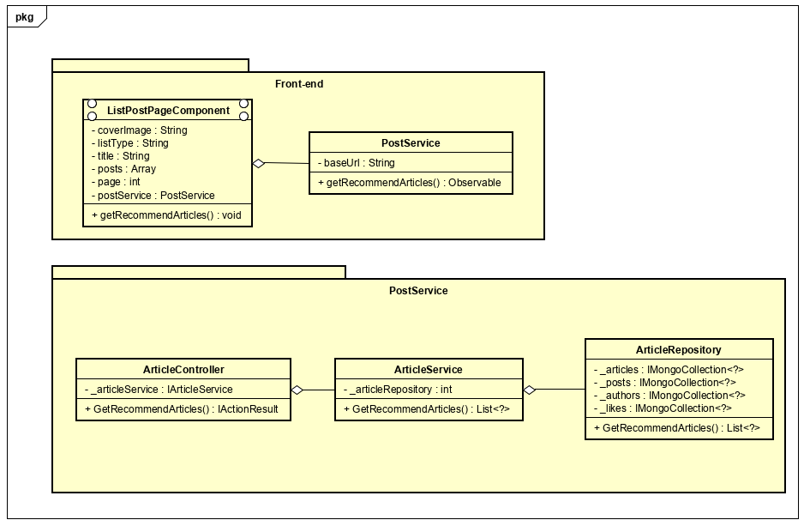

Figure 4-102: View recommended articles Class Diagram

**Class Specification**

***ListPostPageComponent***

|  |  |  |  |  |
| --- | --- | --- | --- | --- |
| **ListPostPageComponent** | | | | |
| Physical address | src\app\pages\list-post-page\list-post-page.component.ts | | | |
| Base Class | Class | | | |
| **Attributes** | | | | |
| No | Name | Type | Description | |
| 1 | coverImage | String |  | |
| 2 | listType | String |  | |
| 3 | title | String |  | |
| 4 | posts | Array |  | |
| 5 | page | Int |  | |
| 6 | postService | PostService |  | |
| **Operations** | | | | |
| No | Name | Return Type | | Description |
| 1 | getRecommendArticles | Void | |  |

***PostService***

|  |  |  |  |
| --- | --- | --- | --- |
| **PostService** | | | |
| Physical address | src\app\core\services\post-service\post.service.ts | | |
| Base Class | Class | | |
| **Attributes** | | | |
| No | Name | Type | Description |
| 1 | baseUrl | String |  |
| **Operations** | | | |
| No | Name | Return Type | Description |
| 1 | getRecommendArticles | Observable |  |

***ArticleController***

|  |  |  |  |
| --- | --- | --- | --- |
| **ArticleController** | | | |
| Physical address | src\Services\PostService\PostService\Controllers\ArticleController.cs | | |
| Base Class | ControllerBase | | |
| **Attributes** | | | |
| No | Name | Type | Description |
| 1 | _articleService | IArticleService |  |
| **Operations** | | | |
| No | Name | Return Type | Description |
| 1 | GetRecommendArticles | IActionResult |  |

***ChatService***

|  |  |  |  |
| --- | --- | --- | --- |
| **ArticleService** | | | |
| Physical address | src\Services\PostService\PostService\Services\ArticleService.cs | | |
| Base Class | IArticleService | | |
| **Attributes** | | | |
| No | Name | Type | Description |
| 1 | _articleRepository | IArticleRepository |  |
| **Operations** | | | |
| No | Name | Return Type | Description |
| 1 | GetRecommendArticles | List<?> |  |

***ArticleRepository***

|  |  |  |  |
| --- | --- | --- | --- |
| **ArticleRepository** | | | |
| Physical address | src\Services\PostService\PostService\Repositories\ArticleRepository.cs | | |
| Base Class | IArticleRepository | | |
| **Attributes** | | | |
| No | Name | Type | Description |
| 1 | _articles | IMongoCollection<?> |  |
| 2 | _posts | IMongoCollection<?> |  |
| 3 | _authors | IMongoCollection<?> |  |
| 4 | _likes | IMongoCollection<?> |  |
| **Operations** | | | |
| No | Name | Return Type | Description |
| 1 | GetRecommendArticles | List<?> |  |

**Sequence Diagram**

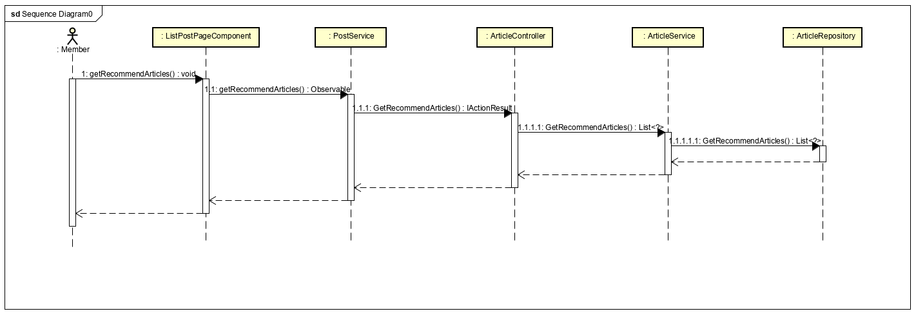

Figure 4-103: View recommended articles Sequence Diagram

**4.3.4.32 View all users' account**

**Screen design**

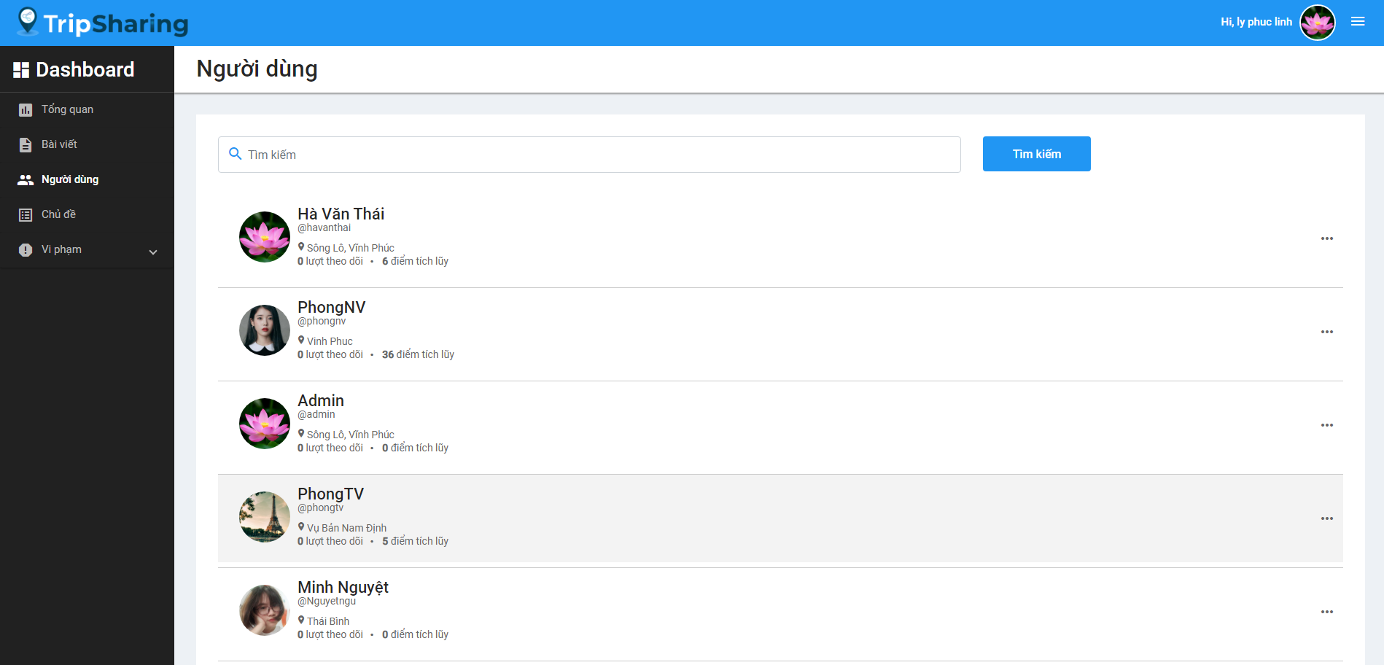

Figure 4-104: View all users' account Screen Design

**Class Diagram**

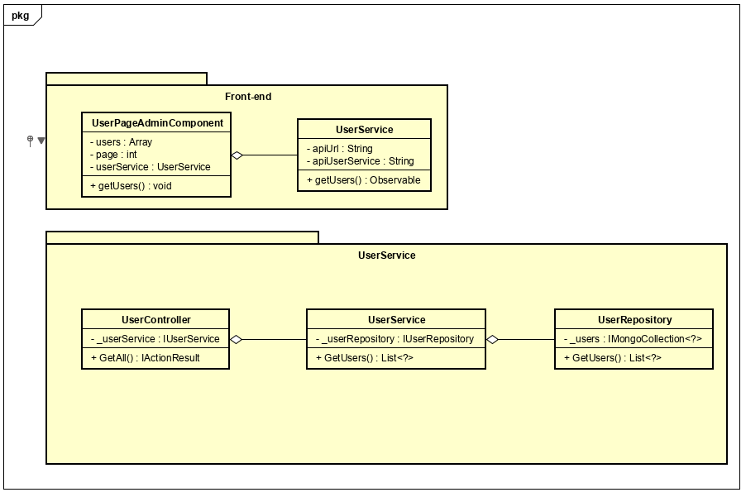

Figure 4-105: View all users' account Class Diagram

**Class Specification**

***UserPageAdminComponent***

|  |  |  |  |  |
| --- | --- | --- | --- | --- |
| **UserPageAdminComponent** | | | | |
| Physical address | src\app\admin\pages\dashboard-page\components\user-page-admin\user-page-admin.component.ts | | | |
| Base Class | Class | | | |
| **Attributes** | | | | |
| No | Name | Type | Description | |
| 1 | users | Array |  | |
| 2 | userService | UserService |  | |
| 3 | page | Int |  | |
| **Operations** | | | | |
| No | Name | Return Type | | Description |
| 1 | getRecommendArticles | Void | |  |

***UserService***

|  |  |  |  |
| --- | --- | --- | --- |
| **UserService** | | | |
| Physical address | src\app\core\services\user-service\user.service.ts | | |
| Base Class | Class | | |
| **Attributes** | | | |
| No | Name | Type | Description |
| 1 | apiUrl | String |  |
| 2 | apiUserService | String |  |
| **Operations** | | | |
| No | Name | Return Type | Description |
| 1 | getUsers | Observable |  |

***UserController***

|  |  |  |  |
| --- | --- | --- | --- |
| **UserController** | | | |
| Physical address | src\Services\UserService\UserService\Controllers\UserController.cs | | |
| Base Class | ControllerBase | | |
| **Attributes** | | | |
| No | Name | Type | Description |
| 1 | _userService | IUserService |  |
| **Operations** | | | |
| No | Name | Return Type | Description |
| 1 | GetAll | IActionResult |  |

***UserService***

|  |  |  |  |
| --- | --- | --- | --- |
| **UserService** | | | |
| Physical address | src\Services\UserService\UserService\Services\UserService.cs | | |
| Base Class | IUserService | | |
| **Attributes** | | | |
| No | Name | Type | Description |
| 1 | _userRepository | IUserRepository |  |
| **Operations** | | | |
| No | Name | Return Type | Description |
| 1 | GetUsers | List<?> |  |

***UserRepository***

|  |  |  |  |
| --- | --- | --- | --- |
| **UserRepository** | | | |
| Physical address | src\Services\UserService\UserService\Reponsitories\UserRepository.cs | | |
| Base Class | IUserRepository | | |
| **Attributes** | | | |
| No | Name | Type | Description |
| 1 | _users | IMongoCollection<?> |  |
| **Operations** | | | |
| No | Name | Return Type | Description |
| 1 | GetUsers | List<?> |  |

**Sequence Diagram**

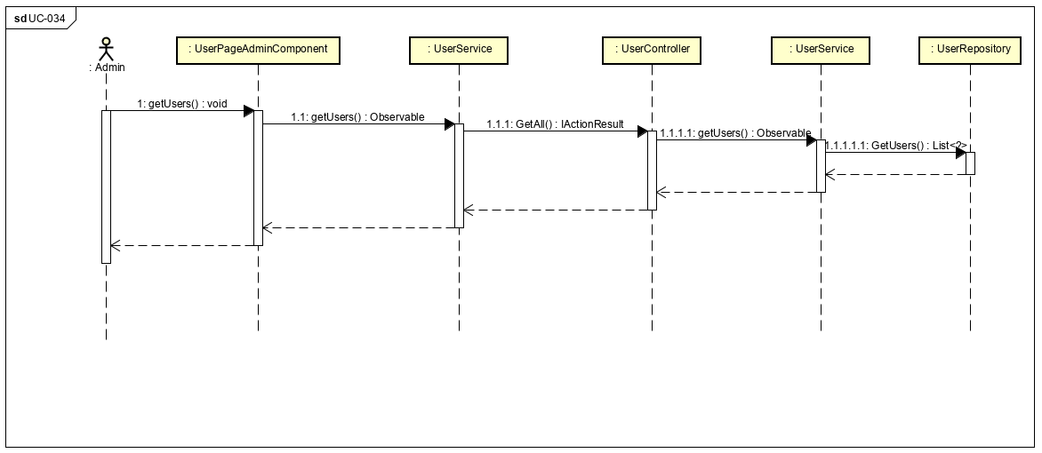

Figure 4-106: View all users' account Sequence Diagram

**4.3.4.33 View reported accounts**

**Screen design**

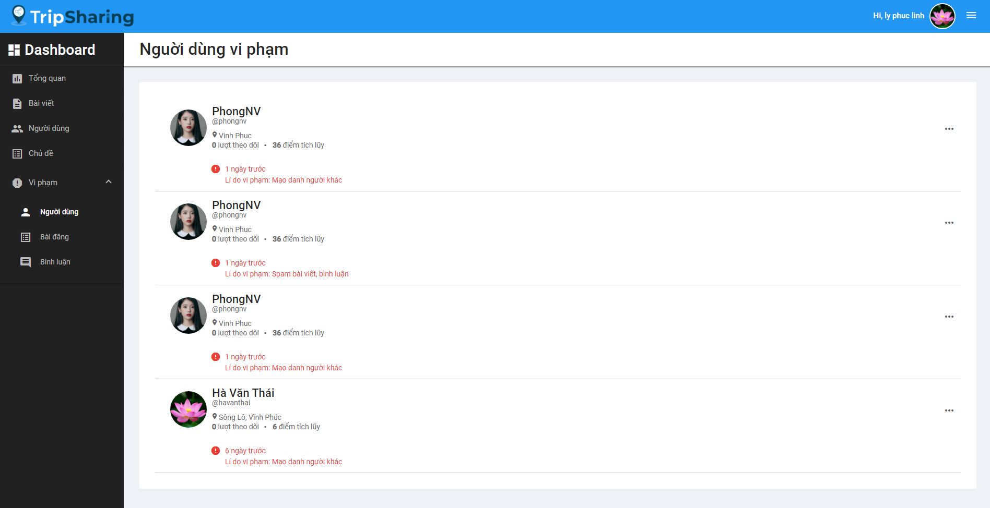

Figure 4-107: View reported accounts Screen Design

**Class Diagram**

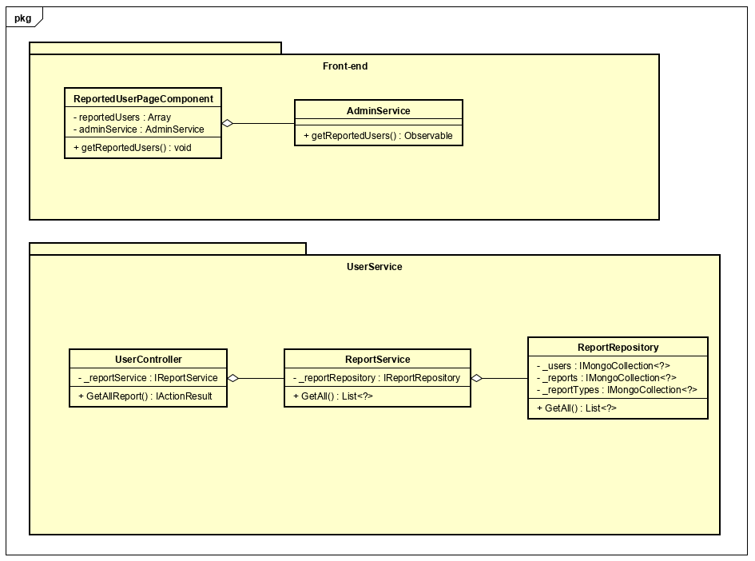

Figure 4-108: View reported accounts Class Diagram

**Class Specification**

***ReportedUserPageComponent***

|  |  |  |  |  |
| --- | --- | --- | --- | --- |
| **UserPageAdminComponent** | | | | |
| Physical address | src\app\admin\pages\dashboard-page\components\reported-user-page\reported-user-page.component.ts | | | |
| Base Class | Class | | | |
| **Attributes** | | | | |
| No | Name | Type | Description | |
| 1 | reportedUsers | Array |  | |
| 2 | adminService | AdminService |  | |
| **Operations** | | | | |
| No | Name | Return Type | | Description |
| 1 | getReportedUsers | Void | |  |

***AdminService***

|  |  |  |  |
| --- | --- | --- | --- |
| **AdminService** | | | |
| Physical address | src\app\admin\services\admin-service\admin.service.ts | | |
| Base Class | Class | | |
| **Attributes** | | | |
| No | Name | Type | Description |
|  |  |  |  |
| **Operations** | | | |
| No | Name | Return Type | Description |
| 1 | getReportedUsers | Observable |  |

***UserController***

|  |  |  |  |
| --- | --- | --- | --- |
| **UserController** | | | |
| Physical address | src\Services\UserService\UserService\Controllers\UserController.cs | | |
| Base Class | ControllerBase | | |
| **Attributes** | | | |
| No | Name | Type | Description |
| 1 | _reportService | IReportService |  |
| **Operations** | | | |
| No | Name | Return Type | Description |
| 1 | GetAllReport | IActionResult |  |

***ReportService***

|  |  |  |  |
| --- | --- | --- | --- |
| **ReportService** | | | |
| Physical address | src\Services\UserService\UserService\Services\ReportService.cs | | |
| Base Class | IReportService | | |
| **Attributes** | | | |
| No | Name | Type | Description |
| 1 | _reportRepository | IReportRepository |  |
| **Operations** | | | |
| No | Name | Return Type | Description |
| 1 | GetAll | List<?> |  |

***ReportRepository***

|  |  |  |  |
| --- | --- | --- | --- |
| **UserRepository** | | | |
| Physical address | src\Services\UserService\UserService\Reponsitories\ReportRepository.cs | | |
| Base Class | IReportRepository | | |
| **Attributes** | | | |
| No | Name | Type | Description |
| 1 | _users | IMongoCollection<?> |  |
| 2 | _reports | IMongoCollection<?> |  |
| 3 | _reportTypes | IMongoCollection<?> |  |
| **Operations** | | | |
| No | Name | Return Type | Description |
| 1 | GetAll | List<?> |  |

**Sequence Diagram**

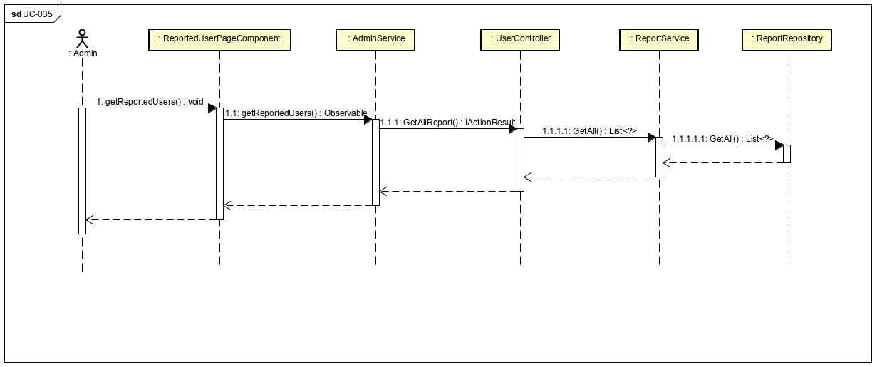

Figure 4-109: View reported accounts Sequence Diagram

**4.3.4.34 Ban a user**

**Screen design**

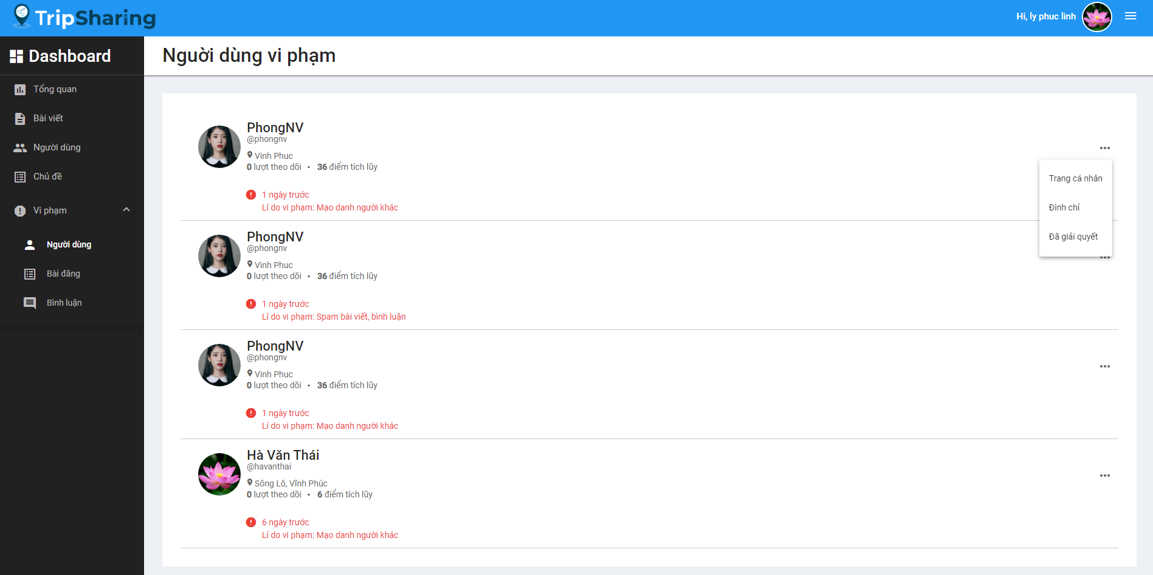

Figure 4-110: Ban a user Screen Design

**Class Diagram**

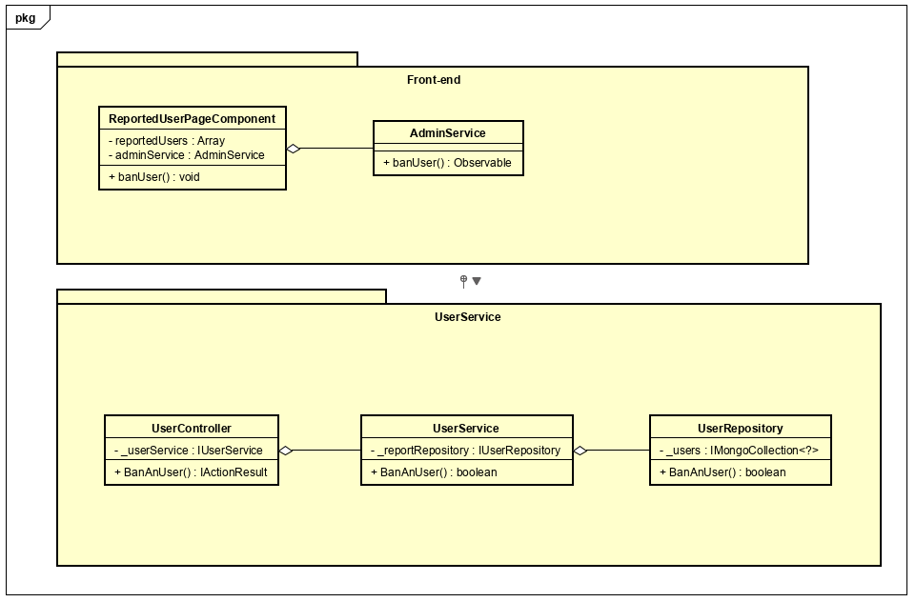

Figure 4-111: Ban a user Class Diagram

**Class Specification**

***ReportedUserPageComponent***

|  |  |  |  |  |
| --- | --- | --- | --- | --- |
| **UserPageAdminComponent** | | | | |
| Physical address | src\app\admin\pages\dashboard-page\components\reported-user-page\reported-user-page.component.ts | | | |
| Base Class | Class | | | |
| **Attributes** | | | | |
| No | Name | Type | Description | |
| 1 | reportedUsers | Array |  | |
| 2 | adminService | AdminService |  | |
| **Operations** | | | | |
| No | Name | Return Type | | Description |
| 1 | banUser | Void | |  |

***AdminService***

|  |  |  |  |
| --- | --- | --- | --- |
| **AdminService** | | | |
| Physical address | src\app\admin\services\admin-service\admin.service.ts | | |
| Base Class | Class | | |
| **Attributes** | | | |
| No | Name | Type | Description |
|  |  |  |  |
| **Operations** | | | |
| No | Name | Return Type | Description |
| 1 | banUser | Observable |  |

***UserController***

|  |  |  |  |
| --- | --- | --- | --- |
| **UserController** | | | |
| Physical address | src\Services\UserService\UserService\Controllers\UserController.cs | | |
| Base Class | ControllerBase | | |
| **Attributes** | | | |
| No | Name | Type | Description |
| 1 | _reportService | IReportService |  |
| **Operations** | | | |
| No | Name | Return Type | Description |
| 1 | BanAnUser | IActionResult |  |

***UserService***

|  |  |  |  |
| --- | --- | --- | --- |
| **ReportService** | | | |
| Physical address | src\Services\UserService\UserService\Services\UserService.cs | | |
| Base Class | IUserService | | |
| **Attributes** | | | |
| No | Name | Type | Description |
| 1 | _userRepository | IUserRepository |  |
| **Operations** | | | |
| No | Name | Return Type | Description |
| 1 | BanAnUser | Bool |  |

***UserRepository***

|  |  |  |  |
| --- | --- | --- | --- |
| **UserRepository** | | | |
| Physical address | src\Services\UserService\UserService\Reponsitories\UserRepository.cs | | |
| Base Class | IUserRepository | | |
| **Attributes** | | | |
| No | Name | Type | Description |
| 1 | _users | IMongoCollection<?> |  |
| **Operations** | | | |
| No | Name | Return Type | Description |
| 1 | BanAnUser | Bool |  |

**Sequence Diagram**

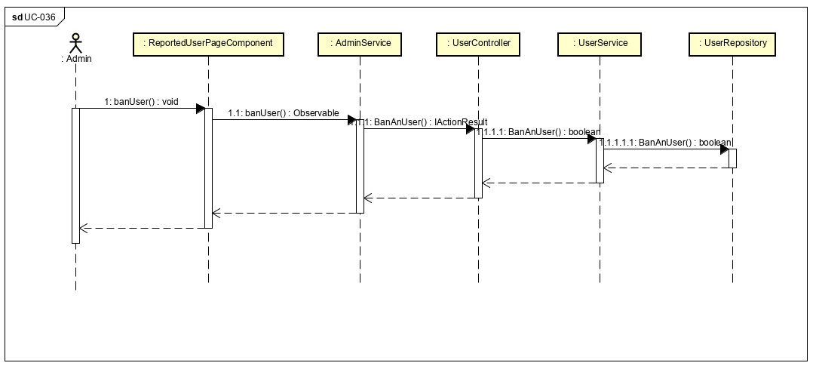

Figure 4-112: Ban a user Sequence Diagram

**4.3.4.35 Unban a user**

**Screen design**

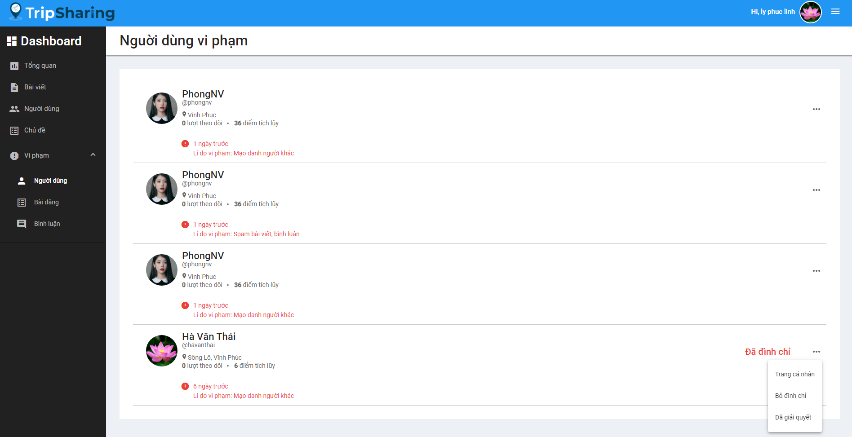

Figure 4-113: Unban a user Screen Design

**Class Diagram**

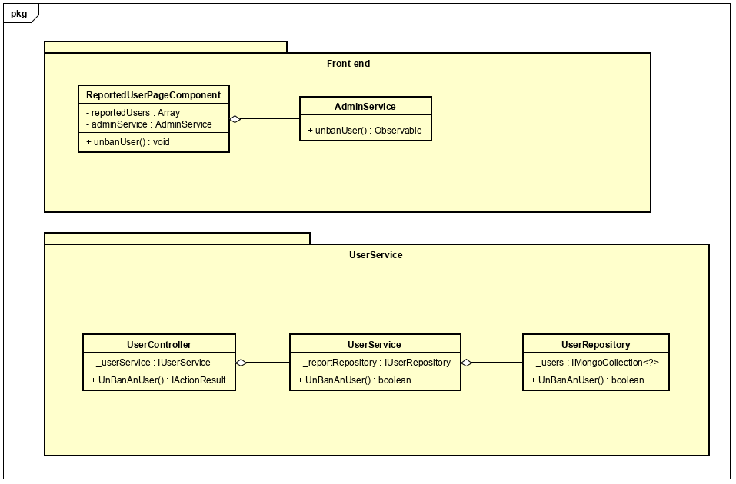

Figure 4-114: Unban a user Class Diagram

**Class Specification**

***ReportedUserPageComponent***

|  |  |  |  |  |
| --- | --- | --- | --- | --- |
| **UserPageAdminComponent** | | | | |
| Physical address | src\app\admin\pages\dashboard-page\components\reported-user-page\reported-user-page.component.ts | | | |
| Base Class | Class | | | |
| **Attributes** | | | | |
| No | Name | Type | Description | |
| 1 | reportedUsers | Array |  | |
| 2 | adminService | AdminService |  | |
| **Operations** | | | | |
| No | Name | Return Type | | Description |
| 1 | unbanUser | Void | |  |

***AdminService***

|  |  |  |  |
| --- | --- | --- | --- |
| **AdminService** | | | |
| Physical address | src\app\admin\services\admin-service\admin.service.ts | | |
| Base Class | Class | | |
| **Attributes** | | | |
| No | Name | Type | Description |
|  |  |  |  |
| **Operations** | | | |
| No | Name | Return Type | Description |
| 1 | unbanUser | Observable |  |

***UserController***

|  |  |  |  |
| --- | --- | --- | --- |
| **UserController** | | | |
| Physical address | src\Services\UserService\UserService\Controllers\UserController.cs | | |
| Base Class | ControllerBase | | |
| **Attributes** | | | |
| No | Name | Type | Description |
| 1 | _reportService | IReportService |  |
| **Operations** | | | |
| No | Name | Return Type | Description |
| 1 | UnBanAnUser | IActionResult |  |

***UserService***

|  |  |  |  |
| --- | --- | --- | --- |
| **ReportService** | | | |
| Physical address | src\Services\UserService\UserService\Services\UserService.cs | | |
| Base Class | IUserService | | |
| **Attributes** | | | |
| No | Name | Type | Description |
| 1 | _userRepository | IUserRepository |  |
| **Operations** | | | |
| No | Name | Return Type | Description |
| 1 | UnBanAnUser | Bool |  |

***UserRepository***

|  |  |  |  |
| --- | --- | --- | --- |
| **UserRepository** | | | |
| Physical address | src\Services\UserService\UserService\Reponsitories\UserRepository.cs | | |
| Base Class | IUserRepository | | |
| **Attributes** | | | |
| No | Name | Type | Description |
| 1 | _users | IMongoCollection<?> |  |
| **Operations** | | | |
| No | Name | Return Type | Description |
| 1 | UnBanAnUser | Bool |  |

**Sequence Diagram**

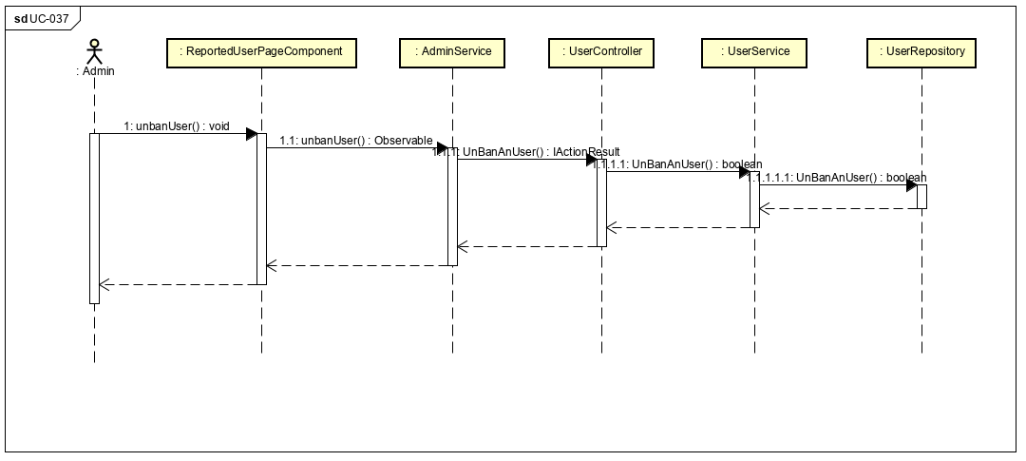

Figure 4-115: Unban a user Sequence Diagram

**4.3.4.36 View reported posts**

**Screen design**

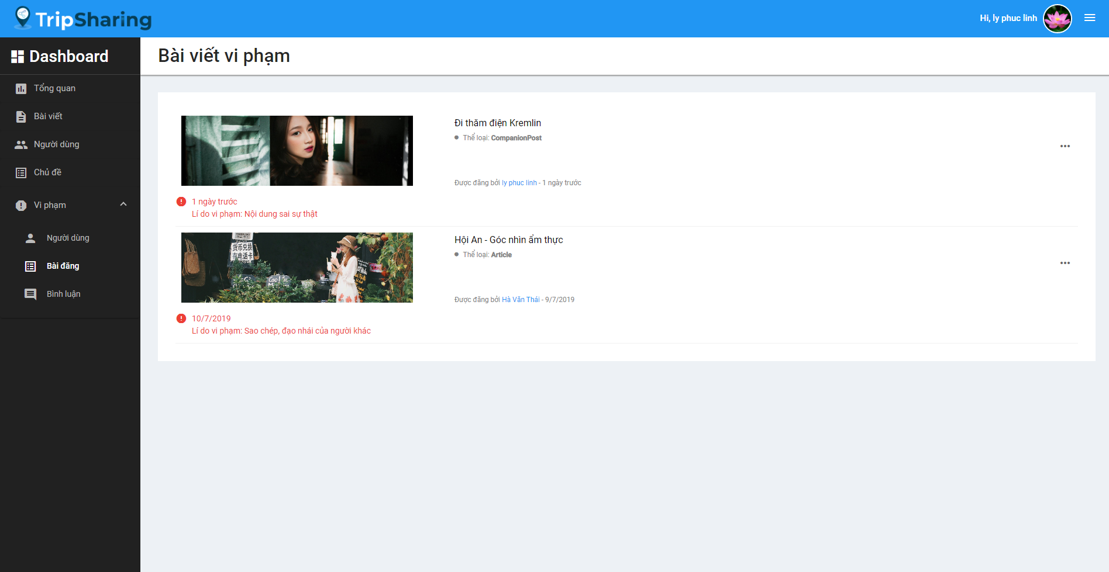

Figure 4-116: View reported posts Screen Design

**Class Diagram**

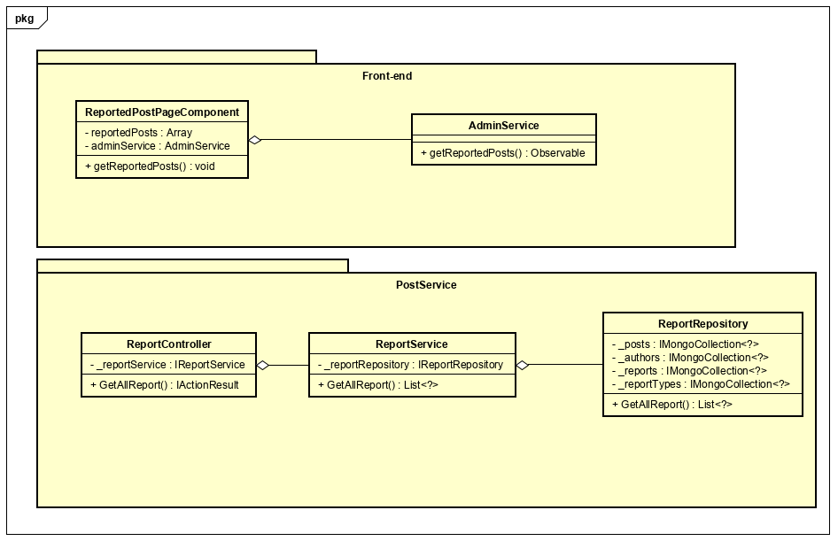

Figure 4-117: View reported posts Class Diagram

**Class Specification**

***ReportedUserPageComponent***

|  |  |  |  |  |
| --- | --- | --- | --- | --- |
| **ReportedUserPageComponent** | | | | |
| Physical address | src\app\admin\pages\dashboard-page\components\reported-user-page\reported-user-page.component.ts | | | |
| Base Class | Class | | | |
| **Attributes** | | | | |
| No | Name | Type | Description | |
| 1 | reportedPosts | Array |  | |
| 2 | adminService | AdminService |  | |
| **Operations** | | | | |
| No | Name | Return Type | | Description |
| 1 | getReportedPosts | Void | |  |

***AdminService***

|  |  |  |  |
| --- | --- | --- | --- |
| **AdminService** | | | |
| Physical address | src\app\admin\services\admin-service\admin.service.ts | | |
| Base Class | Class | | |
| **Attributes** | | | |
| No | Name | Type | Description |
|  |  |  |  |
| **Operations** | | | |
| No | Name | Return Type | Description |
| 1 | getReportedPosts | Observable |  |

***ReportController***

|  |  |  |  |
| --- | --- | --- | --- |
| **ReportController** | | | |
| Physical address | src\Services\PostService\PostService\Controllers\ReportController.cs | | |
| Base Class | ControllerBase | | |
| **Attributes** | | | |
| No | Name | Type | Description |
| 1 | _reportService | IReportService |  |
| **Operations** | | | |
| No | Name | Return Type | Description |
| 1 | GetAllReport | IActionResult |  |

***ReportService***

|  |  |  |  |
| --- | --- | --- | --- |
| **ReportService** | | | |
| Physical address | src\Services\PostService\PostService\Services\ReportService.cs | | |
| Base Class | IReportService | | |
| **Attributes** | | | |
| No | Name | Type | Description |
| 1 | _reportRepository | IReportRepository |  |
| **Operations** | | | |
| No | Name | Return Type | Description |
| 1 | GetAllReport | List<?> |  |

***ReportRepository***

|  |  |  |  |
| --- | --- | --- | --- |
| **ReportRepository** | | | |
| Physical address | src\Services\PostService\PostService\Repositories\ReportRepository.cs | | |
| Base Class | IUserRepository | | |
| **Attributes** | | | |
| No | Name | Type | Description |
| 1 | _posts | IMongoCollection<?> |  |
| 2 | _authors | IMongoCollection<?> |  |
| 3 | _reports | IMongoCollection<?> |  |
| 4 | _reportTypes | IMongoCollection<?> |  |
| **Operations** | | | |
| No | Name | Return Type | Description |
| 1 | GetAllReport | List<?> |  |

**Sequence Diagram**

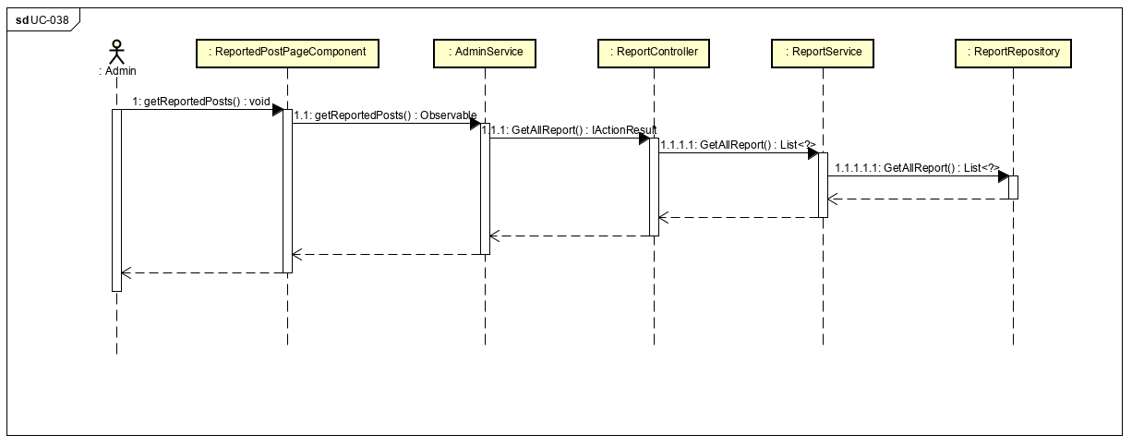

Figure 4-118: View reported posts Sequence Diagram

**4.3.4.37 Remove a reported post**

**Screen Design**

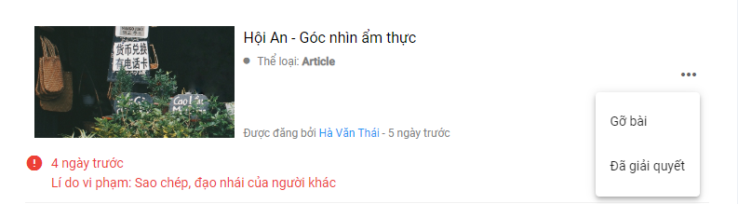

Figure 4-119: Remove a reported post screen design

**Class Diagram**

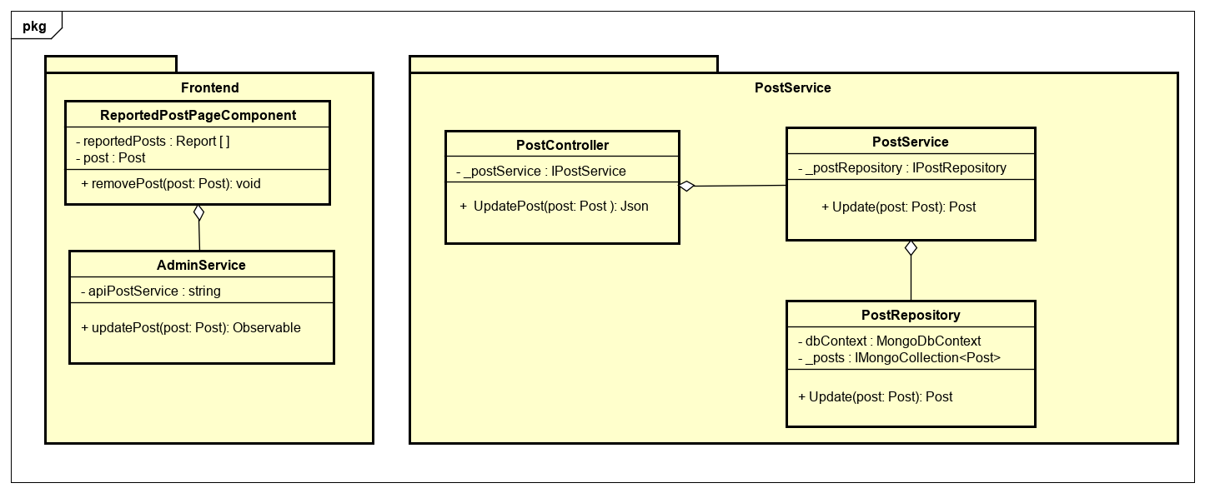

Figure 4-120: Administrator removes a reported post class diagram

**Class Specification**

***ReportedPostPageComponent***

|  |  |  |  |
| --- | --- | --- | --- |
| **ReportedPostPageComponent** | | | |
| Physical address | src/app/admin/pages/dashboard-page/components/reported-post-page/reported-post-page.component.ts | | |
| Base class | Class | | |
| **Attributes** | | | |
| No | Name | Type | Description |
| 1 | reportedPosts | Report [ ] |  |
| 2 | post | Post |  |
| **Operation** | | | |
| No | Name | Return Type | Description |
| 1 | removePost | void |  |

***AdminService***

|  |  |  |  |
| --- | --- | --- | --- |
| **AdminService** | | | |
| Physical address | src/app/admin/services/admin-service/admin.service | | |
| Base class | Class | | |
| **Attributes** | | | |
| No | Name | Type | Description |
| 1 | apiPostService | string |  |
| **Operation** | | | |
| No | Name | Retun Type | Description |
| 1 | updatePost | Observable |  |

***PostController***

|  |  |  |  |
| --- | --- | --- | --- |
| **PostController** | | | |
| Physical address | src/Services/PostService/PostService/Controllers/PostController.cs | | |
| Base class | ControllerBase | | |
| **Attributes** | | | |
| No | Name | Type | Description |
| 1 | _postService | IPostService |  |
| **Operation** | | | |
| No | Name | Retun Type | Description |
| 1 | UpdatePost | Json |  |

***PostService***

|  |  |  |  |
| --- | --- | --- | --- |
| **PostService** | | | |
| Physical address | src/Services/PostService/PostService/Service/PostService.cs | | |
| Base class | IPostService | | |
| **Attributes** | | | |
| No | Name | Type | Description |
| 1 | _postRepository | IPostRepository |  |
| **Operation** | | | |
| No | Name | Retun Type | Description |
| 1 | Update | Post |  |

***PostReposiory***

|  |  |  |  |
| --- | --- | --- | --- |
| **PostRepository** | | | |
| Physical address | src/Services/PostService/PostService/Repository/PostRepository.cs | | |
| Base class | IPostRepository | | |
| **Attributes** | | | |
| No | Name | Type | Description |
| 1 | dbContext | MongoDbContext |  |
| 2 | _posts | ImongoCollection  <Post> |  |
| **Operation** | | | |
| No | Name | Retun Type | Description |
| 1 | Update | Post |  |

**Sequence Diagram**

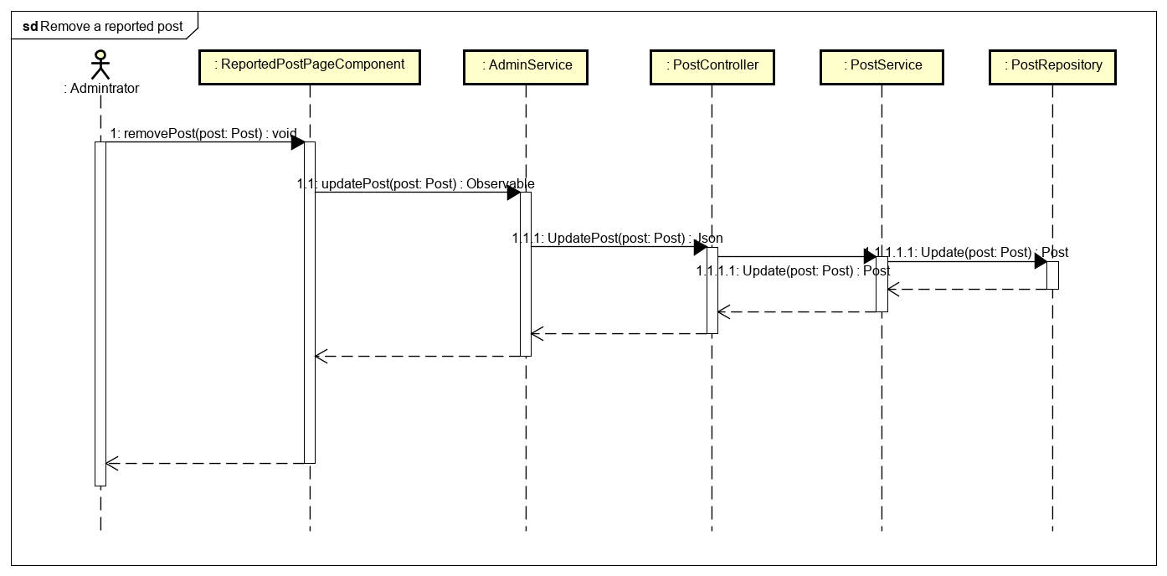

Figure 4-121: Administrator remove a reported post sequence diagram

**4.3.4.38 Restore a removed post**

**Screen Design**

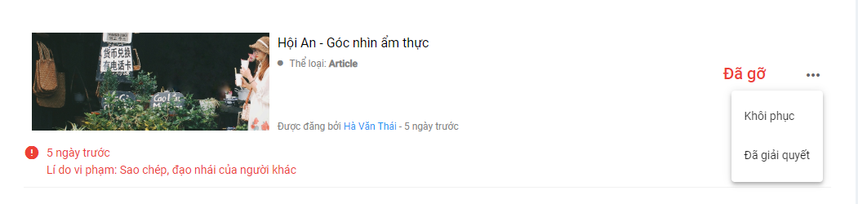

Figure 2-122: Restore a removed post screen design

**Class Diagram**

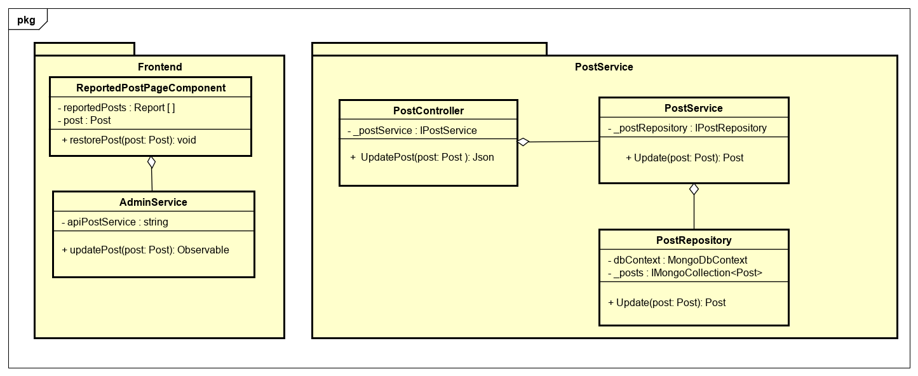

Figure 4-123: Administrator restore a removed post class diagram

**Class Specification**

***ReportedPostPageComponent***

|  |  |  |  |
| --- | --- | --- | --- |
| **ReportedPostPageComponent** | | | |
| Physical address | src/app/admin/pages/dashboard-page/components/reported-post-page/reported-post-page.component.ts | | |
| Base class | Class | | |
| **Attributes** | | | |
| No | Name | Type | Description |
| 1 | reportedPosts | Report [ ] |  |
| 2 | post | Post |  |
| **Operation** | | | |
| No | Name | Return Type | Description |
| 1 | restorePost | void |  |

***AdminService***

|  |  |  |  |
| --- | --- | --- | --- |
| **AdminService** | | | |
| Physical address | src/app/admin/services/admin-service/admin.service | | |
| Base class | Class | | |
| **Attributes** | | | |
| No | Name | Type | Description |
| 1 | apiPostService | string |  |
| **Operation** | | | |
| No | Name | Retun Type | Description |
| 1 | updatePost | Observable |  |

***PostController***

|  |  |  |  |
| --- | --- | --- | --- |
| **PostController** | | | |
| Physical address | src/Services/PostService/PostService/Controllers/PostController.cs | | |
| Base class | ControllerBase | | |
| **Attributes** | | | |
| No | Name | Type | Description |
| 1 | _postService | IPostService |  |
| **Operation** | | | |
| No | Name | Retun Type | Description |
| 1 | UpdatePost | Json |  |

***PostService***

|  |  |  |  |
| --- | --- | --- | --- |
| **PostService** | | | |
| Physical address | src/Services/PostService/PostService/Service/PostService.cs | | |
| Base class | IPostService | | |
| **Attributes** | | | |
| No | Name | Type | Description |
| 1 | _postRepository | IPostRepository |  |
| **Operation** | | | |
| No | Name | Retun Type | Description |
| 1 | Update | Post |  |

***PostReposiory***

|  |  |  |  |
| --- | --- | --- | --- |
| **PostRepository** | | | |
| Physical address | src/Services/PostService/PostService/Repository/PostRepository.cs | | |
| Base class | IPostRepository | | |
| **Attributes** | | | |
| No | Name | Type | Description |
| 1 | dbContext | MongoDbContext |  |
| 2 | _posts | ImongoCollection  <Post> |  |
| **Operation** | | | |
| No | Name | Retun Type | Description |
| 1 | Update | Post |  |

**Sequence Diagram**

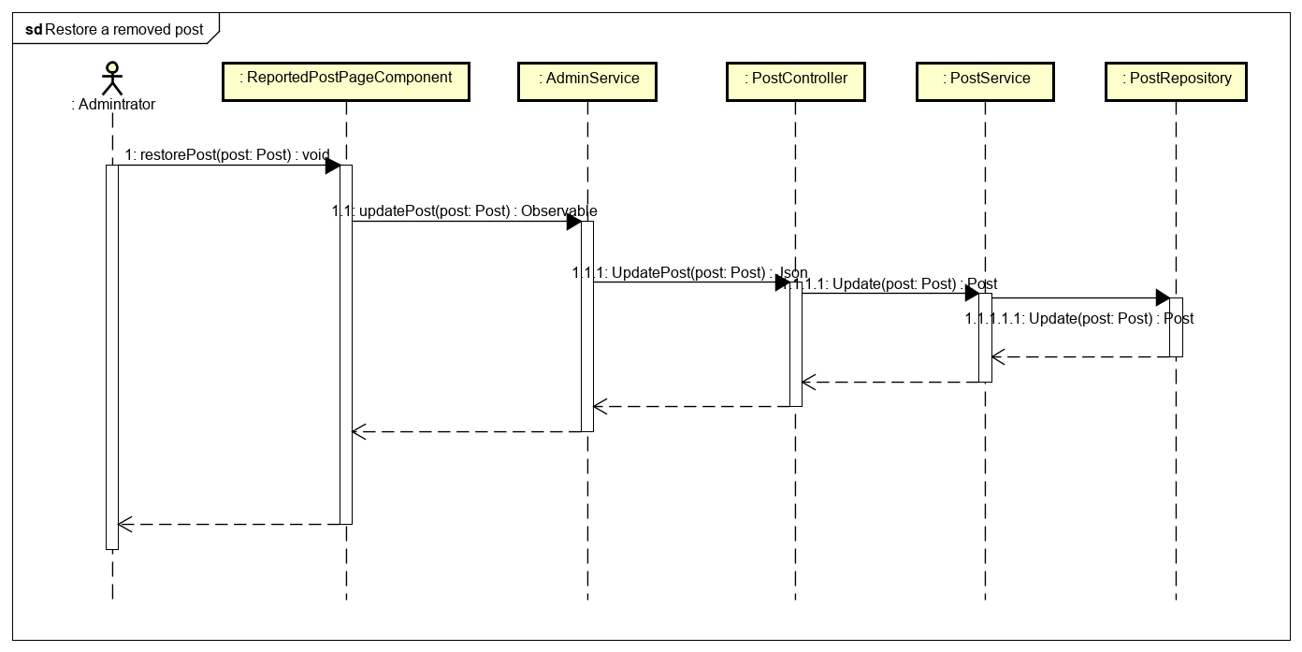

Figure 4-124: Administrator restore a removed post sequence diagram

**4.3.4.39 View reported comments**

**Screen Design**

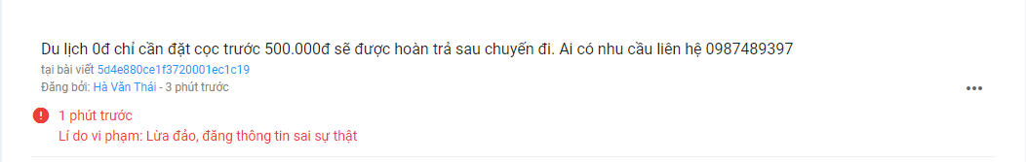

Figure 4-125: View reported comments screen design

**Class Diagram**

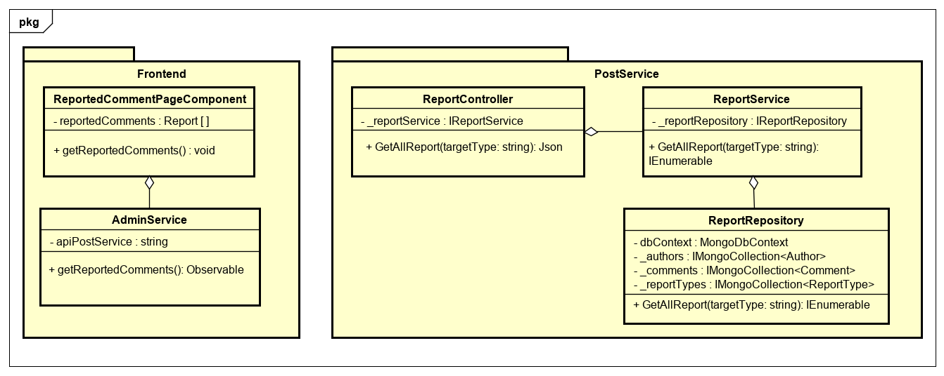

Figure 4-126: Administrator view reported comment class diagram

**Class Specification**

***ReportedCommentPageComponent***

|  |  |  |  |
| --- | --- | --- | --- |
| **ReportedCommentPageComponent** | | | |
| Physical address | src/app/admin/pages/dashboard-page/components/reported-comment-page/reported-comment-page.component.ts | | |
| Base class | Class | | |
| **Attributes** | | | |
| No | Name | Type | Description |
| 1 | reportedComments | Report [ ] |  |
| **Operation** | | | |
| No | Name | Return Type | Description |
| 1 | getReportedComments | void |  |

***AdminService***

|  |  |  |  |
| --- | --- | --- | --- |
| **AdminService** | | | |
| Physical address | src/app/admin/services/admin-service/admin.service | | |
| Base class | Class | | |
| **Attributes** | | | |
| No | Name | Type | Description |
| 1 | apiPostService | String |  |
| **Operation** | | | |
| No | Name | Type | Description |
| 1 | getReportedComments | Observable |  |

***ReportController***

|  |  |  |  |
| --- | --- | --- | --- |
| **ReportController** | | | |
| Physical address | src/Services/PostService/PostService/Controllers/ReportController.cs | | |
| Base class | ControllerBase | | |
| **Attributes** | | | |
| No | Name | Type | Description |
| 1 | _reportService | IReportService |  |
| **Operation** | | | |
| No | Name | Return Type | Description |
| 1 | GetAllReport | Json |  |

***ReportService***

|  |  |  |  |
| --- | --- | --- | --- |
| **ReportService** | | | |
| Physical address | src/Services/PostService/PostService/Service/ReportService.cs | | |
| Base class | IReportService | | |
| **Attributes** | | | |
| No | Name | Type | Description |
| 1 |  |  |  |
| **Operation** | | | |
| No | Name | Return Type | Description |
| 1 | GetAllReport | IEnumerable |  |

***ReportRepository***

|  |  |  |  |
| --- | --- | --- | --- |
| **ReportRepository** | | | |
| Physical address | src/Services/PostService/PostService/Repository/ReportRepository.cs | | |
| Base class | IReportRepository | | |
| **Attributes** | | | |
| No | Name | Type | Description |
| 1 | dbContext | MongoDbContext |  |
| 2 | _authors | ImongoCollection  <Author> |  |
| 3 | _comments | ImongoCollection  <Comment> |  |
| 4 | _reportTypes | ImongoCollection  <ReportType> |  |
| **Operation** | | | |
| No | Name | Return Type | Description |
| 1 | GetAllReport | IEnumerable |  |

**Sequence Diagram**

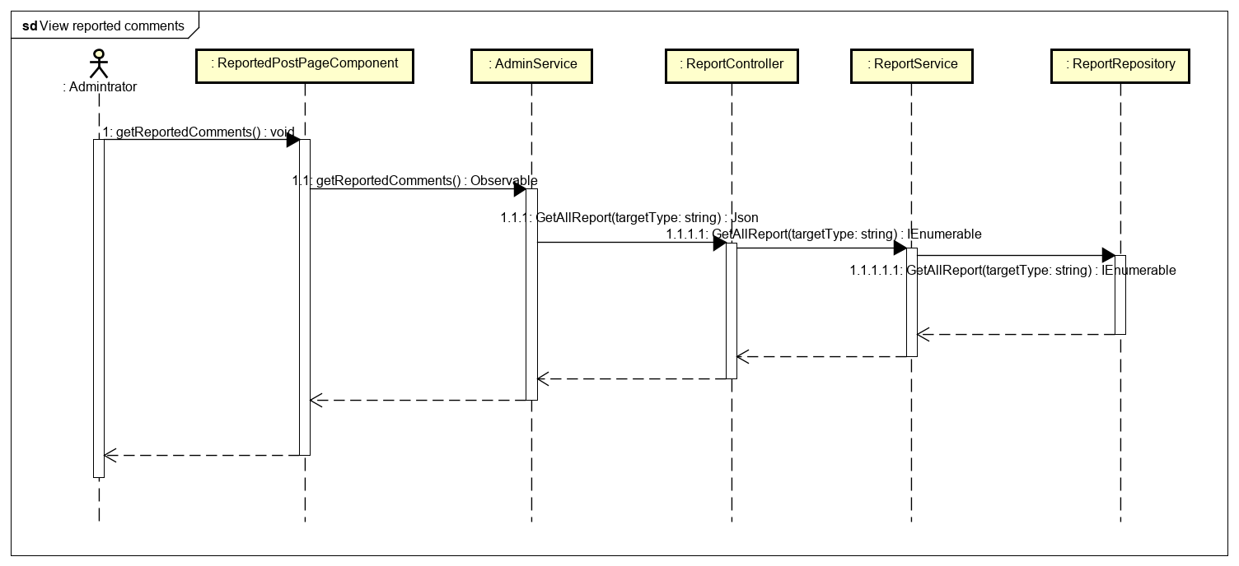

Figure 4-127: Administrator view reported comment sequence diagram

**4.3.4.40 Remove a reported comment**

**Screen Design**

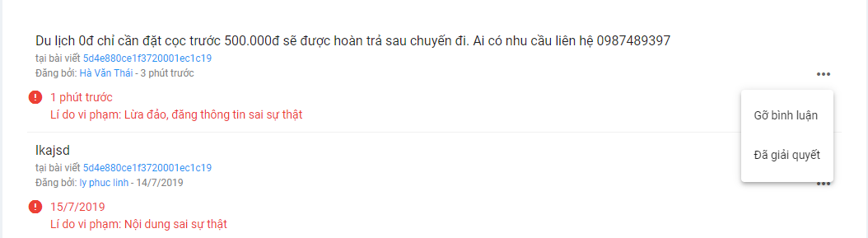

Figure 4-128: Remove a reported comment screen design

**Class Diagram**

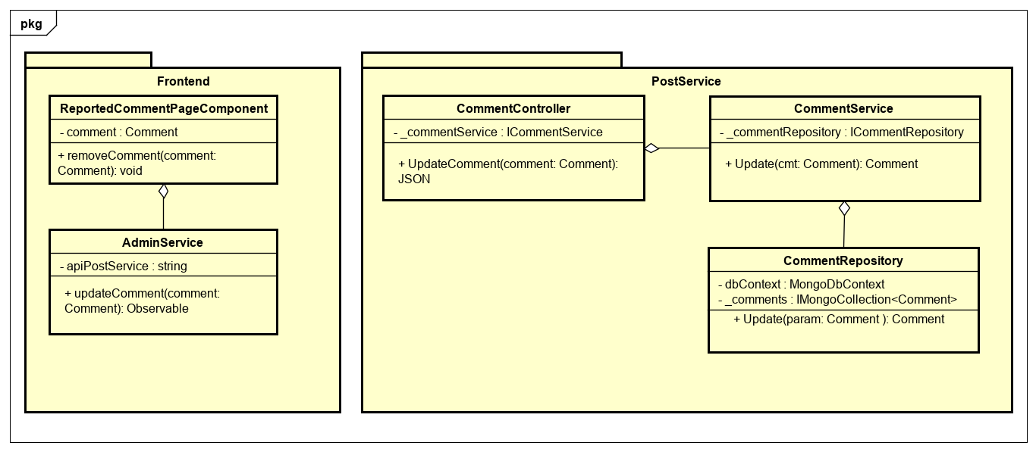

Figure 4-129: Administrator remove a reported comment class diagram

**Class Specification**

***ReportedCommentPageComponent***

|  |  |  |  |
| --- | --- | --- | --- |
| **ReportedCommentPageComponent** | | | |
| Physical address | src/app/admin/pages/dashboard-page/components/reported-comment-page/reported-comment-page.component.ts | | |
| Base class | Class | | |
| **Attributes** | | | |
| No | Name | Type | Description |
| 1 | Comment | Comment |  |
| **Operation** | | | |
| No | Name | Type | Description |
| 1 | removeComment | void |  |

***AdminService***

|  |  |  |  |
| --- | --- | --- | --- |
| **AdminService** | | | |
| Physical address | ./ src/app/admin/services/admin-service/admin.service | | |
| Base class | Class | | |
| **Attributes** | | | |
| No | Name | Type | Description |
| 1 | apiPostService | String |  |
| **Operation** | | | |
| No | Name | Return Type | Description |
| 1 | updateComment | Observable |  |

***CommentController***

|  |  |  |  |
| --- | --- | --- | --- |
| **CommentController** | | | |
| Physical address | src/Services/PostService/PostService/Controllers/CommentController.cs | | |
| Base class | ControllerBase | | |
| **Attributes** | | | |
| No | Name | Type | Description |
| 1 | _commentService | ICommentService |  |
| **Operation** | | | |
| No | Name | Type | Description |
| 1 | UpdateComment | Json |  |

***CommentService***

|  |  |  |  |
| --- | --- | --- | --- |
| **CommentService** | | | |
| Physical address | src/Services/PostService/PostService/Service/CommentService.cs | | |
| Base class | ICommentService | | |
| **Attributes** | | | |
| No | Name | Type | Description |
| 1 | _commentRepository | ICommentRepository |  |
| **Operation** | | | |
| No | Name | Type | Description |
| 1 | Update | Comment |  |

***CommentRepository***

|  |  |  |  |
| --- | --- | --- | --- |
| **CommentRepository** | | | |
| Physical address | src/Services/PostService/PostService/Repository/CommentRepository.cs | | |
| Base class | ICommentRepository | | |
| **Attributes** | | | |
| No | Name | Type | Description |
| 1 | dbContext | MongoDbContext |  |
| 2 | _comments | ImongoCollection  <Comment> |  |
| **Operation** | | | |
| No | Name | Type | Description |
| 1 | Update | Comment |  |

**Sequence Diagram**

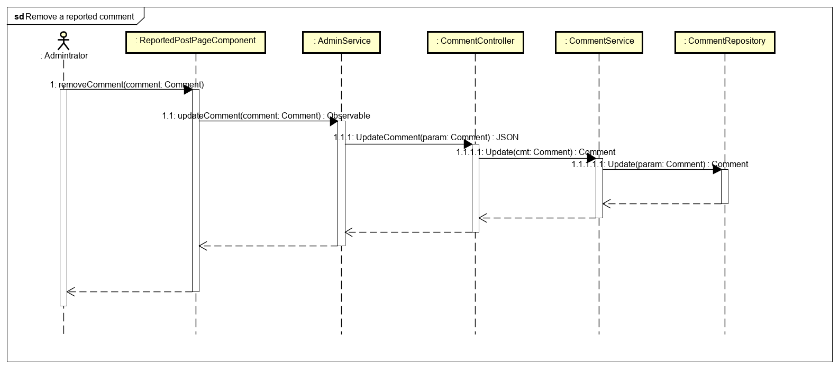

Figure 4-130: Administrator remove a reported comment sequence diagram

**4.3.4.41 Restore a removed comment**

**Screen Design**

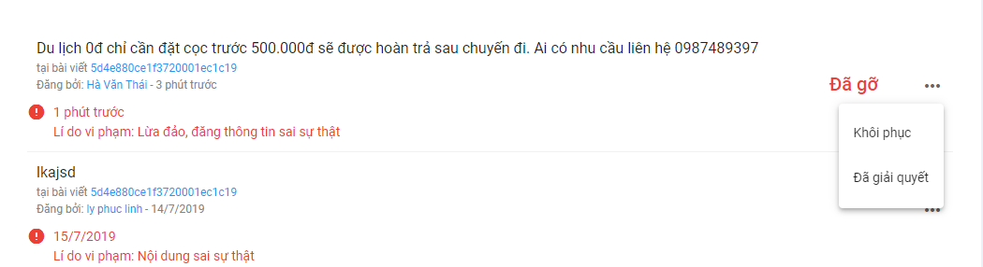

Figure 4-131: Restore a removed comment screen design

**Class Diagram**

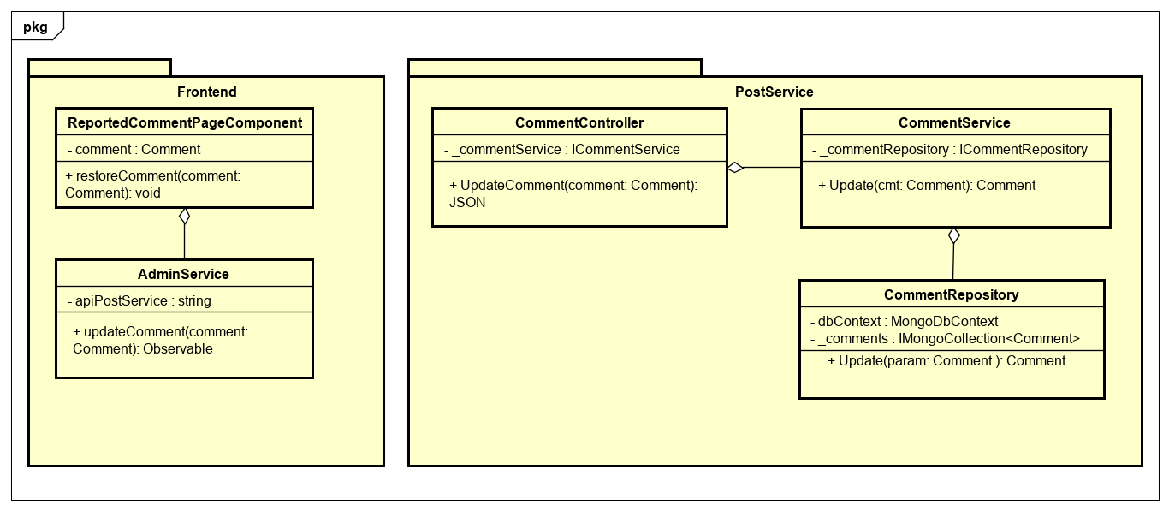

Figure 4-132: Administrator restore a removed comment class diagram

**Class Specification**

***ReportedCommentPageComponent***

|  |  |  |  |
| --- | --- | --- | --- |
| **ReportedCommentPageComponent** | | | |
| Physical address | src/app/admin/pages/dashboard-page/components/reported-comment-page/reported-comment-page.component.ts | | |
| Base class | Class | | |
| **Attributes** | | | |
| No | Name | Type | Description |
| 1 | comment | Comment |  |
| **Operation** | | | |
| No | Name | Type | Description |
| 1 | restoreComment | void |  |

***AdminService***

|  |  |  |  |
| --- | --- | --- | --- |
| **AdminService** | | | |
| Physical address | src/app/admin/services/admin-service/admin.service | | |
| Base class | Class | | |
| **Attributes** | | | |
| No | Name | Type | Description |
| 1 | apiPostService | String |  |
| **Operation** | | | |
| No | Name | Return Type | Description |
| 1 | updateComment | Observable |  |

***CommentController***

|  |  |  |  |
| --- | --- | --- | --- |
| **CommentController** | | | |
| Physical address | src/Services/PostService/PostService/Controllers/CommentController.cs | | |
| Base class | ControllerBase | | |
| **Attributes** | | | |
| No | Name | Type | Description |
| 1 | _commentService | ICommentService |  |
| **Operation** | | | |
| No | Name | Type | Description |
| 1 | UpdateComment | Json |  |

***CommentService***

|  |  |  |  |
| --- | --- | --- | --- |
| **CommentService** | | | |
| Physical address | src/Services/PostService/PostService/Service/CommentService.cs | | |
| Base class | ICommentService | | |
| **Attributes** | | | |
| No | Name | Type | Description |
| 1 | _commentRepository | ICommentRepository |  |
| **Operation** | | | |
| No | Name | Type | Description |
| 1 | Update | Comment |  |

***CommentRepository***

|  |  |  |  |
| --- | --- | --- | --- |
| **CommentRepository** | | | |
| Physical address | src/Services/PostService/PostService/Repository/CommentRepository.cs | | |
| Base class | ICommentRepository | | |
| **Attributes** | | | |
| No | Name | Type | Description |
| 1 | dbContext | MongoDbContext |  |
| 2 | _comments | ImongoCollection  <Comment> |  |
| **Operation** | | | |
| No | Name | Type | Description |
| 1 | Update | Comment |  |

**Sequence Diagram**

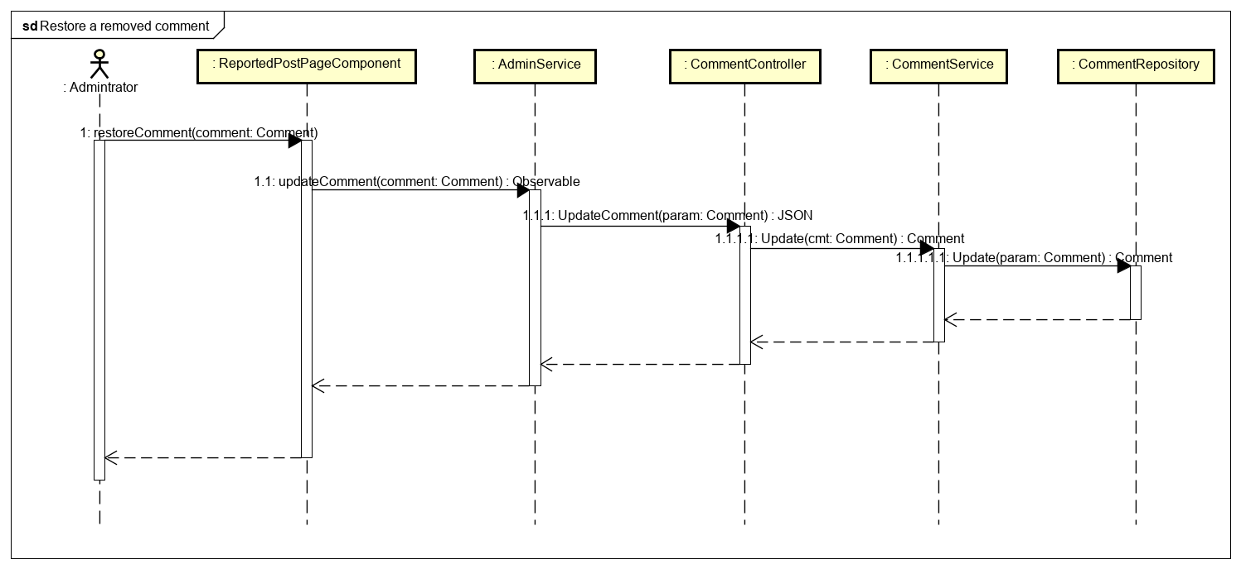

Figure 4-133: Administrator restore a removed comment sequence diagram

**4.3.4.42 Add a travel topic**

**Screen Design**

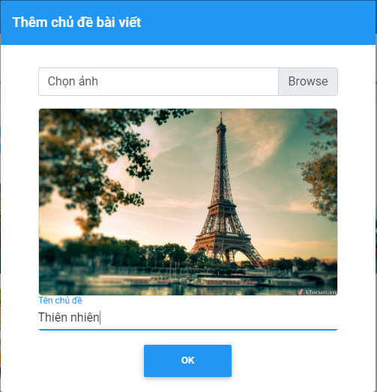

Figure 4-134: Add a travel topic screen design

**Class Diagram**

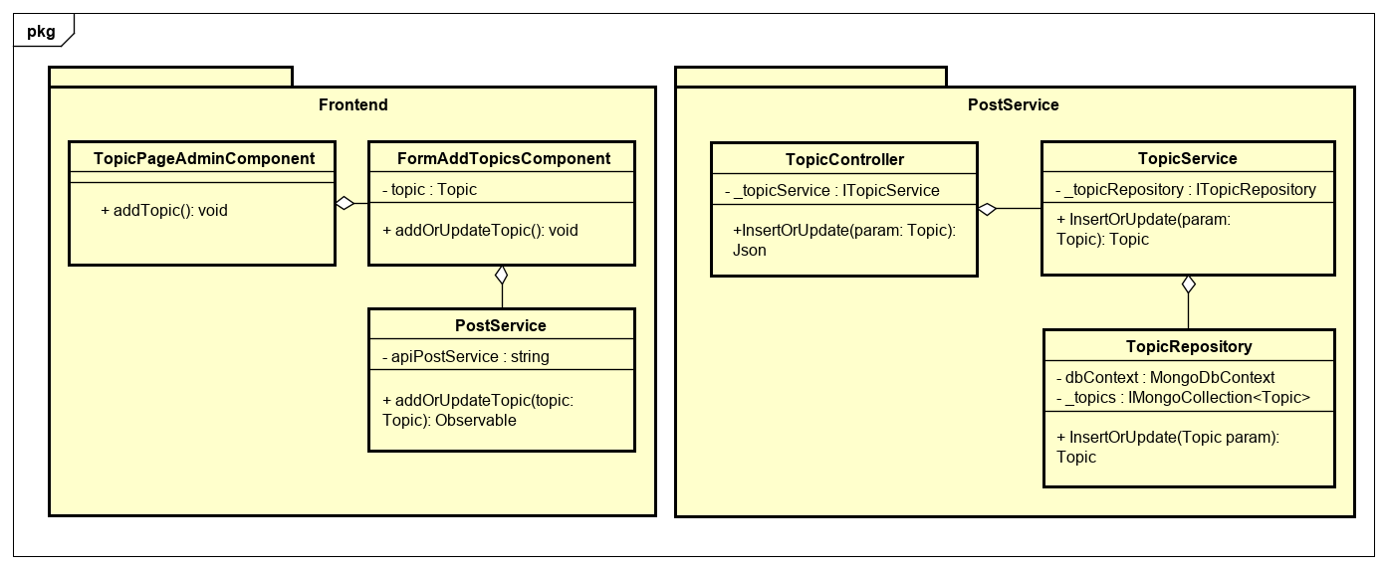

Figure 4-135: Administrator add a travel topic class diagram

**Class Specification**

***TopicPageAdminComponent***

|  |  |  |  |
| --- | --- | --- | --- |
| **TopicPageAdminComponent** | | | |
| Physical address | src/app/admin/pages/dashboard-page/components/topic-page-admin/topic-page-admin.component.ts | | |
| Base class | Class | | |
| **Attributes** | | | |
| No | Name | Type | Description |
|  |  |  |  |
| **Operation** | | | |
| No | Name | Type | Description |
| 1 | addTopic | void |  |

***FormAddTopicsComponent***

|  |  |  |  |
| --- | --- | --- | --- |
| **FormAddTopicsComponent** | | | |
| Physical address | src/app/admin/pages/dashboard-page/components/topic-page-admin/form-add-topics/form-add-topics.component.ts | | |
| Base class | Class | | |
| **Attributes** | | | |
| No | Name | Type | Description |
| 1 | topic | Topic |  |
| **Operation** | | | |
| No | Name | Type | Description |
| 1 | addOrUpdateTopic | void |  |

***PostService***

|  |  |  |  |
| --- | --- | --- | --- |
| **PostService** | | | |
| Physical address | src/app/core/services/post-service/post.service.ts | | |
| Base class | Class | | |
| **Attributes** | | | |
| No | Name | Type | Description |
| 1 | apiPostService | String |  |
| **Operation** | | | |
| No | Name | Return Type | Description |
| 1 | addOrUpdateTopic | Observable |  |

***TopicController***

|  |  |  |  |
| --- | --- | --- | --- |
| **TopicController** | | | |
| Physical address | src/Services/PostService/PostService/Controllers/TopicController.cs | | |
| Base class | ControllerBase | | |
| **Attributes** | | | |
| No | Name | Type | Description |
| 1 | _topicService | ITopicService |  |
| **Operation** | | | |
| No | Name | Type | Description |
| 1 | InsertOrUpdate | Json |  |

***TopicService***

|  |  |  |  |
| --- | --- | --- | --- |
| **TopicService** | | | |
| Physical address | src/Services/PostService/PostService/Service/TopicService.cs | | |
| Base class | ITopicService | | |
| **Attributes** | | | |
| No | Name | Type | Description |
| 1 | _topicRepository | ITopicRepository |  |
| **Operation** | | | |
| No | Name | Type | Description |
| 1 | InsertOrUpdate | Topic |  |

***TopicRepository***

|  |  |  |  |
| --- | --- | --- | --- |
| **TopicRepository** | | | |
| Physical address | src/Services/PostService/PostService/Repository/TopicRepository.cs | | |
| Base class | ITopicRepository | | |
| **Attributes** | | | |
| No | Name | Type | Description |
| 1 | dbContext | MongoDbContext |  |
| 2 | _topics | ImongoCollection  <Topic> |  |
| **Operation** | | | |
| No | Name | Type | Description |
| 1 | InsertOrUpdate | Topic |  |

**Sequence Diagram**

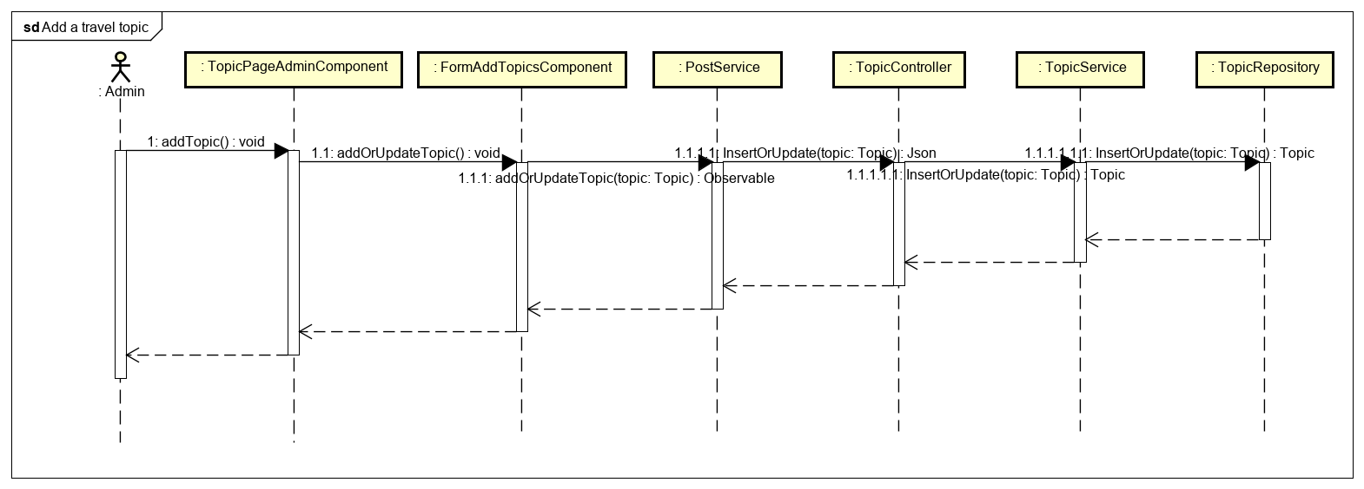

Figure 4-136: Administrator add a travel topic sequence diagram

**4.3.4.43 Edit a travel topic**

**Screen Design**

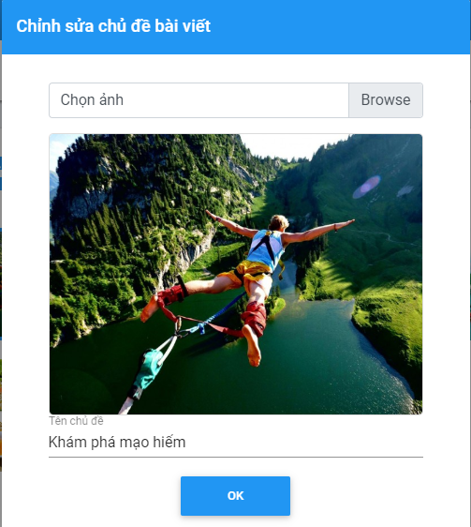

Figure 4-137: Edit a travel topic screen design

**Class Diagram**

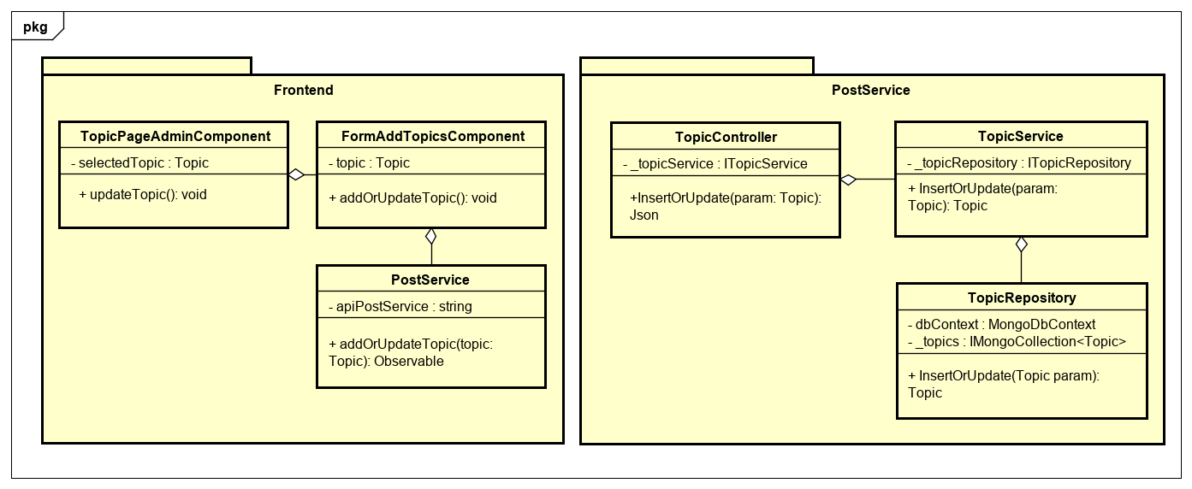

Figure 4-138: Administrator edit a travel topic class diagram

**Class Specification**

***TopicPageAdminComponent***

|  |  |  |  |
| --- | --- | --- | --- |
| **TopicPageAdminComponent** | | | |
| Physical address | src/app/admin/pages/dashboard-page/components/topic-page-admin/topic-page-admin.component.ts | | |
| Base class | Class | | |
| **Attributes** | | | |
| No | Name | Type | Description |
| 1 | selectedTopic | Topic |  |
| **Operation** | | | |
| No | Name | Type | Description |
| 1 | updateTopic | void |  |

***FormAddTopicsComponent***

|  |  |  |  |
| --- | --- | --- | --- |
| **FormAddTopicsComponent** | | | |
| Physical address | src/app/admin/pages/dashboard-page/components/topic-page-admin/form-add-topics/form-add-topics.component.ts | | |
| Base class | Class | | |
| **Attributes** | | | |
| No | Name | Type | Description |
| 1 | topic | Topic |  |
| **Operation** | | | |
| No | Name | Type | Description |
| 1 | addOrUpdateTopic | void |  |

***PostService***

|  |  |  |  |
| --- | --- | --- | --- |
| **PostService** | | | |
| Physical address | src/app/core/services/post-service/post.service.ts | | |
| Base class | Class | | |
| **Attributes** | | | |
| No | Name | Type | Description |
| 1 | apiPostService | String |  |
| **Operation** | | | |
| No | Name | Return Type | Description |
| 1 | addOrUpdateTopic | Observable |  |

***TopicController***

|  |  |  |  |
| --- | --- | --- | --- |
| **TopicController** | | | |
| Physical address | src/Services/PostService/PostService/Controllers/TopicController.cs | | |
| Base class | ControllerBase | | |
| **Attributes** | | | |
| No | Name | Type | Description |
| 1 | _topicService | ITopicService |  |
| **Operation** | | | |
| No | Name | Type | Description |
| 1 | InsertOrUpdate | Json |  |

***TopicService***

|  |  |  |  |
| --- | --- | --- | --- |
| **TopicService** | | | |
| Physical address | src/Services/PostService/PostService/Service/TopicService.cs | | |
| Base class | ITopicService | | |
| **Attributes** | | | |
| No | Name | Type | Description |
| 1 | _topicRepository | ITopicRepository |  |
| **Operation** | | | |
| No | Name | Type | Description |
| 1 | InsertOrUpdate | Topic |  |

***TopicRepository***

|  |  |  |  |
| --- | --- | --- | --- |
| **TopicRepository** | | | |
| Physical address | src/Services/PostService/PostService/Repository/TopicRepository.cs | | |
| Base class | ITopicRepository | | |
| **Attributes** | | | |
| No | Name | Type | Description |
| 1 | dbContext | MongoDbContext |  |
| 2 | _topics | ImongoCollection  <Topic> |  |
| **Operation** | | | |
| No | Name | Type | Description |
| 1 | InsertOrUpdate | Topic |  |

**Sequence Diagram**

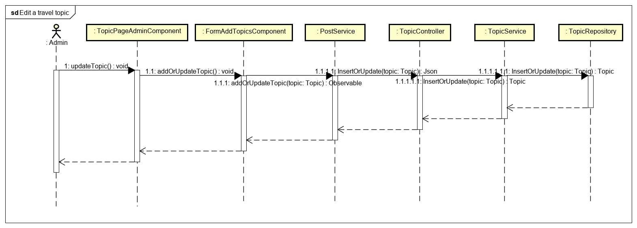

Figure 4-139: Administrator edit a travel topic sequence diagram

**4.3.4.44 Delete travel topics**

**Screen Design**

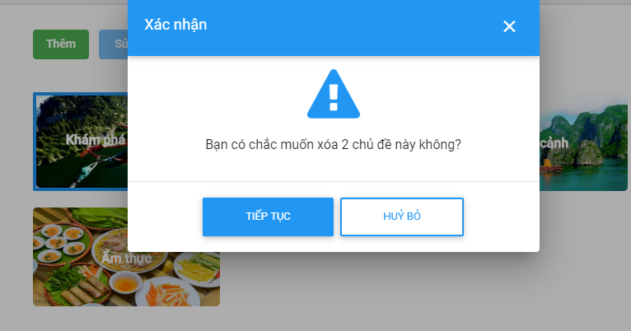

Figure 4-140: Delete travel topics screen design

**Class Diagram**

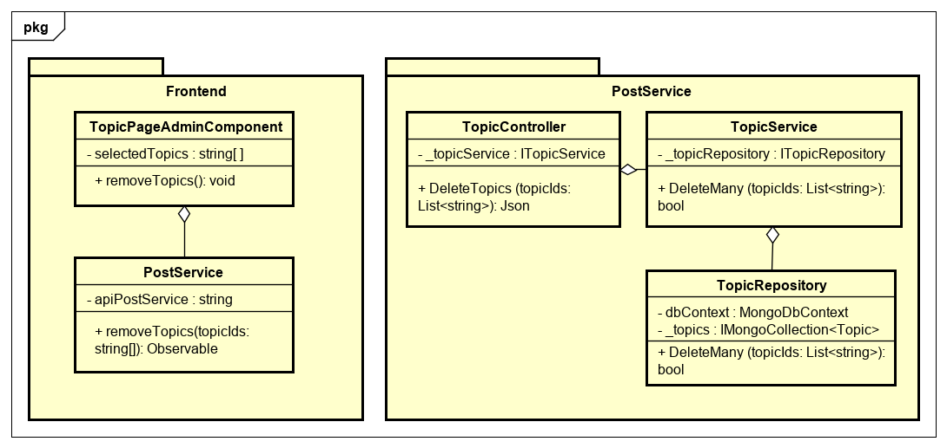

Figure 4-141: Administrator delete travel topics class diagram

**Class Specification**

***TopicPageAdminComponent***

|  |  |  |  |
| --- | --- | --- | --- |
| **TopicPageAdminComponent** | | | |
| Physical address | src/app/admin/pages/dashboard-page/components/topic-page-admin/topic-page-admin.component.ts | | |
| Base class | Class | | |
| **Attributes** | | | |
| No | Name | Type | Description |
| 1 | selectedTopics | String [ ] |  |
| **Operation** | | | |
| No | Name | Type | Description |
| 1 | removeTopics | void |  |

***PostService***

|  |  |  |  |
| --- | --- | --- | --- |
| **PostService** | | | |
| Physical address | src/app/core/services/post-service/post.service.ts | | |
| Base class | Class | | |
| **Attributes** | | | |
| No | Name | Type | Description |
| 1 | apiPostService | String |  |
| **Operation** | | | |
| No | Name | Return Type | Description |
| 1 | removeTopics | Observable |  |

***TopicController***

|  |  |  |  |
| --- | --- | --- | --- |
| **TopicController** | | | |
| Physical address | src/Services/PostService/PostService/Controllers/TopicController.cs | | |
| Base class | ControllerBase | | |
| **Attributes** | | | |
| No | Name | Type | Description |
| 1 | _topicService | ITopicService |  |
| **Operation** | | | |
| No | Name | Type | Description |
| 1 | DeleteTopics | Json |  |

***TopicService***

|  |  |  |  |
| --- | --- | --- | --- |
| **TopicService** | | | |
| Physical address | src/Services/PostService/PostService/Service/TopicService.cs | | |
| Base class | ITopicService | | |
| **Attributes** | | | |
| No | Name | Type | Description |
| 1 | _topicRepository | ITopicRepository |  |
| **Operation** | | | |
| No | Name | Type | Description |
| 1 | DeleteMany | Bool |  |

***TopicRepository***

|  |  |  |  |
| --- | --- | --- | --- |
| **TopicRepository** | | | |
| Physical address | src/Services/PostService/PostService/Repository/TopicRepository.cs | | |
| Base class | ITopicRepository | | |
| **Attributes** | | | |
| No | Name | Type | Description |
| 1 | dbContext | MongoDbContext |  |
| 2 | _topics | ImongoCollection  <Topic> |  |
| **Operation** | | | |
| No | Name | Type | Description |
| 1 | DeleteMany | Bool |  |

**Sequence Diagram**

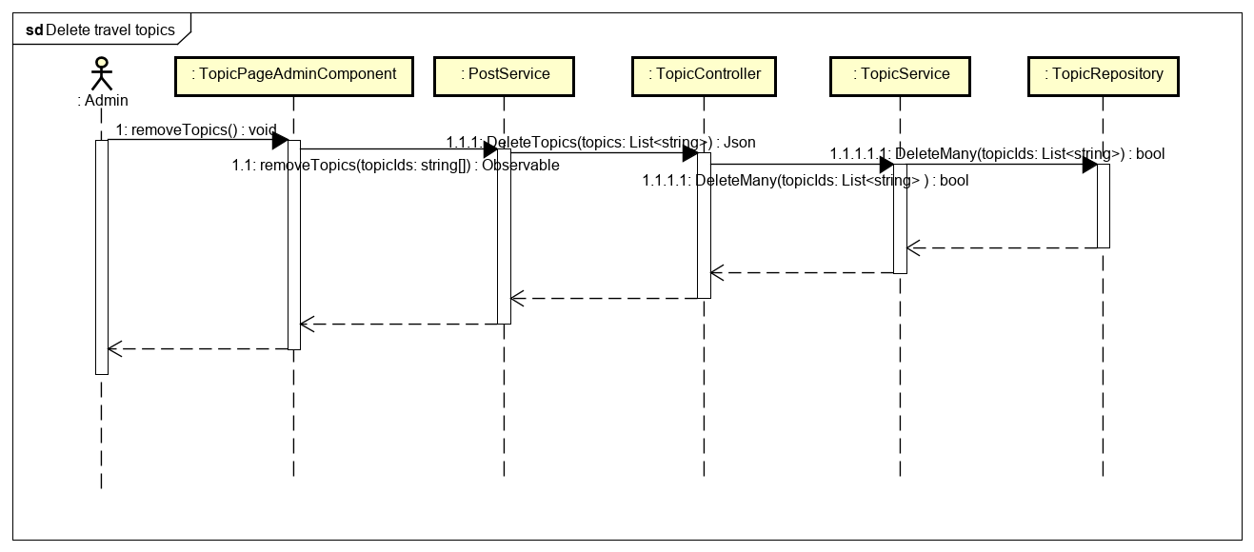

Figure 4-142: Administrator delete travel topics sequence diagram

**4.3.4.45 View statistic of users**

**Screen Design**

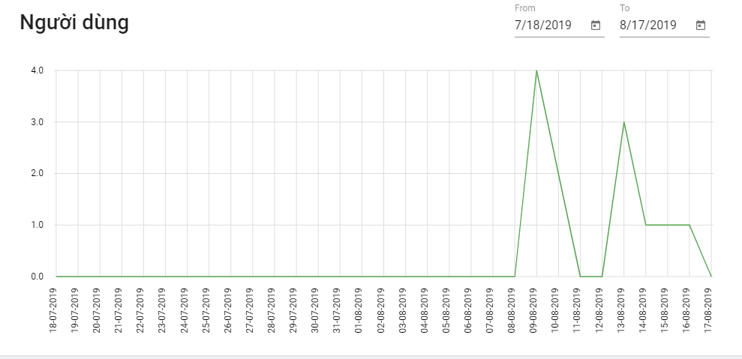

Figure 4-143: View statistic of user screen design

**Class Diagram**

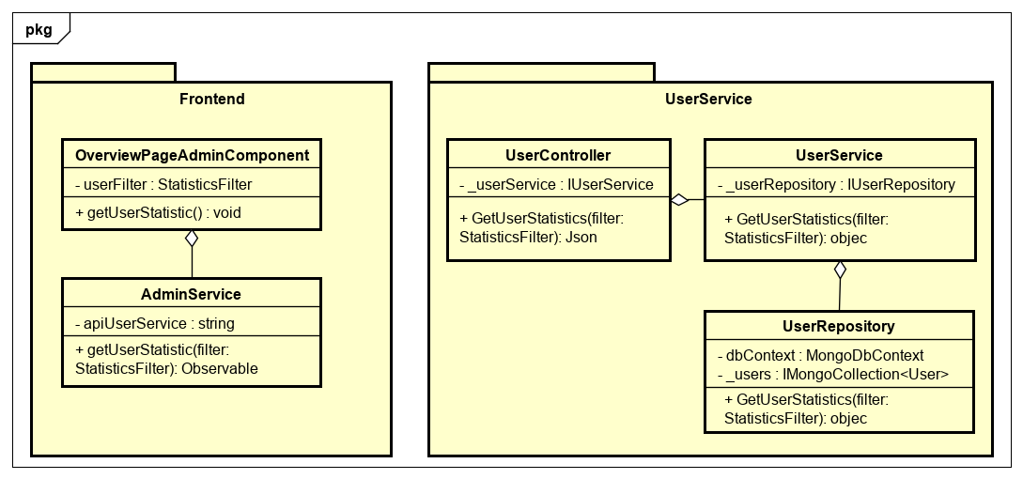

Figure 4-144: Administrator view statistic of user class diagram

**Class Specification**

***OverviewPageAdminComponent***

|  |  |  |  |
| --- | --- | --- | --- |
| **OverviewPageAdminComponent** | | | |
| Physical address | src/app/admin/pages/dashboard-page/components/overview-page-admin/overview-page-admin.component.ts | | |
| Base class | Class | | |
| **Attributes** | | | |
| No | Name | Type | Description |
| 1 | userFilter | StatisticsFilter |  |
| **Operation** | | | |
| No | Name | Type | Description |
| 1 | getUserStatistic | void |  |

***AdminService***

|  |  |  |  |
| --- | --- | --- | --- |
| **AdminService** | | | |
| Physical address | src/app/admin/services/admin-service/admin.service.ts | | |
| Base class | Class | | |
| **Attributes** | | | |
| No | Name | Type | Description |
| 1 | apiUserService | String |  |
| **Operation** | | | |
| No | Name | Return Type | Description |
| 1 | getUserStatistic | Observable |  |

***UserController***

|  |  |  |  |
| --- | --- | --- | --- |
| **UserController** | | | |
| Physical address | src/Services/UserService/UserService/Controllers/UserController.cs | | |
| Base class | ControllerBase | | |
| **Attributes** | | | |
| No | Name | Type | Description |
| 1 | _userService | IUserService |  |
| **Operation** | | | |
| No | Name | Type | Description |
| 1 | GetUserStatistics | Json |  |

***UserService***

|  |  |  |  |
| --- | --- | --- | --- |
| **UserService** | | | |
| Physical address | src/Services/UserService/UserService/Service/UserService.cs | | |
| Base class | IUserService | | |
| **Attributes** | | | |
| No | Name | Type | Description |
| 1 | _userRepository | IUserRepository |  |
| **Operation** | | | |
| No | Name | Type | Description |
| 1 | GetUserStatistics | Object |  |

***UserRepository***

|  |  |  |  |
| --- | --- | --- | --- |
| **UserRepository** | | | |
| Physical address | src/Services/UserService/UserService/Repository/UserRepository.cs | | |
| Base class | IUserRepository | | |
| **Attributes** | | | |
| No | Name | Type | Description |
| 1 | dbContext | MongoDbContext |  |
| 2 | _users | ImongoCollection  <User> |  |
| **Operation** | | | |
| No | Name | Type | Description |
| 1 | GetUserStatistics | Object |  |

**Sequence Diagram**

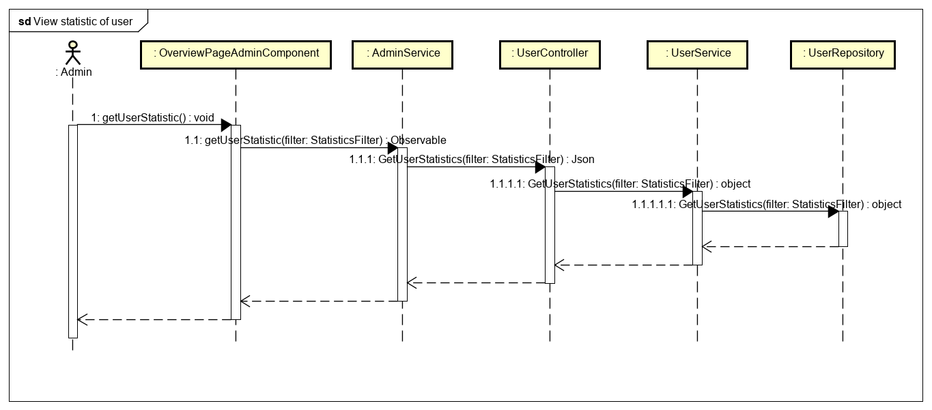

Figure 4-145: Administrator view statistic of user sequence diagram

**4.3.4.46 View statistic of posts**

**Screen Design**

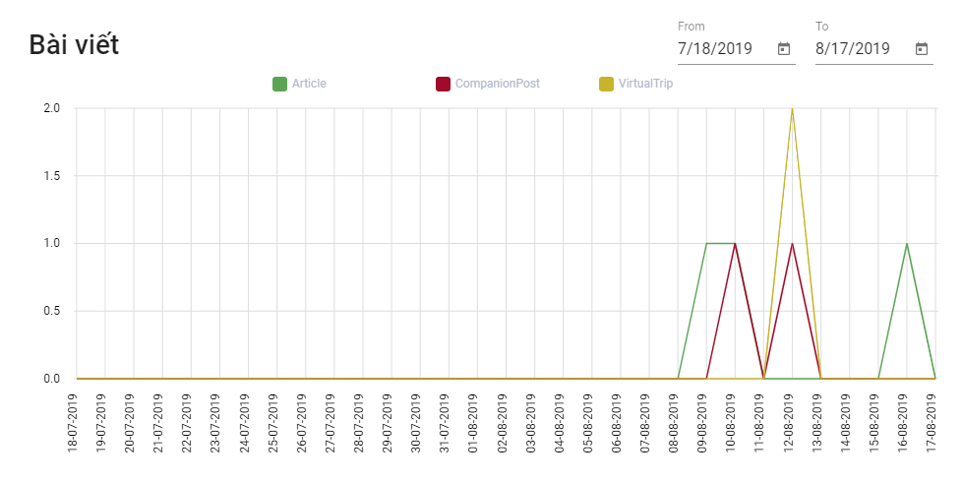

Figure 4-146: View statistic of posts screen design

**Class Diagram**

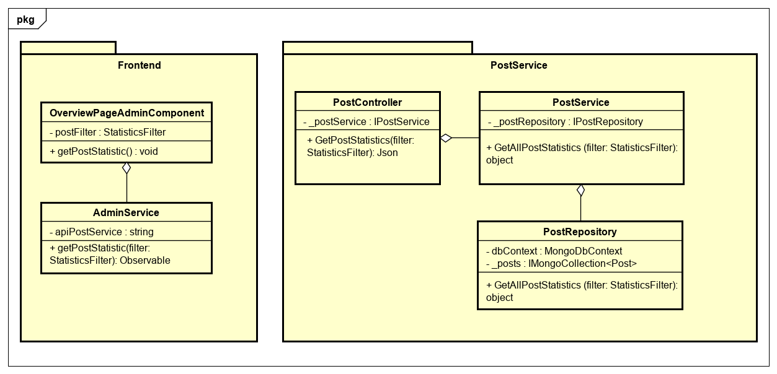

Figure 4-147: Administrator view statistic of posts class diagram

**Class Specification**

***OverviewPageAdminComponent***

|  |  |  |  |
| --- | --- | --- | --- |
| **OverviewPageAdminComponent** | | | |
| Physical address | src/app/admin/pages/dashboard-page/components/overview-page-admin/overview-page-admin.component.ts | | |
| Base class | Class | | |
| **Attributes** | | | |
| No | Name | Type | Description |
| 1 | postFilter | StatisticsFilter |  |
| **Operation** | | | |
| No | Name | Type | Description |
| 1 | getPostStatistic | void |  |

***AdminService***

|  |  |  |  |
| --- | --- | --- | --- |
| **AdminService** | | | |
| Physical address | src/app/admin/services/admin-service/admin.service.ts | | |
| Base class | Class | | |
| **Attributes** | | | |
| No | Name | Type | Description |
| 1 | apiPostService | String |  |
| **Operation** | | | |
| No | Name | Return Type | Description |
| 1 | getPostStatistic | Observable |  |

***PostController***

|  |  |  |  |
| --- | --- | --- | --- |
| **PostController** | | | |
| Physical address | src/Services/PostService/PostService/Controllers/PostController.cs | | |
| Base class | ControllerBase | | |
| **Attributes** | | | |
| No | Name | Type | Description |
| 1 | _postService | IPostService |  |
| **Operation** | | | |
| No | Name | Type | Description |
| 1 | GetPostStatistics | Json |  |

***PostService***

|  |  |  |  |
| --- | --- | --- | --- |
| **PostService** | | | |
| Physical address | src/Services/PostService/PostService/Service/PostService.cs | | |
| Base class | IPostService | | |
| **Attributes** | | | |
| No | Name | Type | Description |
| 1 | _postRepository | IPostRepository |  |
| **Operation** | | | |
| No | Name | Type | Description |
| 1 | GetAllPostStatistics | Object |  |

***PostRepository***

|  |  |  |  |
| --- | --- | --- | --- |
| **PostRepository** | | | |
| Physical address | ./src/Services/ PostService/PostService /Repository/PostRepository.cs | | |
| Base class | IPostRepository | | |
| **Attributes** | | | |
| No | Name | Type | Description |
| 1 | dbContext | MongoDbContext |  |
| 2 | _posts | ImongoCollection  <Post> |  |
| **Operation** | | | |
| No | Name | Type | Description |
| 1 | GetAllPostStatistics | Object |  |

**Sequence Diagram**

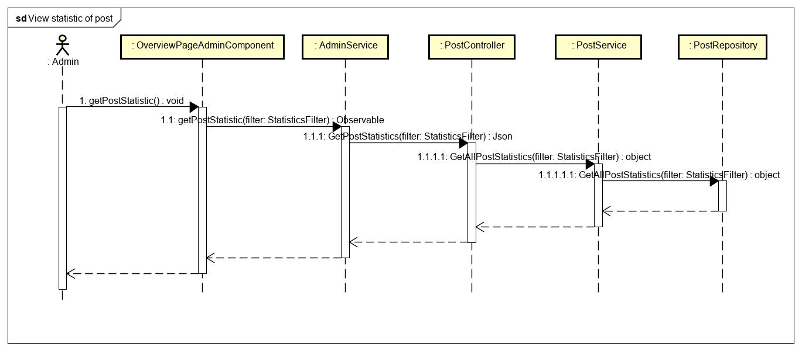

Figure 4-148: Administrator view statistic of posts sequence diagram

**4.3.4.47 Search posts**

**Screen Design**

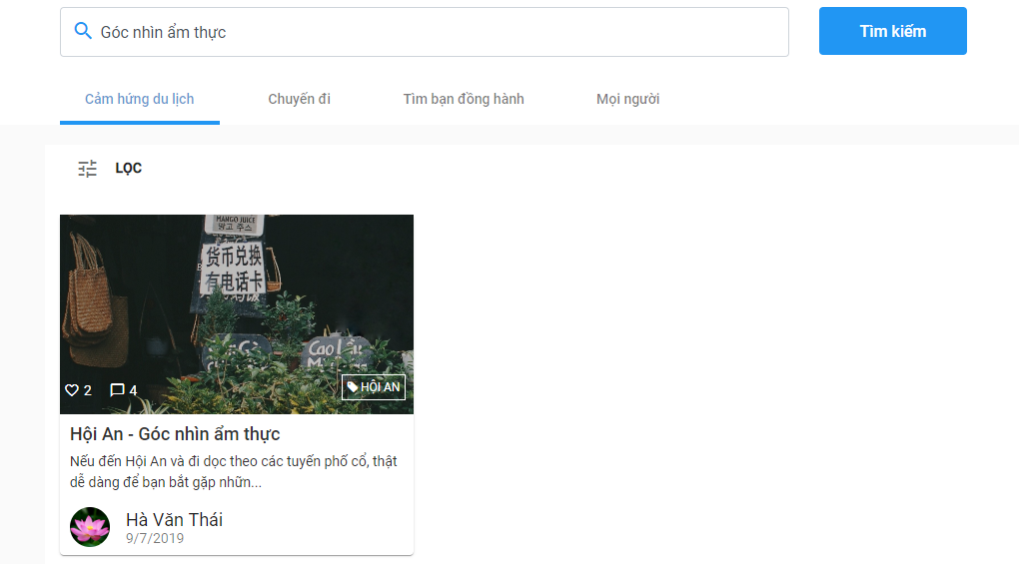

Figure 4-149: Search posts screen design

**Class Diagram**

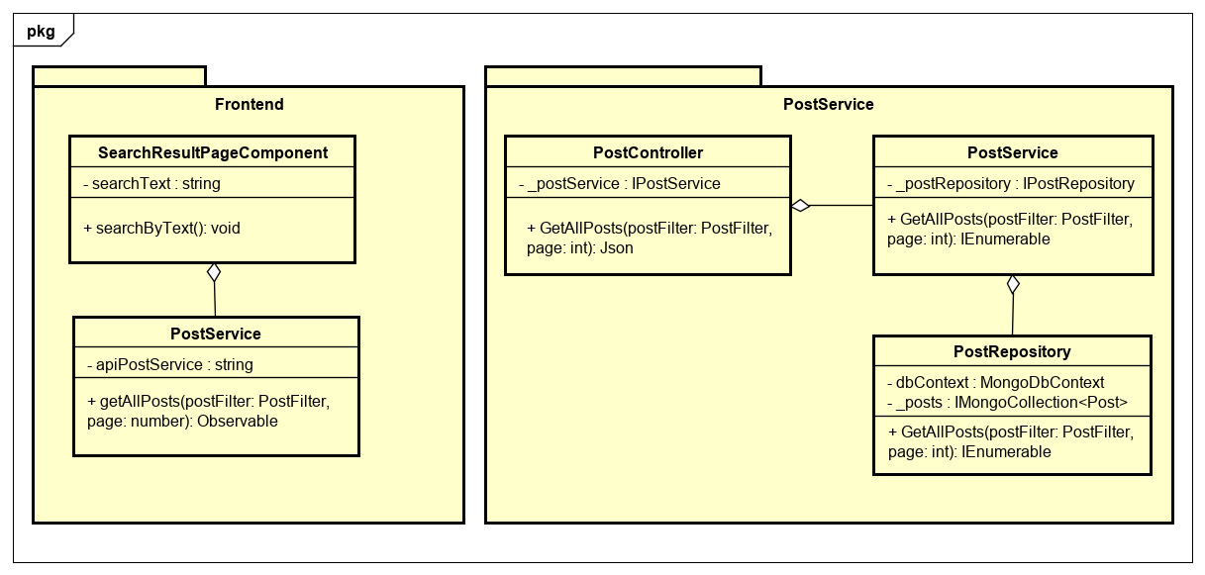

Figure 4-150: Search posts class diagram

**Class Specification**

**SearchResultPageComponent**

|  |  |  |  |
| --- | --- | --- | --- |
| **SearchResultPageComponent** | | | |
| Physical address | src/app/pages/search-result-page/search-result-page.component.ts | | |
| Base class | Class | | |
| **Attributes** | | | |
| No | Name | Type | Description |
| 1 | searchText | String |  |
| **Operation** | | | |
| No | Name | Type | Description |
| 1 | searchByText | void |  |

***PostService***

|  |  |  |  |
| --- | --- | --- | --- |
| **PostService** | | | |
| Physical address | src/app/core/services/post-service/post.service.ts | | |
| Base class | Class | | |
| **Attributes** | | | |
| No | Name | Type | Description |
| 1 | apiPostService | String |  |
| **Operation** | | | |
| No | Name | Return Type | Description |
| 1 | getAllPosts | Observable |  |

***PostController***

|  |  |  |  |
| --- | --- | --- | --- |
| **PostController** | | | |
| Physical address | src/Services/PostService/PostService/Controllers/PostController.cs | | |
| Base class | ControllerBase | | |
| **Attributes** | | | |
| No | Name | Type | Description |
| 1 | _postService | IPostService |  |
| **Operation** | | | |
| No | Name | Type | Description |
| 1 | GetAllPosts | Json |  |

***PostService***

|  |  |  |  |
| --- | --- | --- | --- |
| **PostService** | | | |
| Physical address | ./src/Services/ PostService/PostService/Service/PostService.cs | | |
| Base class | IPostService | | |
| **Attributes** | | | |
| No | Name | Type | Description |
| 1 | _postRepository | IPostRepository |  |
| **Operation** | | | |
| No | Name | Type | Description |
| 1 | GetAllPosts | IEnumerable |  |

***PostRepository***

|  |  |  |  |
| --- | --- | --- | --- |
| **PostRepository** | | | |
| Physical address | ./src/Services/ PostService/PostService /Repository/PostRepository.cs | | |
| Base class | IPostRepository | | |
| **Attributes** | | | |
| No | Name | Type | Description |
| 1 | dbContext | MongoDbContext |  |
| 2 | _posts | ImongoCollection  <Post> |  |
| **Operation** | | | |
| No | Name | Type | Description |
| 1 | GetAllPost | IEnumerable |  |

**Sequence Diagram**

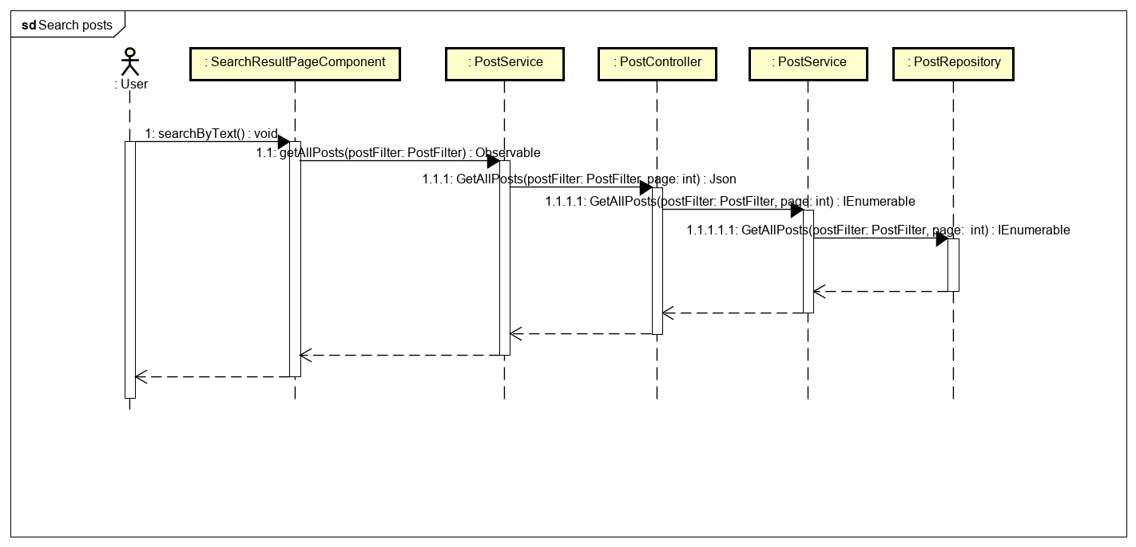

Figure 4-151: Search posts sequence diagram

**4.3.4.48 Search a user**

**Screen Design**

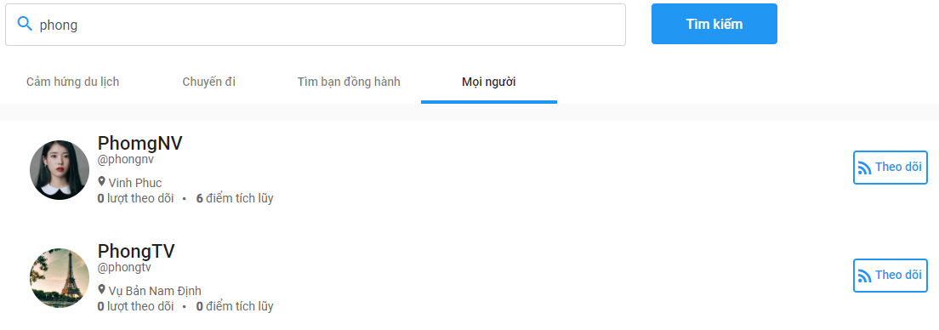

Figure 4-152: Search a user class diagram

**Class Diagram**

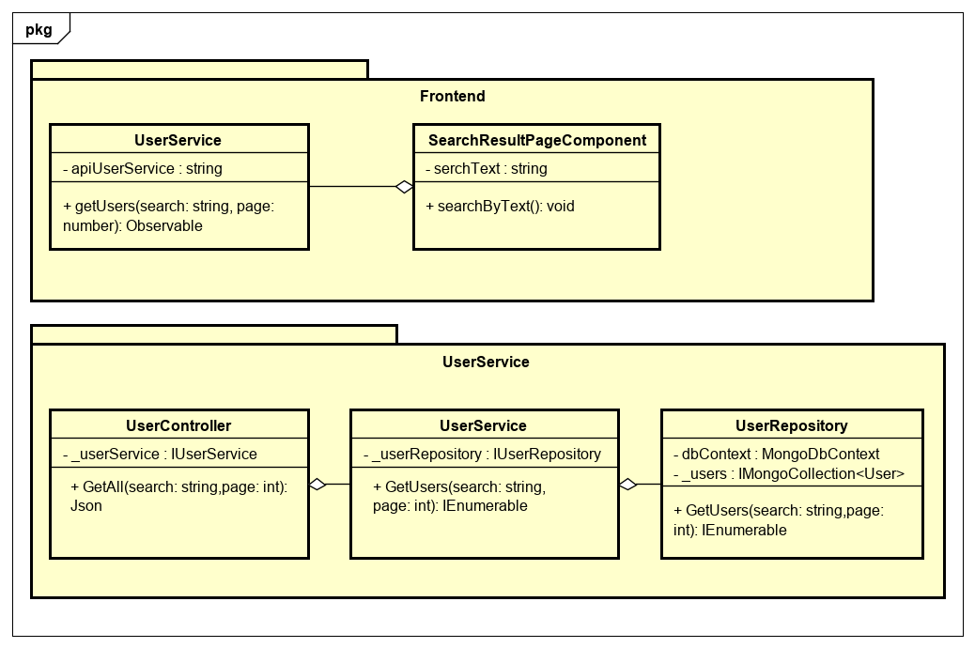

Figure 4-153: Search a user class diagram

**Class Specification**

***SearchResultPageComponent***

|  |  |  |  |
| --- | --- | --- | --- |
| **SearchResultPageComponent** | | | |
| Physical address | src/app/pages/search-result-page/search-result-page.component.ts | | |
| Base class | Class | | |
| **Attributes** | | | |
| No | Name | Type | Description |
| 1 | serchText | String |  |
| **Operation** | | | |
| No | Name | Type | Description |
| 1 | searchByText | void |  |

***UserService***

|  |  |  |  |
| --- | --- | --- | --- |
| **UserService** | | | |
| Physical address | src/app/core/services/user-service/user.service.ts | | |
| Base class | Class | | |
| **Attributes** | | | |
| No | Name | Type | Description |
| 1 | apiUserService | String |  |
| **Operation** | | | |
| No | Name | Return Type | Description |
| 1 | getUsers | Observable |  |

***UserController***

|  |  |  |  |
| --- | --- | --- | --- |
| **UserController** | | | |
| Physical address | src/Services/UserService/UserService/Controllers/UserController.cs | | |
| Base class | ControllerBase | | |
| **Attributes** | | | |
| No | Name | Type | Description |
| 1 | _userService | IUserService |  |
| **Operation** | | | |
| No | Name | Type | Description |
| 1 | GetAll | Json |  |

***UserService***

|  |  |  |  |
| --- | --- | --- | --- |
| **UserService** | | | |
| Physical address | src/Services/UserService/UserService/Service/UserService.cs | | |
| Base class | IUserService | | |
| **Attributes** | | | |
| No | Name | Type | Description |
| 1 | _userRepository | IUserRepository |  |
| **Operation** | | | |
| No | Name | Type | Description |
| 1 | GetUsers | IEnumerable |  |

***UserRepository***

|  |  |  |  |
| --- | --- | --- | --- |
| **UserRepository** | | | |
| Physical address | src/Services/UserService/UserService/Repository/UserRepository.cs | | |
| Base class | IUserRepository | | |
| **Attributes** | | | |
| No | Name | Type | Description |
| 1 | dbContext | MongoDbContext |  |
| 2 | _users | ImongoCollection  <User> |  |
| **Operation** | | | |
| No | Name | Type | Description |
| 1 | GetUsers | IEnumerable |  |

**Sequence Diagram**

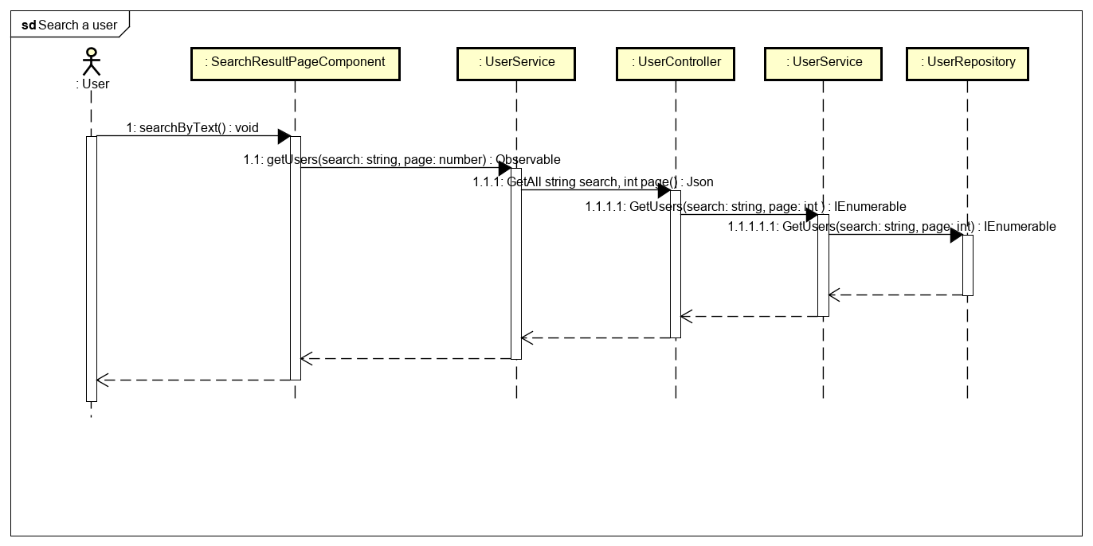

Figure 4-154: Search a user sequence diagram

**4.3.4.49 View popular articles**

**Screen design**

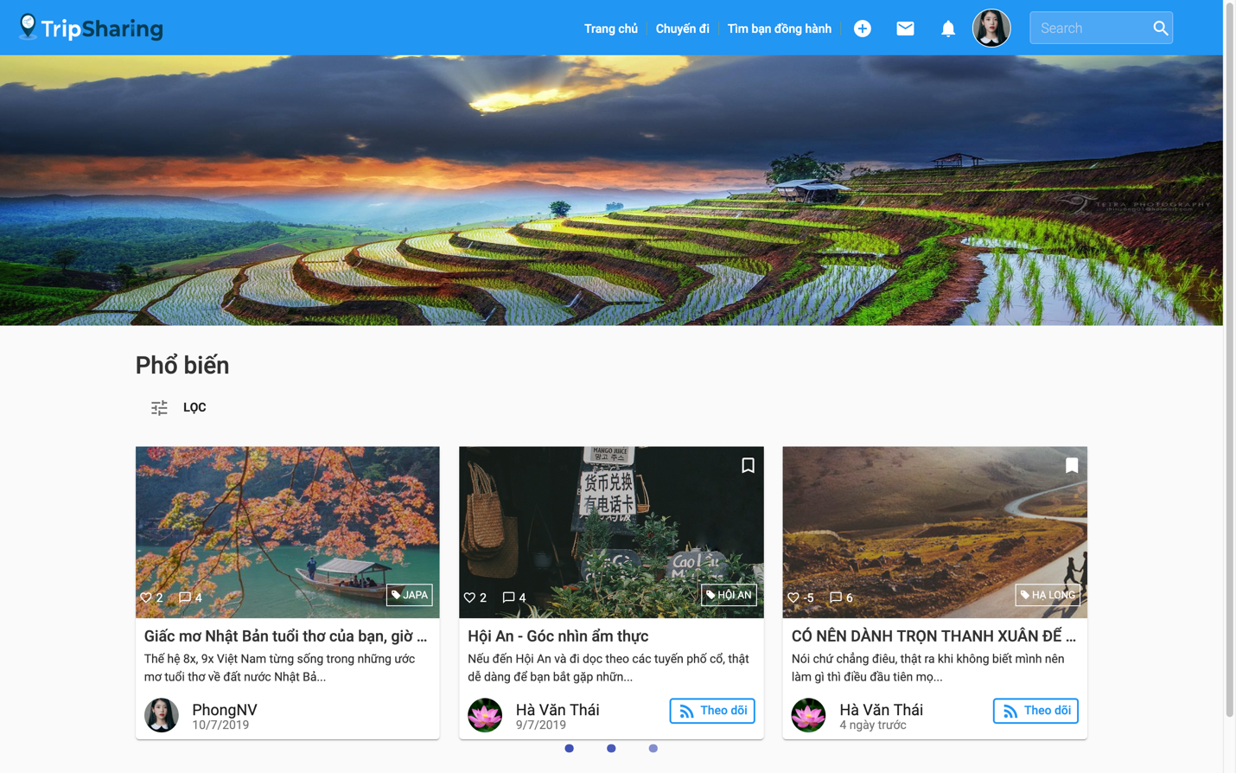

Figure 4-155: View popular articles screen

**Class Diagram**

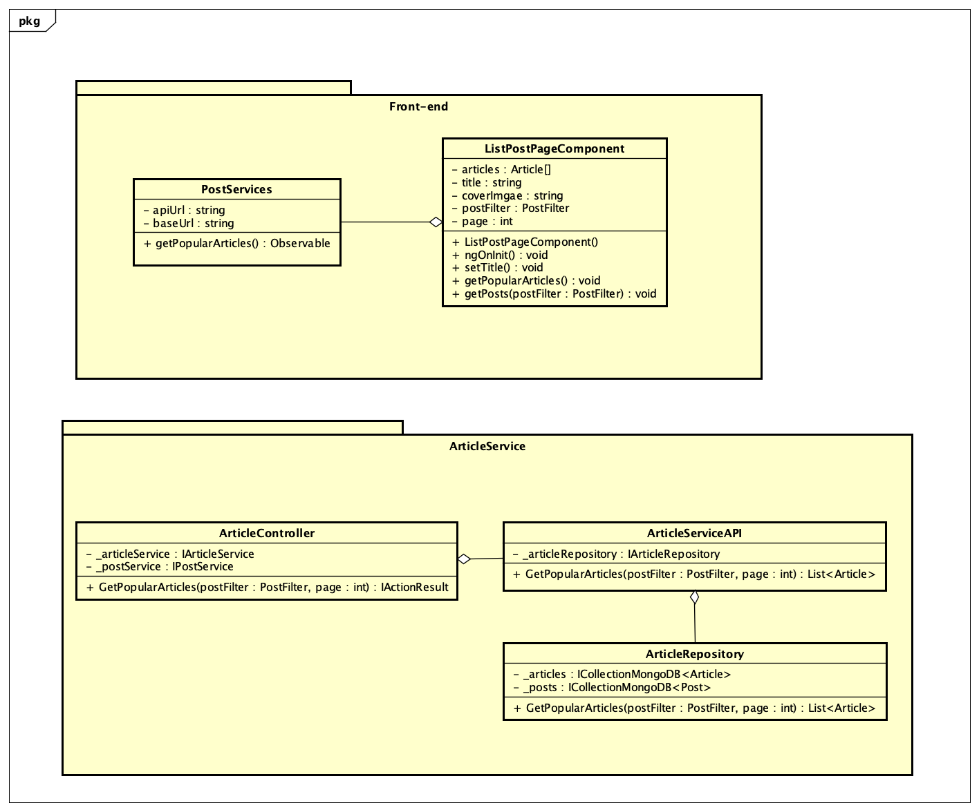

Figure 4-156: View Popular Articles Class Diagram

**Class Specification**

***ListPostPageComponent***

|  |  |  |  |
| --- | --- | --- | --- |
| **ListPostPageComponent** | | | |
| Physical address | src\app\pages\list-post-page\list-post-page.component.ts | | |
| Base Class | Class | | |
| **Attributes** | | | |
| No | Name | Type | Description |
| 1 | articles | Article[] |  |
| 2 | title | String |  |
| 3 | coverImage | String |  |
| 4 | postFilter | PostFilter |  |
| 5 | page | Int |  |
| **Operations** | | | |
| No | Name | Return Type | Description |
| 1 | ListPostPageComponent | void | Contructor excecute function setTitle() |
| 2 | ngOninit | void | Life circle hook in Angular execute function getPosts() |
| 3 | setTitle | void | Set page’s title |
| 4 | getPopularArticles | void | Get popular articles posts |
| 5 | getPosts |  | Get articles posts execute function getPopularArticles() |

***PostServices***

|  |  |  |  |
| --- | --- | --- | --- |
| **PostServices** | | | |
| Physical address | src\app\core\services\post-service\post.service.ts | | |
| Base Class | Class | | |
| **Attributes** | | | |
| No | Name | Type | Description |
| 1 | apiUrl | String |  |
| 2 | baseUrl | String |  |
| **Operations** | | | |
| No | Name | Return Type | Description |
| 1 | getPopularArticles | Observable | Call api get data from server |

***ArticleController***

|  |  |  |  |
| --- | --- | --- | --- |
| **ArticleController** | | | |
| Physical address | Src\Services\PostService\PostService\Controllers\ArticleController.cs | | |
| Base Class | Class | | |
| **Attributes** | | | |
| No | Name | Type | Description |
| 1 | _articleService | IArticleService |  |
| 2 | _postService | IPostService |  |
| **Operations** | | | |
| No | Name | Return Type | Description |
| 1 | GetPopularArticles | IActionResult | Get popular article posts and return data to font-end. |

***ArticleServiceAPI***

|  |  |  |  |
| --- | --- | --- | --- |
| **ArticleServiceAPI** | | | |
| Physical address | Src\Services\PostService\PostService\Services\ArticleServiceAPI.cs | | |
| Base Class | Class | | |
| **Attributes** | | | |
| No | Name | Type | Description |
| 1 | _articleRepository | IArticleRepository |  |
| **Operations** | | | |
| No | Name | Return Type | Description |
| 1 | GetPopularArticles | List<Object> | Get popular article posts |

***ArticleRepository***

|  |  |  |  |
| --- | --- | --- | --- |
| **ArticleRepository** | | | |
| Physical address | Src\Services\PostService\PostService\Repositories\ArticleRepository.cs | | |
| Base Class | Class | | |
| **Attributes** | | | |
| No | Name | Type | Description |
| 1 | _articles | ICollectionMongoDB<Article> |  |
| 2 | _posts | ICollectionMongoDB <Post> |  |
| **Operations** | | | |
| No | Name | Return Type | Description |
| 1 | GetPopularArticles | List<Article> | Get popular article posts from database |

**Sequence Diagram**

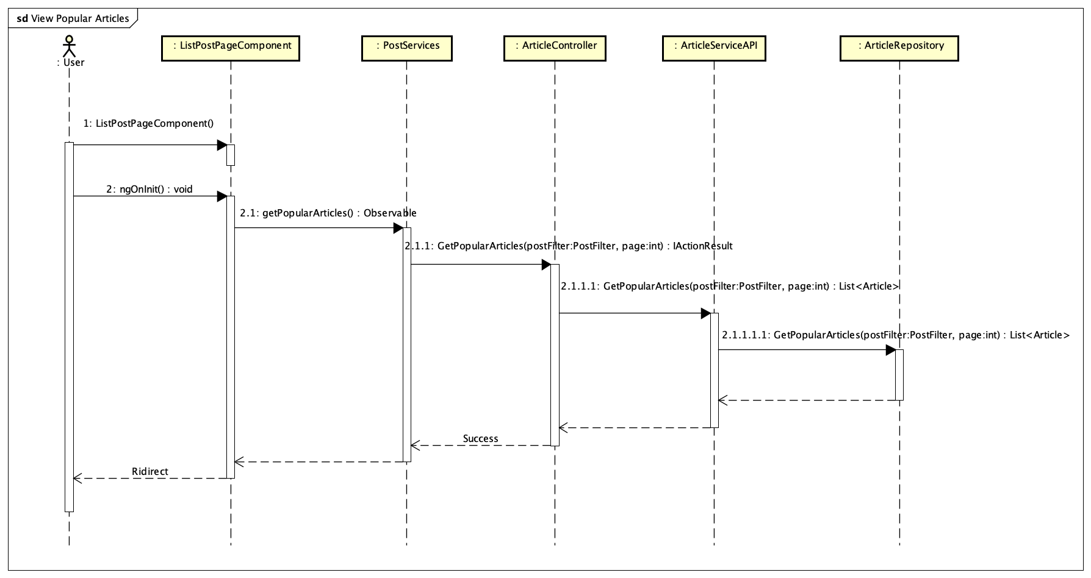

Figure 4-157: View Popular Articles Sequence Diagram

**4.3.4.50 View recently articles**

**Screen design**

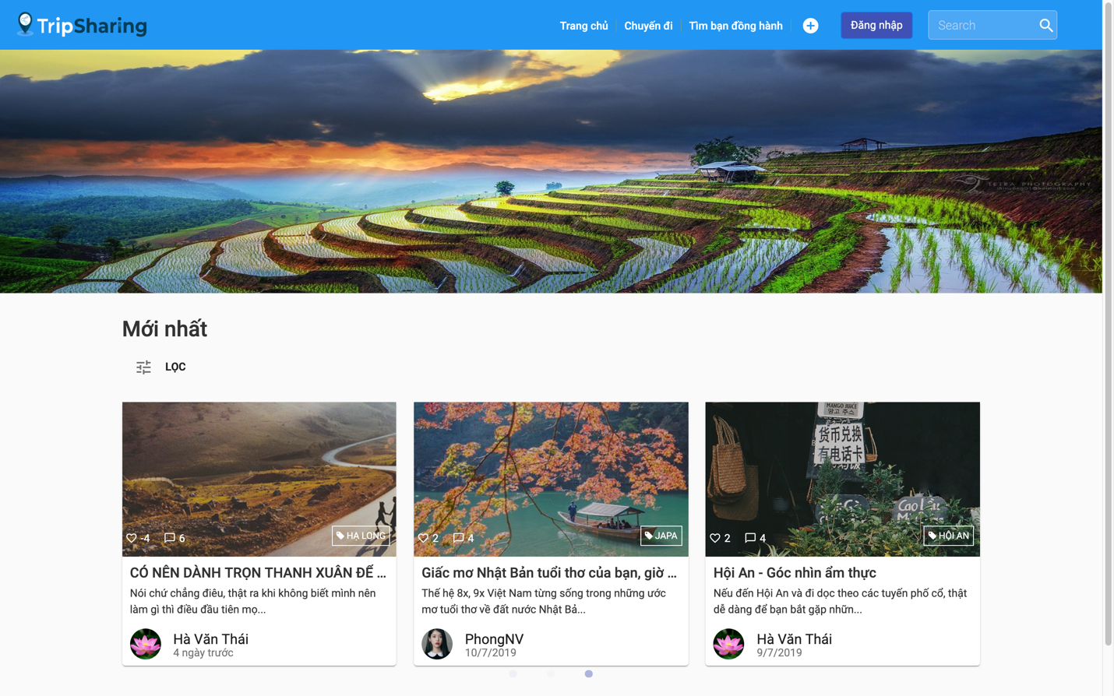

Figure 2-158: View Recently Articles screen

**Class Diagram**

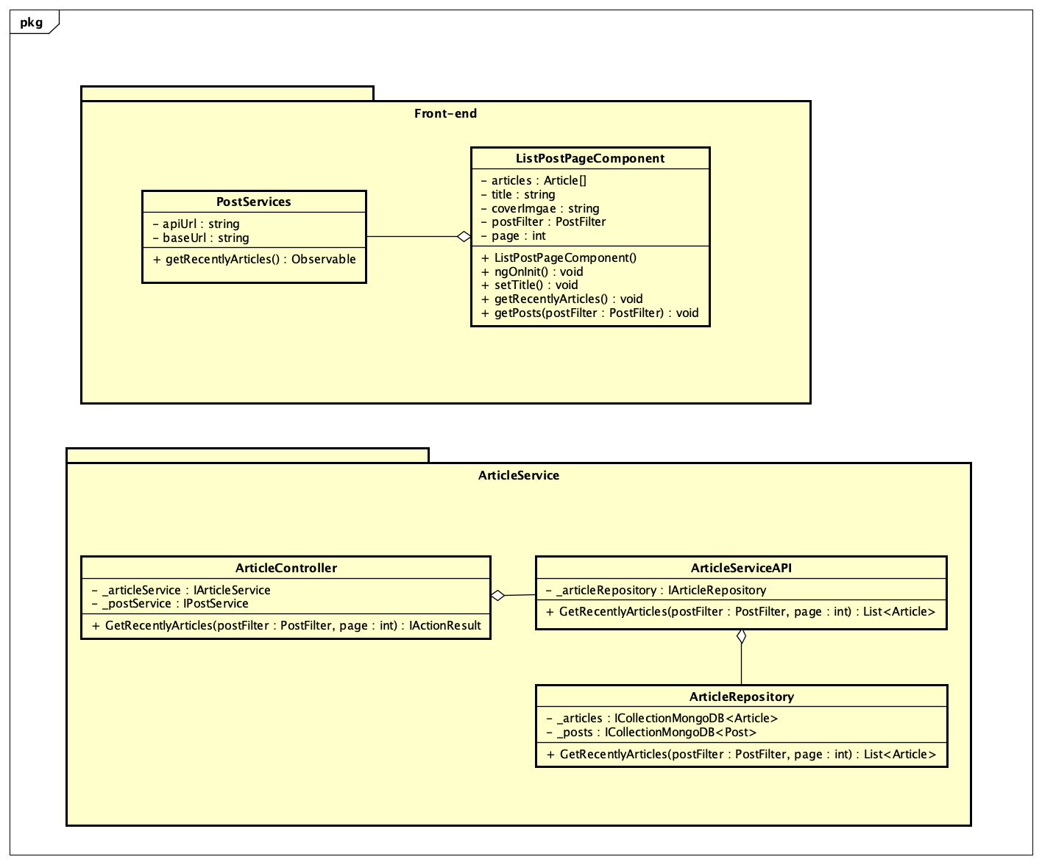

Figure 4-159: View recently articles Class Diagram

**Class Specification**

***ListPostPageComponent***

|  |  |  |  |
| --- | --- | --- | --- |
| **ListPostPageComponent** | | | |
| Physical address | src\app\pages\list-post-page\list-post-page.component.ts | | |
| Base Class | Class | | |
| **Attributes** | | | |
| No | Name | Type | Description |
| 1 | articles | Article[] |  |
| 2 | title | String |  |
| 3 | coverImage | String |  |
| 4 | postFilter | PostFilter |  |
| 5 | page | Int |  |
| **Operations** | | | |
| No | Name | Return Type | Description |
| 1 | ListPostPageComponent | void | Contructor excecute function setTitle() |
| 2 | ngOninit | void | Life circle hook in Angular execute function getPosts() |
| 3 | setTitle | void | Set page’s title |
| 4 | getRecentlyArticles | void | Get popular articles posts |
| 5 | getPosts |  | Get articles posts execute function getRecentlyArticles() |

***PostServices***

|  |  |  |  |
| --- | --- | --- | --- |
| **PostServices** | | | |
| Physical address | src\app\core\services\post-service\post.service.ts | | |
| Base Class | Class | | |
| **Attributes** | | | |
| No | Name | Type | Description |
| 1 | apiUrl | String |  |
| 2 | baseUrl | String |  |
| **Operations** | | | |
| No | Name | Return Type | Description |
| 1 | getRecentlyArticles | Observable | Call api get data from server |

***ArticleController***

|  |  |  |  |
| --- | --- | --- | --- |
| **ArticleController** | | | |
| Physical address | Src\Services\PostService\PostService\Controllers\ArticleController.cs | | |
| Base Class | Class | | |
| **Attributes** | | | |
| No | Name | Type | Description |
| 1 | _articleService | IArticleService |  |
| 2 | _postService | IPostService |  |
| **Operations** | | | |
| No | Name | Return Type | Description |
| 1 | GetRecentlyArticles | IActionResult | Get recently article posts and return data to font-end. |

***ArticleServiceAPI***

|  |  |  |  |
| --- | --- | --- | --- |
| **ArticleServiceAPI** | | | |
| Physical address | Src\Services\PostService\PostService\Services\ArticleServiceAPI.cs | | |
| Base Class | Class | | |
| **Attributes** | | | |
| No | Name | Type | Description |
| 1 | _articleRepository | IArticleRepository |  |
| **Operations** | | | |
| No | Name | Return Type | Description |
| 1 | GetRecentlyArticles | List<Article > | Get recently article posts |

***ArticleRepository***

|  |  |  |  |
| --- | --- | --- | --- |
| **ArticleRepository** | | | |
| Physical address | Src\Services\PostService\PostService\Repositories\ArticleRepository.cs | | |
| Base Class | Class | | |
| **Attributes** | | | |
| No | Name | Type | Description |
| 1 | _articles | ICollectionMongoDB<Article> |  |
| 2 | _posts | ICollectionMongoDB<Post> |  |
| **Operations** | | | |
| No | Name | Return Type | Description |
| 1 | GetRecentlyArticles | List<Article > | Get recently article posts from database |

**Sequence Diagram**

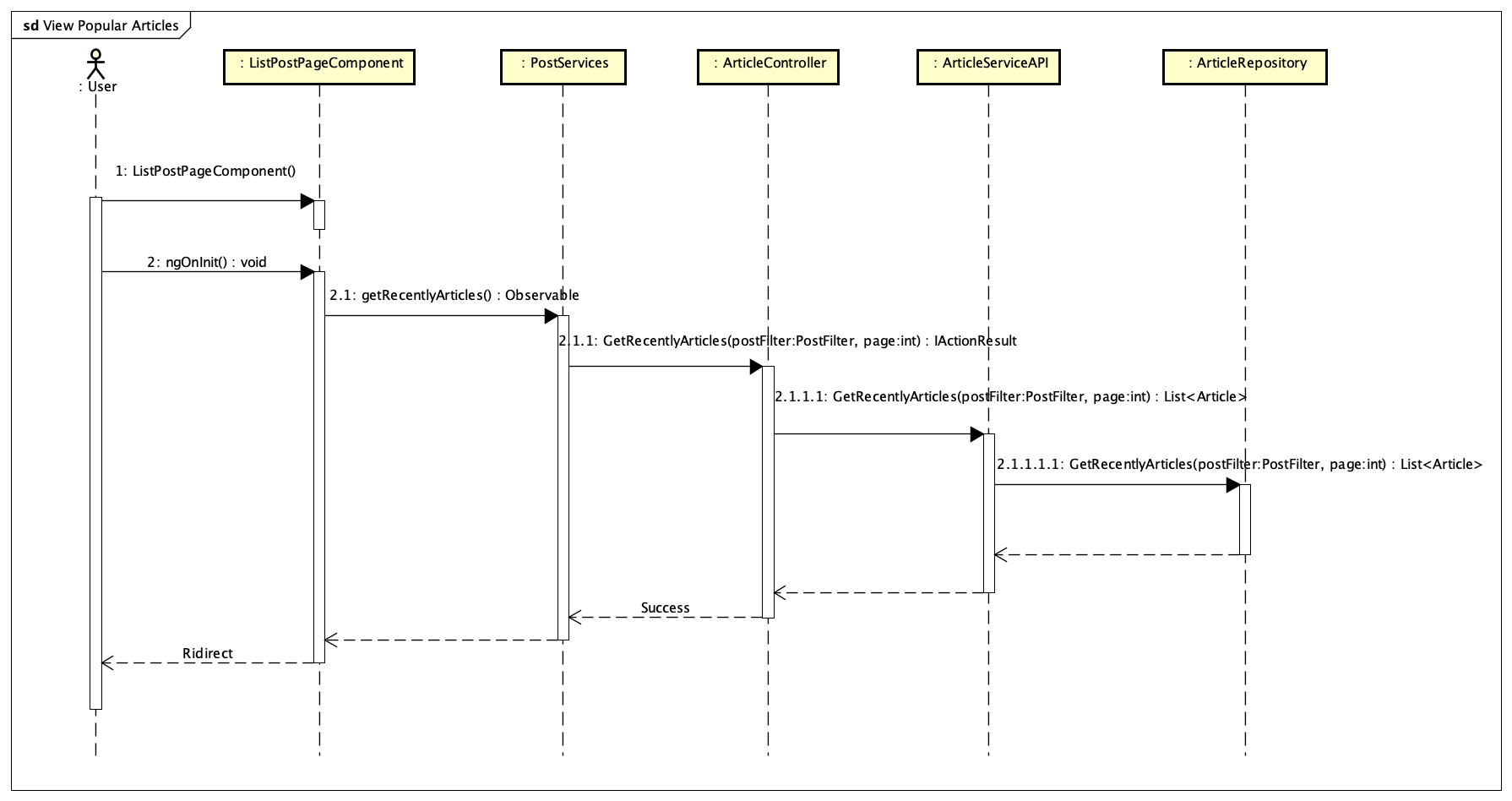

Figure 4-160: View Recently Articles Sequence Diagram

**4.3.4.51 View a post detail**

**Screen design**

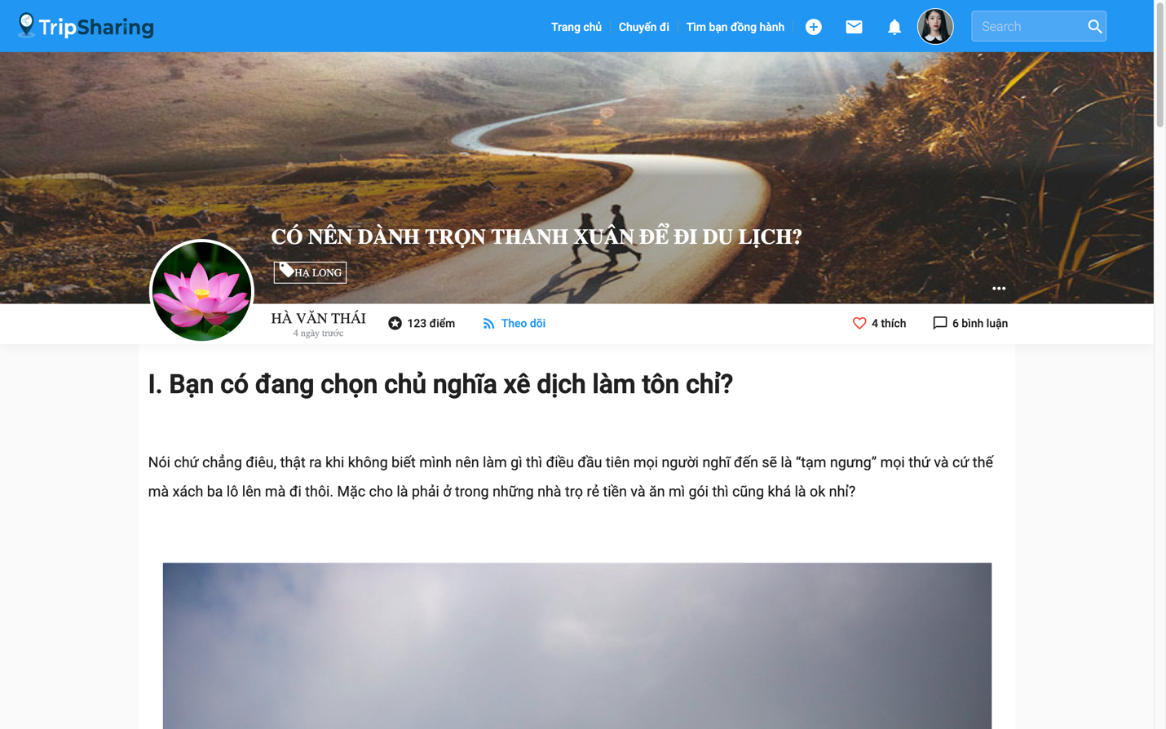

Figure 4-161: View a Post Detail screen

**Class Diagram**

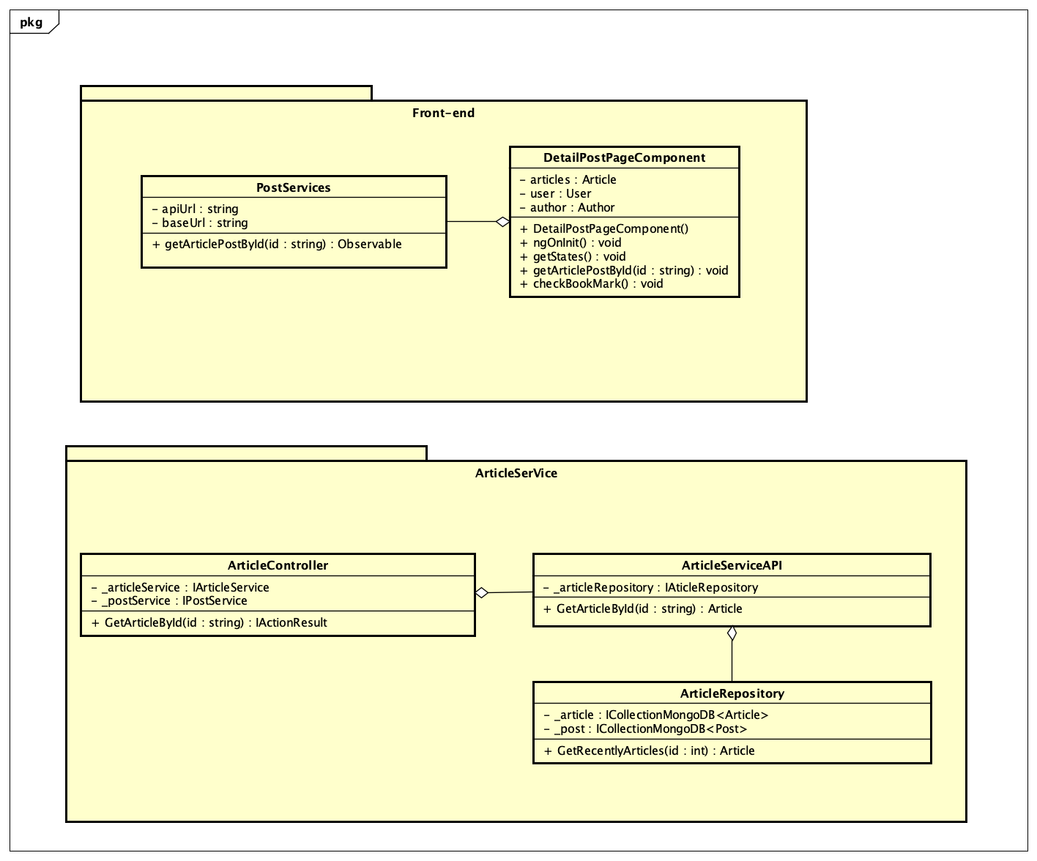

Figure 4-162: View a Post Detail Class Diagram

**Class Specification**

***DetailPostPageComponent***

|  |  |  |  |  |
| --- | --- | --- | --- | --- |
| **ListPostPageComponent** | | | | |
| Physical address | src\app\pages\list-post-page\detail-post-page.component.ts | | | |
| Base Class | Class | | | |
| **Attributes** | | | | |
| No | | Name | Type | Description |
| 1 | article | | Article |  |
| 2 | user | | User |  |
| 3 | author | | Author |  |
| **Operations** | | | | |
| No | Name | | Return Type | Description |
| 1 | DetailPostPageComponent | | void | Contructor |
| 2 | ngOninit | | void | Life circle hook in Angular execute function getArticlePostById() |
| 3 | getState | | void | Get state of post |
| 4 | getArticlePostById | | void | Get detail article post by id |

***PostServices***

|  |  |  |  |
| --- | --- | --- | --- |
| **PostServices** | | | |
| Physical address | src\app\core\services\post-service\post.service.ts | | |
| Base Class | Class | | |
| **Attributes** | | | |
| No | Name | Type | Description |
| 1 | apiUrl | String |  |
| 2 | baseUrl | string |  |
| **Operations** | | | |
| No | Name | Return Type | Description |
| 1 | getArticlePostById | Observable | Call api get data from server |

***ArticleController***

|  |  |  |  |
| --- | --- | --- | --- |
| **ArticleController** | | | |
| Physical address | Src\Services\PostService\PostService\Controllers\ArticleController.cs | | |
| Base Class | Class | | |
| **Attributes** | | | |
| No | Name | Type | Description |
| 1 | _articleService | IArticleService |  |
| 2 | _postService | IPostService |  |
| **Operations** | | | |
| No | Name | Return Type | Description |
| 1 | GetArticlePostById | IActionResult | Get detail article post by id and return data to font-end. |

***ArticleServiceAPI***

|  |  |  |  |  |
| --- | --- | --- | --- | --- |
| **ArticleServiceAPI** | | | | |
| Physical address | Src\Services\PostService\PostService\Services\ArticleServiceAPI.cs | | | |
| Base Class | Class | | | |
| **Attributes** | | | | |
| No | Name | Type | Description | |
| 1 | _articleRepository | IArticleRepository | |  |
| **Operations** | | | | |
| No | Name | Return Type | Description | |
| 1 | GetArticlePostById | Object | Get detail article post by id | |

***ArticleRepository***

|  |  |  |  |  |
| --- | --- | --- | --- | --- |
| **ArticleRepository** | | | | |
| Physical address | Src\Services\PostService\PostService\Repositories\ArticleRepository.cs | | | |
| Base Class | Class | | | |
| **Attributes** | | | | |
| No | Name | Type | | Description |
| 1 | _articles | ICollectionMongoDB<Article> | |  |
| 2 | _posts | ICollectionMongoDB<Post> | |  |
| **Operations** | | | | |
| No | Name | Return Type | Description | |
| 1 | GetArticlePostById | Object | Get detail article post by id from database | |

**Sequence Diagram**

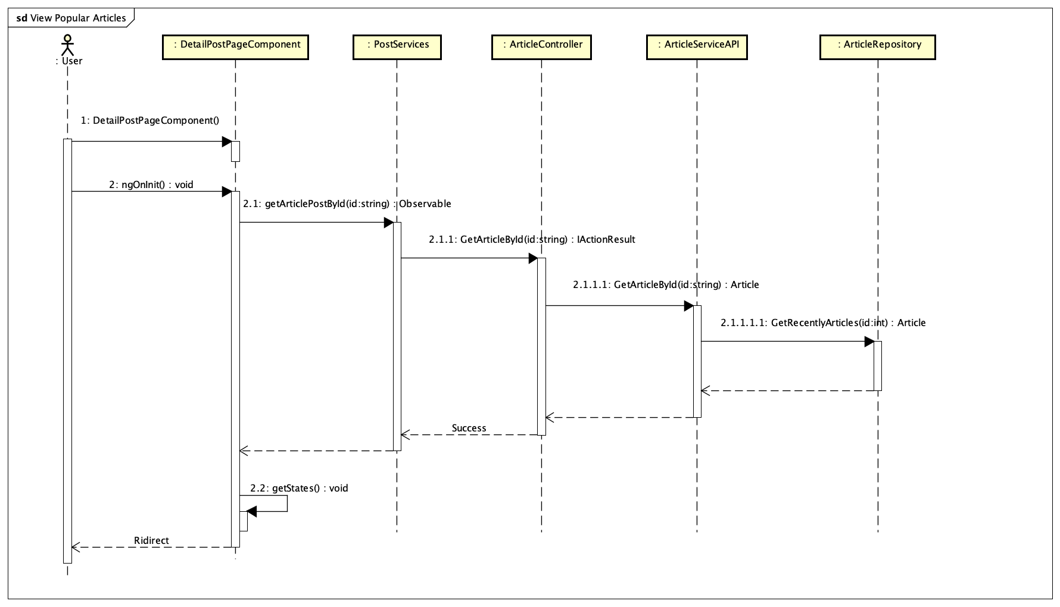

Figure 4-163: View detail a post sequence diagram

**4.3.4.52 View user’s created posts**

**Screen design**

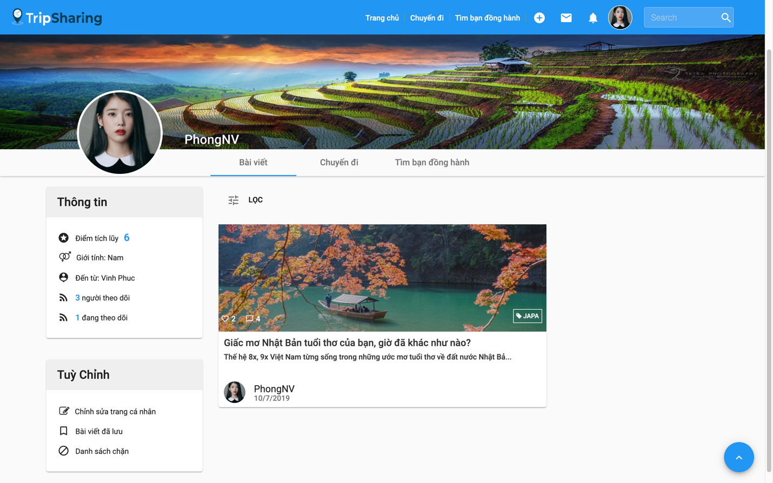

Figure 4-164: View user’s created posts screen

**Class Diagram**

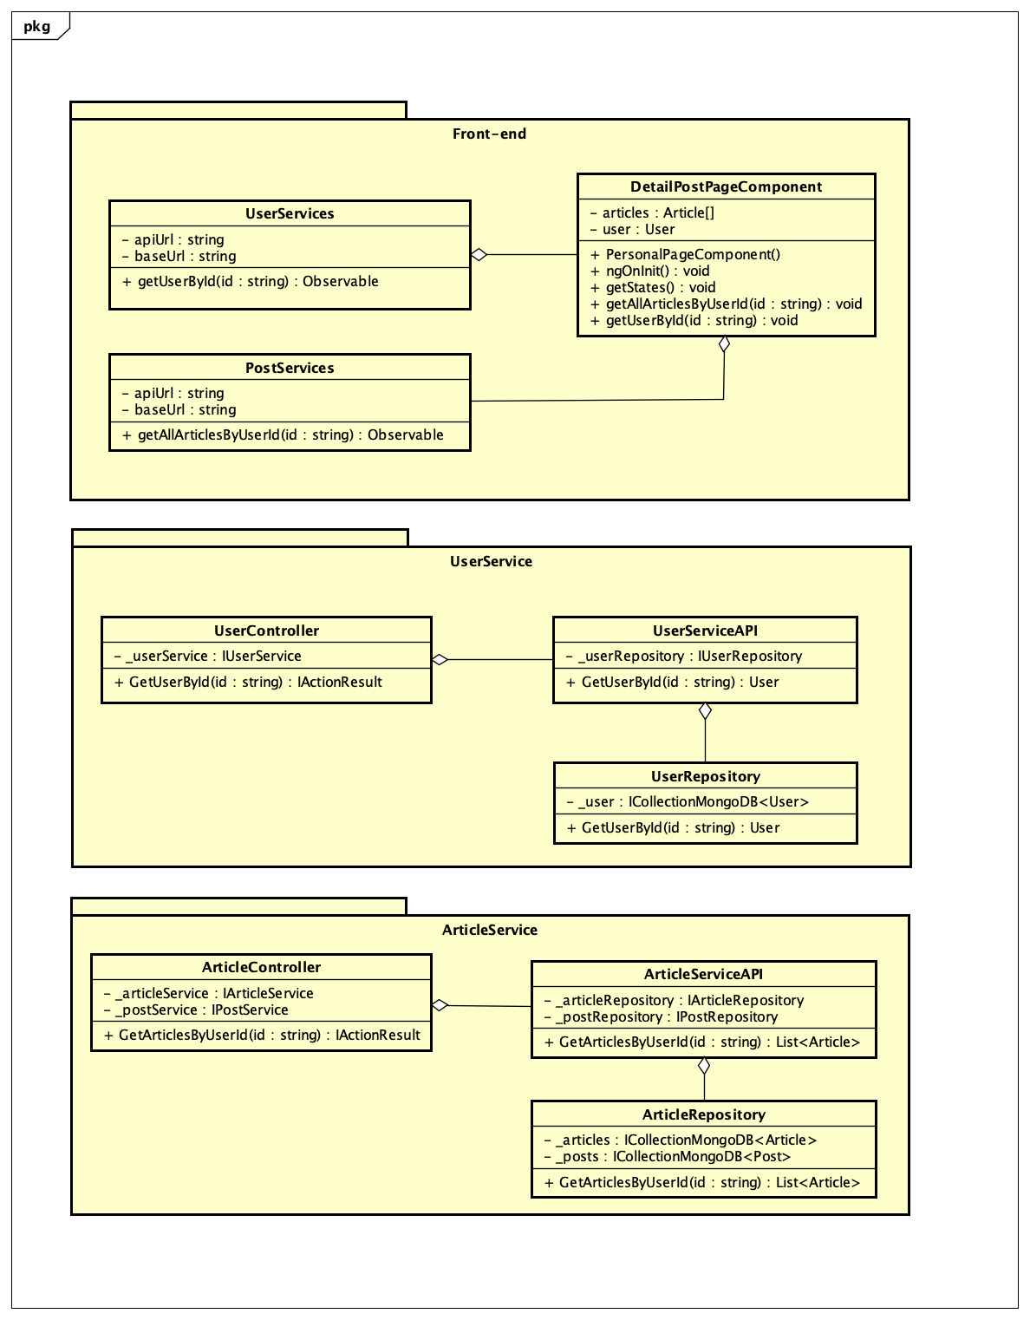

Figure 4-165: View User’s created posts Class Diagram

**Class Specification**

***PersonalPageComponent***

|  |  |  |  |
| --- | --- | --- | --- |
| **PersonalPageComponent** | | | |
| Physical address | src\app\pages\list-post-page\personal-page.component.ts | | |
| Base Class | Class | | |
| **Attributes** | | | |
| No | Name | Return Type | Description |
| 1 | articles | Article |  |
| 2 | user | User |  |
| **Operations** | | | |
| No | Name | Return Type | Description |
| 1 | PersonalPageComponent | void | Contructor |
| 2 | ngOninit | void | Life circle hook in Angular |
| 3 | getUserById | void | Get user by id |
| 4 | getAllArticlesByUserId | void | Get all user’s created article posts |
| 5 | getSate | void | Get state |

***PostServices***

|  |  |  |  |
| --- | --- | --- | --- |
| **PostServices** | | | |
| Physical address | src\app\core\services\post-service\post.service.ts | | |
| Base Class | Class | | |
| **Attributes** | | | |
| No | Name | Type | Description |
| 1 | apiUrl | string |  |
| 2 | baseUrl | string |  |
| **Operations** | | | |
| No | Name | Return Type | Description |
| 1 | getAllArticlesByUserId | Observable | Call api get data from server |

***ArticleController***

|  |  |  |  |
| --- | --- | --- | --- |
| **ArticleController** | | | |
| Physical address | Src\Services\PostService\PostService\Controllers\ArticleController.cs | | |
| Base Class | Class | | |
| **Attributes** | | | |
| No | Name | Type | Description |
| 1 | _articleService | IArticleService |  |
| 2 | _postService | IPostService |  |
| **Operations** | | | |
| No | Name | Return Type | Description |
| 1 | GetArticlesByUserId | IActionResult | Get user’s created article posts and return data to font-end. |

***ArticleServiceAPI***

|  |  |  |  |
| --- | --- | --- | --- |
| **ArticleService** | | | |
| Physical address | Src\Services\PostService\PostService\Services\ArticleService.cs | | |
| Base Class | Class | | |
| **Attributes** | | | |
| No | Name | Type | Description |
| 1 | _articleRepository | IArticleRepository |  |
| **Operations** | | | |
| No | Name | Return Type | Description |
| 1 | GetArticlesByUserId | List<Object> | Get user’s created posts |

***ArticleRepository***

|  |  |  |  |
| --- | --- | --- | --- |
| **ArticleRepository** | | | |
| Physical address | Src\Services\PostService\PostService\Repositories\ArticleRepository.cs | | |
| Base Class | Class | | |
| **Attributes** | | | |
| No | Name | Type | Description |
| 1 | _articles | ICollectionMongoDB <Article> |  |
| 2 | _posts | ICollectionMongoDB <Post> |  |
| **Operations** | | | |
| No | Name | Return Type | Description |
| 1 | GetArticlesByUserId | List<Object> | Get user’s created posts from database |

***UserServices***

|  |  |  |  |
| --- | --- | --- | --- |
| **UserServices** | | | |
| Physical address | src\app\core\services\post-service\user.service.ts | | |
| Base Class | Class | | |
| **Attributes** | | | |
| No | Name | Type | Description |
| 1 | apiUrl | String |  |
| 2 | baseUrl | String |  |
| **Operations** | | | |
| No | Name | Return Type | Description |
| 1 | getUserById | Observable | Call api get data from server |

***UserController***

|  |  |  |  |
| --- | --- | --- | --- |
| **UserController** | | | |
| Physical address | Src\Services\PostService\PostService\Controllers\UserController.cs | | |
| Base Class | Class | | |
| **Attributes** | | | |
| No | Name | Type | Description |
| 1 | _userService | IUserService |  |
| **Operations** | | | |
| No | Name | Return Type | Description |
| 1 | GetUserById | IActionResult | Get user detail return data to font-end. |

***UserServiceAPI***

|  |  |  |  |
| --- | --- | --- | --- |
| **UserServiceAPI** | | | |
| Physical address | Src\Services\PostService\PostService\Services\UserServiceAPI.cs | | |
| Base Class | Class | | |
| **Attributes** | | | |
| No | Name | Type | Description |
| 1 | _userRepository | IUserRepository |  |
| **Operations** | | | |
| No | Name | Return Type | Description |
| 1 | GetUserById | Object | Get user detail |

***UserRepository***

|  |  |  |  |
| --- | --- | --- | --- |
| **UserRepository** | | | |
| Physical address | Src\Services\PostService\PostService\Repositories\UserRepository.cs | | |
| Base Class | Class | | |
| **Attributes** | | | |
| No | Name | Type | Description |
| 1 | _users | ICollectionMongoDB <User> |  |
| **Operations** | | | |
| No | Name | Return Type | Description |
| 1 | GetUserById | Object | Get user detail from database |

**Sequence Diagram**

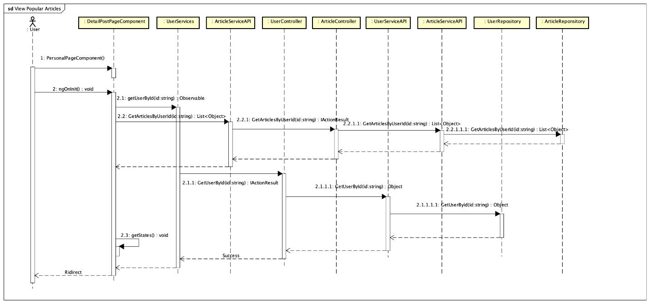

Figure 4-166: View user's created posts Sequence Diagram

**4.3.4.53 View user’s followings/followers**

**Screen design**

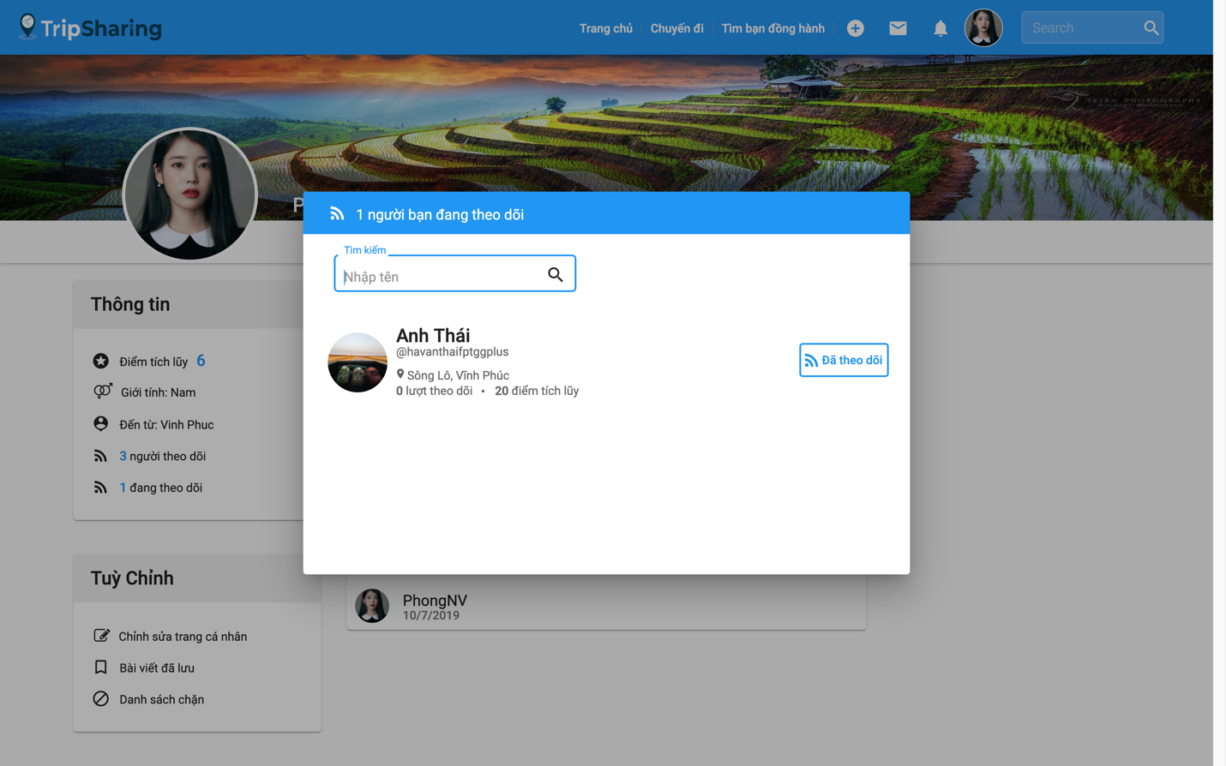

Figure 4-167: View user’s followings/ followers screen

**Class Diagram**

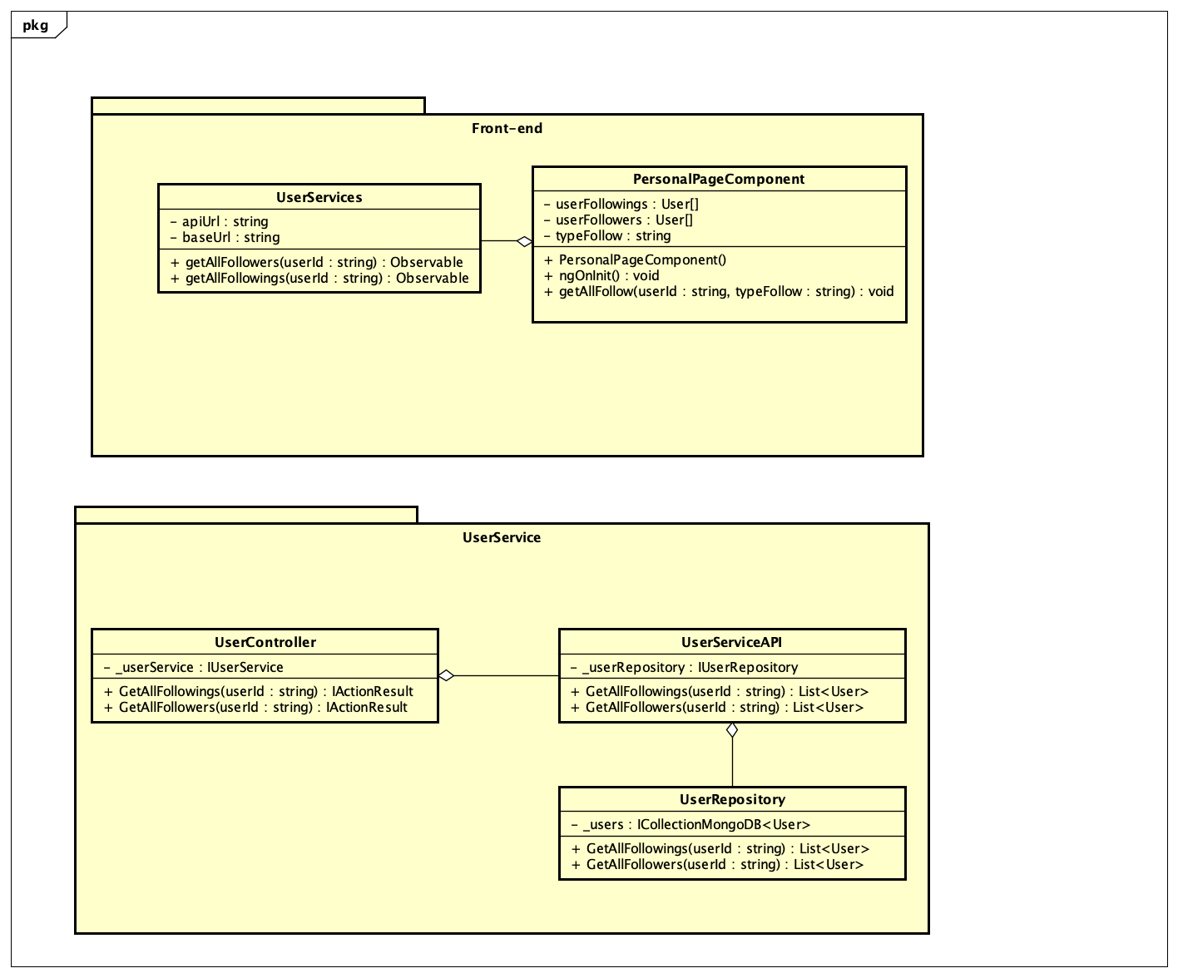

Figure 4-168: View user's following follower Class Diagram

**Class Specification**

***PersonalPageComponent***

|  |  |  |  |
| --- | --- | --- | --- |
| **PersonalPageComponent** | | | |
| Physical address | src\app\pages\list-post-page\personal-page.component.ts | | |
| Base Class | Class | | |
| **Attributes** | | | |
| No | Name | Return Type | Description |
| 1 | userFollowings | User[] |  |
| 2 | userFollowers | User[] |  |
| **Operations** | | | |
| No | Name | Return Type | Description |
| 1 | PersonalPageComponent | void | Contructor |
| 2 | ngOninit | void | Life circle hook in Angular |
| 3 | getAllFollowers | void | Get all user’s followers |
| 4 | getAllFollowings | void | Get all user’s followings |

***UserServices***

|  |  |  |  |
| --- | --- | --- | --- |
| **UserServices** | | | |
| Physical address | src\app\core\services\post-service\user.service.ts | | |
| Base Class | Class | | |
| **Attributes** | | | |
| No | Name | Type | Description |
| 1 | apiUrl | String |  |
| 2 | baseUrl | String |  |
| **Operations** | | | |
| No | Name | Return Type | Description |
| 1 | getAllFollowers | Observable | Call api get data from server |
| 2 | getAllFollowings | Observable | Call api get data from server |

***UserController***

|  |  |  |  |
| --- | --- | --- | --- |
| **UserController** | | | |
| Physical address | Src\Services\PostService\PostService\Controllers\UserController.cs | | |
| Base Class | Class | | |
| **Attributes** | | | |
| No | Name | Type | Description |
| 1 | _userService | IUserService |  |
| **Operations** | | | |
| No | Name | Return Type | Description |
| 1 | GetAllFollowers | IActionResult | Get user’s followers return data to font-end. |
| 2 | GetAllFollowings | IActionResult | Get user’s following and return data to font-end. |

***UserServiceAPI***

|  |  |  |  |
| --- | --- | --- | --- |
| **UserServiceAPI** | | | |
| Physical address | Src\Services\PostService\PostService\Services\UserServiceAPI.cs | | |
| Base Class | Class | | |
| **Attributes** | | | |
| No | Name | Type | Description |
| 1 | _userRepository | IUserRepository |  |
| **Operations** | | | |
| No | Name | Return Type | Description |
| 1 | GetAllFollowers | List<Object> | Get user’s followers |
| 2 | GetAllFollowings | List<Object> | Get user’s followings |

***UserRepository***

|  |  |  |  |
| --- | --- | --- | --- |
| **UserRepository** | | | |
| Physical address | Src\Services\PostService\PostService\Repositories\UserRepository.cs | | |
| Base Class | Class | | |
| **Attributes** | | | |
| No | Name | Type | Description |
| 1 | _users | ICollectionMongoDB <User> |  |
| **Operations** | | | |
| No | Name | Return Type | Description |
| 1 | GetAllFollowers | List<Object> | Get user’s followers from database |
| 2 | GetAllFollowings | List<Object> | Get user’s followings from database |

**Sequence Diagram**

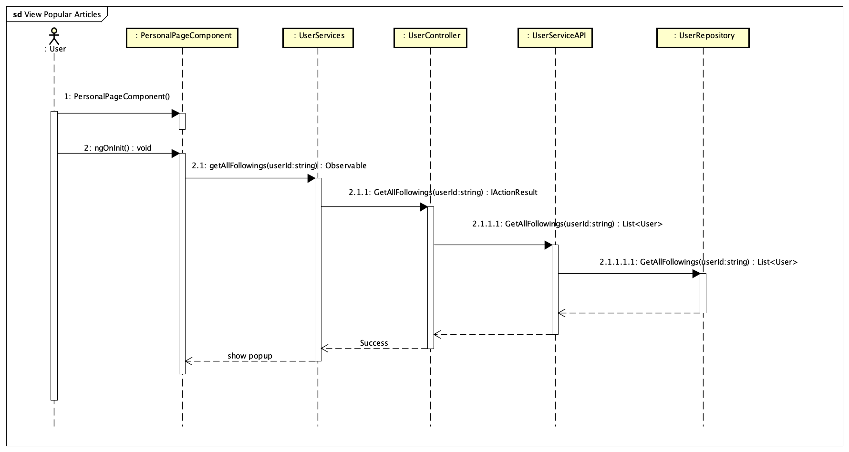

Figure 4-169: View user's following follower Sequence Diagram

**4.3.4.54 View user’s profile**

**Screen design**



Figure 4-170: View user’s profile screen

**Class Diagram**

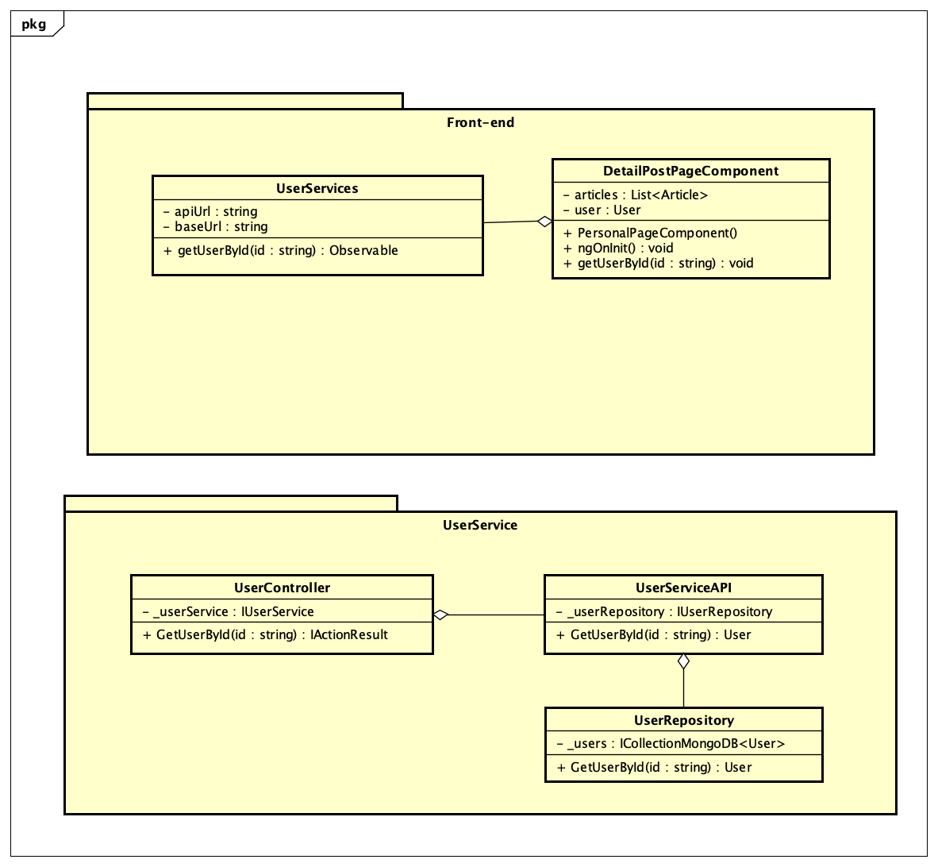

Figure 4-171: User's profile

**Class Specification**

***PersonalPageComponent***

|  |  |  |  |
| --- | --- | --- | --- |
| **PersonalPageComponent** | | | |
| Physical address | src\app\pages\list-post-page\personal-page.component.ts | | |
| Base Class | Class | | |
| **Attributes** | | | |
| No | Name | Return Type | Description |
| 1 | articles | List<Article> |  |
| 2 | user | List<User> |  |
| **Operations** | | | |
| No | Name | Return Type | Description |
| 1 | PersonalPageComponent | void | Contructor |
| 2 | ngOninit | void | Life circle hook in Angular |
| 3 | getUserById | void | Get user by id |

***UserServices***

|  |  |  |  |
| --- | --- | --- | --- |
| **UserServices** | | | |
| Physical address | src\app\core\services\post-service\user.service.ts | | |
| Base Class | Class | | |
| **Attributes** | | | |
| No | Name | Type | Description |
| 1 | apiUrl | String |  |
| 2 | baseUrl | String |  |
| **Operations** | | | |
| No | Name | Return Type | Description |
| 1 | getUserById | Observable | Call api get data from server |

***UserController***

|  |  |  |  |
| --- | --- | --- | --- |
| **UserController** | | | |
| Physical address | Src\Services\PostService\PostService\Controllers\UserController.cs | | |
| Base Class | Class | | |
| **Attributes** | | | |
| No | Name | Type | Description |
| 1 | _userService | IUserService |  |
| **Operations** | | | |
| No | Name | Return Type | Description |
| 1 | GetUserById | IActionResult | Get user detail return data to font-end. |

***UserServiceAPI***

|  |  |  |  |
| --- | --- | --- | --- |
| **UserServiceAPI** | | | |
| Physical address | Src\Services\PostService\PostService\Services\UserServiceAPI.cs | | |
| Base Class | Class | | |
| **Attributes** | | | |
| No | Name | Type | Description |
| 1 | _userRepository | IUserRepository |  |
| **Operations** | | | |
| No | Name | Return Type | Description |
| 1 | GetUserById | Object | Get user detail |

***UserRepository***

|  |  |  |  |
| --- | --- | --- | --- |
| **UserRepository** | | | |
| Physical address | Src\Services\PostService\PostService\Repositories\UserRepository.cs | | |
| Base Class | Class | | |
| **Attributes** | | | |
| No | Name | Type | Description |
| 1 | _users | ICollectionMongoDB <User> |  |
| **Operations** | | | |
| No | Name | Return Type | Description |
| 1 | GetUserById | Object | Get user detail from database |

**Sequence Diagram**

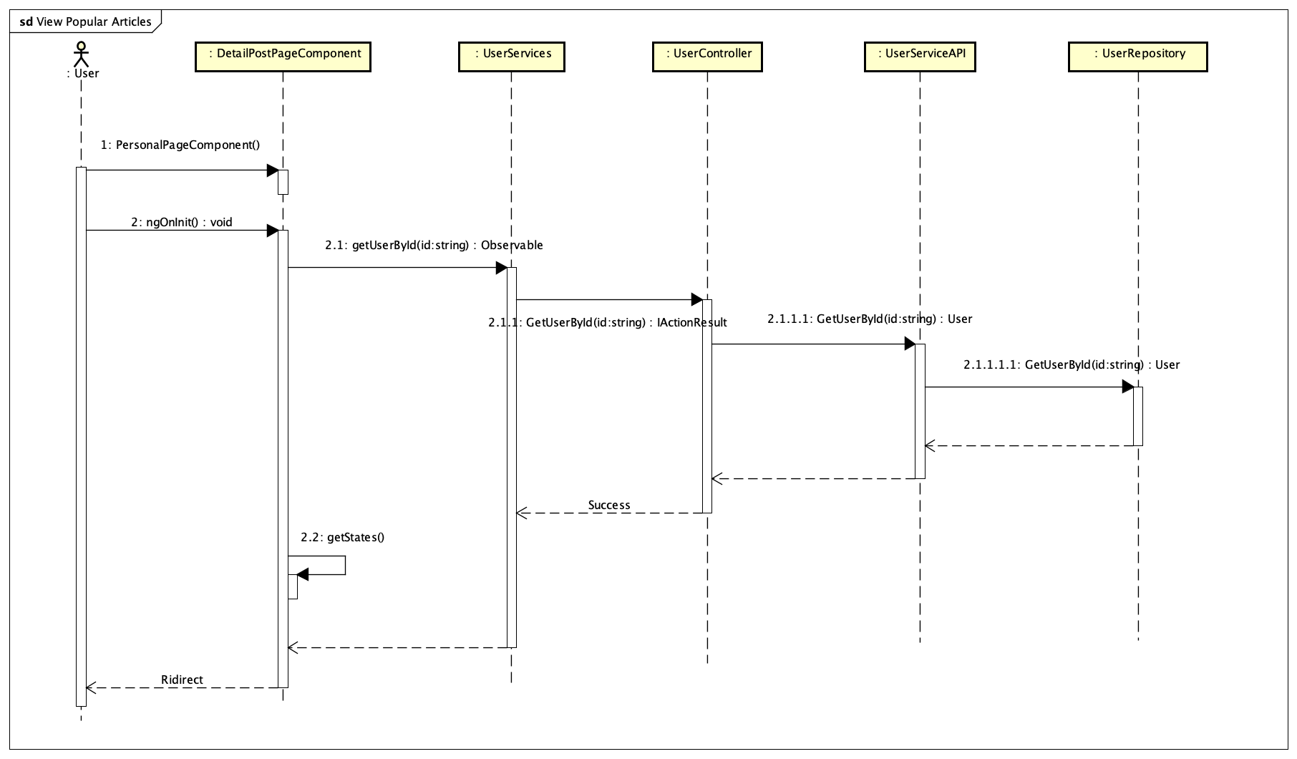

Figure 4-172: View user's profile

# **Chapter 5: Software Testing Documentation**

## **5.1 Introduction**

### **5.1.1 Purpose**

This chapter’s primary goal is to create testing plans and execute the defects detection and prevention procedures, which may cause software malfunctioning. Another objective of this chapter is to provide details about the software quality and to ensure that the end result meets the business and user requirements.

### **5.1.2 Scope of testing**

* **Stages of testing:**

There are 4 phases in the Testing Process: Unit testing, Integration testing, System testing and Acceptance testing.

|  |  |  |
| --- | --- | --- |
| **ID** | **Test Stages** | **Description** |
| 1 | Unit testing | Unit Tests are performed by developers to ensure that individual units of source code function as intended. Unit tests are primarily used to test complicated algorithms and automatically test important functions. |
| 2 | Integration testing | Integration Tests are performed by testers, this is a software testing method in which individual software modules are combined and tested as a group. We also know defects between the modules. After that, developer will fix the system suitably. |
| 3 | System testing | System Tests are performed by testers. In this test, tester will test of a complete, fully integrated software product and determine whether or not the system meets the requirements. |
| 4 | Acceptance testing | Testers create check list include some rules between team members and customers. If customers don’t have any requirements, we will build acceptance test base on the purpose of project |

* **Type of testing**

The following types of testing are performed:

* Functional testing
* User interface testing
* **Range of testing**

Team performs all functions defined in the SRS based on the approved version.

## **5.2 Test plan**

### **5.2.1 Testing tools and environment**

**5.2.1.1 Testing tools**

* **­Chrome Developer Tools: To view logs, inspect elements.**



Figure 5-1 Chrome Dev Tools

* **Trello and Backlog: manage bugs, to log bugs, resolve bugs and close bug**
* **Microsoft Excel: To manage test cases**



Figure 5-2 Microsoft Excel

* **Postman: A tool to test API endpoints and returned results.**



Figure 5-3 Postman

**5.2.1.2 Testing environment**

|  |  |  |
| --- | --- | --- |
| **Type of testing** | **Software** | **Hardware** |
| Unit test | Visual Studio | Personal computer for developing with the minimum configuration:  - Windows 10 Pro 64-bit.  - Intel® Core™ i5 5200 CPU.  - Installed memory (RAM): 8.00GB  - Visual Studio 2017 or 2019 |
| Integration Test | Google chrome | Personal computer for developing with the minimum configuration:  - Windows 10 Pro 64-bit.  - Intel® Core™ i5 5200 CPU.  - Installed memory (RAM): 8.00GB |
| System Test | Google chrome | Personal computer for developing with the minimum configuration:  - Windows 10 Pro 64-bit.  - Intel® Core™ i5 5200 CPU.  - Installed memory (RAM): 8.00GB |
| Acceptance Test | Google chrome | Personal computer for developing with the minimum configuration:  - Windows 10 Pro 64-bit.  - Intel® Core™ i5 5200 CPU.  - Installed memory (RAM): 8.00GB |

### **5.2.2 Resources and responsibilities**

This table shows the staffing assumptions for the project.

|  |  |  |
| --- | --- | --- |
| **ID** | **Resources** | **Responsibilities** |
| 1 | Project Manager | * Responsible for Project Schedules and overall success of the project. * Review Test Plan and Test report. |
| 2 | Test Leader | * Manage Test resource and assign test tasks * Create Test Plan * Review Test case * Create Test report |
| 3 | Tester | * Preforming the actual system testing. * Create Test Cases. * Execute Test. * Report test result. * Log bugs |
| 4 | Developer | * Create and execute unit tests * Fix bugs. |

### **5.2.3 Test strategy**

**5.2.3.1 Test model**

* TripSharing deploys a contemporary of traditional software development models is "V-Model":
* At V-model, corresponding to a test phase is a software development phase, testing in the V-model is done in parallel with the software development cycle.
* Each level of the development lifecycle is verified before moving on to the next level.
* This helps in identifying errors very early in the lifecycle and minimizes potential future defects appearing in the code later in the lifecycle.

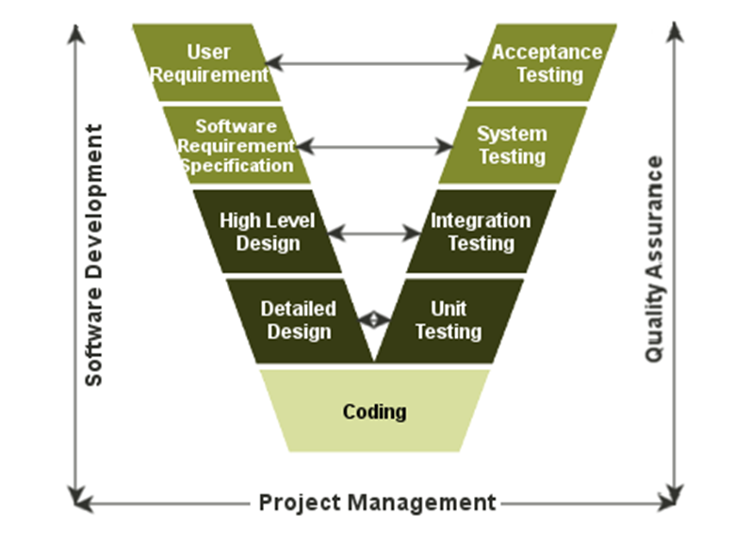

Figure 5-4 Architecture of V-Model

* + - 1. **Test types**

**5.2.3.2.1 Functional testing**

Functional testing is a formal type of testing performed by testers. Functional testing focuses on testing each function of the software application operates in conformance with the requirement specification.

* **Test Objective:**
  + Testing the main functions of an application
  + It involves basic usability testing of the system. It checks whether a user can freely navigate through the screens without any difficulties.
  + Checks the accessibility of the system for the user
  + Usage of testing techniques to check for error conditions. It checks whether suitable error messages are displayed.
* **Technique**
* Each and every functionality of the system is tested by providing appropriate input, verifying the output and comparing the actual results with the expected results.
* **Completion Criteria**
* All planned tests have been executed.
* All identified defects have been resolved and closed

**5.2.3.2.2 User interface testing**

User Interface testing is a testing technique used to identify the presence of defects is a product/software under test by using Graphical user interface [GUI].

* **Test Objective**
  + Ensure that the GUI provides the user with an appropriate access and navigation through the functions of the target-of-test.
  + GUI testing ensures that the objects within the GUI function as expected and conform to requirement.
* **Technique**
* GUI test will be performed fully on all screens
* Verification of the overall look and feel of the TripSharing system including initial position, text size, color, initial button, tab order, label, screen sizes and text font is readable.
* **Completion Criteria**
* Verifying that the application responds correctly to events such as clicking on the button.
* GUI testing would also confirm that appearance elements such as fonts and images conform to design specifications.

**5.2.3.3 Test schedule**

Table below is the Test Schedule for TripSharing Project

|  |  |  |
| --- | --- | --- |
| **Test Schedule** | **Start Date** | **End Date** |
| *Phase 1:* | 06/06/2019 | 20/07/2019 |
| Unit Testing | 10/06/2019 | 30/06/2019 |
| Integration Testing | 15/06/2019 | 10/07/2019 |
| System Testing | 17/06/2019 | 20/07/2019 |
| *Phase 2:* | 20/07/2019 | 25/08/2019 |
| Unit Testing | 23/07/2019 | 10/08/2019 |
| Integration Testing | 26/07/2019 | 15/08/2019 |
| System Testing | 28/07/2019 | 16/08/2019 |
| Acceptance Testing | 10/08/2019 | 20/08/2019 |

Table 5-1 Test schedule

### **5.2.4 Features to be tested**

All features are listed in the use case list.

### **5.2.5 Features not to be tested**

All features are listed in 1.5.1.3 above will not to be tested.

## **5.3 Test Approach**

### **5.3.1 Unit testing**

* Unit testing is a software testing method by which small units of source code are tested to determine whether they meet the requirements.
* Unit testing will be done by the developers and approved by the development team leader. The TripSharing development team embrace these features to gain the following advantages:
* Reduce the number of bugs in production code.
* Saving development time.
* Ensure the functions of the software are in accordance with customer requirements
* Identify errors very early in the development process and minimize potential future errors that may appear

**5.3.1.1 Unit testing framework**

* We use NUnit is a unit testing framework for .NET, it is the most used framework for writing unit test cases and JetBrains dotCover is a .NET unit test runner and code coverage tool.
* Mock function are simulated functions that mimic the behavior of real functions in controlled ways.
* Unit testing scripts are created manually and saved to ProjectName.Tests directory of TripSharing API services.

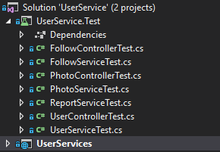

Figure 5-5 Test directory structure

* Unit tests focus on individual functions in a class and are created as in the picture.

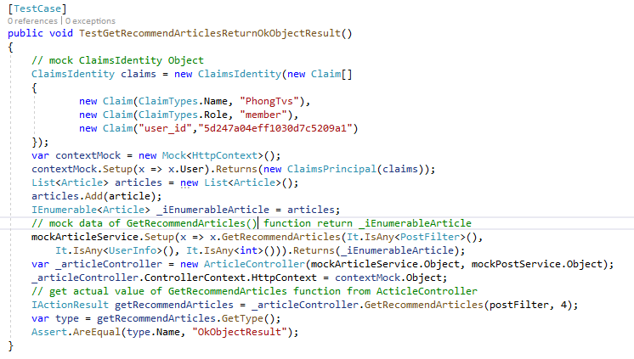

Figure 5-6: Unit test case sample

This factory function used to get recommend articles

* Coverage report:

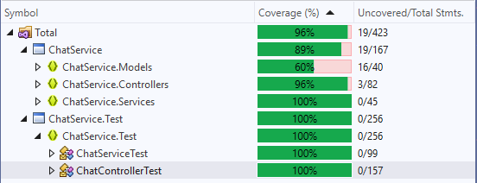

Figure 5-7: Unit test chat service coverage

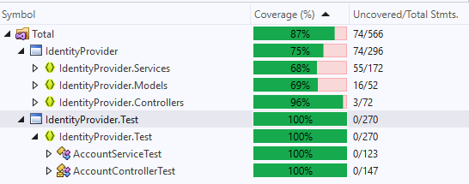

Figure 5-8 Unit test identity provider service coverage

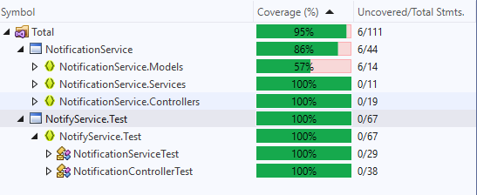

Figure 5-9 Unit test notification service coverage

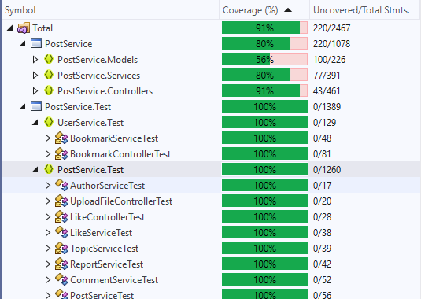

Figure 5-10 Unit test post service coverage

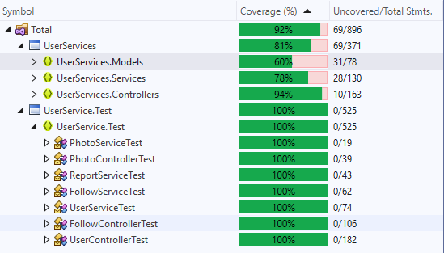

Figure 5-11 Unit test user service coverage

### **5.3.2 Integration testing and System test**

* Integration testing is a software testing method in which individual software modules are combined and tested as a group.
* System testing is testing conducted on a complete integrated system to evaluate the system's compliance with its specified requirements.
* Detailed test cases will be described in TripSharing_TestCase_Final folder. As a standard definition, TripSharing defines that a test case is:
  + A set of test data and their expected results. A test case validates one or more system requirements and generates a result is pass or fail, from there can verify if the system works as expected or not.
  + A good test case should follow two basic aspects, the Contents and the Style. Test cases should be developed for each use case scenario
  + TripSharing Project System testing will not focus on common logic of system like length of text but focus on behavior of website and aims to validate that all software module dependencies are functionally correct, and the communications is maintained between separate modules.

### **5.3.4 Acceptance Test**

Acceptance testing is a level of the software testing process where a system is tested for acceptability. The purpose of this test is to evaluate the system’s compliance with the business requirements and assess whether it is acceptable for delivery. But our project will use the checklist as a substitute for acceptance testing.

The content of the checklist is shown in the table below:

|  |  |  |  |
| --- | --- | --- | --- |
| **ID** | **Checklists** | **Yes** | **No** |
| **Functional** | | | |
| CL-001 | User can sign up a new account | ✓ |  |
| CL-002 | User can sign in to TripSharing.net by Facebook account | ✓ |  |
| CL-003 | User can sign in to TripSharing.net by Google account | ✓ |  |
| CL-004 | User can sign in to TripSharing.net by normal account | ✓ |  |
| CL-005 | User can change the new password for account | ✓ |  |
| CL-006 | User can reset the password | ✓ |  |
| CL-007 | User can update profile and update information | ✓ |  |
| CL-008 | User can choose more interested topics | ✓ |  |
| CL-009 | User can create a new article | ✓ |  |
| CL-010 | User can create a new virtual trip | ✓ |  |
| CL-011 | User can create a new finding companion post | ✓ |  |
| CL-012 | Users are allowed to delete their own posts | ✓ |  |
| CL-013 | Users are allowed to edit their own posts | ✓ |  |
| CL-014 | User can join to a companion group that other member created | ✓ |  |
| CL-015 | User can leave to a companion group that other member created | ✓ |  |
| CL-016 | User can share one or more posts from TripSharing.net to Facebook application | ✓ |  |
| CL-017 | If an article violates the website's rules, user can report it to the administrator. | ✓ |  |
| CL-018 | If a comment violates the website's rules, users can report it to the administrator. | ✓ |  |
| CL-019 | If a member violates the website's rules, users can report them to the administrator. | ✓ |  |
| CL-020 | User can bookmark one or more posts and add them to the bookmarks list. | ✓ |  |
| CL-021 | User can view bookmarks list | ✓ |  |
| CL-022 | User can remove one or more posts from bookmarks list. | ✓ |  |
| CL-023 | User can add a new comment below the content of any post | ✓ |  |
| CL-024 | User can edit their own comments | ✓ |  |
| CL-025 | User can delete their own comments | ✓ |  |
| CL-026 | User can like any comment | ✓ |  |
| CL-027 | User can unlike any comment | ✓ |  |
| CL-028 | User can follow other member | ✓ |  |
| CL-029 | User can unfollow other member | ✓ |  |
| CL-030 | User can like one or more posts | ✓ |  |
| CL-031 | User can unlike one or more posts | ✓ |  |
| CL-032 | User can create a group chat | ✓ |  |
| CL-033 | User can remove a member from group chat | ✓ |  |
| CL-034 | User can send or receive messages and system will notify for user when they have new messages | ✓ |  |
| CL-035 | Administrator can add a new travel topic to topics list | ✓ |  |
| CL-036 | Administrator can remove one or more travel topic to topics list | ✓ |  |
| CL-037 | Administrator can edit a travel topic | ✓ |  |
| CL-038 | User can search 3 posts type: article, virtual trip and finding companion | ✓ |  |
| CL-039 | User can search a member from members list of system | ✓ |  |
| CL-040 | User can view recommended articles on home page | ✓ |  |
| CL-041 | User can view popular articles on home page | ✓ |  |
| CL-042 | User can view recently articles on home page | ✓ |  |
| CL-043 | User can view a post detail with category: article, virtual trip and finding companion | ✓ |  |
| CL-044 | User can view a other member’s profile | ✓ |  |
| CL-045 | User can view a other member's followings/followers number | ✓ |  |
| CL-046 | User can view a other member's created posts | ✓ |  |
| CL-047 | Administrator can view all user’s account | ✓ |  |
| CL-048 | Administrator can view all accounts that users reported | ✓ |  |
| CL-049 | Administrator can ban an account | ✓ |  |
| CL-050 | Administrator can unban an account |  |  |
| CL-051 | Administrator can view all posts reported by users | ✓ |  |
| CL-052 | Administrator can remove a post reported by users | ✓ |  |
| CL-053 | Administrator can restore a post that previously removed | ✓ |  |
| CL-054 | Administrator can view all comments that is reported by other members | ✓ |  |
| CL-055 | Administrator can remove a comment that is reported by other members | ✓ |  |
| CL-056 | Administrator can restore a comment that previously removed | ✓ |  |
| CL-057 | Administrator can view statistic of users | ✓ |  |
| CL-058 | Administrator can view statistic of posts | ✓ |  |
| CL-059 | Check application logout functionality. | ✓ |  |
| **GUI and Usability** | | | |
| CL-060 | All mandatory fields are validated. | ✓ |  |
| CL-061 | Validation error messages are displayed properly below the field. | ✓ |  |
| CL-062 | All error messages are displayed in red color. | ✓ |  |
| CL-063 | Delete functionality for any record on page are asked for confirmation. | ✓ |  |
| CL-064 | All like, comment number values are formatted properly. | ✓ |  |
| CL-065 | Application crash or unavailable pages are redirected to error page. | ✓ |  |
| CL-066 | The screen is well organized and easy to interact with. | ✓ |  |
| CL-067 | All fields on page (e.g. text box, radio options, dropdown lists) should be aligned properly. | ✓ |  |
| CL-068 | System display notification message when meet trouble, error. | ✓ |  |
| CL-069 | All images displayed on the website must be of good quality | ✓ |  |
| **Database** | | | |
| CL-070 | All data must save in database when submit data successful. | ✓ |  |
| CL-071 | The id field in the data base is required, cannot be left blank. | ✓ |  |
| CL-072 | Field length shown to user on page and in database schema should be same. | ✓ |  |
| CL-073 | Database fields are designed with correct data type and data length. | ✓ |  |
| CL-074 | The relationship between the tables must be clear and true to the customer's requirements | ✓ |  |

### **5.3.5 Defect Log**

* Trip Sharing project used http://www.trello.com in phase 1 and http://www.backlog.com in phase 2 to manager tasks and defects.
* Every member of TripSharing project creates an account backlog and Trello to take part in activities: control bugs, fix bugs, re-test bugs and close bug. Bug will be log by tester or developer in develop progress.

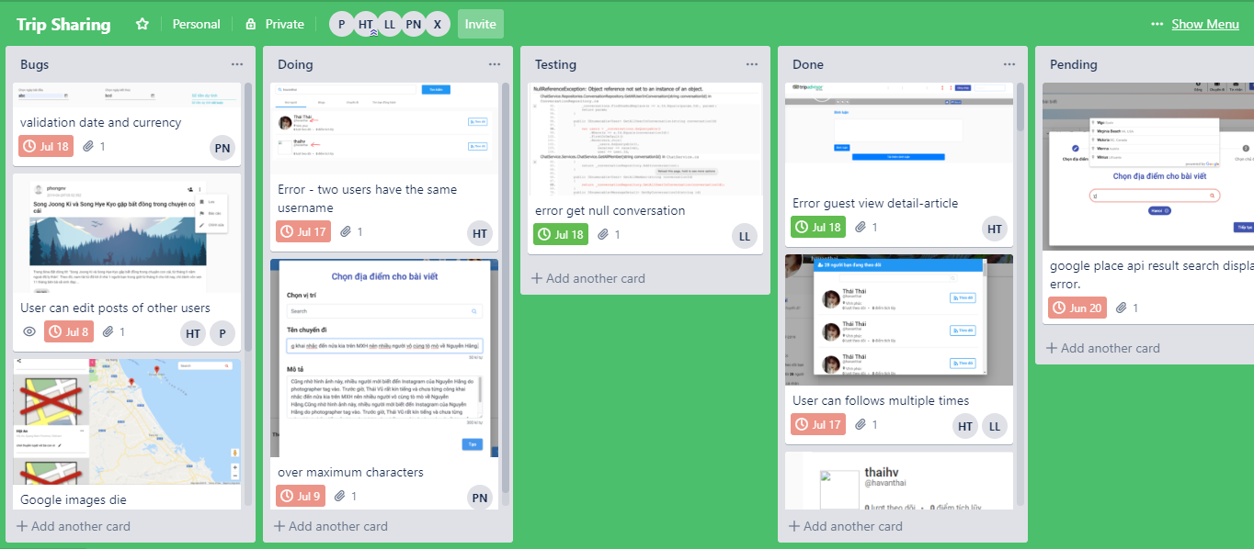

Figure 5-12 Control task and bug with Trello

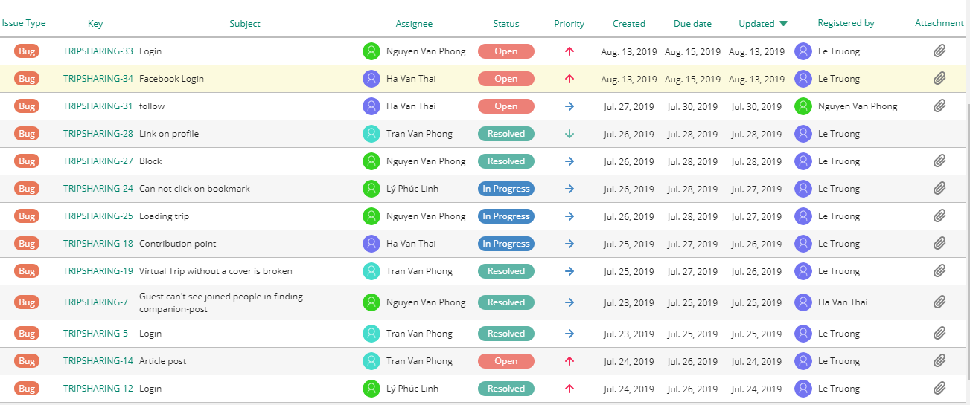

Figure 5-13 Control task and bug with Backlog

## **5.4 Test Report**

### **5.4.1 Unit test report**

The contents of the Unit Test Case Report are shown in the table below:

|  |  |  |  |  |  |
| --- | --- | --- | --- | --- | --- |
| **Service Name** | **Controller/Service Name** | **Pass** | **Fail** | **Not available** | **Number of Test Case** |
| **Chat Service** | Chat Controller | 15 | 0 | 0 | 15 |
| Chat Service | 10 | 0 | 0 | 10 |
| **Total** | **25** | **0** | **0** | **25** |
| **Identity Provider** | Account Controller | 16 | 0 | 0 | 16 |
| Account Service | 15 | 0 | 0 | 15 |
| **Total** | **31** | **0** | **0** | **31** |
| **Notification Service** | Notification Controller | 2 | 0 | 0 | 2 |
| Notification Service | 2 | 0 | 0 | 2 |
| **Total** | **4** | **0** | **0** | **4** |
| **Post Service**  **UserService** | Article Controller | 11 | 0 | 0 | 11 |
| Article Service | 8 | 0 | 0 | 8 |
| Author Service | 2 | 0 | 0 | 2 |
| Bookmark Controller | 6 | 0 | 0 | 6 |
| Bookmark Service | 5 | 0 | 0 | 5 |
| Comment Controller | 5 | 0 | 0 | 5 |
| Commnet Service | 5 | 0 | 0 | 5 |
| Companion Controller | 13 | 0 | 0 | 13 |
| Companion Post Service | 15 | 0 | 0 | 15 |
| Like Controller | 2 | 0 | 0 | 2 |
| Like Service | 4 | 0 | 0 | 4 |
| Post Controller | 6 | 0 | 0 | 6 |
| Post Service | 6 | 0 | 0 | 6 |
| Report Controller | 6 | 0 | 0 | 6 |
| Report Service | 5 | 0 | 0 | 5 |
| Topic Controller | 8 | 0 | 0 | 8 |
| Topic Service | 5 | 0 | 0 | 5 |
| Upload File Controller | 2 | 0 | 0 | 2 |
| Upload File Service | 1 | 0 | 0 | 1 |
| Virtual Trip Controller | 7 | 0 | 0 | 7 |
| Virtual Trip Service | 7 | 0 | 0 | 7 |
| **Total** | **133** | 0 | 0 | **133** |
| Follow Controller | 10 | 0 | 0 | 10 |
| Follow Service | 7 | 0 | 0 | 7 |
| Photo Controller | 3 | 0 | 0 | 3 |
| Photo Service | 2 | 0 | 0 | 2 |
| Report Service | 5 | 0 | 0 | 5 |
| User Controller | 19 | 0 | 0 | 19 |
| User Service | 10 | 0 | 0 | 10 |
| **Total** | **56** | 0 | 0 | **56** |
| **Email Service** | Email Service | 0 | 0 | 0 | 0 |
| **Total** | **0** | **0** | **0** | **0** |
| **Total of Test Case** | | **249** | **0** | **0** | **249** |

Table 5-2: Unit test case report

|  |  |  |  |  |  |
| --- | --- | --- | --- | --- | --- |
| **Service Name** | **Number of test cases** | | | | **Final** |
| **Phase 1** | | **Phase 2** | |
| **Pass** | **Fail** | **Pass** | **Fail** |
| Chat Service | 25 | 0 | 25 | 0 | 25 |
| Identity Provider | 31 | 0 | 31 | 0 | 31 |
| Notify Service | 4 | 0 | 4 | 0 | 4 |
| Post Service | 113 | 0 | 133 | 0 | 133 |
| User Service | 42 | 0 | 56 | 0 | 56 |
| Email Service | 0 | 0 | 0 | 0 | 0 |
| **Total of test cases** | **215** | **0** | **249** | **0** | **249** |

Table 5-3: Unit test report

|  |  |  |
| --- | --- | --- |
| **Service Name** | **Coverage** | |
| **Phase 1** | **Phase 2** |
| Chat Service | 89% | 89% |
| Identity Provider | 75% | 75% |
| Notify Service | 86% | 86% |
| Post Service | 77% | 80% |
| User Service | 78% | 81% |
| Email Service | 0% | 0% |
| **Overall** | **76%** | **78%** |

Table 5-4: Unit test coverage report

### **5.4.2 Integration test report**

|  |  |  |  |  |
| --- | --- | --- | --- | --- |
| **Module code** | **Pass** | **Fail** | **Not available** | **Number of test case** |
| Sign Up | 17 | 0 | 0 | 17 |
| Sign In | 14 | 0 | 0 | 14 |
| Forgot password | 6 | 0 | 0 | 6 |
| Sign Out | 2 | 0 | 0 | 2 |
| Change Password | 16 | 0 | 0 | 16 |
| Update Profile | 14 | 0 | 0 | 14 |
| Choose Interested Topic | 14 | 0 | 0 | 14 |
| View user's profile | 2 | 0 | 0 | 2 |
| Create a post | 60 | 0 | 0 | 60 |
| Edit a post | 59 | 0 | 0 | 59 |
| Like Unlike a post | 7 | 0 | 0 | 7 |
| Delete a post | 11 | 0 | 0 | 11 |
| Comment to a post | 6 | 0 | 0 | 6 |
| Edit a comment | 5 | 0 | 0 | 5 |
| Delete a comment | 5 | 0 | 0 | 5 |
| Like Unlike a comment | 8 | 0 | 0 | 8 |
| View a post detail | 14 | 0 | 0 | 14 |
| Bookmark a post | 6 | 0 | 0 | 6 |
| View all bookmarks | 2 | 0 | 0 | 2 |
| Remove a bookmark | 7 | 0 | 0 | 7 |
| Follow Unfollow a user | 13 | 0 | 0 | 13 |
| ViewPost | 6 | 0 | 0 | 6 |
| View user's follower following | 3 | 0 | 0 | 3 |
| View user's created posts | 6 | 0 | 0 | 6 |
| TravelTopic | 14 | 0 | 0 | 14 |
| Search | 11 | 0 | 0 | 11 |
| Join Leave to a companion group | 5 | 0 | 0 | 5 |
| Share a post | 4 | 0 | 0 | 4 |
| Send receive messages | 9 | 0 | 0 | 9 |
| View all users' account | 3 | 0 | 0 | 3 |
| View Statistic | 5 | 0 | 0 | 5 |
| View Reported | 3 | 0 | 0 | 3 |
| Reported | 17 | 0 | 0 | 17 |
| Ban a user | 4 | 0 | 0 | 4 |
| Unban a user | 4 | 0 | 0 | 4 |
| Remove a reported post | 4 | 0 | 0 | 4 |
| Restore a removed post | 4 | 0 | 0 | 4 |
| Remove a reported comment | 4 | 0 | 0 | 4 |
| Restore a removed comment | 4 | 0 | 0 | 4 |
| **Total of Test Case** | **398** | **0** | **0** | **398** |

Table 5-6 Integration test case report

|  |  |  |  |  |  |
| --- | --- | --- | --- | --- | --- |
| **Integration test** | **Phase 1** | | **Phase 2** | | **Final** |
| **Pass** | **Fail** | **Pass** | **Fail** |
| **Total of test case** | **346** | **0** | **398** | **0** | **398** |

Table 5-7 Integration test report

### **5.4.3 System test report**

The contents of the System Test Case Report are shown in the table below:

|  |  |  |  |  |
| --- | --- | --- | --- | --- |
| **Module code** | **Pass** | **Fail** | **Not available** | **Number of test case** |
| Guest | 25 | 0 | 0 | 25 |
| Member | 95 | 0 | 0 | 95 |
| User | 30 | 0 | 0 | 30 |
| Admin | 35 | 0 | 0 | 35 |
| **Total of Test Case** | **185** | **0** | **0** | **185** |

Table 5-8 System test case report

We execute test with 2 stages with 2 phases of process model, to finish project.

The contents of the Test Report are shown in the table below:

|  |  |  |  |  |  |
| --- | --- | --- | --- | --- | --- |
| **Service Name** | **Number of test cases** | | | | **Final** |
| **Phase 1** | | **Phase 2** | |
| **Pass** | **Fail** | **Pass** | **Fail** |
| Guest | 25 | 0 | 25 | 0 | 25 |
| Member | 89 | 0 | 95 | 0 | 95 |
| User | 30 | 0 | 30 | 0 | 30 |
| Admin | 21 | 0 | 35 | 0 | 35 |
| **Total of test cases** | **165** | **0** | **185** | **0** | **185** |

Table 5-9 System test report

# **Chapter 6: User manual**

## **6.1 Deployment guidelines**

### **6.1.1 Environment for development**

* Operating system: Window 10 Pro
* Code IDE: Visual Studio 2017
* Code Editor: Visual Studio Code
* Node.js: 10.15.3
* Docker: 18.09.2
* Plugins:
  + TSLint
  + Dotcover

**6.1.1.1 Setup development environment**

*6.1.1.1.1 Install Visual Studio 2017*

* Go to <https://visualstudio.microsoft.com/downloads/>

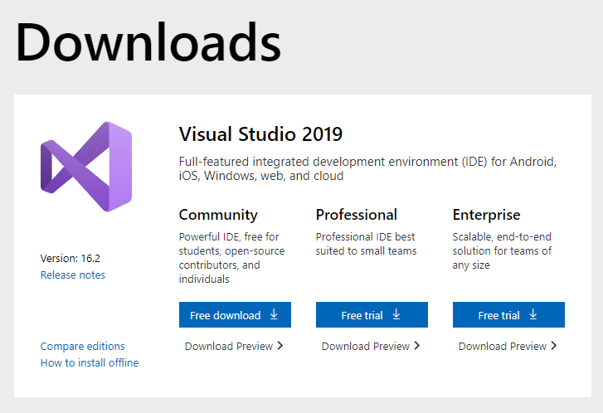

Figure 6-1: Visual Studio download page

* Currently, If the last version is not the Visual Studio 2017, scroll to the bottom of the page then click “Older versions” button. Otherwise, Click “Free download” button
* In older version page, Choose the right version (2017) and click “Download” button.

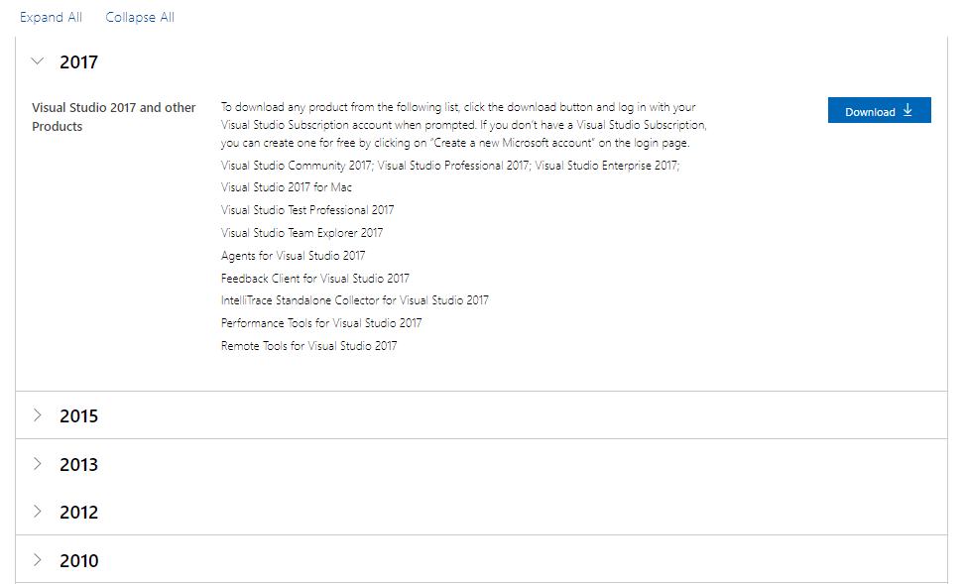

Figure 6-2: Visual Studio download old version page

* Run the downloaded executable file, follow the instructions.
* Start the application by opening the shortcut on desktop or from start menu.

*6.1.1.1.2 Install Visual Studio Code*

* Go to <https://code.visualstudio.com/> and click on “Download” button.

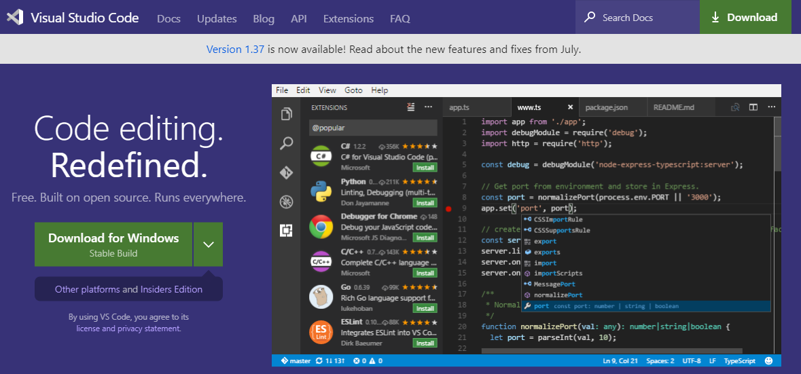

Figure 6-3: Visual Studio Code download page

* Run the downloaded executable file, follow the instructions.
* Start the application by opening the shortcut on desktop or from start menu.

*6.1.1.1.3 Install Node.js*

* Go to <https://nodejs.org/en/download/> and click “Windows Installer” to download the installation file.

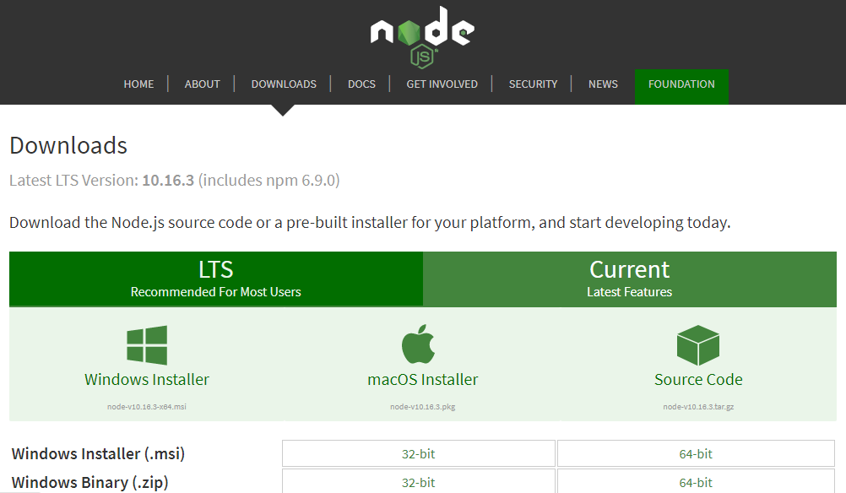

Figure 6-4: Node.js download page

* Run the downloaded executable file, follow the instructions.
* To test if Node.js is install successful, open Command Prompt then enter “node -v”.

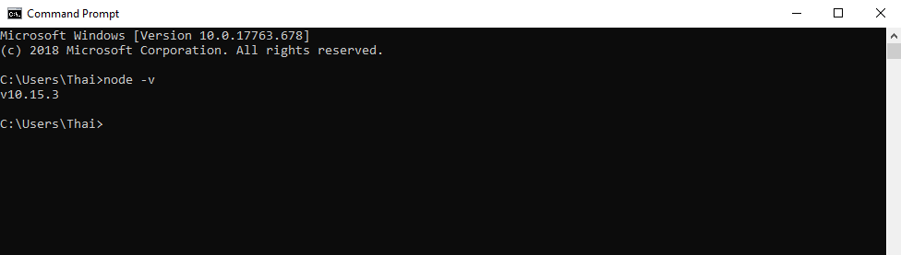

Figure 6-5: Show node's version

*6.1.1.1.4 Install Docker*

* Go to <https://hub.docker.com/editions/community/docker-ce-desktop-windows> and click “Get Docker” button.

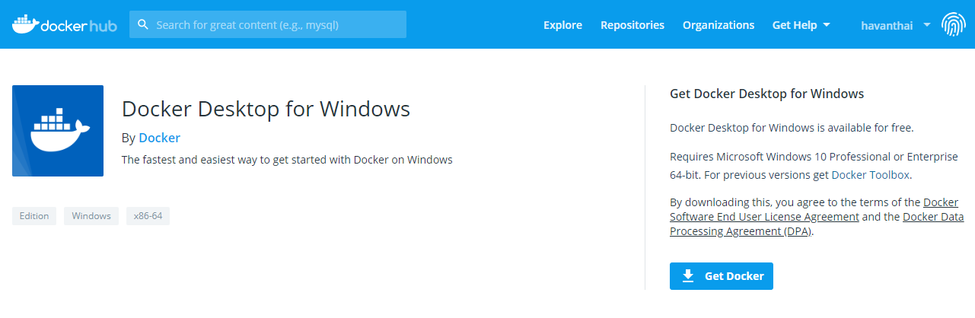

Figure 6-6: Docker download page

* Run the downloaded executable file, follow the instructions. Be sure to keep using Linux container when prompted to switch to Windows container.
* Start the application by open the short cut “Docker Desktop” on the desktop.

**6.1.1.2 Run unit test and coverage**

* Run unit test:
* Open the solution which is needed to run test with visual studio.
* On the menu bar, click **Test > Run > All Tests**

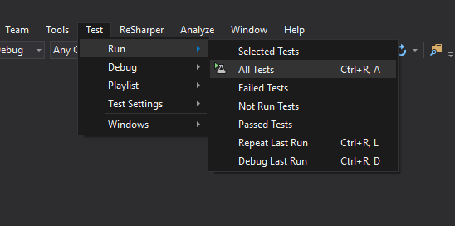

Figure 6-7: Run unit test

* Unit test result will be displayed in Test Explorer.

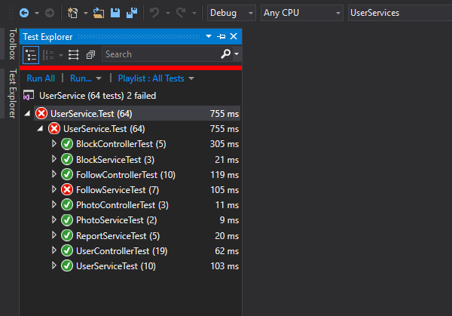

Figure 6-8: Unit test result

* Run coverage:
* In Solution Explorer, right-click on solution name, then select **Cover Unit Tests**

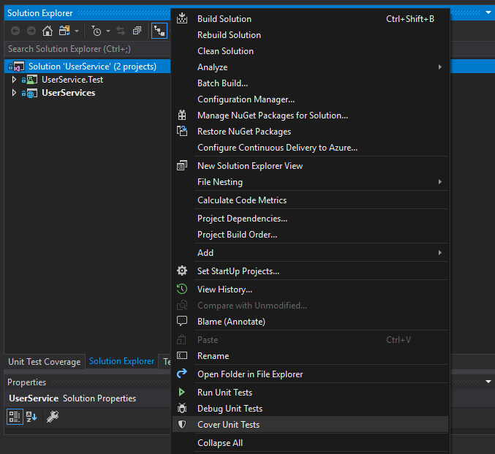

Figure 6-9: Run test coverage

* Wait for the process finish, test coverage result will be displayed in **Unit Test Coverage tab**.

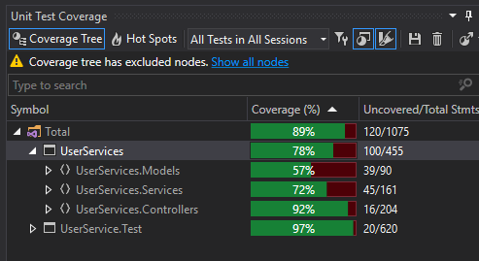

Figure 6-10: Test coverage result

**6.1.1.3 Local network setup**

* Run “Notepad” as Administrator.
* From File menu, click “Open”.
* Navigate to <Windows Drive>\Windows\system32\drivers\etc\.
* Choose “All Files (*.*)” from the dropdown to the right of the “File name” box.
* Choose “hosts” file and click “Open”.
* Add the following new lines at the end of the file:

127.0.0.1 dev-trip-sharing.net

### **6.1.2 Environment for deployment**

Platform: Kubernetes Engine on Google Cloud Platform

**6.1.2.1 Install Google Cloud SDK**

* Download the Google Cloud SDK installer:

<https://dl.google.com/dl/cloudsdk/channels/rapid/GoogleCloudSDKInstaller.exe>

* Launch the installer and follow the prompts.
* After installation has completed, the installer presents several options:

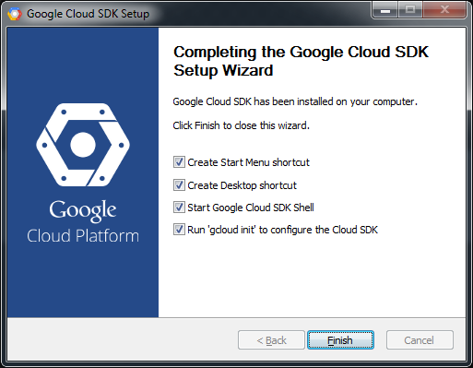

Figure 6-11: Google cloud SDK’s installation completed window

* Make sure that the following are selected:
  + Start Google Cloud SDK Shell
  + Run 'gcloud init'
* The installer then starts a terminal window and runs the gcloud init command.

*Reference:* [*https://cloud.google.com/sdk/docs/quickstart-windows*](https://cloud.google.com/sdk/docs/quickstart-windows)

**6.1.2.2 Configure for Google Cloud SDK**

* Run the following at a command prompt:

> gcloud init

* Accept the option to log in using your Google user account:

To continue, you must log in. Would you like to log in (Y/n)? Y

* In your browser, log in to your Google user account when prompted and click *Allow* to grant permission to access Google Cloud Platform resources.
* At the command prompt, select a Cloud Platform project from the list of those where you have *Owner*, *Editor* or *Viewer* permissions:

Pick cloud project to use:

[1] [my-project-1]

[2] [my-project-2]

...

Please enter your numeric choice:

If you only have one project, “gcloud init” selects it for you.

* If you have the Google Compute Engine API enabled, “gcloud init” allows you to choose a default Compute Engine zone:

Which compute zone would you like to use as project default?

[1] [asia-east1-a]

[2] [asia-east1-b]

...

[14] Do not use default zone

Please enter your numeric choice:

“gcloud init” confirms that you have complete the setup steps successfully:

gcloud has now been configured!

You can use [gcloud config] to change more gcloud settings.

Your active configuration is: [default]

*Reference:* [*https://cloud.google.com/sdk/docs/quickstart-windows*](https://cloud.google.com/sdk/docs/quickstart-windows)

**6.1.2.3 Setup Kubernetes Engine on Google Cloud**

* Setting a default project

> gcloud config set project [PROJECT_ID]

Replace [PROJECT_ID] with your project ID.

* Setting a default compute zone

> gcloud config set compute/zone [COMPUTE_ZONE]

where [COMPUTE_ZONE] is the desired geographical compute zone

* Get authentication credentials for the cluster

> gcloud container clusters get-credentials [CLUSTER_NAME]

* Creating the Deployment

> kubectl create deployment <DEPLOYMENT-NAME> --image=asia.gcr.io/trip-sharing-cp/<SERVICE-NAME>

* Exposing the Deployment

kubectl expose deployment <DEPLOYMENT-NAME> --type LoadBalancer \ --port 80 --target-port 8080

*Reference:* [*https://cloud.google.com/kubernetes-engine/docs/quickstart*](https://cloud.google.com/kubernetes-engine/docs/quickstart)

**6.1.2.4 Build and push docker images**

* Build the docker image

> docker build -t asia.gcr.io/trip-sharing-cp/<SERVICE-NAME> .

* Push the docker image

> docker push asia.gcr.io/trip-sharing-cp/<SERVICE-NAME>

**6.1.2.5 Setup Google pub/sub**

* Create a topic

> gcloud pubsub topics create mail-sending-topic

* Create a subscription

> gcloud pubsub subscriptions create --topic mail-sending-topic mail-service-sub

**6.1.2.6 Setup SendGrid**

* Go to <https://signup.sendgrid.com/> and register a SendGrid account.

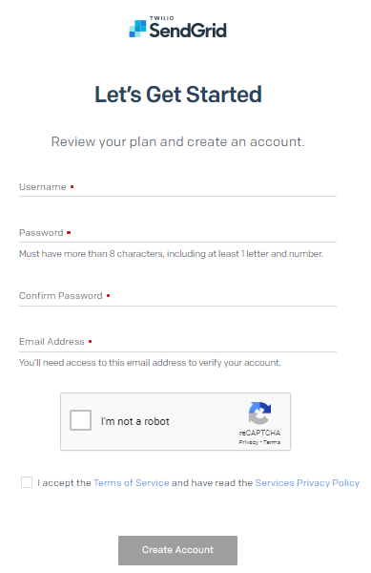

Figure 6-12: Sign up SendGrid

* Go to <https://app.sendgrid.com> and sign in
* From the menu bar on the left, click **Settings** > **API Keys** to navigate to API Keys management page
* Click **Create API Key** at the top right corner and follow instructions to create a new API Key

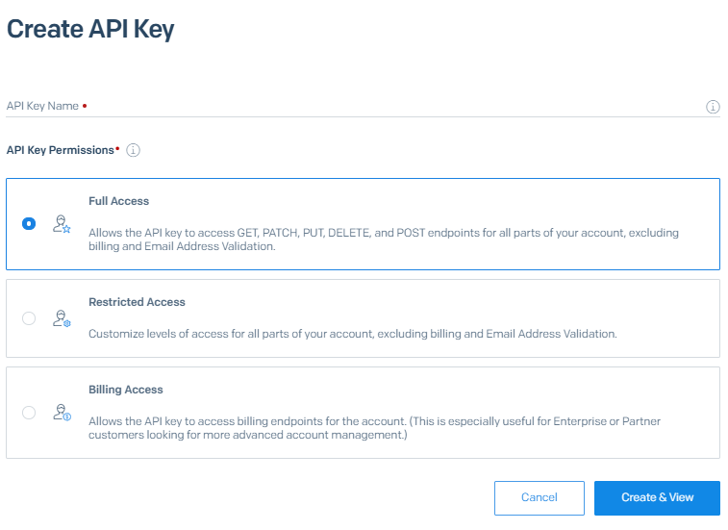

Figure 6-13: Create SendGrid API key

## **6.2 User guidelines**

* Our system work well on Google Chrome browser for desktop, so we suggest using it to access our system.
* User visits <https://trip-sharing.net> and follows our guidelines bellow.

### **6.2.1 User sign up**

* On any page, user click on “Đăng nhập” button.
* Sign in popup will be displayed, user click on “Đăng kí” link at the bottom of the popup.

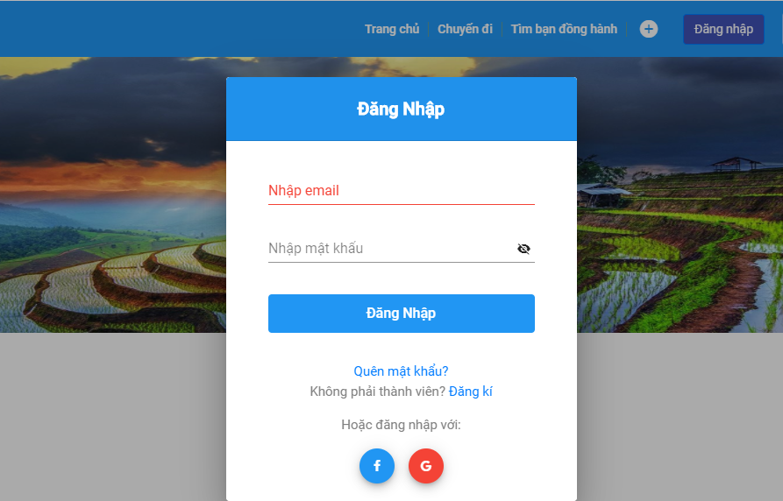

Figure 6-14: Sign in form

* Browser will redirect to sign up page. User fill in all needed field and click “Đăng kí” button.

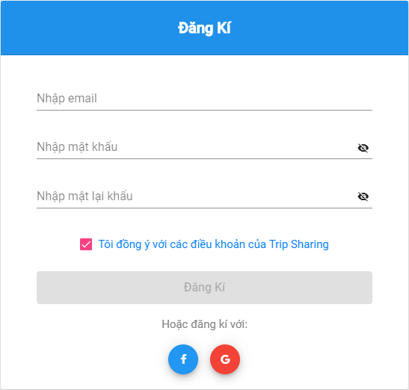

Figure 6-15: Sign up form

* System will send to user an email to confirm. User click on link on the email to complete.

### **6.2.2 User sign in**

* On any page, user click on “Đăng nhập” button.
* Sign in popup will be displayed. User fill in email and password to sign in.

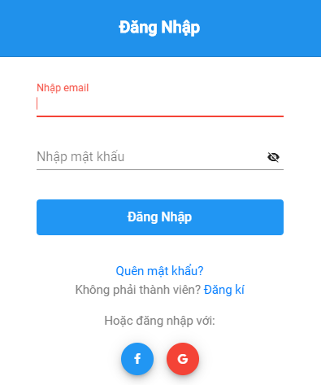

Figure 6-16: Sign in form

* User now signed in the system and redirect to homepage.

### **6.2.3 User sign out**

* On any page, user click on image profile on the header.
* System will display a list of options, then user click on “Đăng xuất” option.

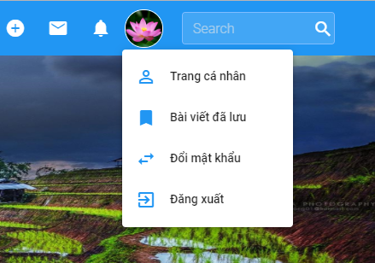

Figure 6-17: User's menu

* User now signed out of the system.

### **6.2.4 User update profile**

* On any page, user click on image profile on the header.
* System will display a list of options, then user click on “Trang cá nhân”.
* Browser will redirect to user’s personal page.
* User click on “Chỉnh sửa trang cá nhân” at the left side of the page.

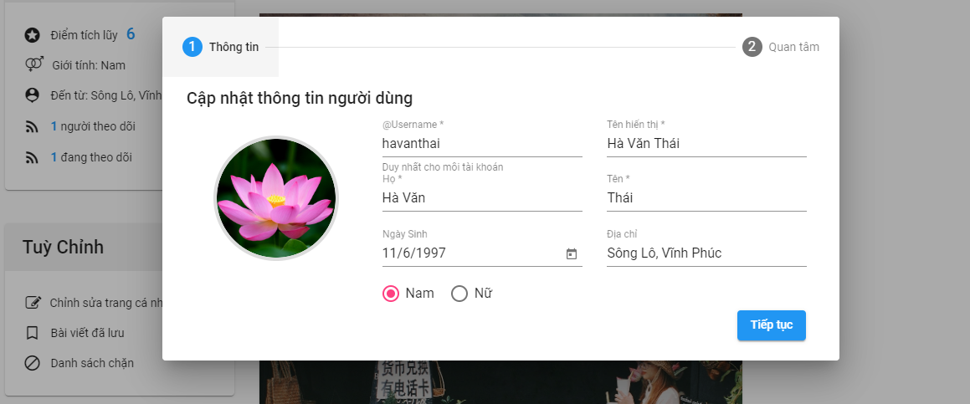

Figure 6-18: Update profile screen

* A popup of user information will be display, then user edit the field user want to change and click on “Tiếp tục” button.
* System will display update interest topics popup. User change the interest topics then click on “Cập nhật” button.

### **6.2.5 User searches posts**

* *Search posts by location:*
  + From home page, user enter the location to the search input.
  + System will suggest list of location base on Google Maps. User select one location.

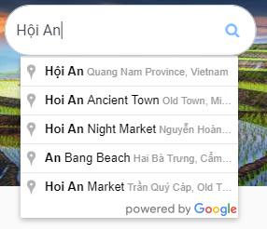

Figure 6-19: Search by Google Map location

* + Browser will redirect to search-result page.
* *Search posts by keyword:*
  + From any page, user enter search keyword into search field at the top-right of the page then press “Enter”.



Figure 6-20: Search by keyword

* + Browser will redirect to search-result page

### **6.2.6 User searches other users**

* + From any page, user enter search keyword into search field at the top-right of the page then press “Enter”.
  + Browser will redirect to search-result page
  + User switch to “Mọi người” tab to see searched users.

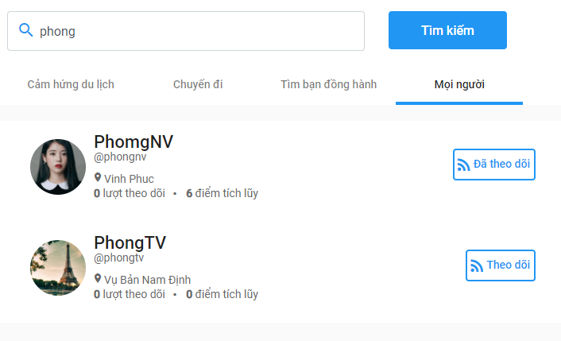

Figure 6-21: Search a user

### **6.2.7 User creates posts**

* From any page, click on “+” button on the header. A list of post type will be displayed.
* User choose post type user want to create.

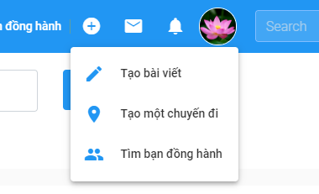

Figure 6-22: Create-post options

* Browser will redirect to create-post page.
* *Create an article*

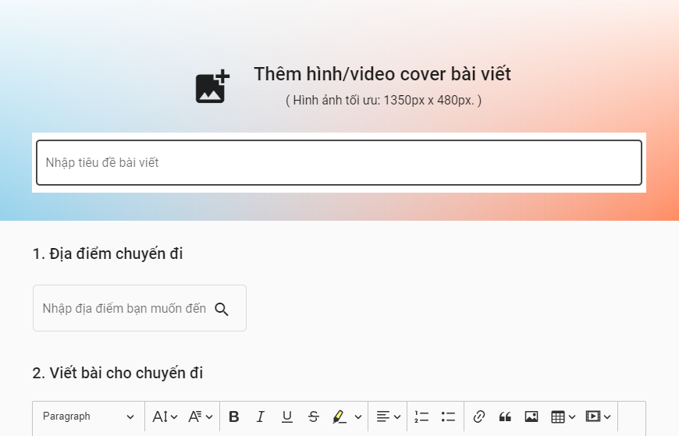

Figure 6-23: Create an article page

* *Create a virtual trip*

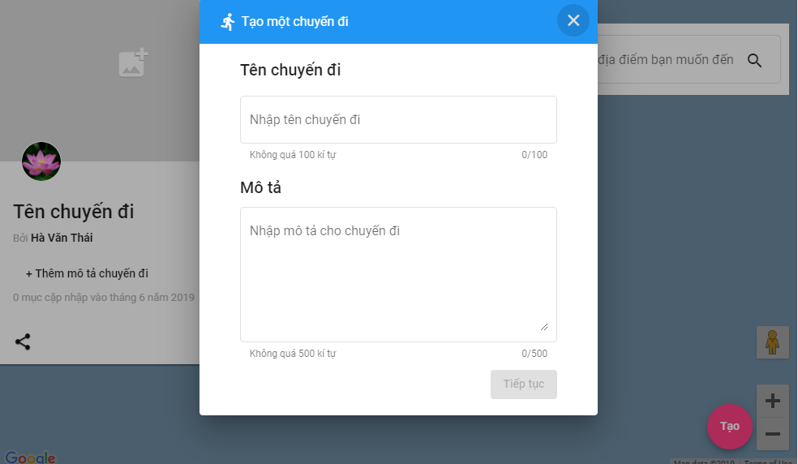

Figure 6-24: Create a virtual trip page

* *Create a finding-companion post*

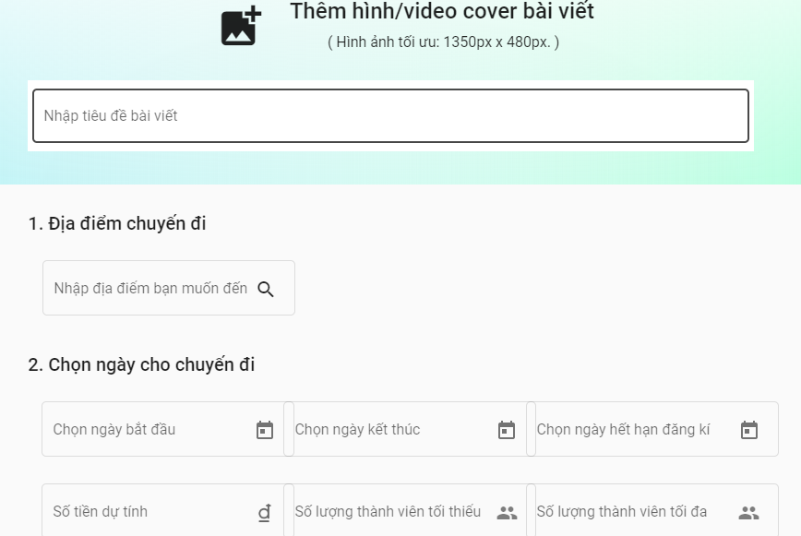

Figure 6-25: Create a finding-companion post page

### **6.2.8 User chats with other users**

* User go to the personal page of the user that he/she want to chat with.
* User click on “Gửi tin nhắn” button.

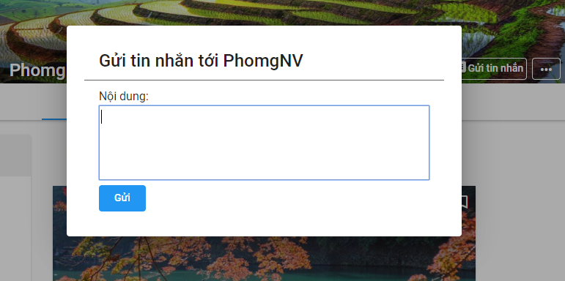

Figure 6-26: Send a message to another

* A popup will be displayed. User enter message then click on “Gửi” button.
* From now on, a conversation between two users is initiated. They can quickly see received message and send new message by click on message icon on the header and select conversation.

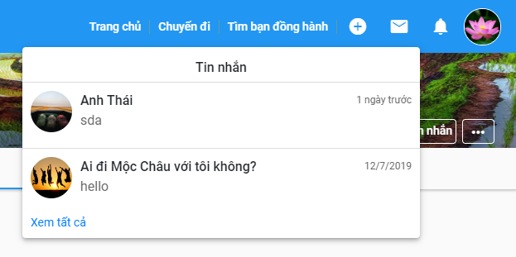

Figure 6-27: List of conversations

### **6.2.9 User joins a group**

* User go to the finding-companion post page which he/she wants to join.
* At the right side of the page, click on “Tham gia” button.

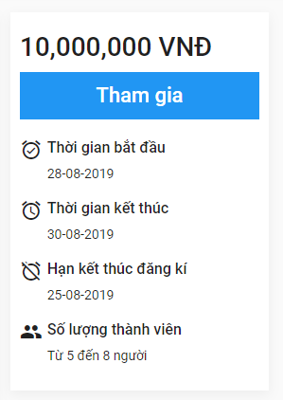

Figure 6-28: Finding-companion post information box

* System will send a request to the post’s author
* If the author accepts your join request, system will notify to you. Now you can see the group chat in the list of your conversations.

### **6.2.10 User follows other users and views followings/followers**

* On any page, user click on image profile on the header.
* System will display a list of options, then user click on “Trang cá nhân”.
* Browser will redirect to user’s personal page.
* User click on “n – Người đang theo dõi bạn” to see followers or “n – Người bạn đang theo dõi” to see followings.

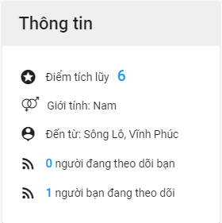

Figure 6-29: User profile

* System will display a popup with list of followings/followers

### **6.2.11 User bookmarks posts and view bookmarked posts**

* On any page that display list of posts, click on bookmark icon at the top-right of post item.

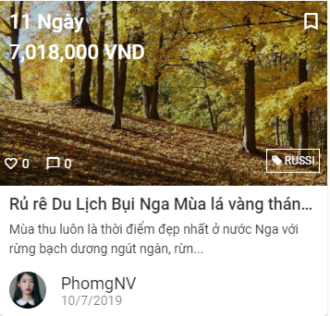

Figure 6-30: A post item

* Or on post detail page, click on bookmark icon at the left side of the page.

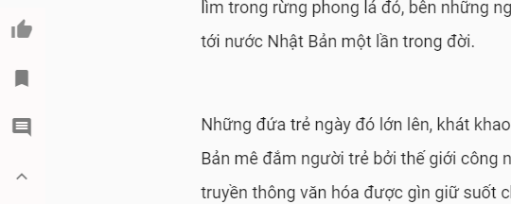

Figure 6-31: Post interaction in detail post page

1. <http://vietnamtourism.gov.vn/index.php/items/13460>
2. <http://flcholiday.com/tin-tuc/xu-huong-du-lich-2018-kham-pha-va-tan-huong-cuoc-song-117.htm>
3. <http://www.younetmedia.com/insights/infographic-xu-huong-du-lich-cua-gioi-tre-qua-phan-tich-tren-social-media.html>
4. <https://www.topsinfosolutions.com/methodology/>